Bridging Course 2022
Holland, Peter
Computing Dept
Bridging Course 2022
Computer Science Week 1
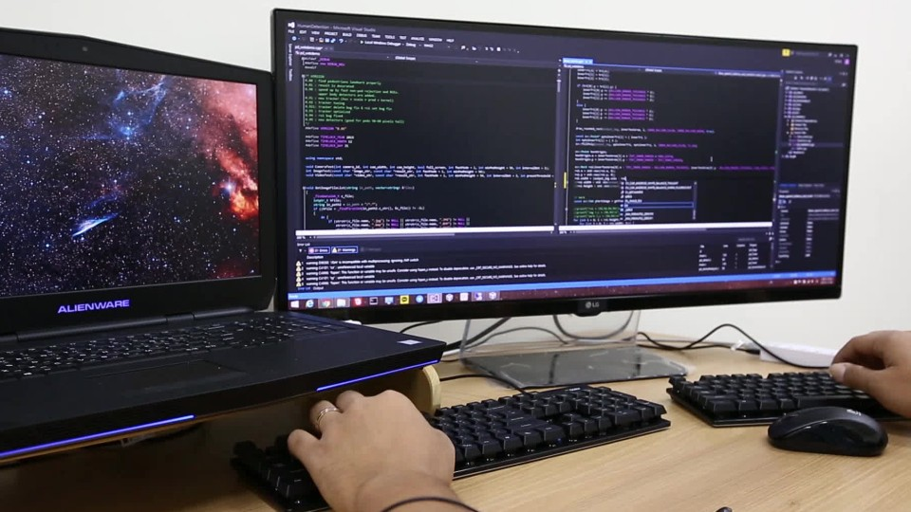

Studying A-Level Computer Science

Entry Requirements for Studying A-level Computer Science
- Students are expected to achieve at least a grade 7 in GCSE Computer Science.
- It is preferable to have a grade 7 in GCSE Maths as the A-Level course contains more mathematical content than the GCSE course.
- Students should be confident programmers by now – able to use core structures such as selection and iteration consistently. You should have an understanding of Python syntax and be able to debug your own programs. You must also enjoy programming – there will be a lot of it in the A-Level course!
- Students should have a keen interest in technology and advancements in it.
- Student should enjoy problem solving.

What to expect from A-level Computer SCIENCE
A-level Computer Science gives broad coverage of a range of important areas of the subject. The course is a mix of theory and practical skills. These complement the other and much of the theory work can be applied by completing practical programming tasks as homework of classwork.
There is a real focus on developing problem-solving skills and learning the application of concepts such as abstraction and decomposition to develop solutions.
As with GCSE, we will use OneNote to allow you to evidence your work. Students will also be expected to keep a paper file where they can keep handouts from lessons and assessments they have taken. Assessments typically come at the end of topic blocks and may also contain questions which require students to use learning from previous topics.
This bridging course will provide you with a mixture of information about A-level Computer Science, and what to expect from the course, as well as key work to complete. Students who are expecting to study Computer Science at A-level, and are likely to meet the entry requirements, must complete the bridging course fully and thoroughly, to the best of their ability.

You should complete all work electronically and keep it in a folder, in an ordered way. You will submit it to your teacher in September via OneNote. All of the work will be reviewed, and selected work will be assessed, and you will be given feedback on it. This work will be signalled to you. If you do not have access to the internet, please contact the school and appropriate resources will be sent to you. If you are thinking about studying Computer Science at A-level, you should attempt this work to see whether or not you think studying a subject like this is right for you. If you later decide to study Computer Science, you must ensure you complete this work in full. This work should be completed after you have read and completed the Study Skills work that all of Year 12 should complete.

Course outline
Paper 1D – Examination - worth 40% | Paper 2 – Examination - worth 40%
- An exam lasting 2 hours 30 minutes.  - On-screen and will take place in a computer room  - The paper examines practical programming skills and programming theory such as data structures and algorithms.  - A pre-release is issued in September of Year 13, consisting of a ‘skeleton program’ and notes on the function of the program. The skeleton program is partially complete. In the exam students will be expected to amend the program to fix issues and to extend its functionality.  - There are 4 sections in the exam.  - Section A – Questions on programming theory  - Section B – Unseen programming question  - Section C – Questions relating to pre-release material  - Section D – Programming questions based on pre-release material | - An exam lasting 2 hours 30 minutes.  - Written paper.  - Number of questions varies year on year but typically covers all fundamental theory areas other than those associated with programming.  - Topics include:  - Computer systems  - Architecture  - Networking  - Databases
NEA – a Practical Programming Project worth 20%
- You will choose an area of your own interest.
- You will develop a software solution to a problem by applying a spiral software lifecycle development model.
- Solution may be in the form of a desktop application, mobile app or website
- The process will involve completing an analysis, detailed design work, implementation of the solution, rigorous testing and an evaluation.

Week 1

Part 1: IDEs

What is an IDE?
Integrated Development Environment. In other words these are the tools you will use to develop programs.
You’ve been used to using Python’s bog-standard default ‘IDLE’ for this. This has been good for helping you to learn the basics of Python. However you do have a choice. There are a number of IDEs that you could use which provide some additional functionality that IDLE doesn’t have, particularly when it comes to debugging. At A-Level you should really be using a more advanced IDE to help you be able to work faster and be more organised.

Task – Compare IDEs
Look at the table in the following link:
https://en.wikipedia.org/wiki/Comparison_of_integrated_development_environments#Python
As you can see there are many IDEs for developing in Python. The two that I would recommend that you look at are PyCharm and Visual Studio Code.
Download PyCharm, Visual Studio & one other of your choice from the table in the link.
Try writing some simple, short programs in these IDEs. Make some comments in the table below as to how you found the IDEs (strengths/weaknesses, ease of use etc).
IDE | Link | Comments
PyCharm | https://www.jetbrains.com/pycharm/ | Pros: Easy to use, lots of useful shortcuts, tells you where errors are, relatively easy setup
Visual Studio Code | https://code.visualstudio.com/ | Pros:  Cons: More difficult setup, difficult to use
??? | ???

Which IDE will you choose?
Pycharm

Part 2: Analysing Programs

Reading Code
For this please find the attached Battleships program, along with the text file. A copy of the program is also in the Appendix of this document

Look at the program and answer the following questions. If there are any terms you are not sure of, you can look them up (potential terms are in bold). Sources of information may include Wikipedia or StackOverflow.
State the name of an identifier for a variable that is used to store a single character
State the name of an identifier for a user-defined subroutine that has one parameter
State the name of an identifier for a user-defined subroutine that returns a Boolean value
A constant is used to hold the filename 'Training.txt'. State one advantage of using named constants for constant values.
There is a variable called Row in the subroutine SetUpBoard. There is also a different variable called Row in the subroutine LoadGame. Explain why these two different variables can have the same identifier.
What is the purpose of the line

if __name__ == "__main__":

You can look this up to find out what it means!

Testing the Program
Run the program and play a few normal games.
Test the program with both expected and unexpected inputs
Make a list of any problems with the game in its current form. In the table describe the types of errors you have encountered.
Input | What happens (If you think you know why this might be happening then describe)
e.g. ‘p’ input on the main menu | Error returned. The program does not yet have a code to tell it what to do with that input
Decimal number input on menu | Error is returned. The program does not yet have a code to tell it what to do with that input
Number smaller or greater than 1-9 during the game | Error. The program does not yet have a code to tell it what to do with that input

Part 3: Basic Programming Tasks
Edit the program to carry out the following tasks:
Task | Allow the user to input their name at the beginning of the game, and for this to be displayed on the main menu in appropriate way
Code | name=input('What is your name? ')  print('Welcome '+name+'!')
Clipping of Running

Task | Adapt the program source code for the subroutine GetMainMenuChoice so that prevents a non-integer value being entered. If an invalid value is entered for the row the program should output Invalid option entered. The subroutine should not return any values until a valid integer has been entered
Code | def GetMainMenuChoice():  print("Please enter your choice: ", end="")  Choice = int(input())  print('Invalid value entered.')  return Choice
Clipping of Running

Task | Adapt the program source code for the subroutine GetRowColumn so that it checks that the row entered by the player is in the allowed range. If an invalid value is entered for the row the program should output Invalid value entered The subroutine should not return any values until a valid row has been entered
Code
Clipping of Running

Task | Introduce a variable called ‘moves’ to count how many moves the player has taken in the game. The number should then be displayed on the screen with an appropriate message after the message informing the player if they have achieved a hit or a miss.
Code
Clipping of Running

Appendix

Battleships Code Listing
import random

def GetRowColumn():
print()
Column = int(input("Please enter column: "))
Row = int(input("Please enter row: "))
print()
return Row, Column

def MakePlayerMove(Board, Ships):
Row, Column = GetRowColumn()
if Board[Row][Column] == "m" or Board[Row][Column] == "h":
print("Sorry, you have already shot at the square (" + str(Column) + "," + str(Row) + "). Please try again.")
elif Board[Row][Column] == "-":
print("Sorry, (" + str(Column) + "," + str(Row) + ") is a miss.")
Board[Row][Column] = "m"
else:
print("Hit at (" + str(Column) + "," + str(Row) + ").")
Board[Row][Column] = "h"

def SetUpBoard():
Board = []
for Row in range(10):
BoardRow = []
for Column in range(10):
BoardRow.append("-")
Board.append(BoardRow)
return Board

def LoadGame(Filename, Board):
BoardFile = open(Filename, "r")
for Row in range(10):
Line = BoardFile.readline()
for Column in range(10):
Board[Row][Column] = Line[Column]
BoardFile.close()

def PlaceRandomShips(Board, Ships):
for Ship in Ships:
Valid = False
while not Valid:
Row = random.randint(0, 9)
Column = random.randint(0, 9)
HorV = random.randint(0, 1)
if HorV == 0:
Orientation = "v"
else:
Orientation = "h"
Valid = ValidateBoatPosition(Board, Ship, Row, Column, Orientation)
print("Computer placing the " + Ship[0])
PlaceShip(Board, Ship, Row, Column, Orientation)

def PlaceShip(Board, Ship, Row, Column, Orientation):
if Orientation == "v":
for Scan in range(Ship[1]):
Board[Row + Scan][Column] = Ship[0][0]
elif Orientation == "h":
for Scan in range(Ship[1]):
Board[Row][Column + Scan] = Ship[0][0]

def ValidateBoatPosition(Board, Ship, Row, Column, Orientation):
if Orientation == "v" and Row + Ship[1] > 10:
return False
elif Orientation == "h" and Column + Ship[1] > 10:
return False
else:
if Orientation == "v":
for Scan in range(Ship[1]):
if Board[Row + Scan][Column] != "-":
return False
elif Orientation == "h":
for Scan in range(Ship[1]):
if Board[Row][Column + Scan] != "-":
return False
return True

def CheckWin(Board):
for Row in range(10):
for Column in range(10):
if Board[Row][Column] in ["A","B","S","D","P"]:
return False
return True

def PrintBoard(Board):
print()
print("The board looks like this: ")
print()
print (" ", end="")
for Column in range(10):
print(" " + str(Column) + " ", end="")
print()
for Row in range(10):
print (str(Row) + " ", end="")
for Column in range(10):
if Board[Row][Column] == "-":
print(" ", end="")
elif Board[Row][Column] in ["A","B","S","D","P"]:
print(" ", end="")
else:
print(Board[Row][Column], end="")
if Column != 9:
print(" | ", end="")
print()

def DisplayMenu():
print("MAIN MENU")
print()
print("1. Start new game")
print("2. Load training game")
print("9. Quit")
print()

def GetMainMenuChoice():
print("Please enter your choice: ", end="")
Choice = int(input())
print()
return Choice

def PlayGame(Board, Ships):
GameWon = False
while not GameWon:
PrintBoard(Board)
MakePlayerMove(Board, Ships)
GameWon = CheckWin(Board)
if GameWon:
print("All ships sunk!")
print()

if __name__ == "__main__":
TRAININGGAME = "Training.txt"
MenuOption = 0
while not MenuOption == 9:
Board = SetUpBoard()
Ships = [["Aircraft Carrier", 5], ["Battleship", 4], ["Submarine", 3], ["Destroyer", 3], ["Patrol Boat", 2]]
DisplayMenu()
MenuOption = GetMainMenuChoice()
if MenuOption == 1:
PlaceRandomShips(Board, Ships)
PlayGame(Board,Ships)
if MenuOption == 2:
LoadGame(TRAININGGAME, Board)
PlayGame(Board, Ships)

