Structuring a written report in a logical effective manner
Your report must include:
- Introduction
- Clear paragraphs
- PEE or PEEL structure
- Answer all parts of the PSA set

Link your paragraph to the case study or the question in the task

Have a look at the PSA questions below. Create a paragraph layout of how you would approach your written report for each question. The first one has been done for you.
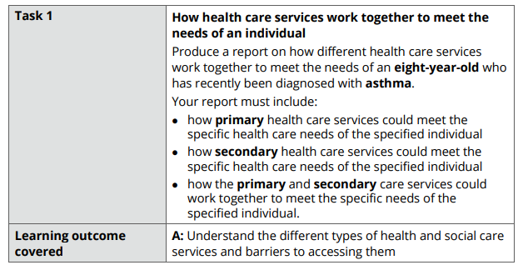
Introduction
  - Outline what you will do in your report
  - Include a definition of the illness that the person in your case study has
PEE Paragraph 1
  - Define what primary health care is
  - Explain how primary HCS can meet the needs of the individual
PEE Paragraph 2
  - Explain another way how primary HCS can meet the needs of the individual
PEE Paragraph 3
  - Define secondary health care
  - Explain how secondary HCS can meet the needs of the individual
PEE Paragraph 4
  - Explain another way how secondary HCS can meet the needs of the individual
PEE Paragraph 5
  - Define multidisciplinary working
  - Explain how primary and secondary HCS can work together to meet the needs of the individual
Conclusion

