
GCSE English Language Paper 1 Homework Booklet

Explorations in creative reading and writing



Summary of the exam

- This exam lasts 1 hour and 45 minutes
- The total mark for this exam is 80: 40 marks for section A and 40 marks for section B
- This exam requires you to respond to an unseen literary, fictional text.
- You will also be required to produce a piece of descriptive or narrative writing

Overall marking descriptors for Section A
Level | Skills Descriptors
Level 4 | Detailed, perceptive analysis
Level 3 | Clear, relevant explanation
Level 2 | Some understanding and comment
Level 1 | Simple, limited comment

Overall marking descriptors for Section B
Level | Skills Descriptors
Level 4 | Compelling, convincing
Level 3 | Consistent, clear
Level 2 | Some success
Level 1 | Simple, limited

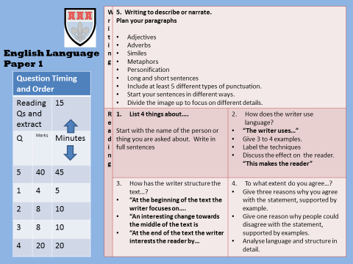
How to use this booklet:
- Read the guidance for each question carefully
- Use the extracts in each section to revise and practice important skills
- Read the example answers and make sure you understand how to produce a good answer
- Practise producing an answer for each question
- Use the key reminders section for each question to guide your revision

How to interpret and understand the extract

Who  - Who is narrating the extract? Is this narrator unreliable or limited in any way?  - What type of narrator is the writer using? Why might this be important?  - Who else is in the extract? How are the characters connected? | What  - What is happening in the extract?  - What importance might these events have?  - What do we think might have taken place before it?  - What do we think might take place after it?
Where  - Where is the extract set?  - Is the setting urban or rural?  - Is the setting very busy and crowded or is it isolated?  - What is the weather like in the extract? | When  - When is the extract taking place?  - Is the extract taking place in the daytime or night time? Why might this be important?  - How much time passes during the extract?

Section A: Question 1. List four things…

Question 1 tests your comprehension skills and your ability to retrieve relevant information. Therefore, you need to
- read the question carefully and underline the key words in the question
- make sure that you understand what information you need to look for

To make it clear to the examiner that you know what to do, start each sentence with either the name of the topic/thing that you are being asked to find information on or the relevant pronoun.
Look at this extract from Jane Eyre by Charlotte Bronte

The red-room was a square chamber, very seldom slept in, I might say
never, indeed, unless when a chance influx of visitors at Gateshead
Hall rendered it necessary to turn to account all the accommodation
it contained: yet it was one of the largest and stateliest chambers
in the mansion. A bed supported on massive pillars of mahogany,
hung with curtains of deep red damask, stood out like a tabernacle
in the centre; the two large windows, with their blinds always drawn
down, were half shrouded in festoons and falls of similar drapery;
the carpet was red; the table at the foot of the bed was covered
with a crimson cloth; the walls were a soft fawn colour with a blush
of pink in it; the wardrobe, the toilet-table, the chairs were of
darkly polished old mahogany. Out of these deep surrounding shades
rose high, and glared white, the piled-up mattresses and pillows of
the bed, spread with a snowy Marseilles counterpane. Scarcely less
prominent was an ample cushioned easy-chair near the head of the
bed, also white, with a footstool before it; and looking, as I
thought, like a pale throne.

List 4 things that you learn about the red room
- The red room wasn’t usually occupied
- The chair looked like a throne
- It had lots of furniture inside including a large bed
- The writer uses a simile to describe the chair “like a pale throne”
Out of this response, answers one and three are correct. They are specifically about what the question asks (the red room).
Answer two isn’t specifically about what is named in the question, therefore it wouldn’t get a mark. Answer four is about a language feature. This isn’t what the question asks and therefore it wouldn’t get a mark.
Overall, this would be awarded two out of four.

Look at this extract from Jane Eyre by Charlotte Bronte.

List four things you learn about John Reed
John Reed was a schoolboy of fourteen years old; four years older
than I, for I was but ten: large and stout for his age, with a
dingy and unwholesome skin; thick lineaments in a spacious visage,
heavy limbs and large extremities. He gorged himself habitually at
table, which made him bilious, and gave him a dim and bleared eye
and flabby cheeks. He ought now to have been at school; but his
mama had taken him home for a month or two, "on account of his
delicate health." Mr. Miles, the master, affirmed that he would do
very well if he had fewer cakes and sweetmeats sent him from home;
but the mother's heart turned from an opinion so harsh, and inclined
rather to the more refined idea that John's sallowness was owing to
over-application and, perhaps, to pining after home.

1………………………………………………………………………………………………………..
2………………………………………………………………………………………………………..
3………………………………………………………………………………………………………..
4……………………………………………………………………………………………………….

Look at this extract from One Hundred Years of Solitude by Gabriel Garcia Marquez.

List four things you learn about the Gypsies.

Every year during the month of March a family of ragged gypsies would set up their tents near the village, and with a great uproar of pipes and kettledrums they would display new inventions. First they brought the magnet. A heavy gypsy with an untamed beard and sparrow hands, who introduced himself as Melquíades, put on a bold public demonstration of what he himself called the eighth wonder of the learned alchemists of Macedonia. He went from house to house dragging two metal ingots and everybody was amazed to see pots, pans, tongs and braziers tumble down from their places and beams creak from the desperation of nails and screws trying to emerge, and even objects that had been lost for a long time appeared from where they had been searched for most and went dragging along in turbulent confusion behind Melquíades' magical irons. 'Things have a life of their own,' the gypsy proclaimed with a harsh accent

1………………………………………………………………………………………………………..
2………………………………………………………………………………………………………..
3………………………………………………………………………………………………………..
4……………………………………………………………………………………………………….

Look at this extract from The Grass is Singing by Doris Lessing.

List four things you learn about the Turner family and their house.

Long before the murder marked them out, people spoke of the Turners in the hard, careless voices reserved for misfits, outlaws, and the self-exiled. The Turners were disliked, though few of their neighbours had ever met them, or even seen them in the distance. Yet what was there to dislike? They simply 'kept themselves to themselves'; that was all. They were never seen at district dances, or fêtes, or gymkhanas. They must have had something to be ashamed of; that was the feeling. It was not right to seclude themselves like that; it was a slap in the face of everyone else; what had they got to be so stuck-up about? What, indeed! Living the way they did! That little box of a house - it was forgivable as a temporary dwelling, but not to live in permanently. Why, some natives (though not many, thank heavens) had houses as good; and it would give them a bad impression to see white people living in such a way.

1………………………………………………………………………………………………………..
2………………………………………………………………………………………………………..
3………………………………………………………………………………………………………..
4……………………………………………………………………………………………………….

Question 2: Writing about language
To succeed in question 2, you must be able to identify and accurately label a wide range of language features. You need to make sure that you learn all of the techniques listed below and that you can identify them correctly within a text.
Language technique | Definition | Example | How confident do I feel about this feature?
Adverb | A word that describes how a verb is done | She stood silently.
Adjective | A word that describes | The lion had a fiery, bushy mane.
Pronouns | A word that takes the place of a noun | What would you do?(2nd person pronoun)  We can do it; together (1st person pronoun)  But with our help, we can stop this injustice (possessive pronoun)
Modal verbs | An auxiliary verb that expresses necessity or possibility. It appears before the main verb in the sentence | You could revise for your English exam  You should revise for your English exam  You must revise for your English exam
Imperatives | A verb that commands | Talk to your friends about how they feel.
Simile | Using ‘like’ or ‘as’ to describe something by comparing it to something else | The water poured into the village as swift as the rushing wind.
Metaphor | Where you describe something as if it actually is something else | The water was a hurricane, destroying everything in its path.
Onomatopoeia | Using the sound | Crash! Buildings tumbled to the ground.
Personification | A descriptive technique – give something that isn’t human, human qualities | The gentle, calming breeze fluttered through the city.
Rhyme | Using words that have the same vowel sound | What you need to understand is they all just need a helping hand from us.
Anecdotes | Using a story to illustrate, reinforce a point | You still don’t think your health is important? Take Sarah…
Alliteration | Beginning words with the same sound, often words that are next to each other | The rampaging, rushing river ripped its way through the mountain village.
Fact | Something which is true and can be backed up by evidence | Kenya is one of the largest African countries.
Opinion | A writer says what they think | Animal testing is plain wrong.
Repetition | Repeating words or a phrase | Animal testing is wrong; plain wrong.
Rhetorical question | A question that doesn’t need to be answered | Would you like to live in a town plagued by death and disease?
Emotive language | Words that have an emotional effect on the reader | Every night, thousands of children in Syria come home to freezing, filthy conditions.
Exaggeration | Embellishing or overstating a point/idea/opinion | This is surely the most horrendous example of animal neglect that we have seen in the last ten years.
Statistics | Using numbers, percentages and/or fractions | 66% of young adults said that they were worried about debt.
(Rule of) Three | Using a sequence of three words (usually adjectives) | But with your help, we can provide clean water, tools to grow food and shelter for the most needy.
Pun | A play on words/double meaning | Rooney is going to kick himself for missing that open goal.
Question 2: Writing about language
To achieve excellent marks in this section of the exam it is essential that you not only accurately identify a range of language features, but that you also analyse the effects of the features that you find in detail. Therefore, the following phrases are banned. If you use these phrases you are limiting your chances of achieving anything above Level 1 (the lowest level)

Banned phrases:
It makes the reader want to read on
It makes the reader think
It is effective
It has an effect
It puts a picture in the reader’s head
It stands out
It draws the reader in
It grabs the reader’s attention

Look at this extract from Survivor by Chuck Palahniuck. It is from the opening of the novel.

Testing, testing. One, two, three.
Testing, testing. One, two, three.

Maybe this is working. I don’t know. If you can even hear me, I don’t know.
But if you can hear me, listen. And if you’re listening then what you’ve found is the story of everything that went wrong. This is what you’d call the flight recorder of Flight 2039. The black box, people call it, even though its orange and on the inside is a loop of wire that’s the permanent record of all that’s left. What you’ve found is the story of what happened.
Feature | Quotation | Effect
Repetition | “I don’t know. If you can even hear me, I don’t know.” | The repetition of “I don’t know” reinforces the panic and desperation felt by the narrator. It highlights the sense of chaos established within the extract, which is further emphasised by the fact that the narrator is on a crashing plane.
Imperative verb
2nd person pronoun
Add in your own language feature

Look at this extract from Great Expectations by Charles Dickens. It is a description of the character Miss Havisham
It was then I began to understand that everything in the room had stopped, like the watch and the clock, a long time ago. I noticed that Miss Havisham put down the jewel exactly on the spot from which she had taken it up. As Estella dealt the cards, I glanced at the dressing-table again, and saw that the shoe upon it, once white, now yellow, had never been worn. I glanced down at the foot from which the shoe was absent, and saw that the silk stocking on it, once white, now yellow, had been trodden ragged. Without this arrest of everything, this standing still of all the pale decayed objects, not even the withered bridal dress on the collapsed from could have looked so like grave-clothes, or the long veil so like a shroud.
So she sat, corpse-like, as we played at cards; the frillings and trimmings on her bridal dress, looking like earthy paper. I knew nothing then, of the discoveries that are occasionally made of bodies buried in ancient times, which fall to powder in the moment of being distinctly seen; but, I have often thought since, that she must have looked as if the admission of the natural light of day would have struck her to dust.

Feature | Quotation | Effect
Simile

Adjective

Add in your own language feature

Add in your own language feature

How to produce a successful answer
Look at this extract from ‘Norwegian Wood’ by Haruki Murakami. The narrator, is discussing a memory from when he attended university.
Question 2: How does the writer use language here to describe the effects his memories? You could include the writer’s choice of:
- words and phrases
- language features and techniques
- sentence forms.

I do need that time, though, for Naoko's face to appear. And as the years have passed, the time has grown longer. The sad truth is that what I could recall in five seconds all too needed ten, then thirty, then a full minute-like shadows lengthening at dusk. Someday, I suppose, the shadows will be swallowed up in darkness. There is no way around it: my memory is growing ever more distant from the spot where Naoko used to stand-ever more distant from the spot where my old self used to stand. And nothing but scenery, that view of the meadow in October, returns again and again to me like a symbolic scene in a movie. Each time is appears, it delivers a kick to some part of my mind. "Wake up," it says. "I'm still here. Wake up and think about it. Think about why I'm still here." The kicking never hurts me. There's no pain at all. Just a hollow sound that echoes with each kick. And even that is bound to fade one day. At the Hamburg airport, though, the kicks were longer and harder than usual. Which is why I am writing this book. To think. To understand. It just happens to be the way I'm made. I have to write things down to feel I fully comprehend them.
The writer uses words to describe how he feels for example “my memory is growing ever more distant” this is very descriptive and makes the reader want tp read on. The text also uses personification “The kicking never hurts me”. This is personification because it is giving something that isn’t human a human quality. This is a great technique used by the writer and makes it really interesting to read. He also uses place names “Hamburg airport” to show the reader where he is.

This answer would be awarded 2/8. The student uses relevant quotations and some subject terminology but the explanations are simple and limited. The student has not attempted to think about the real effect of the features or engage with their connotations.

Question 2: How does the writer use language here to describe his memories? You could include the writer’s choice of:
- words and phrases
- language features and techniques
- sentence forms.

I do need that time, though, for Naoko's face to appear. And as the years have passed, the time has grown longer. The sad truth is that what I could recall in five seconds all too needed ten, then thirty, then a full minute-like shadows lengthening at dusk. Someday, I suppose, the shadows will be swallowed up in darkness. There is no way around it: my memory is growing ever more distant from the spot where Naoko used to stand-ever more distant from the spot where my old self used to stand. And nothing but scenery, that view of the meadow in October, returns again and again to me like a symbolic scene in a movie. Each time is appears, it delivers a kick to some part of my mind. "Wake up," it says. "I'm still here. Wake up and think about it. Think about why I'm still here." The kicking never hurts me. There's no pain at all. Just a hollow sound that echoes with each kick. And even that is bound to fade one day. At the Hamburg airport, though, the kicks were longer and harder than usual. Which is why I am writing this book. To think. To understand. It just happens to be the way I'm made. I have to write things down to feel I fully comprehend them.

________________________________________________________________________________________________________________________________________________________________________________________________________________________________________________________________________________________________________________________________________________________________________________________________________________________________________________________________________________________________________________________________________________________________________________________________________________________________________________________________________________________________________________________________________________________________________________________________________________________________________________________________________________________________________________________________________________________________________________________________________________________________________________________________________________________________________________________________________________________________________________________________________________________________________________________________________________________________________________________________________________________________________________________________________________________________________________________________________________________________________________________________________________________________________________________________________________________________________________________________________________________________________________________________________________________________________________________________________________________________________________________________________________________________________________________________________________________________________________________________________________________________________________________

Look at this extract from Dr Jekyll and Mr Hyde by Robert Louis Stephenson.
Here, a young girl is describing her encounter with the character Mr Hyde.

Question 2: How does the writer use language here to describe Mr Hyde?
- words and phrases
- language features and techniques
- sentence forms

Presently her eye wandered to the other, and she was surprised to recognise in him a certain Mr Hyde, who had once visited her master, and for whom she had conceived a dislike. He had in his hand a heavy cane, with which he was trifling; but he answered never a word, and seemed to listen with an ill-contained impatience. And then all of a sudden he broke out in a great flame of anger, stamping with his foot, brandishing the cane, and carrying on (as the maid described it) like a madman. The very old gentleman took a step back, with the air of one very much surprised and a trifle hurt; and at that Mr Hyde broke out of all bounds, and clubbed him to the earth. And next moment, with ape-like fury, he was trampling his victim under foot, and hailing down a storm of blows, under which the bones were audibly shattered and the body jumped upon the roadway. At the horror of these sights and sounds, the maid fainted.

The writer uses verbs to demonstrate the ferocity of Mr Hyde and emphasise his animalistic qualities. For example, the present participle verb “trampling” implies that the character is able to use significant force and in fact is able to almost flatten his victim, suggesting that this character is devoid of any human emotion or empathy for his victim. His inhumane qualities are also reinforced by the adverb “audibly” which further demonstrates his almost superhuman, abnormal abilities and heightens the danger and threat that he poses.
This answer demonstrates level 4 skills. The student is able to pick out relevant features, quote them precisely and offer a detailed and perceptive analysis of their effect. They have clearly thought about the connotations of the words and then use these to explain what effect this has on the reader and what it implies about the character.
You should now write two more paragraphs demonstrating these skills.

____________________________________________________________________________________________________________________________________________________________________________________________________________________________________________________________________________________________________________________________________________________________________________________________________________________________________________________________________________________________________________________________________________________________________________________________________________________________________________________________________________________________________________________________________________________________________________________________________________________________________________________________________________________________________________________________________________________________________________________________________________________________________________________________________________________________________________________________________________________________________________________________________________________________________________________________________________________________________________________________________________________________________________________________________________________________________________________________________________________________________________________________________________________________________________________________________________________________________________________________________________

Key reminders for question 2

In my answer have I…. |  or X
Focused specifically on language
Used precise terminology when naming a language feature
Used a small and relevant quotation
Discussed the effects of the language feature: how it makes the reader feel/what it implies or suggests/what sort of atmosphere it creates
Discussed the connotations of a word/words within the quotation and linked this back to the effect

Question 3: Writing about structure
Structure Toolkit
Chronological/ Linear Structure: ordering of events in the order that they occur
Flashback: where characters/ narrators remember and retell events that have happened in the past
Parallel Narrative: a narrative structure that switches between two narrative perspectives
Multiple Narrative: a narrative structure that switches between several narrative perspectives
Nonlinear Narrative/ Disjointed Narrative/ Disrupted Narrative: a narrative technique, where events are portrayed out of chronological order, often moving backwards and forwards in time
Cyclical Narrative: A narrative structure that revisits the idea at the end of the text which was presented at the start
Framed Narrative: where a story is presented within the overall narrative e.g. within a letter or diary entry
Comparison and Contrast: where comparisons and contrasts are drawn within a text
Cause and Effect: where consequences of events are detailed
Inductive Structure: where detail moves from the specific to the more general
Deductive Structure: where details move from the more general to the specific
Shifting of focus: other movement within a text e.g. from outside to inside, from inside to outside, from the collective to the individual etc.
Exposition: the part of a text where setting, characters and background information is introduced
Rising Action: the part of a text where some form of problem or crisis begins to emerge
Climax: the part of the text where there is the highest level of tension, usually involving a turning point
Falling Action: the part of a text where characters begin to solve their problems or crisis
Resolution/ Denouement: the part of the text which offers closure and problems/ crises are resolved
Foreshadowing: where future events of the text are hinted at (usually in early parts of a narrative)
Foreboding: a suggestion or hint that something bad or dangerous might occur later in a text
Plot: story or sequence of events
Anticlimax: where expectations of dramatic events are raised, and then dashed
Accumulation: where lists of details are piled up to create a cumulative effect
Anaphora: a type or repetition where the opening detail of a phrase is repeated
Perspective Shifts: where the narrative perspective (e.g. first ‘I’, second ‘you’, third ‘he’ / ‘she’) changes
Topic sentence: the opening sentence of a paragraph which introduces the focus on that paragraph
Repetition: where a word, phrase or idea is repeated through a text
Beginnings and Endings: these should be considered when analysing introductions, changes, developments and resolutions in texts
Paragraphs: sections that a text is broken down into, often separated by changes in topic, time, person or place
Paragraph length: consider the length of the paragraph and how this impacts upon the idea and shape of the text as a whole
Clause: a group of words that include a verb. Clauses can sometimes be complete sentences e.g. ‘It was raining’
Main Clause: sentences are made up of at least one main clause – the main idea of a sentence e.g. ‘It was raining’ Sometimes sentences can be made up of more that one main clause e.g. ‘It was raining but the sun was shining’.
Subordinate Clause: A clause which is subordinate to another part of the same sentence e.g. ‘The apple that I ate was sour but it looked very tasty’.
Single-clause Sentence: A sentence made up from one main clause e.g. ‘It was raining’.
Multi-clause Sentence: A sentence that includes two or more clauses e.g. ‘She went shopping but took back everything she had bought because she didn’t like any of it.’ Multi clause sentences can be made up of sentences of more than one main clause e.g. ‘It was raining but the sun was shining.’ Multi-clause sentences can also be made up of main and subordinate clauses e.g. ‘The apple that I ate was sour but it looked very tasty’.
Declarative Sentence / Statements: sentences that are statements e.g. ‘You are my friend.’
Commands: Sentences that give commands e.g. ‘Be my friend!’
Interrogative Sentences / Questions: sentences that ask questions e.g. ‘Are you my friend?’
Exclamatory Sentence / Exclamation: sentences that exclaim e.g. ‘You are such a good friend!’

Question 3: Writing about structure
In this section of the exam you will be required to look at the whole of an extract and analyse how it is structured to interest the reader. You will be asked to focus on what is written about in the beginning, middle and end of the extract as well as picking out any other structural features.
Key questions to ask myself:
- What does the writer focus my attention on at the beginning, middle and end? What does the writer zoom in on?
- How does the focus of the extract change as the text progresses? Does the writer zoom out to look at the whole at any point?
- What are the effects of the change in focus?
Look at this extract from ‘To kill a mockingbird’ by Harper Lee. In this extract, the character Scout is describing her father, Atticus.
Atticus was feeble: he was nearly fifty. When Jem and I asked him why he was so old, he said he got started late, which we felt reflected upon his abilities and manliness. He was much older than the parents of our school contemporaries, and there was nothing Jem or I could say about him when our classmates said, ‘My father – ’
Jem was football crazy. Atticus was never too tired to play keep-away, but when Jem wanted to tackle him Atticus would say, ‘I’m too old for that, son.’
Our father didn’t do anything. He worked in an office, not in a drugstore. Atticus did not drive a dump-truck for the county, he was not the sheriff, he did not farm, work in a garage, or do anything that could possibly arouse the admiration of anyone.
Besides that, he wore glasses. He was nearly blind in his left eye, and said left eyes were the tribal curse of the Finches. Whenever he wanted to see something well, he turned his head and looked from his right eye.
He did not do the things our schoolmates’ fathers did; he never went hunting, he did not play poker or fish or drink or smoke. He sat in the living-room and read.
With these attributes, however, he would not remain as inconspicuous as we wished him to; that year, the school buzzed with talk about him defending Tom Robinson, none of which was complimentary. After my bout with Cecil Jacobs when I committed myself to a policy of cowardice, word got around that Scout Finch wouldn’t fight any more, her daddy wouldn’t let her. This was not entirely correct: I wouldn’t fight publicly for Atticus, but the family was private ground. I would fight anyone from a third cousin upwards tooth and nail. Francis Hancock, for example, knew that.
When he gave us our air-rifles Atticus wouldn’t teach us to shoot. Uncle Jack instructed us in the rudiments thereof; he said Atticus wasn’t interested in guns, Atticus said to Jem one day, ‘I’d rather you shot at tin cans in the back yard, but I know you’ll go after birds. Shoot all the bluejays you want, if you can hit ‘em, but remember it’s a sin to kill a mockingbird.’
That was the only time I heard Atticus say it was a sin to do something, and I asked Miss Maudie about it.
‘Your father’s right,’ she said. ‘Mockingbirds don’t do one thing but make music for us to enjoy. They don’t eat up people’s gardens, don’t nest in corncribs, they don’t do one thing but sing their hearts out for us. That’s why it’s a sin to kill a mockingbird.’
What emotion, idea or concept is suggested in the opening, middle and end of the extract? The three boxes below have been completed for you.

Look at this extract from ‘To kill a mockingbird’ by Harper Lee. In this extract, the character Scout is describing her father, Atticus.
How has the text been structured to interest you as a reader?
 | Example | Effect | Link to the question
In the opening of the extract, the writer focuses the reader on the idea of disappointment. | For example, “Atticus was feeble” | This suggests that the character of Atticus is regarded as weak, certainly in the eyes of his children. They do not seem to value the qualities that he has and instead wish he was like the parents of their classmates. | This would interest the audience because it is a contrast to a stereotypical father figure who the reader would expect to be strong and highly respected. Therefore, the character of Atticus is not what we expect, which could potentially foreshadow his role within the novel.
Then, the writer shifts our attention to the many ways in which Atticus is viewed as different.

However, at the end the writer finishes with a warning.

Look at this extract from ‘Half of a yellow sun’ by Chimamanda Ngozi Adichie set in Nigeria. The extract is from the opening of the novel. The character Ugwu, a 13 year old boy, is meeting his new employer.
Master was a little crazy; he had spent too many years reading books overseas, talked to himself in his office, did not always return greetings, and had too much hair. Ugwu's aunty said this in a low voice as they walked on the path. "But he is a good man," she added. "And as long as you work well, you will eat well. You will even eat meat every day." She stopped to spit; the saliva left her mouth with a sucking sound and landed on the grass.
Ugwu did not believe that anybody, not even this master he was going to live with, ate meat every day. He did not disagree with his aunty, though, because he was too choked with expectation, too busy imagining his new life away from the village. They had been walking for a while now, since they got off the lorry at the motor park, and the afternoon sun burned the back of his neck. But he did not mind. He was prepared to walk hours more in even hotter sun.
He had never seen anything like the streets that appeared after they went past the university gates, streets so smooth and tarred that he itched to lay his cheek down on them. He would never be able to describe to his sister Anulika how the bungalows here were painted the colour of the sky and sat side by side like polite well-dressed men, how the hedges separating them were trimmed so flat on top that they looked like tables wrapped with leaves.
His aunty walked faster, her slippers making slap-slap sounds that echoed in the silent street.
Ugwu wondered if she, too, could feel the coal tar getting hotter underneath, through her thin soles.
They went past a sign, ODIM STREET, and Ugwu mouthed street, as he did whenever he saw an English word that was not too long ... Master sat in an armchair, wearing a singlet and a pair of shorts.
He was not sitting upright but slanted, a book covering his face, as though oblivious that he had just asked people in.
"Good afternoon, sah! This is the child," Ugwu's aunty said.
Master looked up. His complexion was very dark, like old bark, and the hair that covered his chest and legs was a lustrous, darker shade. He pulled off his glasses. "The child?"
"The houseboy, sah."

What emotion, idea or concept is suggested in the opening, middle and end of the extract?

How has the text been structured to interest you as a reader?
 | Example | Effect | Link to the question
In the opening of the extract, the writer focuses the reader on

Then, the writer shifts our attention to

However, at the end the writer focuses my attention on

Look at this extract from ‘1984’ by George Orwell. The novel is set in a dystopian future set in the fictional super-state of Oceania.
'Comrades!' cried an eager youthful voice. 'Attention, comrades! We have glorious news for you. We have won the battle for production! Returns now completed of the output of all classes of consumption goods show that the standard of living has risen by no less than 20 per cent over the past year. All over Oceania this morning there were irrepressible spontaneous demonstrations when workers marched out of factories and offices and paraded through the streets with banners voicing their gratitude to Big Brother for the new, happy life which his wise leadership has bestowed upon us. Here are some of the completed figures. Foodstuffs-'
The phrase 'our new, happy life' recurred several times. It had been a favourite of late with the Ministry of Plenty. Parsons, his attention caught by the trumpet call, sat listening with a sort of gaping solemnity, a sort of edified boredom. He could not follow the figures, but he was aware that they were in some way a cause for satisfaction. He had lugged out a huge and filthy pipe which was already half full of charred tobacco. With the tobacco ration at 100 grammes a week it was seldom possible to fill a pipe to the top. Winston was smoking a Victory Cigarette which he held carefully horizontal. The new ration did not start till tomorrow and he had only four cigarettes left. For the moment he had shut his ears to the remoter noises and was listening to the stuff that streamed out of the telescreen. It appeared that there had even been demonstrations to thank Big Brother for raising the chocolate ration to twenty grammes a week. And only yesterday, he reflected, it had been announced that the ration was to be reduced to twenty grammes a week. Was it possible that they could swallow that, after only twenty-four hours? Yes, they swallowed it. Parsons swallowed it easily, with the stupidity of an animal. The eyeless creature at the other table swallowed it fanatically, passionately, with a furious desire to track down, denounce, and vaporize anyone who should suggest that last week the ration had been thirty grammes. Syme, too-in some more complex way, involving doublethink, Syme swallowed it. Was he, then, alone in the possession of a memory?
The fabulous statistics continued to pour out of the telescreen. As compared with last year there was more food, more clothes, more houses, more furniture, more cooking-pots, more fuel, more ships, more helicopters, more books, more babies -- more of everything except disease, crime, and insanity. Year by year and minute by minute, everybody and everything was whizzing rapidly upwards. As Syme had done earlier Winston had taken up his spoon and was dabbling in the pale-coloured gravy that dribbled across the table, drawing a long streak of it out into a pattern. He meditated resentfully on the physical texture of life. Had it always been like this? Had food always tasted like this? He looked round the canteen. A low-ceilinged, crowded room, its walls grimy from the contact of innumerable bodies; battered metal tables and chairs, placed so close together that you sat with elbows touching; bent spoons, dented trays, coarse white mugs; all surfaces greasy, grime in every crack; and a sourish, composite smell of bad gin and bad coffee and metallic stew and dirty clothes. Always in your stomach and in your skin there was a sort of protest, a feeling that you had been cheated of something that you had a right to. It was true that he had no memories of anything greatly different. In any time that he could accurately remember, there had never been quite enough to eat, one had never had socks or underclothes that were not full of holes, furniture had always been battered and rickety, rooms underheated, tube trains crowded, houses falling to pieces, bread dark-coloured, tea a rarity, coffee filthy-tasting, cigarettes insufficient -- nothing cheap and plentiful except synthetic gin. And though, of course, it grew worse as one's body aged, was it not a sign that this was not the natural order of things, if one's heart sickened at the discomfort and dirt and scarcity, the interminable winters, the stickiness of one's socks, the lifts that never worked, the cold water, the gritty soap, the cigarettes that came to pieces, the food with its strange evil tastes? Why should one feel it to be intolerable unless one had some kind of ancestral memory that things had once been different?
He looked round the canteen again. Nearly everyone was ugly, and would still have been ugly even if dressed otherwise than in the uniform blue overalls. On the far side of the room, sitting at a table alone, a small, curiously beetle-like man was drinking a cup of coffee, his little eyes darting suspicious glances from side to side. How easy it was, thought Winston, if you did not look about you, to believe that the physical type set up by the Party as an ideal-tall muscular youths and deep-bosomed maidens, blond-haired, vital, sunburnt, carefree - existed and even predominated. Actually, so far as he could judge, the majority of people in Airstrip One were small, dark, and ill-favoured. It was curious how that beetle-like type proliferated in the Ministries: little dumpy men, growing stout very early in life, with short legs, swift scuttling movements, and fat inscrutable faces with very small eyes. It was the type that seemed to flourish best under the dominion of the Party.

How has the writer structured the text to interest you as a reader?
You could write about:
- what the writer focuses your attention on at the beginning
- how and why the writer changes this focus as the Source develops
- any other structural features that interest you.

The writer begins with somebody talking and shouting and the writer focuses our attention on what the person says. This is interesting to the reader because they are shouting and they want to know what they are shouting about. This is good for the first part of the extract because it would make the reader pay attention

This answer makes some good points and makes some reference to methods. The student refers to the structure by mentioning what the extract “begins” with and talking about the “first part”. They make some link back to the question and attempt to comment on the effect. However, there is no use of quotation and no real explanation, therefore if this answer were written in full it couldn’t be awarded more than 2/8.

In the opening of the extract the writer focuses our attention on the announcement “Comrades! cried an eager youthful voice” The use of punctuation and short, exclamatory sentences in the opening signals to the reader that something important is about to be announced. It creates a sense of drama and tension as it uses words from the semantic field of war like ‘won’, ‘battle’, ‘glorious’ and ‘comrades’ making the reader immediately feel as if they are in place of conflict and fighting implying that this world is not a safe one. However in the second half of the opening the “eager youthful voice” is taken out of focus and the narrator zooms into the character’s thoughts. The fact that this shift in narrative perspective happens mid-sentence and rather abruptly “Foodstuffs-“ emphasises the sense of disdain that the narrator feels for the announcement and imbues a sense of cynicism and contempt. This interests the reader as it suggests it provides a distinct contrast to the patriotic and jingoistic voice established in the opening.

This answer uses a range of relevant quotations and explains their effects in detail with a clear focus on the structure of the text. The point that it makes about the shift in narrative perspective is perceptive and detailed, showing a more insightful understanding of how the text is structured. The answer also talks about other structural features such as sentence types. If this were completed in full it would receive a minimum of 7/8.

Now continue this answer, reflecting the skills demonstrated in the second sample response.
__________________________________________________________________________________________________________________________________________________________________________________________________________________________________________________________________________________________________________________________________________________________________________________________________________________________________________________________________________________________________________________________________________________________________________________________________________________________________________________________________________
_________________________________________________________________________________________________________________________________________________________________________________________________________________________________________________________________________________________________________________________________________________________________________________________________________________________________________________________________________________________________________________________________________________________________________________________________________________________________________________________________________________________________________________________________________________________________________________________________________________________________________________________________________________________________________________________________________________________________________________________________________________________________________________________________________________________________________________________________________________________________________________________________________________________________________________________________________________________________________________________________________________________________________________________________________________________________________________________________________________________________________________________________________________________________________________________________________________________________________________________________________________________

Key reminders for question 3

In my answer have I…. | or X
Focused specifically on structure
Written about what my attention is focused on at the beginning, middle and end of the extract.
Used small and relevant quotations
Discussed the effects of quotations, with a focus on how the extract changes as the text develops
Linked back to the question and explained how this interests the reader

Remember! You can also write about any structural features that you think are worthy of note. Use your structure toolkit to help you pick
out these features.

Question 4: evaluating an interpretation of the text

In this section of the exam you will be provided with a statement about part of the text. The statement will be a comment that a student has made about their own personal interpretation of the text. You will need to decide to what extent you agree with the statement and provide detailed evidence to back up your response.

The first step to succeeding in this question is to make sure that you understand the statement.

Look again at this extract from ‘Norwegian Wood’ by Haruki Murakami. The narrator, is discussing a memory from when he attended university.

I do need that time, though, for Naoko’s face to appear. And as the years have passed, the time has grown longer. The sad truth is that what I could recall in five seconds all too needed ten, then thirty, then a full minute-like shadows lengthening at dusk. Someday, I suppose, the shadows will be swallowed up in darkness. There is no way around it: my memory is growing ever more distant from the spot where Naoko used to stand-ever more distant from the spot where my old self used to stand. And nothing but scenery, that view of the meadow in October, returns again and again to me like a symbolic scene in a movie. Each time is appears, it delivers a kick to some part of my mind. “Wake up,” it says. “I’m still here. Wake up and think about it. Think about why I’m still here.” The kicking never hurts me. There’s no pain at all. Just a hollow sound that echoes with each kick. And even that is bound to fade one day. At the Hamburg airport, though, the kicks were longer and harder than usual. Which is why I am writing this book. To think. To understand. It just happens to be the way I’m made. I have to write things down to feel I fully comprehend them.

A student, having read this section of the text said: “The writer shows the reader that the character of Naoko was clearly important to the narrator. The writer creates a really strong sense of sadness and regret and it seems that the narrator may be forgetting the memory.

To what extent do you agree?

In your response, you could:
- write about your own impressions of the memory
- evaluate how the writer has created these impressions
- support your opinions with references to the text.

To ensure that you understand the statement, underline key words and annotate what they mean. Some key words have already been underlined for you.

A student, having read this section of the text said: “The writer shows the reader that the character of Naoko was clearly important to the narrator. The writer creates a really strong sense of sadness and regret and it seems that the narrator may be forgetting the memory.

In your answer, try to address every part of the statement and focus on how the writer creates this effect.

 | Method and quotation | Analysis
Naoko was clearly important to the narrator | Simile: “like shadows lengthening at dusk”
Strong sense of sadness and regret | Adjectives “Just a hollow sound”
Narrator may be forgetting the memory | Repetition “To think. To understand”
Look again at this extract from Dr Jekyll and Mr Hyde by Robert Louis Stephenson.
Here, a young girl is describing her encounter with the character Mr Hyde.

Presently her eye wandered to the other, and she was surprised to recognise in him a certain Mr Hyde, who had once visited her master, and for whom she had conceived a dislike. He had in his hand a heavy cane, with which he was trifling; but he answered never a word, and seemed to listen with an ill-contained impatience. And then all of a sudden he broke out in a great flame of anger, stamping with his foot, brandishing the cane, and carrying on (as the maid described it) like a madman. The very old gentleman took a step back, with the air of one very much surprised and a trifle hurt; and at that Mr Hyde broke out of all bounds, and clubbed him to the earth. And next moment, with ape-like fury, he was trampling his victim under foot, and hailing down a storm of blows, under which the bones were audibly shattered and the body jumped upon the roadway. At the horror of these sights and sounds, the maid fainted.

Underline and annotate key words in the statement:

A student having read this section of the text said ‘The writer creates a horrifying image of a brutal attack. The writer creates the impression that Mr Hyde is a highly dangerous, almost inhuman character’.

I agree with the statement because in the text it says “with ape-like fury” which makes me feel really scared about what the character of Mr Hyde can do. He seems like a merciless man who can destroy any enemy that stands in his path. Also the fact that the maid “fainted” tells me that the attack was horrific as it shocked her so much that she actually passed out so it must have been awful for the victim.

This answer has a lot of positive points. It addresses points of the statement (although not directly) and uses relevant quotations with some explanations. However, it makes no reference to methods that the writer uses and doesn’t explain in enough detail. If this answer was in full then it would receive a minimum of 8/20.

I agree with the statement because the metaphorical description of “ape-like fury” implies that the character of Mr Hyde is more animal than human. This suggests that he is wild and primitive and doesn’t possess any human qualities such as morality or rationality. This in turn makes the reader feel that he is devoid of any regard for his victim’s feelings, making him even more threatening and dangerous. Therefore I also fully agree that this was a brutal attack, as the verb “fainted” implies that the character of the maid was so overwhelmed by the viciousness that it caused her to lose consciousness. This implies that the maid was unable to comprehend how someone could treat another human being in such a way conveying the sense that Mr Hyde is cold and callous.

This answer, importantly, focuses on methods mentioning ‘metaphorical description and ‘verb’. It also analyses the effect of the quotations it selects in depth and then links these back to why they agree with the statement in clear detail. If this answer was longer it would achieve a minimum of 16/20.

Write at least three more detailed paragraphs continuing the answer.

___________________________________________________________________________________________________________________________________________________________________________________________________________________________________________________________________________________________________________________________________________________________________________________________________________________________________________________________________________________________________________________________________________________________________________________________________________________________________________________________________________________________________________________________________________________________________________________________________________________________________________________________________________________________________________________________________________________________________________________________________________________________________________________________________________________________________________________________________________________________________________________________________________________________________________________________________________________________________________________________________________________________________________________________________________________________________________________________________________________________________________________________________________________________________________________________________________________________________________________________________________________________________________________________________________________________________________________________________________________________________________________________________________________________________________________________________________________________________________________________________________________________________________________________________________________________________________________________________________________________________________________________________________________________________________________________________________________________________________________________________________________________________________________________________________________________________________________________________________________________________________________________________________________________________________________________________________________________________________________________________________________________________________________________________________________________________________________________________________________________________________________________________________________________________________________________________________________________________________________________________________________________________________________________________________________________________________________________________________________________________________________________________________________________________________________________________________________________________________________________________________________________________________________________________________________________________________________________________________________________________________________________________________________________________________________________________________________________________________________________________________________________________________________________________________________________________________________________________________________________________________________________________________________________________________________________________________________________________________________________
______________________________________________________________________________________________________________________________________________________________________________________________________________________________________________________________________________________________________________________________________________________________________________________________________________________________________________________________________________________________________________________________________________________________________________________________________________________________________________________________________________________________________________________________________________________________________________________________________________________________________________________________________________________________________________________________________________________________________________________________________________________________________________________________________________________________________________________________________________________________________________________________________________________________________________________________________________________________________________________________________________________________________________________________________________________________________________________________________________________________________________________________________________________________________________________________________________________________________________________________________________________________________________________________________________________________________________________________________________________________________________________________________________________________________________________________________________________________________________________________________________________________________________________________________________________________________________________________________________________________________________________________________________________________________________________________________________________________________________________________________________________________________________________________________________________________________________________________________________________________________________________________________________________________________

To improve your ability to answer question 4, practise forming your own statements for sample texts. Use the texts that you have already analysed in this booklet.

Extract from: | A student, having read this section of the text said…
1984 by George Orwell
Great Expectations by Charles Dickens
Half of a yellow sun by Chimamanda Ngozi Adichie
To kill a mockingbird by Harper Lee
Survivors by Chuck Palahniuck

To what extent do I agree?

In most cases, it is likely that you will agree with the statement. However, as a final paragraph you may want to disagree with the statement or find another way to interpret the text. Only include this in your answer if you can think of valid and insightful ideas. An example has been done for you below.

However, in some ways I also disagree with the statement. Whilst there is no doubt that the attack described was brutal, as emphasised by “audibly shattered”, to some extent I do not agree that the character of Mr Hyde is ‘almost inhuman’. Rather, I think that the writer is trying to show the reader just how human Mr Hyde is and reveal to the reader the cruel and terrible side of human nature: that human beings are capable of inflicting horrible pain and suffering. The writer might be using the character of Mr Hyde to imply that there is both a very good and indeed very bad side to humanity.

Key reminders for question 4

In my answer have I…. | or X
Made sure I understand the statement and its relevant parts
Focused my attention on why I agree or don’t agree with the statement
Focused on methods
Used small and relevant quotations
Analysed the effects of the quotations and linked these back to the statement

Section B: Question 5. Writing to describe or narrate

This section of the exam requires you to produce a piece of narrative or descriptive writing that is based on an image or a story prompt/idea. You need to produce a piece of writing that is structured, engaging, well planned and written with a high level of accuracy.

Writing to describe, suggested by/inspired by an image

How to plan your answer:
- Divide your image up using a grid. An example has been done for you
- Pick a between 5-8 boxes to write about
- Annotate each of the boxes with adkectives, similes, metaphors, examples of personification and impressive examples of vocabulary.
Each of these annotated boxes will form a paragraph, ensuring that each paragraph of your writing has a different focus. Most importantly, it will ensure that you write a lot about a little.

Annotate between 5 and 8 of the boxes below.

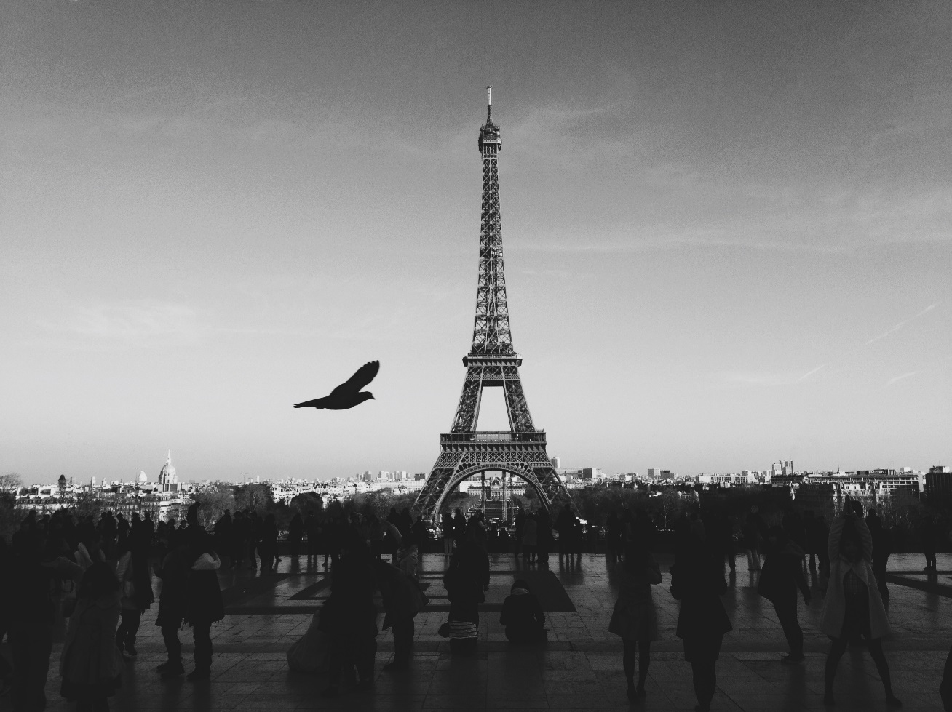

Read the example paragraph completed for you. This is based on the bottom left hand box.

In the shadows, the crowd gathers to look upon the hulking, towering monument. Huddled together for warmth and comfort, dirty, grimy shoes scuff the shining, cream paving stones. In the distance, a dome gleams gold in the sunlight, contrasting the darkness of the crowds. The hectic, busy city turns ever-onwards; the city is forever alive and glowing with life. Not here though. Here, there is a dimness, a stillness, a peacefulness. The gaudy and showy lights of the city don’t permeate here – rather, there is an aura of contemplation, as hushed tourists gather to gaze at the monolith that glowers over them.

Now, write a minimum of three more paragraphs, based on three boxes that you have annotated. Like the above paragraph, your aim is to use lists of adjectives and varied punctuation. These techniques have been underlined for you.

__________________________________________________________________________________________________________________________________________________________________________________________________________________________________________________________________________________________________________________________________________________________________________________________________________________________________________________________________
____________________________________________________________________________________________________________________________________________________________________________________________________________________________________________________________________________________________________________________________________________________________________________________________________________________________________________________________________________________________________________________________________________________________________________________________________________________________________________________________________________________________________________________________________________________________________________________________________________________________________________________________________________________________________________________________________________________________________________________________________________________________________________________________________________________________________________________________________________________________________________________________________________________________________________________________________________________________________________________________________________________________________________________________________________________________________________________________________________________________________________________________________________________________

Write a description suggested by this image:

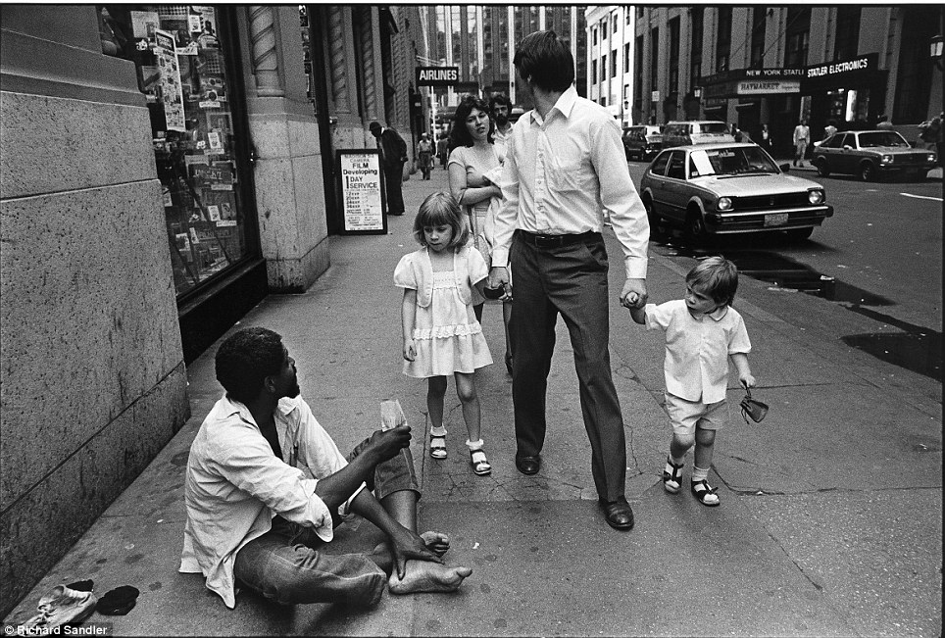

Annotate between 5-8 of the boxes in the grid with your writing ideas

The man walks. The girl walks. The boy, inquisitive and curious walks. His youthful, fragile face stares at the man with interest. His shirt and chino shorts are a pristine white, not too dissimilar to the man sitting on the ground. The boy cannot help but notice however, that his own shirt is pressed and ironed, his own shirt is clean and free from dirt, his own shirt is one of many. Not so the man on the ground. His shirt is crumpled and creased, his shirt is stained and old, his shirt is the only one he has. The boy stares at the man with wide, naïve eyes, gawps at his well-worn feet, his calloused hands. The boy, young and stupid, does not understand; he has not yet known the cruelties of life.
Now, write a minimum of three more paragraphs, based on three boxes that you have annotated. Like the above paragraph, your aim is to use the short, short stretch technique, embedded clauses and repetition for effect. These have been underlined for you.

__________________________________________________________________________________________________________________________________________________________________________________________________________________________________________________________________________________________________________________________________________________________________________________________________________________________________________________________________
____________________________________________________________________________________________________________________________________________________________________________________________________________________________________________________________________________________________________________________________________________________________________________________________________________________________________________________________________________________________________________________________________________________________________________________________________________________________________________________________________________________________________________________________________________________________________________________________________________________________________________________________________________________________________________________________________________________________________________________________________________________________________________________________________________________________________________________________________________________________________________________________________________________________________________________________________________________________________________________________________________________________________________________________________________________________________________________________________________________________________________________________________________________________
____________________________________________________________________________________________________________________________________________________________________________________________________________________________________________________________________________________________________________________________________________________________________________________________________________________________________________________________________________________________________________________________________________________________________________________________________________________________________________________________________________________________________________________________________________________________________________________________________________________________________________________________________________________________________________________________________

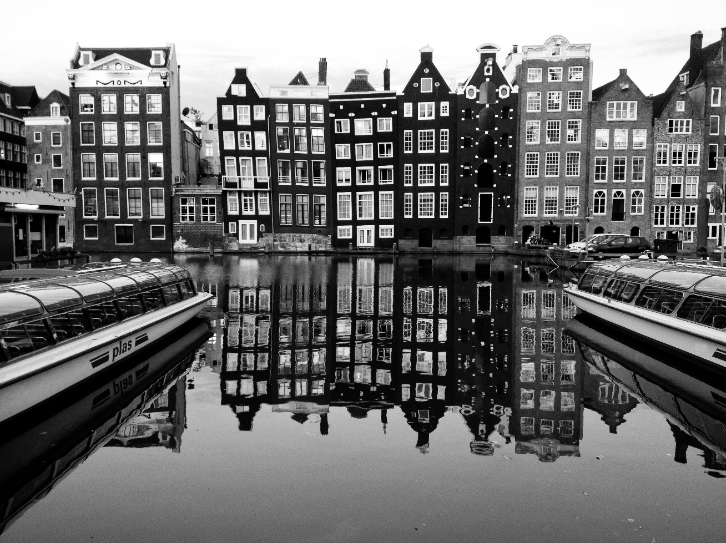
Practise annotating and planning ideas inspired by an image using the photographs below.

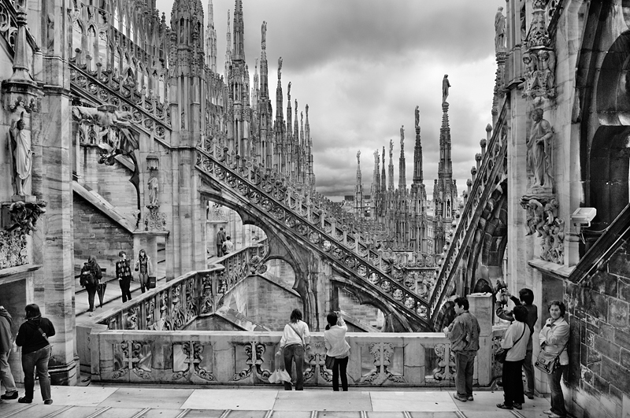


Writing to narrate

Use the following tasks to help you practise writing to narrate:

Write the opening to a short story that is set in place that is new to the narrator.

Write a story that begins “Just one look outside told me that it was a bad idea”.

Write a story that ends with the sentence “The door slammed shut, never to be opened again”.

Write a short story that is inspired by a colour.

Write the opening to a short story in which something unexpected happens.

Write about a place that is very different at night in comparison to the day time.

Write a story that begins “The world was different now, it would never be the same again”.

Write the opening to a short story that is set in a famous place.

Write the opening to a short story that involves water in some way.

Write a story that ends with the sentence “He would never go back to that place, not even if his life depended on it”.

Write the opening to a short story that begins with a journey.

Key reminders for question 5

In my answer have I…. | or X
Planned each paragraph
Used engaging and impressive examples of vocabulary throughout
Used a range of language techniques (check your language toolkit)
Used a range of structural techniques (check your structure toolkit)
Checked that my punctuation is accurate
Written in paragraphs that link together and used features like one sentence paragraphs for effect
Carefully checked my spelling and grammar to ensure that it is as accurate as possible
Used a range of punctuation accurately and for effect

