Please write clearly, in block capitals
Centre number Candidate number
Surname
Forenames(s)
Candidate’s signature

GCSE Design and Technology
Date of Exam Time allowed: 2 hours
Materials
For this paper you must have:
- normal writing and drawing instruments
- a calculator
- a protractor
Instructions
- Use black ink or black ball-point pen. Use pencil only for drawing
- Fill in the information at the top of this page
- Answer all questions
- You must answer the questions in the spaces provided. Do not write on blank pages
- Do all rough work in this paper. Cross through any work that you do not want to
be marked
Information
- The marks for questions are shown in brackets
- The maximum mark for this paper is 100
- There are 20 marks for Section A, 30 marks for Section B and 50 marks for Section C
SECTION A - Core Technical Principles
Questions 1-10 are multiple choice questions. For multiple choice questions you should shade in one lozenge. If you make a mistake, cross through the incorrect answer and shade the correct response.

1: Which of the following power sources is classed as a fossil fuel? [1 mark]
⬨ Hydroelectric
⬨ Natural gas
⬨ Nuclear
⬨ Tidal

2: Figure 1 shows an inflated balloon being held.

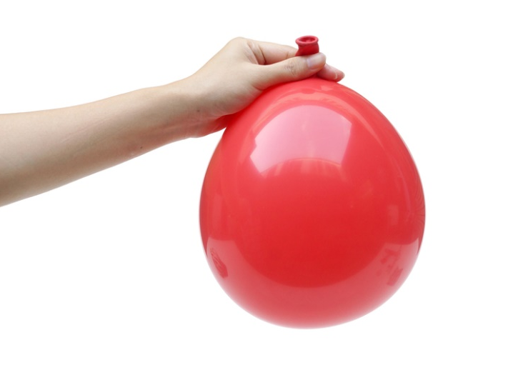
Figure 1
What is the force that is acting upon the air inside the balloon? [1 mark]
⬨ Compression
⬨ Shear
⬨ Tension
⬨ Torsion

3: What is the voltage of a single cell found in a non-rechargeable AA battery? [1 mark]
⬨ 1.5 volts
⬨ 3 volts
⬨ 5 volts
⬨ 12 volts

4: Which of the following materials change state in response to ultraviolet light? [1 mark]
⬨ Graphene
⬨ Photochromic pigment
⬨ Shape memory alloy
⬨ Thermochromic pigment

5: Which of the following is used as an output component? [1 mark]
⬨ Heat sensor
⬨ Lamp
⬨ Pressure sensor
⬨ Switch

6: Which motion best describes a child’s swing in use? [1 mark]
⬨ Linear
⬨ Oscillating
⬨ Reciprocating
⬨ Rotary

7: State the value of the weight needed at point A in figure 2 for the scales
to balance? [1 mark]
Figure 2
⬨ 2.5kg
⬨ 3.3kg
⬨ 5kg
⬨ 10kg

8: Which one of the following cams can only be rotated in a single direction? [1 mark]
⬨ Eccentric
⬨ Heart
⬨ Pear
⬨ Snail

9: Which of the following is a ferrous metal? [1 mark]
⬨ Aluminium
⬨ Low carbon steel
⬨ Tin
⬨ Zinc

10: Figure 3 shows a rotary system.
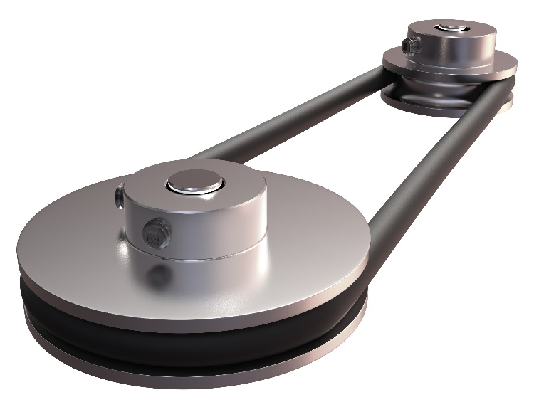
Figure 3

What is the name of the rotary system in figure 3 above? [1 mark]
⬨ Chain and sprocket
⬨ Crank and slider
⬨ Gear train
⬨ Pulley and belt

11: State two properties or characteristics that make medium density fibreboard
(MDF) suitable for use in flatpack furniture. [2 marks]
1.

2.

12: State two reasons why high-speed steel (HSS) is used for cutting tools. [2 marks]
1.

2.

13.1: The Committee on Climate Change state that 40% of the UK’s emissions come from households. In 1990 each household produced an average of 12.8 tonnes of C0₂, in 2014 this had reduced to 8.1 tonnes.
Give two reasons why the amount of CO₂ per household has reduced
during this period. [2 marks]
1.

2.

13.2: The target for household emissions by 2030 is 4.5 tonnes per household.
Explain how households could change their behaviours to help meet
this target. [2 marks]

13.3: If the target for 2030 of 4.5 tonnes per household is met, what would be the percentage reduction from the 1990 level of 12.8 tonnes per household? [2 marks]
Show your working out and give your answer to 1 decimal point.

SECTION B - Specialist Technical Principles
Finishing treatments and techniques
Specialist finishing techniques include:
Tanalising | Spot (UV) varnishing | Stain protection
Self-adhesive decals | PCB lacquering (conformal coating) | Plastic dip coating
14.1: Choose one specialist treatment or technique from the list above.
Name of chosen specialist treatment or technique
Give one reason why the treatment or technique is used. [1 mark]

14.2: In the box below, use notes and sketches to explain how your chosen
treatment or technique from 14.1 is performed using an appropriate
material(s) of your choice. [4 marks]

15: Give two reasons why tolerances are used in designing and manufacturing products.
Give one example in each of your answers.
1. [2 marks]

2. [2 marks]

16.1: Choose one product, material or component in figure 4 and describe two features that make it suitable for computer aided manufacturing (CAM).
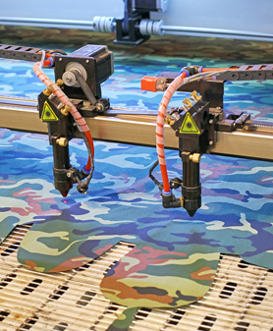 | 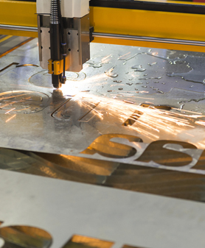 | 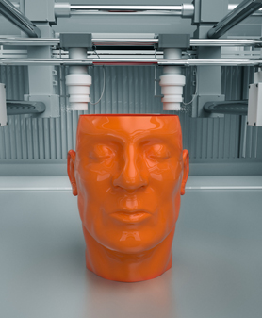
Laser cut clothes | Laser cut metal signage | 3D printed polymer parts
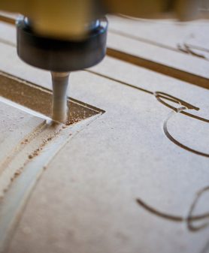 |  | 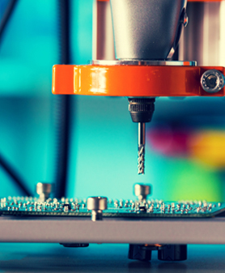
CNC routed furniture | Laser cut card stationary | CNC routed PCB
Figure 4
Name of chosen product, material or component
Feature 1 [2 marks]

Feature 2 [2 marks]

16.2: Choose one specific computer aided manufacturing process that you are familiar with. This may have been one used on your chosen product/component/material in 16.1.
Name of chosen specialist CAM process
In the box below, use notes and sketches to explain a CAM process
in detail. [4 marks]

17.1: Circle one of the following and give two different reasons why its functional and/or aesthetic characteristics are suited for the intended use.
- High impact polystyrene (HIPS) – for moulded yoghurt pots

- Bleed proof paper – for drawing rendered designs with marker pens

- Stainless steel – for a cutlery set

- Beech – for a child’s wooden train set

- Cotton – for a pair of hiking socks

- Buzzer – for use in a battery operated electronic quiz game
1. [2 marks]

2. [2 marks]

17.2: Choose one of the materials or components listed in 17.1 and name one of the primary sources it is made from. [1 mark]

18: Manufacturers and designers often conduct a ‘lifecycle assessment’ to understand the impact that a product or a service has on the environment.
Describe the five stages of a lifecycle assessment and evaluate how the
results could influence the way a product is manufactured. [8 marks]

SECTION C – Designing and Making Principles
Figure 5 shows a pair of walking aids used by teenagers and adults after leg or
back injuries.

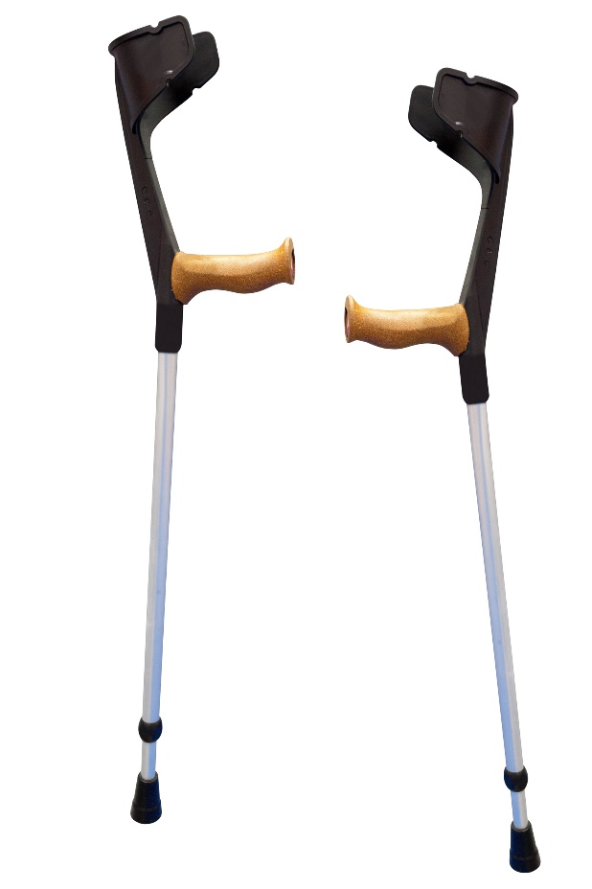
Figure 5
Specification
- Lightweight

- Provides support to upper arm

- Comfortable hand grip

- Non-slip feet

- Adjustable height

Evaluate the walking aids shown in figure 5 in terms of the following points.
19.1: Suitability for the user [4 marks]

19.2: Ergonomics [4 marks]

20.1: Explain what is meant by the term ‘design fixation’ and suggest strategies
that designers could use to avoid it happening. [4 marks]

20.2: Describe and justify two tests that might be carried out on the walking aids shown below that would ensure they were fit for purpose.
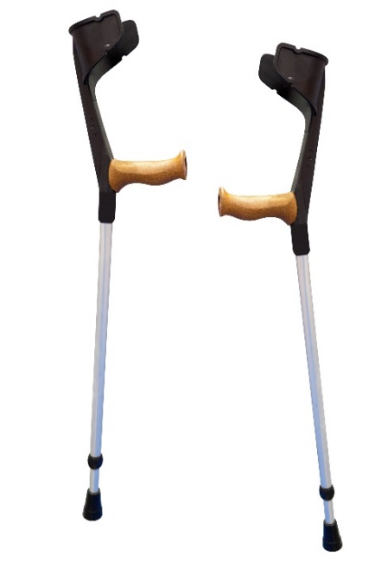
Justify why each test is appropriate.
1. [2 marks]

2. [2 marks]

21.1: An environmentally conscious entrepreneur is designing and making a solar powered USB charger for use in remote areas of developing countries where electricity is not available.
When deciding which materials, components and manufacturers to use to make the solar chargers, there are many important factors to consider.
Explain and justify one way designers can reduce negative global impact on the following factors:
a) Deforestation. [2 marks]

b) CO₂ levels. [2 marks]

c) Poorly paid and unsafe working conditions. [2 marks]

d) Waste going to landfill sites. [2 marks]

21.2: Some of the manufacturing costs of the solar USB charger are listed in the table below. Difficult decisions need to be made regarding the sourcing of materials and components.
Study the table below:
Materials & component costs | Cost 1 | Cost 2 | Cost 2 | Total
Casing made from a plant based biopolymer | £0.85
Casing made from oil-based polymer | £0.55
Solar cell from an unknown supplier in China |  | £1.25
Solar cell from a reliable supplier in Germany |  | £1.75
Packaging materials from managed forest (FSC) |  |  | £0.30
Packaging materials from unmanaged forest |  |  | £0.20
a) What is the total cost of the three most environmentally and socially
responsible options? Show your working out in your answer. [2 marks]

b) If the designer took the cheapest option, how much cheaper would it be
than the option taken in 21.2a? Show your working out in your answer. [2 marks]

c) The designer took the socially and environmentally friendly option to make 2500 solar chargers. Remembering his strategy of giving away one charger for every one sold, how much money did he raise from crowd funding?
Show your working out in your answer. [2 marks]

22.1: Audio and visual recordings are used by designers to find out important information that may influence the design of a product.
Describe two different ways that designers could gather information from audio or video recordings and explain why they might use these techniques.
1. [2 marks]

2. [2 marks]

22.2: Explain why designers may use mathematical modelling in the
design process. [3 marks]

23.1: Designers often use a combination of primary and secondary data sources to research and investigate how they should design products and services.
Explain the difference between primary and secondary data sources for
gathering research, giving one example for each. [3 marks]

24: Study Figure 6, an exploded drawing of a child’s shape sorter toy.
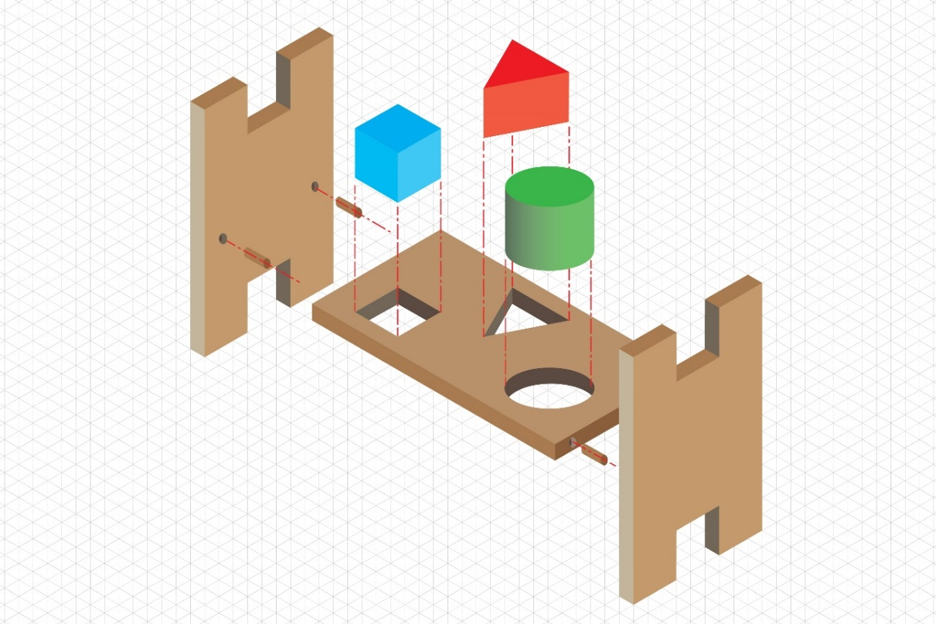
Figure 6
Recreate the shape sorter toy as a complete product with the shapes inserted
half-way into the appropriate holes. Draw in isometric projection on the grid
paper below. Draw the parts to the same scale as the exploded drawing. [4 marks]
Do not colour or shade the drawing.


25: Tessellation is a method used to interlock shapes together with little or no waste.
A manufacturer is cutting components from a sheet of material measuring 70mm
by 60mm.
The component size is shown in figure 7. It can be laid in any position on the sheet.
Figure 7
25.1: Tessellate as many of the components above on to the grid below. [2 marks]
Vary the shading of the components, as suggested above, so that they can be identified separately on the sheet.

25.2: The sheet of material used in 25.1 costs £3.78.
Calculate the following and show your working out in your answer:
- The cost per component in pence. [2 marks]

- Calculate how much waste material is created and its cost in pence. [2 marks]

END OF QUESTIONS

