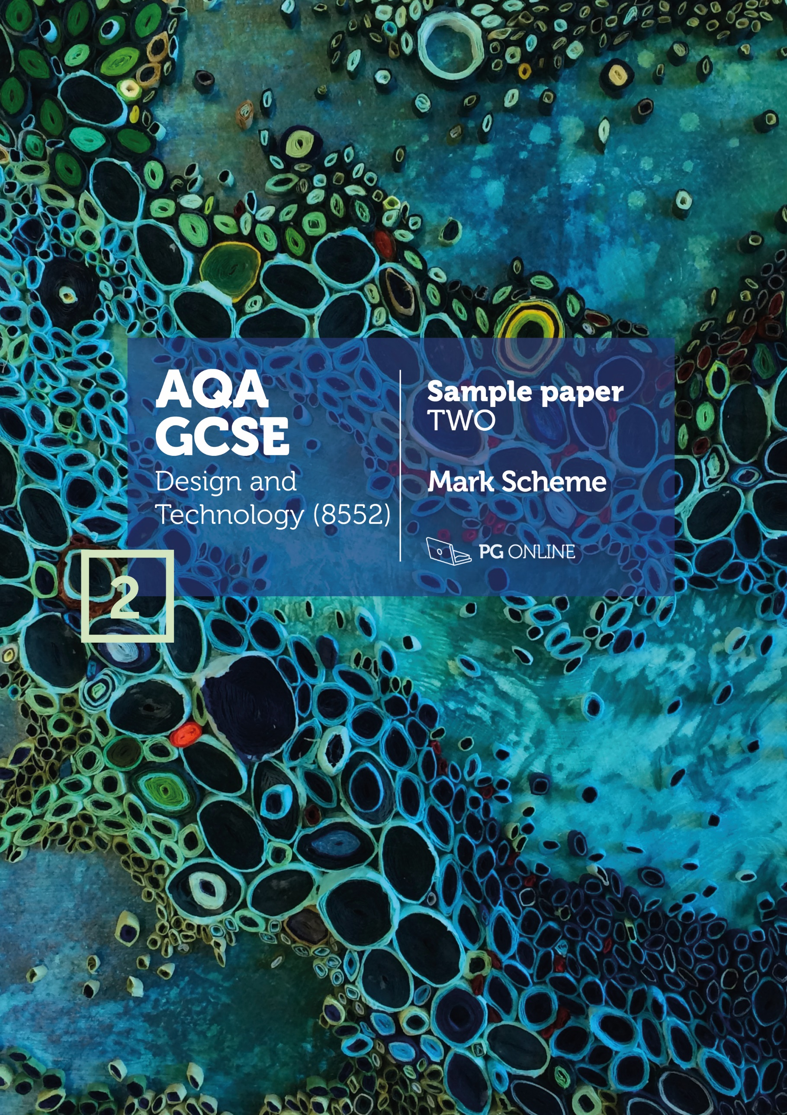

Copyright
© 2018 PG Online Limited
The contents of this pack are protected by copyright.
The pack and all the other associated files distributed with it are supplied to you by PG Online Limited under licence and may be used and copied by you only in accordance with the terms of the licence agreement between you and PG Online Limited. Except as expressly permitted by the licence, no part of the materials distributed with this pack may be used, reproduced, stored in a retrieval system, or transmitted, in any form or by any means, electronic or otherwise, without the prior written permission of PG Online Limited.

License agreement
This is a legal agreement between you, the teaching institution, and PG Online Limited. PG Online Limited grants to you a non-exclusive, non-transferable, revocable licence to use this supplement and all other associated files distributed with it in the course of teaching by your teachers and/or employees.
The materials distributed with this pack may be copied and used by your teachers and/or employees on a single site only in the course of their teaching. You warrant that you shall not, and shall procure that each of your teachers and/or employees shall not, share in any way any of the materials or part of the materials with any third party, including users on another site or individuals who are teachers and/or employees of a separate institution. You acknowledge and agree that the materials must remain with you, the teaching institution, and no part of the materials may be transferred to another institution. You also warrant that you shall not, and shall procure that each of your teachers and/or employees shall not, procure, authorise, encourage, facilitate or enable any third party to reproduce these materials in whole or in part without the prior permission of PG Online Limited.
In consideration of the licence granted to you, you shall indemnify PG Online Limited against all liabilities, costs, expenses, damages and losses (including but not limited to any direct, indirect or consequential losses, loss of profit, loss of reputation and all interest, penalties and legal costs and all other professional costs and expenses) suffered or incurred by PG Online Limited arising out of or in connection with the exercise by you of your rights granted under this licence.

GCSE Design and Technology
Sample paper 2 mark scheme
This sample paper and mark scheme has been carefully compiled and checked to ensure parity across the six specialist areas. It is the normal process for the mark schemes of live papers to go through a standardisation process where students’ responses are analysed and any answers not covered in the mark scheme are discussed and legislated for. As this is a sample paper only, this process has not been undertaken. Whilst this paper and mark scheme have been technically proofread, there may be additional responses that are worthy of marks. Teachers discretion should be applied in these circumstances.
Instructions for level of response marking
Descriptors are provided for different levels of response along with appropriate marks for each level. Read through a students’ answer, annotating to show the qualities that have been achieved, before applying the level based mark scheme.
Determining a level
Start with the lowest level of response in the mark scheme and assess if the different qualities indicated have been met. If they have, move to the next level and check to see if these have been met. Continue the process until you can match the level with the answer. With repetition it becomes easier and quicker to work up through the levels of the mark scheme.
The principle of ‘best fit’ should be adopted and if small elements of a level are missing but the majority has been covered, then this is the appropriate level to award.
Determining a mark within a level
Having decided on the level, the mark within the level must be determined. Use the descriptors to help with this along with the indicative content. Where there is any doubt, it is advisable to read back through the answers again and reapply it to the indicative content. Students do not need to cover all of the indicative content to reach the top marks. Additionally the indicative content is not designed to be exhaustive and alternative appropriate answers may well be taken into consideration.
Student answers that do not contain any relevent content must be awarded zero marks.

SECTION A - Core Technical Principles

1. Natural gas [1 mark]

2. Compression [1 mark]

3. 1.5 volts [1 mark]

4. Photochromic pigment [1 mark]

5. Lamp [1 mark]

6. Oscillating [1 mark]

7. 2.5kg [1 mark]

8. Snail [1 mark]

9. Low carbon steel [1 mark]

10. Pulley and belt [1 mark]

11. Award 1 mark for each property up to 2 marks maximum. [2 marks]
Accept any alternative correct response.
- Flat and rigid
- Comes in large sheets
- Good compressive strength
- Cost effective to cover a large area
- Easy to bond onto veneers/melamine for aesthetic effect
- Easy to machine/mill/route to add features and pre-drilled locations for fittings
- No natural defects/uniformly consistent material e.g. no knots
12. Award 1 mark for each reason up to a maximum of 2 marks. [2 marks]
- It is very hard therefore it can cut through softer materials/metals
- It can withstand high temperatures
- Effective at high speed under load
- Keeps its cutting edge well
13.1 Award 1 mark for each reason up to a maximum of 2 marks [2 marks]
Indicative content: Accept any alternative reasonable response.
- More efficient heating systems
- Low wattage lighting
- More micro green energy generated by households – solar panels, wind turbines, biofuel heating systems, geothermal heating
- More efficient appliances with better standby options
- More people switching off appliances when not in use
- Lower temperature / more efficient washing machines and dishwashers
- Better thermal insulation in dwellings / homes becoming more efficient / upgraded
13.2 Award 1 mark for each reason up to a maximum of 2 marks [2 marks]
Indicative content: Accept any alternative reasonable response.
- Purchase efficient home appliances
- Routine for switching off electrical items or have automatic sensors fitted
- Low energy lamps throughout
- Lower heating temperature
- Don’t waste food and compost any waste
- Eat less meat and dairy
- Have an allotment/grow food
- Don’t take/reduce air travel
- Swap to better transport option such as cycling, walking or car sharing

13.3 Award 1 mark for the correct working out and 1 mark for the correct answer.
12.8 – 4.5 = 8.3
8.3 / 12.8 x 100 = 64.8% [2 marks]

SECTION B - Specialist Technical Principles
14.1 Award 1 mark for identifying one reason why the chosen specialist finishing technique is used. [1 mark]
Indicative responses: accept alternative correct responses.
Spot (UV) varnishing | To create a raised surface or texture / to be attractive or noticeable / to create contrast / to create a reflective surface / to offer protection
Tanalising | To protect from rot / biological / animal infestation / to make it last longer / make usable outdoors (do not accept make waterproof)
Plastic dip coating | To create a protective finish / prevent corrosion / aesthetic finish / electrical insulation / softer feel / prevent damage / create grip
PCB lacquering Conformal coating | To create a protective finish / prevent corrosion and/or degradation of insulative components / protects against salts, moisture, chemicals / electrical insulation
Self-adhesive decals | To create a protective finish / aesthetic finish / advertising / branding / prevent or deter loss or theft
Stain protection | To create a protective layer/barrier on fabric / to prevent/reduce staining and absorption of oils and dirt into the fibres/skin
14.2 Award up to 4 marks for explaining the specialist treatment or technique.
Notes or sketches alone can get up to a maximum of 3 marks. [4 marks]
3-4 marks | A complete explanation of the treatment or technique is well presented/explained. It is accurate and shows good knowledge and understanding of how a material(s) is finished. Good use of correct technical terminology and appropriate tooling/resources for the finishing technique or process to be performed.
1-2 mark | A simplistic description with some errors and/or poorly explained. It shows basic knowledge and understanding of how a material(s) is treated or has a finishing technique applied to it. A basic attempt at technical terminology and tooling/resources used to perform the treatment or technique is given.
0 marks | Nothing worthy of credit

15. Award up to 2 marks for each correct reason with an example [2 x 2 marks]
2 marks | A complete description applying both knowledge and understanding of why tolerances are used in design and/or manufacture. An appropriate example is given.
1 mark | A simple description with some errors and misunderstanding of why tolerances are used in design and/or manufacture. A weak or no example given
0 marks | Nothing worthy of credit
Indicative content: accept alternative suitable response.
To ensure correct fitting: flat packed furniture goes together correctly and robustly / clothes fit well / PCB fits into casing / letter fits an envelope / nut fits on a bolt
To ensure a product works/performs correctly: a drill of the wrong size will drill incorrect holes / wrong tolerance with components can lead to errors in timing etc.
Other responses: systems / machines / products have standardised components and adhering to fine tolerances allows components / parts to be interchanged.
16.1 Award up to 2 marks for two different features. [2 x 2 marks]
2 marks | A complete description applying both knowledge and understanding of why the selected product, material or component is suitable for CAM
1 mark | A simple description with some errors and misunderstanding of why the selected product, material or component is suitable for CAM
0 marks | Nothing worthy of credit

Indicative content:
Product, material or components | Features that are suitable for computer aided manufacture
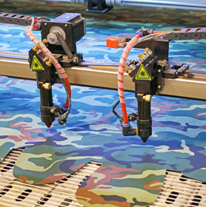  Laser cut clothes | Many fabrics are suitable for use in a laser cutter  Garment design may be too complex to cut by hand. Complex CAD files can be run on laser cutters  Some fabrics prone to fraying are automatically sealed around the edges when laser cut  Textiles can be cut in layers creating numerous identical parts with one pass saving time  Large bed laser cutters are available for larger component parts
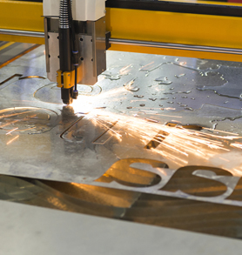  Laser cut metal signage | Many metals are suitable for use in a special laser cutter powerful enough to cut through metal  Sign design may be too complex to cut by hand. Complex CAD files can be run on laser cutters  Thin metals can buckle and warp with heat, lasers reduce this  Laser cutting is faster and more accurate than hand processing  Large bed laser cutters are available for larger component parts
  3D printed  polymer parts | Many different polymers are available for 3D printers  They allow small to medium sized components to be made from CAD files  They are very accurate and can produce complex designs from CAD files  Repetitive accuracy can be assured  Post processing software creates layers for the 3D printer to follow  A fine tolerance can be achieved for parts  CAD files can be “open source” and therefore manufactured by third parties.
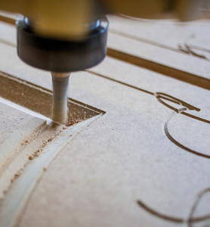CNC routed furniture | Many different materials can be used with CNC routers  Different cutting tools can be used allowing for a variety of profiles, patterns and finishes to be applied to the material  They allow all sized components to be made from CAD files as large bed routers are available for larger furniture components  They are very accurate and can produce complex and intricate designs from CAD files that would be impossible by hand  Extraction can be used to ensure dust levels are kept low  CNC routing is faster and more accurate than hand processing  Repetitive accuracy can be assured
  Laser cut card stationary | Most paper and boards are suitable for use in a laser cutter  Some designs may be too complex to cut by hand. Complex CAD files can be run on laser cutters  Paper and board can be cut in layers creating numerous identical parts with one pass saving time  Large bed laser cutters are available for larger component parts  Laser cutting is faster and more accurate than hand processing  Cheaper than die cutting / does not require expensive tooling / able to achieve a much more intricate detailing than die cutting / stamping
  CNC routed PCB | Both the routing (isolation method) and drilling of different sized holes can be achieved with a CNC router  They allow all sizes of boards to be processed from CAD files  They are very accurate and can produce complex and intricate designs from CAD files that would be difficult by hand  Extraction can be used to ensure dust levels are kept low  CNC routing is faster and more accurate than hand processing  Repetitive accuracy can be assured
16.2 Award up to 4 marks for explaining a CAM process.
Notes or sketches alone can get up to a maximum of 3 marks. [4 marks]
4 marks | A complete explanation of a CAM process is well presented/explained. It is accurate and shows all stages in the correct order. Thorough knowledge and understanding of how a material(s) is processed. Excellent use of correct technical terminology and appropriate tooling/resources for the process to be performed.
3 marks | A good explanation of a CAM process. It is presented/explained with a good level of accuracy. Most stages are shown and mostly in the correct order. Good knowledge and understanding of how a material(s) is processed. Good use of technical terminology and appropriate tooling/resources for the process to be performed.
2 marks | A simplistic description with some errors/gaps and/or poorly explained. It shows basic knowledge and understanding of how a material(s) is processed. A basic attempt at technical terminology and tooling/resources used to perform the process is given.
1 mark | A very basic description of a CAM process that may have stages or information missing. Incorrect sequence and terminology used. The process may not be named correctly.
0 marks | Nothing worthy of credit.

Indicative content: The answers in the table give some areas where the students may have explored. Award credit for the use of diagrams and descriptions that are appropriate to the chosen process. The processes are not necessarily material specific and could be answered with an appropriate material for the process.
Product | Processes requiring hand finishing
Laser cut clothes | Preparation of materials / cutting to bed size / production post processing of CAD file / set up of laser - autofocus, speed and power / material held in position if required / extraction / running file / monitoring cut / QC / removal of materials
Laser cut metal signage | Preparation of materials / cutting to bed size / production post processing of CAD file / set up of laser - autofocus, speed and power / material held in position if required / extraction / running file / monitoring cut / QC / removal of materials
3D printed polymer parts | Installation of appropriate polymer cartridge/materials / preparing build bed for adhesion / production/post processing of CAD file / set-up 3D printer – nozzle size, temperature and resolution / rafting/support provision / running file / monitoring print for failure / QC / removal of material from bed / clean-up of rafting/support / post print finishing if required
CNC routed furniture | Preparation of materials / cutting to bed size / production of CAD file / set up of CNC router – interchangeable heads/bits, speed and feed rate / material held in position clamp/vacuum bed / extraction / running file / monitoring cut / QC / removal of materials
Laser cut card stationary | Preparation of materials / cutting to bed size / production of CAD file / set up of laser - autofocus, speed and power / material held in position if required / extraction / running file / monitoring cut / QC / removal of materials
CNC routed PCB | Preparation of materials / cutting to bed size / production of CAD file / set up of CNC router – interchangeable heads/bits, speed and feed rate / PCB held in position clamp/vacuum bed / extraction / running file / monitoring cut / QC / removal of materials
17.1 Award up to 2 marks for a correct answer in each of two
different areas. [4 marks]
2 marks | A correctly stated functional and/or aesthetic characteristic of the material and a complete reasoning of why it is appropriate for the intended use.
1 mark | A stated characteristic or physical property that may be simplistic or incomplete with some reference as to why it is acceptable for the intended use.
0 marks | Nothing worthy of credit.

Indicative content: accept alternative suitable functional and/or aesthetic characteristics and an appropriate response.
High impact polystyrene (HIPS) – for moulded yoghurt pots | Malleable when heated – so that it can be formed to shape  Tough– so that it can withstand knock/bumps in transportation or use / hold the weight of the contents  Available in a variety of colours – attractive to users  Food safe – safe contact with the contents  Recyclable – can be recycled at the end of use avoiding waste
Bleed proof paper – for drawing rendered designs with marker pens | Sized surface – so that the ink from the markers pens sits on the surface / giving a deeper/richer/less faded colour / marker won’t go through the paper staining the worksurface/material underneath  Non-absorbent – good for water and spirit based colours  Smooth surface – giving a high-quality finish
Stainless steel – for a cutlery set | Sheet material – available for pressed cutlery  Resistant to rust – meaning that it won’t corrode/rust  Hard – meaning that it will keep its shape/edge in use  Tough – meaning it will withstand knock and bumps in use  Food safe – avoiding any contamination with food  Durable – Can withstand very high-water temperatures when being washed/sterilised
Beech – for a child’s wooden train set | Fine and dense grain – to withstand pressure exerted when used or when dropped/thrown and durable/resists splitting / holds paint and stains well  Tough – to withstand wear and indentation in use / resists chipping and splintering / due to a tight/even grain structure  Natural pinkish hue – attractive aesthetics when unfinished
Cotton – for a pair of hiking socks | Easily spun into yarn – so that it can be woven/knitted into fabric / can be blended with other fibres for improved properties  Naturally derived insulation – so that it is warm to wear  Breathable – to prevent/reduce perspiration  Comfortable – so that the wearer can use the socks over a long period  Reasonably hard wearing – the sock will last without breaking/wearing out
Buzzer – for use in a battery operated electronic quiz game | Compact/small – so that less space is required on PCB/in casing  Low power – meaning that battery lasts longer  Loud output – meaning that the users of the game will notice the sound

17.2 Award 1 mark for one correct primary source material. [1 mark]
Material or component | Primary source
High impact polystyrene (HIPS) | Oil or gas
Bleed proof paper | Trees / wood / other source of cellulose fibre
Stainless steel | Iron ore / chromium / manganese. Accept silicon / carbon
Beech | Beech tree
Cotton | Cotton boll / cotton plant
Buzzer | Plastic shell from oil or gas.  Internal parts from copper and/or steel / aluminium

18. Award up to 8 marks for an analysis of the use of lifecycle
assessments. [8 marks]
7-8 marks | A coherent and logical analysis featuring a range of points with excellent understanding of issues surrounding the use of a lifecycle assessment for gauging impact. Detailed analysis and evaluation of all five areas leads to conclusions that designers and manufacturers could use to reduce the environmental impact of a product.
5-6 marks | A logical discussion which includes a good understanding of issues for most of the five areas of a lifecycle assessment. Good analysis and evaluation of points raised, leads to some conclusions being drawn as to how designers and manufacturers could reduce environmental impact of their products.
3-4 marks | The response shows a good understanding of some issues surrounding the use of a lifecycle assessment, however one or two areas may be weak. A few points, raised with some analysis/evaluation from a designer and/or manufacturers point of view. Arguments may lack coherence & conclusions may be weak or unsubstantiated and any benefits may be tentative.
1-2  mark | Some understanding of the key issues is covered with limited awareness of a lifecycle assessment for gauging environmental impact of a product. One or two points showing limited analysis and/or evaluation although lacking coherency. Little or no conclusion drawn.
0 marks | Nothing worthy of credit.

Indicative content:
Indicative content listed is provided to illustrate points that students may make about the examples given in the question, which would demonstrate their understanding of why lifecycle assessments are conducted and the benefits they give. Students may refer to some or all of the examples or they may offer alternative responses in their answer. Marks should be awarded for anything worthy of credit.
The five stages of a lifecycle assessment (LCA) and the influence on product design:

Extraction – energy required, and carbon released for raw materials to be extracted from the ground or to be farmed and harvested / can cause destruction through mining / desertification / deforestation / pollution / physical and social issues for communities / reduce amounts of raw materials needed / rethink, refuse and use alternatives / source more sustainably / use recycled materials

Production/manufacture – energy used while making usable stock forms from the raw materials and in the making of the product / use fewer types of material / use less material / use recycled materials / use of efficient machinery / efficient working practices / energy saving systems / use green energy / reuse and recycle waste including heat / staff engagement and training

Distribution – energy needed for the packaging and movement of the stock materials and products to and from factory/warehouse/wholesalers/retailers to user / reduce product mileage where possible / production based near main market and/or resources / use efficient transport/shipping methods / use efficient routing / reduce, lighten packaging

Use – the energy and consumables used during the products working life / make product efficient in use / rechargeable if appropriate / avoid need for finite consumables / make it repairable / upgradable / last a long time if appropriate to the product type / strong and tough so as not to break

End of life – the energy required to recycle or dispose of the product and any waste / make it reusable / recyclable / compostable / designed for easy separation of materials

SECTION C – Designing and Making Principles
19. Award up to 4 marks for each of the three sections of the question.
3-4 marks | Well described and justified analysis containing full evaluation, drawing conclusions having considered both positive and negative factors.
1-2 mark | Brief points mentioned but not fully explained. Analysis present but limited evaluation / conclusions drawn. May have focused solely on either positive or negative factors.
0 marks | Nothing worthy of credit.
Indicative content for the evaluation of the walking aids in terms of the
following points:
19.1 Suitability for the user [4 marks]

Arm cups for support and convenience

Handles to support weight

Waterproof materials used which allows for use when outdoors

Easy to use and change height making it adaptable for different heights/ages

Lightweight so that it is comfortable to use for long periods of time

Soft material on handle to ease pressure on hand

Rubber stoppers on base to provide grip so safe on most surfaces

Robust enough to resist knock, bumps, wear and tear

Might be awkward to change the height

May be uncomfortable on the hand due to lack of padding
19.2 Ergonomics [4 marks]

Hand grips are rounded and shaped to fit a range of hand sizes

Flexible and anatomically designed arm cups to offer support

The walking aids are lightweight / comfortable when used for long periods of time

Adaptable for different heights and ages

Rubber stoppers positioned to prevent slipping

Plastic arm cup/handle next to the skin may be uncomfortable and cause sweating

Plastic arm cups could slide off walls/surfaces when propped up and not in use
20.1 Award up to 4 marks for an explanation of the term design fixation. [4 marks]
3-4 marks | Student demonstrates a clear knowledge of what design fixation is and a good understanding of how designers can avoid it happening. Relevant points will be used to illustrate the strategies designers use as per the indicative content.
1-2 mark | Student demonstrates some knowledge of what design fixation is but understanding of strategies to avoid it is limited and points to illustrate these strategies may be weak.
0 marks | Nothing worthy of credit.
Indicative content: allow for levels of subjectivity if content is viable. Design fixation is a common condition where designers become stuck/blinkered and can only produce a range of similar designs and become blind to the alternatives. It can be caused by playing safe / not taking risks.
Not limited to, but reference to the following strategies may be included in responses:

Working with others – use collaborative design to exchange ideas / peer review

Force a new starting point – Take an alternative/abstract approach such as working in a different medium/size of paper/use or don’t use CAD / scale up/down / any change is good

Start modelling & stop drawing or vice versa – physical modelling can change perspective

Get some failures completed – acknowledge that ideas come only after many failures

Avoid too much research / take a risk or a hunch / go for the wacky idea

20.2 Award 1 mark for each valid test up to a maximum of 2 marks
and award 1 mark for each valid justification up to a maximum
of 2 marks [2 x 2 marks]
2 marks | A correctly described physical test of the walking aid or a specific part and a complete explanation of how and why is used to determine if they are fit for purpose
1 mark | A stated physical test of the walking aid or a specific part that may be simplistic or incomplete with some or little reference as to how and why is used to determine if they are fit for purpose
0 marks | Nothing worthy of credit
Indicative content: this is not an exhaustive list. Credit any alternative valid response.

Measure the size of aids/parts/components to ensure correct fit

Measure the load bearing of aids/parts/components to ensure it is strong enough to support a decided maximum weight of user

Bend/stress the legs/joints/parts to ensure strength in extreme use

Test the locking mechanisms of the legs to ensure they are safe and don’t slip

Accept: Give to a user group to evaluate in use, provided there is some reference to strength/size/weight or similar.

Conduct tests on materials in order to ensure physical / mechanical properties such as strength, hardness, are suitable for the task.

21.1 Award 1 mark for each valid point and award 1 mark for each valid justification up to a maximum of 2 marks [4 x 2 marks]
Indicative content:
a. Deforestation: accept alternative correct responses.
- Use only FSC or similar sustainably managed timber and products, reducing impact on natural and unprotected forests
- Avoid using companies/suppliers that are involved in actions that have a negative impact on forests, which helps to maintain remaining natural resources and livelihoods that depend on these forests
b. CO₂ levels: accept alternative correct responses.
- Use carbon neutral companies and suppliers, which will reduce the overall CO₂ footprint
- Reduce energy consumption in all areas of production, which preserves resources, lowers cost and reduces CO₂ emissions
- Buy/sell local to reduce product miles and CO₂ emissions
- Use efficient machinery and delivery methods, reducing power needed and distance travelled, for example electric vehicles, or using roads at low congestions times to avoid unnecessary fuel consumption
- Reduce packaging and size/weight of product where possible, lowering the energy needed to make and deliver products
c. Poorly paid and unsafe working conditions: accept alternative correct responses.
- Use known companies and suppliers that have high welfare for their employees, which reduces the chance of exploitation of workers
- Look for ISO (International Standards Organisation) awards where possible as these companies adhere to strict guidelines regarding staff welfare
- Avoid using companies from countries where employment law standards are low and there is no way of checking the validity of the working conditions as this can perpetuate poor working conditions
d. Waste going to landfill sites: accept alternative correct responses.
- Ensure the product is recyclable so that it does not need to go into landfill
- Ensure the components of the product are easily separable so that they can all be recycled separately using less energy
- Provide information on packaging advising consumer about correct disposal / recycling
- Use biodegradable materials which are non-toxic and will eventually become compost

21.2 Award 1 mark for the working out and 1 mark for the answer.
a. 0.85 + 1.75 + 0.30 = £2.90 [2 marks]
b. 0.55 + 1.25 + 0.20 = £2.00 therefore 2.90 – 2.00 = £0.90 [2 marks]
c. 2500 / 2 = 1250 x 2.90 = £3,625.00 [2 marks]

22.1 Award 1 mark for each valid audio or visual recording and award 1 mark for each valid reason [2 x 2 marks]
2 marks | A correctly described audio or visual recording method and a complete explanation of why it is used and how it may influence a design
1 mark | A stated audio or visual recording method that may be simplistic or incomplete with some or weak reference as to why it is used and/or how it may influence a design
0 marks | Nothing worthy of credit
Indicative content:
This is not an exhaustive list. Please give credit for any reasonable response. The
same areas of influence may appear in numerous answers, give credit if appropriate
to the source.
Types of audio and visual recordings |  | Reasons for using the technique
Audio, video & photography | Interviews of clients/users | Answers relating to form, function, user requirements etc.
Audio, video & photography | Focus groups | Answers relating to form, function, user requirements etc.
Audio, video & photography | Observations of users | Answers relating to form, function requirements, user requirements
Video & photography mainly | Physical material testing | Answers relating to materials used, weight, size, thickness, function
Video & photography | Site study | Answers relating to ease of use and accessibility in situ
Video & photography mainly | Exemplar work of others | General influence of form and function
Video & photography mainly | Modelling and testing of models | Answers relating to form, function, anthropometric and ergonomic considerations

22.2 Award up to 3 marks as follows, see indicative content. [3 marks]
3 marks | Response is correct and shows a clear understanding combined with a comprehensive explanation as to why mathematical modelling is used. Consideration is given to a range of factors. Not all need to be covered.
2 marks | Observations are correct and show some understanding as to why mathematical modelling is used. The factors considered are likely to lack detail and will cover only limited points.
1 mark | Limited observations are correct and show only a basic understanding. No, or very limited, explanation of why mathematical modelling is used.
0 marks | Nothing worthy of credit.
Indicative content:
- To work out quantities of material needed
- To work out economic use of materials, nesting/tessellation and manage waste
- To work out sizes and weights etc.
- To analyse data from research and assess viability/trend forecasting/profit and loss
- To find averages, minimums and maximums for various reasons
- To learn whether parts are over-engineered and wasteful/could be more efficiently manufactured
- To manage budgets
- To work out components values/frequency/timing
- To understand and interpret ergonomic and anthropometric data
- To work out repeat pattern needs/waste
- To process tolerances
- To model/draw to scale
- To understand gear ratios/mechanical advantage etc.

23.1 Award 1 mark for describing the difference between data sources and 1 mark for each one data source example up to two marks maximum.
Accept alternative correct responses. [3 marks]
Primary data sources are where information can be taken first hand.
Secondary data sources are where information is from a reported source: [1 mark]
Primary data sources include:  [1 mark] |  | Secondary data sources include:  [1 mark]
Interviews | Product analysis | Reading written articles, books, magazines, Internet
Questionnaires | Taking measurements | Media such as TV, radio and other news sources
Focus groups | Observations of users | Official statistics
Case studies | Physical material testing | Company information
Site studies |  | Exemplar work of others

24. Award up to 4 marks for a conversion of the exploded drawing into a
complete product in isometric projection. See example. [4 marks]
3-4 marks | The drawing is complete and accurate, with a good quality of line. The drawing is to scale and correctly positioned on the isometric grid paper. The shapes are correctly positioned into the body of the toy and a good attempt at drawing the triangle and cylinder is evident.
1-2 mark | The drawing generally resembles the completed toy. The quality of line is variable. The drawing may not be exactly to scale or correctly positioned on the isometric grid paper. The shapes may not be correctly positioned into the body of the toy and only a superficial attempt at drawing the triangle and cylinder may be evident.
0 marks | Nothing worthy of credit.
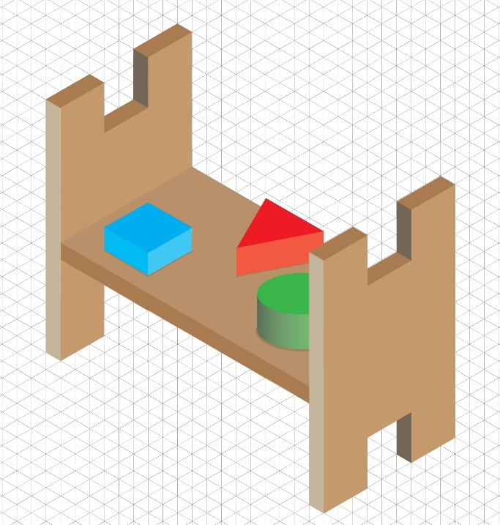

25.1 Award 2 marks for achieving 10 components that are clearly distinguishable. Award 1 mark for either 8 or 9 components. See grid for answer: [2 marks]

25.2 Award 1 mark for working out and one mark for the answer in pence.
a) £3.78 / 42 = 9p per square. 4 x 9p = 36 pence per component or £0.36. [2 marks]
b) Minimum 2cm², allow for error carried forward.
2 x 9p = 18 pence or £0.18. [2 marks]

