Please write clearly, in block capitals
Centre number Candidate number
Surname
Forenames(s)
Candidate’s signature

GCSE Design and Technology
Date of Exam Time allowed: 2 hours
Materials
For this paper you must have:
- normal writing and drawing instruments
- a calculator
- a protractor
Instructions
- Use black ink or black ball-point pen. Use pencil only for drawing
- Fill in the information at the top of this page
- Answer all questions
- You must answer the questions in the spaces provided. Do not write on blank pages
- Do all rough work in this book. Cross through any work that you do not want to
be marked
Information
- The marks for questions are shown in brackets
- The maximum mark for this paper is 100
- There are 20 marks for Section A, 30 marks for Section B and 50 marks for Section C
SECTION A - Core Technical Principles

Questions 1-10 are multiple choice questions. For multiple choice questions you should shade in one lozenge. If you make a mistake, cross through the incorrect answer and shade the correct response.

1: Which of the following is a synthetic fibre? [1 mark]
⬨ Cotton
⬨ Nylon
⬨ Silk
⬨ Wool

2: Figure 1 shows a length of rope being pulled from either end.



Figure 1

When the ends of the rope are being pulled in opposite directions, what is the
main force acting on the rope? [1 mark]
⬨ Centrifugal
⬨ Shear
⬨ Tension
⬨ Torsion

3: Shape memory alloy reacts to which one of the following stimuli? [1 mark]
⬨ Heat
⬨ Moisture
⬨ Pressure
⬨ UV light

4: Which one of the following best describes a thermistor? [1 mark]
⬨ An input component
⬨ An output component
⬨ A power source
⬨ A process component

5: Which one of the types of followers named below creates the least friction? [1 mark]
⬨ Curved
⬨ Flat
⬨ Knife
⬨ Roller

6: Which of the following is a softwood? [1 mark]
⬨ Ash
⬨ Mahogany
⬨ Oak
⬨ Spruce

7: Which one of the following linkages can turn rotary motion into
reciprocating motion? [1 mark]
⬨ Crank and slider
⬨ Parallel motion
⬨ Reverse motion
⬨ Treadle

8: State the most appropriate type of paper or board to be used for sketching,
drawing and water colour painting? [1 mark]
⬨ Cartridge paper
⬨ Foil lined board
⬨ Grid paper
⬨ Tracing paper

9: Which sentence best describes an electronic input or output that
has ‘polarity’? [1 mark]
That it:
⬨ can be positioned any way round in a circuit
⬨ does matter which way round it is positioned in a circuit
⬨ is a digital component
⬨ must only operate on 4.5 to 5 volts

10: A book display stand requires an acrylic book holder to be bent to the specific
angle shown in figure 2. What is the angle? [1 mark]

Figure 2
⬨ 45 degrees
⬨ 55 degrees
⬨ 65 degrees
⬨ 75 degrees

11: State two properties or characteristics that make aluminium suitable for use
as a bicycle frame. [2 marks]
1.

2.

12: State two reasons why gears are used on a bicycle [2 marks]
1.

2.

13.1: The Health and Safety Executive (HSE) state that the number of self-reported non-fatal workplace injuries has fallen by 50% since 2000.
Give two reasons why there has been a continued drop in workplace
injuries. [2 marks]
1.

2.

13.2: Slips, trips and falls are the most common kinds of accidents, which represent
29% of the total reported accidents. Explain how appropriate signage and
training can help to reduce the number of accidents in this category. [2 marks]

13.3: In 2016/2017 there were 609,000 self-reported non-fatal injuries. Of that number, 22% were from the lifting and handling category. Calculate the number of people who reported an injury in this category?
Show your working out in your answer. [2 marks]

SECTION B - Specialist Technical Principles
Additive techniques
Specialist additive techniques include:
Soldering | Printing technique | Batik
3D printing | Bonding technique | Welding
14.1: Choose one specialist additive technique from the list above.
Name of chosen specialist technique
Give one reason why the technique is used. [1 mark]

14.2: In the box below, use notes and sketches to explain how your chosen technique from 14.1 is performed using an appropriate material(s) of your choice. [4 marks]

15: Manufacturing techniques have greatly improved with the introduction of robotic production lines and higher levels of automation. Describe one way in which automation has affected the following factors.
Give examples in your answers.
a) Environmental concerns. [2 marks]

b) Social concerns. [2 marks]

16.1: Choose one product in figure 3 and describe two features or reasons that make it suitable for batch production.
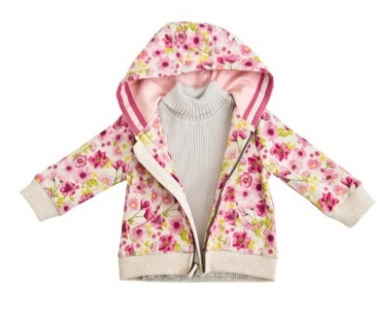 | 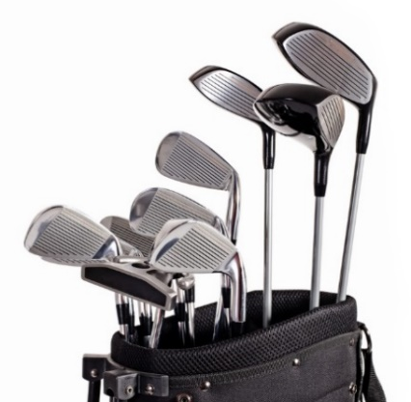 | 
Children’s fashion clothes | Golf clubs | Child’s beach set
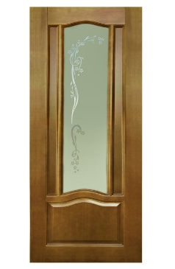 | 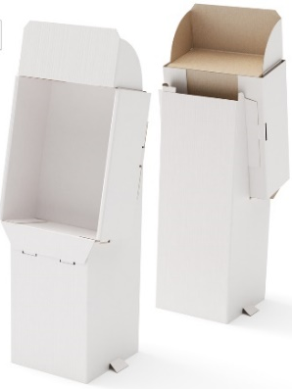 | 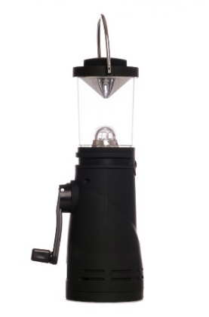
Wooden door | Card display stand | Wind up lantern
Figure 3
Name of chosen product
Feature 1 [2 marks]

Feature 2 [2 marks]

16.2: Choose one specialist process that is commonly found in batch production that uses either a die, pattern, mould, former or jig. This may have been used on your chosen product in 16.1 or it may be another process that you are familiar with.
- Name one specialist process [1 mark]
- In the box below, use notes and sketches to explain the process in detail. [4 marks]

17: Circle one of the following and give two reasons why its characteristics or physical properties are suited for the intended use.
- Polyethylene terephthalate (PET) – for a single use fizzy drinks bottles

- Foil lined board – for the lid of a take away container

- Copper – for plumbing a central heating system

- Oak – for a kitchen table

- Polycotton – for a work shirt

- Light emitting diode (LED) – for use in a portable road safety device

1. [2 marks]

2. [2 marks]

18. An increasing number of companies are becoming aware of the social footprint
that they are creating. A social footprint is created as a result of the policies that
a company has in relation to their employees, partners, subcontractors and the
wider community.
Example policy areas include: flexible working hours for parents, thorough and ongoing provision of training for staff and contributing to the local and wider community.
Explain what factors create a social footprint and evaluate how it can be as
important as its ecological footprint. [8 marks]

SECTION C – Designing and Making Principles
Figure 4 shows a removable child seat designed for safe transportation of young children on an adult bicycle.

Figure 4
Specification
- Lightweight
- Provides protection for the child
- Adjustable leg strap and safety harness positions for different sizes and ages
- Easy to fit to, and remove from the bike with a quick release system
- Comfortable for the child
Evaluate the production and the use of the child’s seat in terms of the following points.
19.1: Suitability for the users; the adult and the child. [4 marks]

19.2: Environmental and social factors. [4 marks]

20: Designers use various methods of market research to help bring a product to market.
20.1: Give two examples of why designers should consider market research before deciding whether to design and make a product. Justify your answers.
1. [2 marks]

2. [2 marks]

20.2 Using an example, explain why designers use scale models to test designs. [3 marks]

21. Study figure 5 showing images of broken and worn products:
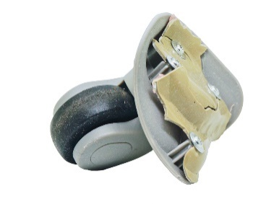 | 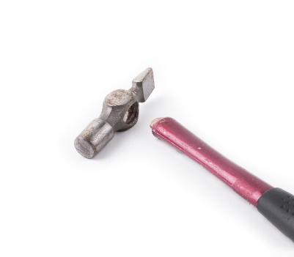 | 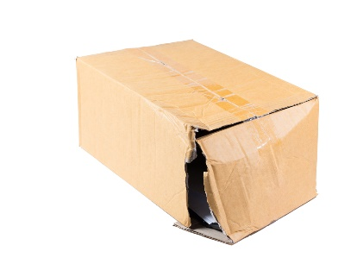
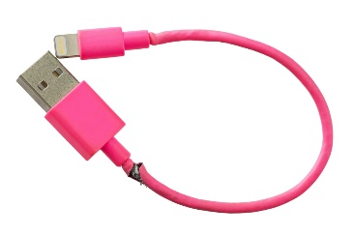 | 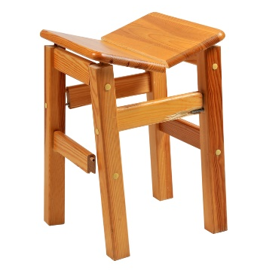 | 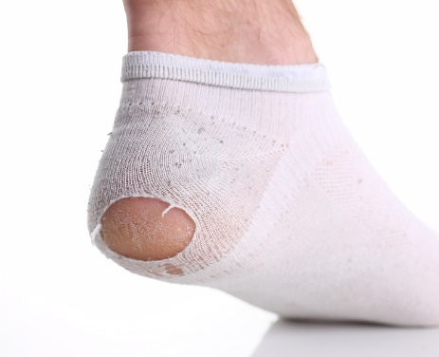
Figure 5
Designers make models and prototypes to test their designs before they are manufactured.

21.1: Select one of the products pictured in figure 5 and describe two different tests that could be performed on a prototype of the product, explaining why it would help to find out if it is fit for purpose.
Chosen product from figure 5:
Test 1. [2 marks]

Test 2. [2 marks]

21.2: Suggest one modification that could be performed on one chosen product
from figure 5 and explain why it would reduce the chance of the same fault
happening again. [3 marks]
Chosen product from figure 5:

22: Designers commonly use a variety of drawing methods throughout the
design process.
22.1: Justify one reason why designers often use freehand sketching when
coming up with initial ideas. [2 marks]

22.2 Explain why designers may use exploded drawings as part of the
instruction manual for products that need assembling at home. [2 marks]

23: Designers can use a number of different design strategies when designing products. Iterative design is one strategy that is commonly used.
23.1: Name two other design strategies that designers could use. [2 marks]
1.
2.

23.2: Choose any one design strategy and evaluate the benefits and any
drawbacks it has, giving examples in your answer. [4 marks]
Name of chosen design strategy:

24: Design movements and design based companies have played a major role in influencing the style, form and function of many elements of our modern society.
Apple | Gap
Alessi | Primark
Dyson | Under Armour
Braun | Zara
Select one design company from the grid below. Use aspects of their work to answer the question.
Name of chosen design company:
Explain how your chosen design company has influenced the area(s) of design that they are known for. Where possible, reference their products, their style and
their business philosophy, and other factors to substantiate your opinions. [6 marks]

25. Study the isometric image from figure 6:
All dimensions are in millimetres.

Figure 6

25.1: In the box below, draw a third angle orthographic projection symbol. [2 marks]

25.2: On the grid paper below, draw and label the two missing views in third
angle orthographic projection from the isometric image in figure 6. [6 marks]

26: Designers need to select materials and components based on many factors including functional need, cost and availability.
26.1: In your chosen specialism, name two components that are commonly
bought in rather than being made in house. [2 marks]
1.
2.

26.2: Chose one of the components named in 26.1 and justify one reason why
it is bought in rather than made in house. [2 marks]

END OF QUESTIONS

