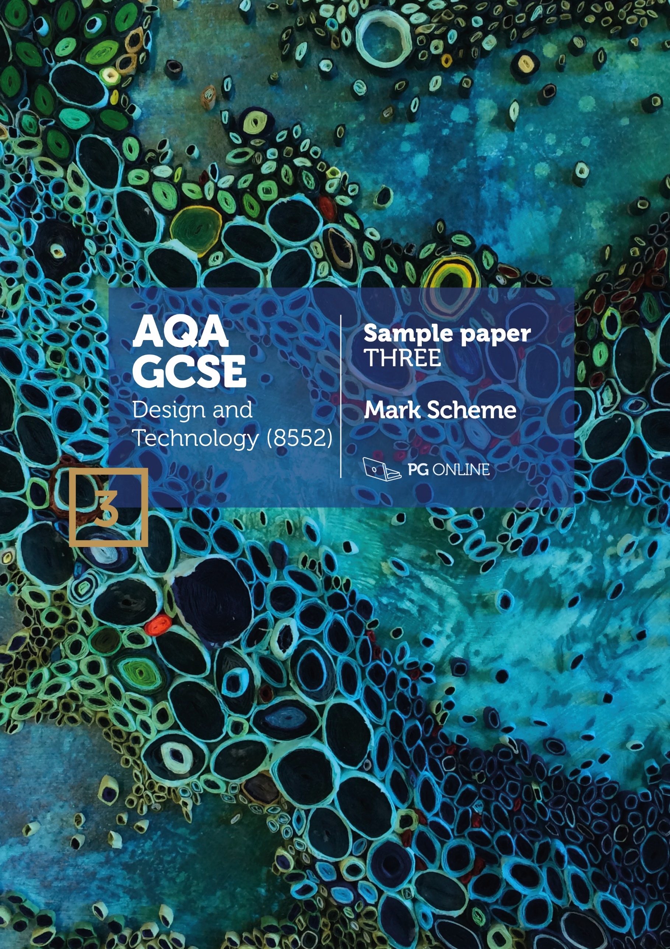

Copyright
© 2018 PG Online Limited
The contents of this pack are protected by copyright.
The pack and all the other associated files distributed with it are supplied to you by PG Online Limited under licence and may be used and copied by you only in accordance with the terms of the licence agreement between you and PG Online Limited. Except as expressly permitted by the licence, no part of the materials distributed with this pack may be used, reproduced, stored in a retrieval system, or transmitted, in any form or by any means, electronic or otherwise, without the prior written permission of PG Online Limited.

License agreement
This is a legal agreement between you, the teaching institution, and PG Online Limited. PG Online Limited grants to you a non-exclusive, non-transferable, revocable licence to use this supplement and all other associated files distributed with it in the course of teaching by your teachers and/or employees.
The materials distributed with this pack may be copied and used by your teachers and/or employees on a single site only in the course of their teaching. You warrant that you shall not, and shall procure that each of your teachers and/or employees shall not, share in any way any of the materials or part of the materials with any third party, including users on another site or individuals who are teachers and/or employees of a separate institution. You acknowledge and agree that the materials must remain with you, the teaching institution, and no part of the materials may be transferred to another institution. You also warrant that you shall not, and shall procure that each of your teachers and/or employees shall not, procure, authorise, encourage, facilitate or enable any third party to reproduce these materials in whole or in part without the prior permission of PG Online Limited.
In consideration of the licence granted to you, you shall indemnify PG Online Limited against all liabilities, costs, expenses, damages and losses (including but not limited to any direct, indirect or consequential losses, loss of profit, loss of reputation and all interest, penalties and legal costs and all other professional costs and expenses) suffered or incurred by PG Online Limited arising out of or in connection with the exercise by you of your rights granted under this licence.

GCSE Design and Technology
Sample paper 3 mark scheme
This sample paper and mark scheme has been carefully compiled and checked to ensure parity across the six specialist areas. It is the normal process for the mark schemes of live papers to go through a standardisation process where students’ responses are analysed and any answers not covered in the mark scheme are discussed and legislated for. As this is a sample paper only, this process has not been undertaken. Whilst this paper and mark scheme have been technically proofread, there may be additional responses that are worthy of marks. Teachers discretion should be applied in these circumstances.
Instructions for level of response marking
Descriptors are provided for different levels of response along with appropriate marks for each level. Read through a students’ answer, annotating to show the qualities that have been achieved, before applying the level based mark scheme.
Determining a level
Start with the lowest level of response in the mark scheme and assess if the different qualities indicated have been met. If they have, move to the next level and check to see if these have been met. Continue the process until you can match the level with the answer. With repetition it becomes easier and quicker to work up through the levels of the mark scheme.
The principle of ‘best fit’ should be adopted and if small elements of a level are missing but the majority has been covered, then this is the appropriate level to award.
Determining a mark within a level
Having decided on the level, the mark within the level must be determined. Use the descriptors to help with this along with the indicative content. Where there is any doubt, it is advisable to read back through the answers again and reapply it to the indicative content. Students do not need to cover all of the indicative content to reach the top marks. Additionally the indicative content is not designed to be exhaustive and alternative appropriate answers may well be taken into consideration.
Student answers that do not contain any relevent content must be awarded zero marks.

SECTION A - Core Technical Principles

1. Nylon [1 mark]

2. Tension [1 mark]

3. Heat [1 mark]

4. An input component [1 mark]

5. Roller [1 mark]

6. Spruce [1 mark]

7. Crank and slider [1 mark]

8. Cartridge paper [1 mark]

9. does matter which way round it is positioned in a circuit [1 mark]

10. 65 degrees [1 mark]

11. Award 1 mark for each property up to 2 marks maximum. [2 marks]
Accept any alternative correct response.
- Lightweight so that the frame is not too heavy
- Anticorrosive so that it doesn’t rust
- Ductile so that it can be formed into tubes
- Rigid and tough so that it can withstand the impacts of being ridden on a bumpy road surface
12. Award 1 mark for each reason up to 2 marks maximum. [2 marks]
- To make it easier to pull climb hills/pull heavy loads
- To allow cyclist to travel faster
- To make effort easier or harder
- To help a cyclist attain the desired cadence when pedalling
- To provide a non-slip drive
- To gain mechanical advantage (MA)

13.1 Award 1 mark for each reason up to a maximum of 2 marks. [2 marks]
Indicative content: Accept any reasonable alternative response.
- Better H&S legislation has let to improvements in the workplace
- Greater chance of court action against employers leading to better regulated
working conditions
- Better training and procedures in place
- Provision of appropriate PPE and a requirement for it to be worn at appropriate times
- Better signage warning of potential hazards
- Designated people within organisations who take responsibility for ensuring that H&S rules are enforced and followed
13.2 Award 1 mark for each reason up to a maximum of 2 marks. [2 marks]
Indicative content: Accept any reasonable alternative response.
- Signage can warn people of potential risks and hazards
- Training teaches people how to use equipment, such as ladders correctly
- Training teaches appropriate behaviours in certain situation i.e. not running in workshops etc.
13.3 Award 1 mark for the correct working out and 1 mark for the correct answer.
609,000 / 100 x 22 = 133,980 [2 marks]

SECTION B - Specialist Technical Principles
14.1 Award 1 mark for identifying one reason why the chosen specialist additive technique is used. No marks are available for naming the process. [1 mark]
Indicative responses: accept alternative correct responses.
Soldering | To create a permanent bond between two or more metal components / to solder components to a PCB by heating the joint and applying solder
Welding | To create a permanent bond between two or more metal components through heating and fusing the metals together
Batik | To create a decorative finish to a material by creating a barrier through the use of wax before dyeing
Printing | To create a decorative finish to a material by applying dyes/inks
Bonding | To create a sturdy joint by applying an adhesive to the surfaces in contact to create additional strength
3D printing | To create an artefact/component/part through a heated polymer (or other material) being applied in layers to form a structure

14.2 Award up to 4 marks for explaining the specialist treatment or technique.
Notes or sketches alone can get up to a maximum of 3 marks. [4 marks]
3-4 marks | A complete explanation of the additive technique is well presented/explained. It is accurate and shows good knowledge and understanding of how a material(s) is manipulated. Good use of correct technical terminology and appropriate tooling/resources for the additive technique or process to be performed.
1-2 mark | A simplistic description with some errors and/or poorly explained. It shows basic knowledge and understanding of how a material(s) is processed. A basic attempt at technical terminology and tooling/resources used to perform the technique is given.
0 marks | Nothing worthy of credit
Indicative content: The answers in the table give some areas where the students may have explored. Award credit for the use of diagrams and descriptions that are appropriate to the chosen additive technique. The techniques are not all material specific and could be answered with an alternative appropriate material.

Process | Procedure of the chosen additive technique
Soldering | Give credit for any soldering process:  Prepare materials to be soldered, clean and free from dust, grease and oxidation. For PCBs, free from residue from the photo etch process  Prepare the workstation with tools, equipment and materials such as heat mat, soldering iron, solder, wire cutters/strippers, desolder pump, components etc.  Ensure correct PPE is available and used  Heat the joint area, applying a flux if not already included within the solder being used  Once the joint is up to the critical temperature for the method chosen the solder is applied to the joint  Capillary action will take the solder around the joint, check the joint is appropriately covered/filled  Look for volcano shape for PCB soldering  Remove the heat source/soldering iron and allow to cool  Clean up if necessary / cut back component legs on PCB
Welding | Give credit for any welding process including plastic welding:  Ensure correct PPE is ready for use  Prepare materials to be fused, clean and free from dust, grease, oxidation, rust  Prepare the workstation with tools, equipment and material such as clamps, binding wire, flux, filler rod etc.  Apply flux to the joint, note that gas may be used instead and automatically fed to nozzle with MIG/TIG  Heat the joint area to the critical temperature for the material chosen, then the filler material is applied to the joint/automatically fed through the nozzle  Capillary action will take the solder around the joint, check the joint is appropriately covered/filled  Remove the heat source/soldering iron and allow to cool  Clean up if necessary / cut back component legs on PCB
Batik | Prepare materials, tools and equipment and PPE  Mark out the desired pattern on to the fabric to be dyed  Heat the wax (paraffin) to the appropriate temperature  Pour wax into the tjanting (canting) tool  Carefully apply the wax to the area to resist the dye  Allow the wax to go all the way through the fabric  Allow the wax to cool and set  Place the fabric in the dye for the appropriate amount of time  Remove fabric and allow to dry (some dyeing methods may vary)  Remove the wax with an iron or heated water bath  Allow to dry
Printing technique –  Offset lithography is listed | Give credit for any relevant printing technique:  The design is laser etched onto an aluminium press plate  The press plate is mounted on to a cylinder in the printer  A different cylinder is used for each colour i.e. CMYK uses four  The press plate rotates on the cylinder of the dampening unit (water rollers) which dampens the non-image area of the press plate  The press plate then passes the inking unit (ink rollers), where the ink sticks to the image area of the press plate  The image is then passed to the blanket (offset) cylinder where the image area is picked up  Then the image is transferred to the impression cylinder  Paper is fed into the printer and passes between the impression cylinder and the blanket (offset) cylinder pressing the image onto the paper  The paper then runs through transfer drums to the next colour  The paper is then dried and stacked on the delivery pile
Bonding technique | Give credit for any relevant bonding technique:  Set up appropriate equipment, tools, materials and PPE  The wood joint is cut to shape and size and checked for a close/compression fit  The joint is sanded as appropriate, and cleaned so free from dust  A key is provided if required  Wood glue (usually PVA) is applied liberally to all surfaces that are to be in contact  The joint is paired and clamped/taped/pinned as required  Excess adhesive should be wiped off  Allow time for adhesive to dry/cure  Remove clamps/tape/pins  Tidy up any excess adhesive from the joint
3D printing | Allow variations for all types of 3D printing techniques  Produce the CAD file to be printed  Post process the CAD file for the 3D printer that is being used  Load the appropriate filament into the 3D printer  Ensure the bed of the printer is prepared/cleaned for the print  Ensure the correct settings are entered for the filament and the resolution of the print  Run the CAD file  Monitor the print to watch for potential failures  Allow to cool and remove from the bed  Clean up the print removing any rafting if appropriate  Add any finishing/smoothing/setting/hardening agents if required using appropriate PPE if necessary

15. Award up to 2 marks for a correct answer in each of two different areas [4 marks]
2 marks | A complete description applying both knowledge and understanding of why automation has led to a reduction or increase in environmental and social issues
1 mark | A simple description with some errors and misunderstanding of why automation has led to a reduction or increase in environmental and/or social issues
0 marks | Nothing worthy of credit
Indicative content: accept suitable response relating to alternative products or systems.
- Environmental concerns:
- Although automated manufacturing has a high set-up cost both financially and environmentally it leads to more efficient manufacturing
- Less waste is produced due to efficient working practices
- Less energy is consumed due to efficient machines, tooling and scheduling
- As products are made smaller through automation fewer resources are needed to create them, meaning smaller products require smaller casings thus fewer resources
- Less human error means less waste
- Highly automated QA and QC ensure products are ‘right first time’, meaning less waste

- Social concerns:
- Highly automated machines and robots are replacing the jobs that were traditionally done by humans, meaning potential for higher unemployment
- Upskilling of labour is required for roles such as maintenance engineers and technicians
- Some workers may be de-skilled and required to do repetitive tasks, creating low job satisfaction and poor worker moral
- Many production lines run 24/7 meaning that shift work is common place, and this can impact family and social life
- Large factories are often set up in place where land is cheaper, which is often away from residential areas, meaning that workers may need to travel further to work or relocate.

16.1 Award up to 2 marks for two different features. [2 x 2 marks]
2 marks | A complete description applying both knowledge and understanding of why the selected product is suitable for batch production
1 mark | A simple description with some errors showing only a basic understanding of why the selected product is suitable for batch production
0 marks | Nothing worthy of credit
Indicative content:
Product etc. | Features that are suitable for batch production
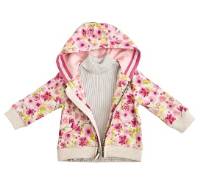  Children’s fashion clothes | Fashions change quickly therefore only a limited number of items will be needed at a time.  Once made, the pattern may be used many times, allowing alternative materials to be added or different colour schemes and/or prints to be added.  Patterns for the item of clothing will be laid out on the material and cut in bulk at the same time.  A series of workstations can be used to perform a specific task on the garment before passing it on to the next workstation.  Patterns will be made in a range of sizes to cover all age groups.
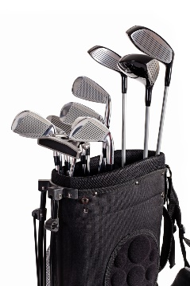Golf clubs | Golf clubs are needed in relatively small numbers and will need to be made in batches to avoid overproduction.  Golf clubs are often branded and or latest/newer versions are produced to boost sales meaning that batches are required.  Designs and materials used change regularly.  Golf clubs last a long time meaning that they are not frequently replaced.  The club heads are either cast or forged meaning that patterns and moulds need to be produced which can be reused.
  Child’s beach set | Beach sets are seasonal therefore sales will fluctuate throughout the year, meaning that they will not need to be produced all year round.  The set will be injection moulded therefore moulds will need to be made, which lend themselves to batch production.  The colours can be changed in different batches.  The injection moulding machine can be set up with different moulds and a specific number run off before changing to an alternative mould to add to the set.
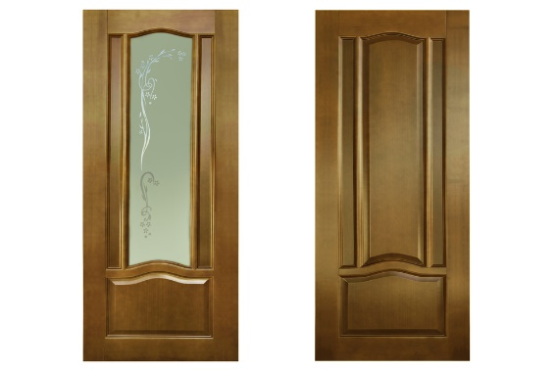Wooden door | The specific design would not be sold in high volumes therefore made in batches  The individual components would be made to a template / pattern / guide to ensure repetitive accuracy  The components would be made in a small production line  CNC routers would be used for some of the procedures  The glass would be cut in batches – possibly bought-in from a specialist glass manufacturer  Alterations to width and height could be easily accommodated in batch production
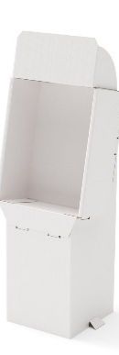  Card display stand | The specific design would not be sold in high volumes therefore made in batches  This might be made and finished for a specific product promotion therefore only required in small to medium numbers  Special dies with steel rules need making to cut, crease and score the card and can be used for batch production  Alterations and/or to some features/parts could be easily accommodated in batch production e.g. shelving in the recess
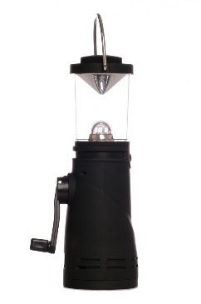Wind-up lantern | The specific design would not be sold in particularly high volumes therefore made in batches  The lantern would be mainly seasonal; therefore production would not need to be constant, lending itself to being batch produced  Many components would be injection moulded, needing expensive moulds to be created – they could all be used with one injection moulding machine in batches

16.2a Award 1 mark for naming a specialist process used in batch production. [1 mark]
16.2b Award up to 4 marks for explaining a batch production process.
Notes or sketches alone can get up to a maximum of 3 marks. [4 marks]
4 marks | A complete explanation of a batch production process is well presented/explained using notes and sketches. It is accurate and shows all stages in the correct order. Thorough knowledge and understanding of how a material(s) is processed. Excellent use of correct technical terminology and appropriate tooling/resources for the process to be performed.
3 marks | A good explanation of a batch process. It is presented/explained with a good level of accuracy. Most stages are shown and mostly in the correct order. Good knowledge and understanding of how a material(s) is processed. Good use of technical terminology and appropriate tooling/resources for the process to be performed.
2 marks | A simplistic description with some errors/gaps and/or poorly explained. It shows basic knowledge and understanding of how a material(s) is batch processed. A basic attempt at technical terminology and tooling/resources used to perform the process is given.
1 mark | A very basic description of a batch process that may have stages or information missing. Incorrect sequence and terminology used. The process may not be named correctly.
0 marks | Nothing worthy of credit.
Indicative content:
The answers in the table give some areas where the students may have explored. Award credit for the use of diagrams and descriptions that are appropriate to the chosen batch production process. The processes are not necessarily material specific and could be answered with an appropriate material for the process.

Product |  | Batch production using dies, patterns, moulds, jigs and formers
Children’s fashion clothes |  | Patterns are used to ensure repetitive accuracy of cutting out of fabric  Jigs used to position buttonholes and other features  Screen printing/dyeing methods in batches
Golf clubs |  | Die/mould used for investment casting process  Moulds used to form the grip  Templates and/or jigs used to cut shaft to length
Child’s beach set |  | Moulds for injection moulded parts  Formers for vacuum formed parts
Wooden door |  | Jigs and/or patterns used for the routing of the mouldings  CNC/CAM machines use CAD files  Templates for the sizing of individual components of the door
Card display stand |  | Die cutting process requires a die to be made  Reference to difference between cut, score, fold or creasing rule, cutting blade and ejection rubber
Wind-up lantern |  | Injection moulding die/mould for most casing components  Jig for clear acrylic tube to be cut to length
17. Award up to 2 marks for a correct answer in each of two
different areas. [2 x 2 marks]
2 marks | A correctly stated functional and/or aesthetic characteristics of the material and a complete reasoning of why it is appropriate for the intended use
1 mark | A stated characteristic or physical property that may be simplistic or incomplete with some reference as to why it is acceptable for the intended use
0 marks | Nothing worthy of credit
Indicative content: accept alternative suitable functional and/or aesthetic characteristics and an appropriate response.
Polyethylene terephthalate (PET) – for a single use fizzy drinks bottles | Malleable when heated – so that it can be formed into a parison to be shaped/blow moulded  Tough– so that it can withstand knock/bumps in transportation or use / hold the weight/pressure of the contents  Available in a variety of colours – attractive to users  Food safe – safe contact with the contents  Recyclable – can be recycled at the end of use avoiding waste
Foil lined board – for the lid of a take away container | Sized/coated/bonded surface – so that the moisture from the food items doesn’t leak through the board  Non-absorbent – good for containing liquid food items  Aluminium foil reflects heat/cold to maintain the temperature longer  Rigid enough to maintain the shape if knocked or bumped in transit
Copper – for plumbing a central heating system | Tube stock form available for piping the water around the system  Resistant to corrosion – meaning that it won’t corrode/rust  Malleable/ductile – meaning it can be bend to shape around corners  Hard enough that it will keep its shape in use  Tough enough that it will withstand knock and bumps in use  Easy to solder joints to/attach components to  Will not deform due to hot water passing through it / high melting point
Oak – for a kitchen table | Tough, durable and strong – to withstand wear and indentation  Attractive warm / light brown / flecked / multi-tonal / grain – attractive aesthetics turning darker with age if unprotected  Naturally resistant to rot from exposure to moisture – making it ideal for being constantly cleaned/used in a kitchen
Polycotton – for a work shirt | Polyester and cotton are easily blended and spun into yarn – so that it can be woven/knitted into fabric  The blended fibres are mixed for improved properties  It is breathable allowing the wearer to regulate their temperature  Polycotton is stronger than 100% cotton and less prone to ripping – meaning that it is likely to last longer in use  It is cheaper that cotton alone  It is less prone to pilling than cotton  It keeps its shape and colour longer than cotton alone and is resistant to shrinkage  Polycotton can be easier to care for i.e. requires less ironing
Light emitting diode (LED) – for use in a portable road safety device | Compact/small – so that less space is required on PCB/in the casing  Low power – meaning that battery lasts longer  Can have a bright output – meaning that the users of the device will be easily noticed  Last a long time – meaning that they rarely need replacing unlike bulbs
18. Award up to 8 marks for an analysis of the use of lifecycle assessments. [8 marks]
7-8 marks | A coherent and logical analysis featuring a range of points with excellent understanding of issues surrounding a company’s social footprint. A number of points are raised other than those given in the question. Detailed analysis and evaluation of how this is important with references of comparison to an ecological footprint.
5-6 marks | A logical discussion, which includes a good understanding of issues surrounding a company’s social footprint. At least one point is raised other than those given in the question. Good analysis and evaluation of points raised, leads to some conclusions being drawn as to how important it is for a company’s image/reputation. Some reference and understanding will be presented of the company’s ecological footprint as a comparison.
3-4 marks | The response shows a good understanding of some issues surrounding a company’s social footprint. A few points raised with some analysis/evaluation from an external point of view, however these may be limited to those given in the question. Arguments may lack some coherence and conclusions may be weak or unsubstantiated and any social benefits or issues may not be specific. Little comparison made to a company’s ecological footprint
1-2 mark | Some understanding of the key issues is covered with limited awareness of a company’s social footprint. One or two points mainly based around those given in the question, show limited analysis and/or evaluation and lack coherency. Little or no conclusion drawn. No real awareness of an ecological footprint as a comparison
0 marks | Nothing worthy of credit
Indicative content:
Indicative content listed is provided to illustrate points that students may make about the examples given in the question, which would demonstrate their understanding of what actions create a social footprint and how it compares to an ecological footprint. Students may refer to some or all of the examples or they may offer alternative responses in their answer. Marks should be awarded for anything worthy of credit.
Issues surrounding social footprints can consist of, but are not limited to the following:
- The impact company’s social policies have on stakeholders and the wider community
- Workers perform better when they feel valued by a company
- Fewer days are lost through illness and stress related issues
- Flexible working hours allow easier childcare/care for other family members and better family relationships
- Fair wages paid to all staff with appropriate holiday allowance
- Overtime paid and not expected for free
- Enhanced maternity/paternity pay
- Healthcare provision
- Provision of appropriate breaks and facilities and for those breaks to be catered for i.e. canteen, seating, social area etc.
- Training is provided for all staff and ongoing CPD for upskilling and moving to other jobs within the company if required
- University/college sponsorship and or apprenticeship schemes
- Company backed local events/fundraising/charity sponsorship
- Promotion of any green credentials within the community
- Enforced code of conduct for all staff including equal rights, equal pay, whistleblowing policy etc
- Adhering to ISO 9000 standards
- Vetting of linked suppliers and organisations avoiding unfair and illegal working practices and conditions throughout the supply chain
Comparison to ecological footprint:
- A company can easily lose respect within a community or nationally if unfair policies are enforced or inappropriate actions are taken
- A company with a poor social footprint can damage its reputation as much as one that pollutes/destroys the natural environment

SECTION C – Designing and Making Principles
19. Award up to 4 marks for each of the three sections of the question.
3-4 marks | Well described and justified analysis containing full evaluation, drawing conclusions having considered both positive and negative factors.
1-2 mark | Brief points mentioned but not fully explained. Analysis present, but limited evaluation / conclusions drawn. May have focused solely on either positive or negative factors.
0 marks | Nothing worthy of credit.
Indicative content for the evaluation of the child’s seat in terms of the following points:
19.1 Suitability for the users; the adult and the child. [4 marks]
- Easily clips on and off the bicycle
- Lightweight, therefore easy to carry and attach
- Handle at top of seat for easy carrying and hooking onto a hanger for storage
- Easy to use and adjust height/size/straps making it adaptable for different heights/ages
- Waterproof materials used which allows for use in poor weather conditions
- Soft material on seat and backing to ease pressure on child’s body and provides comfort for longer journeys
- Foot straps and harness attached to secure child in place with padded straps on shoulders for comfort
- Robust enough to resist knocks, bumps, wear and tear in use
- High back to the seat to protect child from a potential whiplash injury
- Does not protect the child from weather and little protection from accidents/RTA
- Adult cannot see the child whilst cycling

19.2 Environmental and social factors. [4 marks]
- Mainly made from moulded plastic, which are from a finite source (oil) and uses energy to produce
- The design has easily separable parts of which most are recyclable
- Child seats encourage family/commuter cycling which is better for the environment reducing emissions
- Cycling is a healthy activity encouraging/modelling an active lifestyle from an early age
- Risk of harm to child is greater on a bike than in a car
- Risk of breathing in exhaust fumes in transit

20.1 Award 1 mark for each reason market research is used and award the second mark for a justification for its use. [2 x 2 marks]
Indicative content: Accept alternative reasonable responses.
- To see if there is demand for a product/service – so it has a potential market
- To find out about required/important function – so the product will be correctly designed
- To find out about preferred form/aesthetics – so users will desire the product
- To understand minimum and maximum pricing – so it can be made to a certain price point that is likely to sell
- To gather opinions from the client or other user groups – to inform the overall design of the product
- To know they are on the right track before investing too much time and/or money – otherwise investors are unlikely to back the venture
20.2 Award up to 3 marks for explaining the use of scale models. [3 marks]
3 marks | Excellent description and justified explanation including a detailed example for the use of scale models.
2 marks | Well described and justified explanation including a good example for the use of scale models.
1 mark | One brief point mentioned but not fully explained. Some reference to an example may be made but will lack clarity.
0 marks | Nothing worthy of credit.

Indicative content: Accept alternative reasonable responses.
- If the product is too large to make a full-scale model – e.g. architecture
- If the product is too small and it needs to be enlarged to see important features – e.g. the internal space inside a small electronic product to see how parts fit in to it.
- To test mechanism and/or functionality where the size is not important to the functionality – e.g. interlocking mechanisms, testing technical principles
- To test materials and finishes for aesthetic purposes – allowing choice for the user, but not wasting materials on full size versions
- Scale CAD models may be created – to allow for stress and other technical testing including aesthetics
21.1 Award 1 mark for naming each appropriate test and award the
second mark for a justification for its use. [2 x 2 marks]
Indicative content: Accept alternative reasonable responses.
- Stress testing to ensure it will hold up to being compressed, sheared or held under tension
- Repetitive use tests – performing tasks many hundreds or thousands of times to ensure appropriate level of wear and tear
- User group testing – to see how it performs in ‘real life’ applications
- Destructive testing – to see the point at which it breaks and how, so as to devise methods for reinforcement
- Non-destructive testing – using x-ray, ultrasound and other forms of NDT to see if there are any inherent weaknesses
- Accept aesthetic based testing – to see if users will like the product
21.2 Award 1 mark for an appropriate modification and up to two marks for
a detailed explanation of how it would prevent the issue reoccurring. [3 marks]
Indicative content: Accept alternative reasonable responses.
Castor wheel | Thicker plastic used during moulding – withstand greater impact  Webbing included in mould – giving greater support around area  Brace the corners with metal reinforcements – metal less likely to break
Hammer | Thicken the stem of the handle – to take greater impact  Use stronger materiel i.e. steel (anodised aluminium has been used) – will withstand greater impact, less prone to snapping  Ensure the stem is solid and not hollow – less prone to snapping due to thicker material  Use a mechanical fixing to attach the head to the stem – the compression fit/spline wedge sometimes used can work loose
Cardboard box | Use thicker material – to withstand greater impact  Use cross laminated cardboard – ensuring structural strength in all/ horizontal and vertical directions instead of one direction  Use internal packing – to withstand greater impact from the inside therefore supporting the external layer  Use external additions bonded to the packaging – deflect/absorb impact
Phone charger | Use thicker cable/sleeve - reduce the chance of wear  Use additional protective layer such as woven shielding – to add support to the vulnerable area  Enlarge the moulded area around the ends – adding support
Wooden Stool | Use a laminated material for the top of the stool – avoiding it splitting along the grain or use an alternative wood with greater physical / mechanical strength (i.e. oak)  Use stronger wood glue – to reduce the joint coming undone in use  Use joints with more surface area or a mechanical fixing – allowing greater adhesion or a physical hold to be used
Ankle sock | Use a stronger fibre/blend of fibres – to withstand greater wear and tear  Use reinforced areas – to resist wear in areas specifically that are prone  Use alternative harder wearing materials – in areas prone to wear  Use different weight of material – to resist wear  Use alternative weaves – that are harder wearing and less prone to splitting
22.1 Award one mark for a reason and the second mark for a justification. [2 marks]
Indicative content: Accept alternative reasonable responses.
- It is a very quick way to get ideas down – meaning that ideas can flow quickly and not get lost in the delay of using other methods
- Many ideas can be formulated quickly – allowing for a greater range on initial concepts to be explored
- Allows a given idea to be easily developed / details added / scale amended / proportions altered
- Using one large sheet can allow designers to explore ideas holistically – allowing one idea to feed/influence another
- Some designers say that pen/pencil on paper allows the ideas to flow more quickly and lucidly – enabling greater creativity and not concentrating on quality
22.2 Award one mark for a simple explanation and the second mark for additional supporting commentary. [2 marks]
Indicative content: Accept alternative reasonable responses.
- It allows users to see how a product physically fits together – therefore making it visually simpler to assemble
- The drawings can be used in a step by step layout – making assembly a linear process reducing the chance of mistakes
- They allow for the identification of separate components – meaning that each part can be located and counted before assembly, making the process less confusing
23.1 Award one mark for each correctly named design strategy up to a
maximum of 2 marks. [2 marks]
Design strategies: Do not accept iterative design as this is in the question. Allow for alternative explanations/descriptions of design strategies.
- Collaborative design
- User-centred design
- Systems approach
- Intuitive design
- Accept avoiding design fixation
23.2 Award a up to maximum of three marks if only positive or negative
reasons are given. [4 marks]
3-4 marks | Well described and justified analysis of a chosen design strategy containing full evaluation, drawing conclusions having considered both positive and negative factors.
1-2 mark | Brief points mentioned but not fully explained. Analysis present, but limited evaluation / conclusions drawn as to the benefits or issues of using a specific design strategy. May have focused solely on either positive or negative factors.
0 marks | Nothing worthy of credit.

Indicative content: Accept alternative reasonable responses.
Collaborative design | - Working with others shares the load of gathering materials and research data making it faster  - More stimulation and cross pollination when creating design ideas – could be distracting for some  - Peer feedback is constant and moves the design forward, sometimes through competition which is motivating for some but can demotivate and be intimidating for others  - Allows designers to share their particular skills / areas of expertise  - It improves the quality and range of ideas created  - It increases experimentation and risk taking
User-centred design | - Creates a very close relationship with the client/users  - Client/user group are the main focus and consulted at every stage therefore there is less risk of the product not being accepted by the client/user group  - Client/user groups can be fickle and change their mind/wants/needs which can create delays  - GCSE projects are often user centred to ensure the product is fit for purpose  - It can be time consuming dealing with clients/user groups and increase lead-time
Systems approach | - Allows for a logical and structured layout of complex designs and systems, meaning less confusion / fewer mistakes made  - Systems are broken down into manageable steps / subsystems – solutions for each step can be made separately enabling complex sequencing to be made  - There can be less contact with the client however the brief and specification have usually been finalised  - It can be harder to have an overview of the whole project if separate people are working on different subsystems  - It is easier to find issues in a system as the individual steps can be easily identified
Iterative design | - An effective and cyclical approach where several iterations of a design proposal are created meaning that improvements and modifications are made as a response to feedback, analysis and evaluation  - Models and prototypes are made, analysed, tested and evaluated to inform potential modifications  - Failure is used as the driving force to create improvements  - It can be a time consuming and resource hungry process  - It creates a history of iterations which can be viewed to inform future designs/iterations  - Modifications become smaller and the product becomes more refined as the process moves forward
Intuitive design  &  Avoiding design fixation | - ‘Right first-time’ principle – only a few gifted designers have this ability – sometimes it happens that the first ideas generated is the best  - Saves time however the designs still need to be worked through to ensure they are fit for purpose  - Lone designing can cause ‘design fixation’. Although not really a design strategy it draws on other strategies to free up the design process and create stimulation  - Strategies include: Working with others, forcing oneself to start from a totally new place, change format/media, create models, change from 2D to 3D, embrace failures
24. Award marks for content describing the work and influence of a
chosen designer. [6 marks]
Only accept the work of the design companies named in the question.
5-6 marks | A coherent and logical analysis featuring a range of points with excellent understanding of the work and influence of the chosen design company. Detailed analysis and evaluation of at least one product or system or philosophical arguments attributed to the design company. It is likely that additional factors may have been used to substantiate their opinions.
3-4 marks | A logical and detailed understanding of a couple of points demonstrating a good understanding of the work and influence of the chosen design company. Some analysis and/or evaluation of at least one product or system or philosophical arguments attributed to the design company.
1-2 mark | Some understanding of the work of the chosen designer but showing limited awareness of their work and/or influence. There may be some reference to one product or system or philosophical arguments attributed to the design company, but it will lack clarity and depth.
0 marks | Nothing worthy of credit.

25.1 Award 1 mark for both correctly drawn elements of the symbols and
1 mark for the correct orientation. [2 marks]


25.2 [6 marks]
Award up to 2 marks for each correct label:
- 1 mark for both the front view on the left and side view on the right (plan view given)
Award up to two marks for correctly drawn front view:
- 1 mark for the outline shape
- 1 mark for correctly identifying that the lower part of the forward-facing radius does not need a line but that the upper part does.
Award up to 3 marks for the side view.
- 1 mark for the outline shape,
- 1 mark for the two radii
- 1 mark for the correct angle of the diagonal line.

26.1: Award 1 mark for one correctly named component up to a maximum
of two marks. [2 marks]
Indicative content: The lists are not exhaustive, award credit for alternative responses.
- Zip, button, velcro, hook and loop fastner, buckle, toggle, eyelet, press stud
- Nut and bolt, hinge (all varieties), nyloc, rivet, screws, nails, draw runners, knockdown fittings
- Binding methods, clips and fasteners, rachet rivet
26.2: Award one mark for a reason and one mark for a justification. [2 marks]
Indicative content: Award credit for alternative responces.
- It is cheaper/more cost effective – as expensive tools, equipment and machinery is usually required to make components and this would not be financially viable
- It saves time – as bought in componets are ready to use and come in standard sizes which can be allowed for in the design
- They are reliable – as the components will/may have been made to specific tolerance and therefore will function correctly/as expected
- Also accept answers relating to higher quality / availability / standard stock forms

