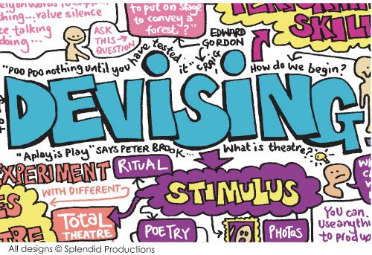

GCSE DRAMA: C2 DEVISING DRAMA +
C3 TEXTS IN PRACTICE HANDBOOK
Developing knowledge of the ‘devising Drama portfolio’
C
O
N
T
E
N
T
S
P1 | Front
P2-3 | Contents
P4 | Devising Drama demands | P166
P5 | Devising drama stimulus | P193
P6 | Interpreting a stimulus | P194
P7-9 | Genre and style | P199-201
P10 | Structuring your piece | P211
P11 | Charting structure | P212
P12 | Performance conventions | P203
P13-17 | Contemporary practitioners: Frantic Assembly, physical theatre, Kneehigh and Forkbeard Fantasy
P18-25 | Practitioners: Stanislavski, Brecht, LeCoq, Artaud and Berkoff
P26 | Statement of dramatic intentions
P27-29 | Exemplar statements of dramatic intentions
P30 | Statement of dramatic intentions blank sheet
P31 | How to rehearse | P162
P32 | What type of group member are you? | P189
P33 | Staying positive in group work | P190
P34 | Planning devising | P191
P35 | Collaboration | P202
P36 | Avoiding rehearsal issues | P207
P37-38 | Vocal and physical skills | P214-215
P39 | Rehearsal planning and the Devising Log | P208
P40 | Response to a stimulus – The devising log | P192
P41 | Research | P198
P42 | Analysis and evaluation | P218
P43 | Checking your devising log | P220
P44-47 | Devising log blank pages
P48-52 | Exemplar devising log
P54-59 | AQA Devising log with marked commentary
P60 | Devising log top sheet
P61 | Petal paragraphs
P62 | Giving and responding to feedback | P209
P63 | Audience questionnaire | P219
P64 | Buddy assessor form | P210
P65-66 | DIRT feedback sheets
P67 | Devising Drama mark and feedback sheet
P68 | What have I learned? | P221
Component 3: Texts in Practice
P69 | Texts in Practise demands | P222
P70 | How to approach a script | P223
P71 | Emotion memory | P224
P72 | Scripts and styles | P225
P73 | Rehearsal techniques | P230
P74 | Physical warm up | P231
P75 | Health and Safety | P235
P76 | Statement of dramatic intentions
P77-78 | Exemplar statements of dramatic intentions
P79 | What have I learned? | P258

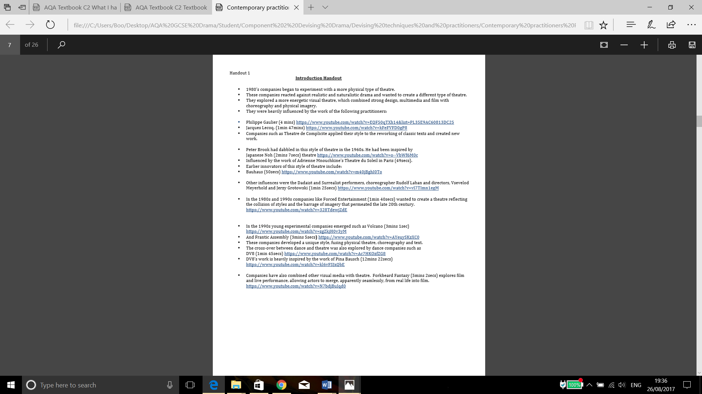
SYNCHRONICITY
PRACTITIONER: Frantic Assembly
Jerzy Grotowski
- Points of Contact and Sharing Weight
- Tension and Support - Developing Dynamism
- Impact of sound and music - the effect on the witness

Group in circle ‘Domino Effect’ Action / Reaction
Start small – palm of hand
Two hands etc
Build up both the impetus and the response

Knock-ons Activation of movement by another
Every action has an equal and opposite re-action
Transition from image to image

Points of Contact Hands and feet are contact points
Small groups given a number to allow points of contact with the floor
Increase the difficulty

Group Work Creating Tension and Sharing Weight Human sculpture and balance
Stillness and exactitude
Whole group seated on laps!

Developing dynamism and impetus – add ‘Lift’ to the points of contact

Using the tension and the weight sharing to give impetus to a dynamic movement
Creation of increasingly larger group ‘Moving Sculptures’
CHAIR DUETS
PRACTITIONER: Frantic Assembly
- Simplicity, fluidity and repetition
- Quality of Physicality
- Integrity of Movement
- Symbiotic Partnerships
- The effects of music and masse
- Development of an emotional integrity

Warm-up using the chairs for support

Brief exploration of tension and support exercises Recall creating dynamism
Pushing off / Pulling through

Partnerships A and B
Three moves A Moves can be interspersed
Three moves B
Repeat sequence three times
Record

Add six more moves
Rehearse; re-iterate; repeat Moves can be discarded or re-invented
Record

Moves to number twenty in total
Rehearse; re-iterate; repeat Addition of music and choices of music
Record

Group work extension Partnerships in unison performance – moving in and out of space
Linked partnership performance
Whole group unison performance of a chosen partnership

The Importance and the effect of music on finished performance
Playing on audience pre-conceived sensibilities – serious / comic / sad / joyous

Using technique with text – poetry / certain fragments / character interpretation

https://www.youtube.com/watch?v=SKYaUEZcF_k Simultaneous Partnerships
https://www.youtube.com/watch?v=UJ_9Eaog2yw Connected Partnerships
https://www.youtube.com/watch?v=dCu5MeHnDyk Pure Physical Theatre
https://www.youtube.com/watch?v=oQCTbCcSxis Empty Chair

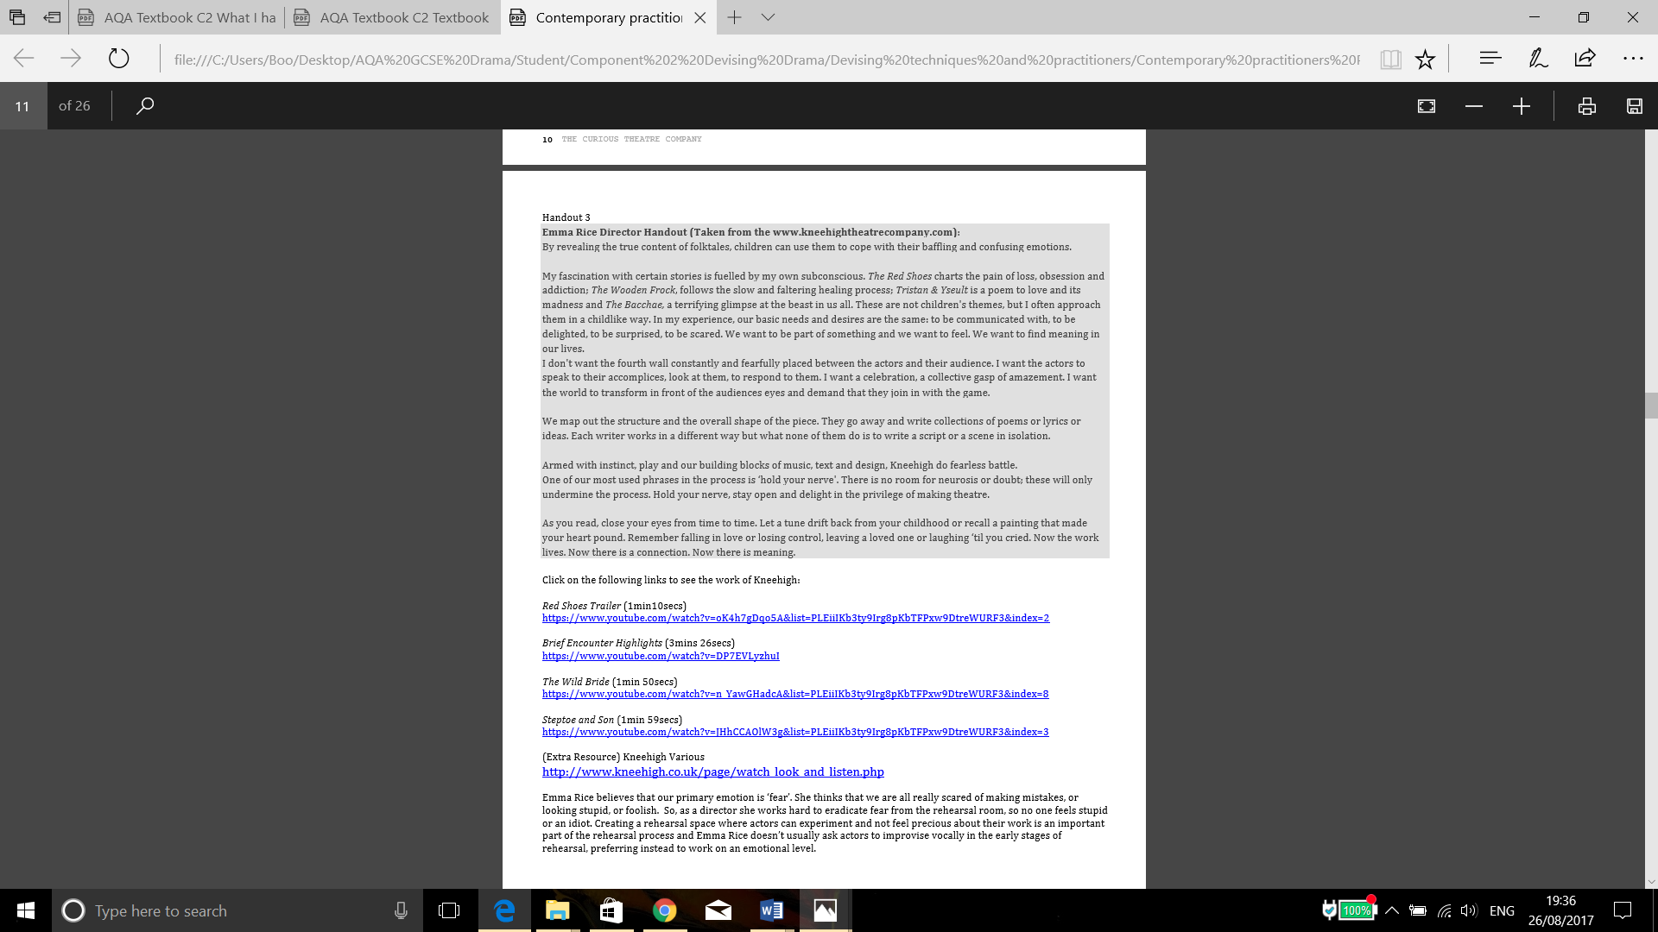
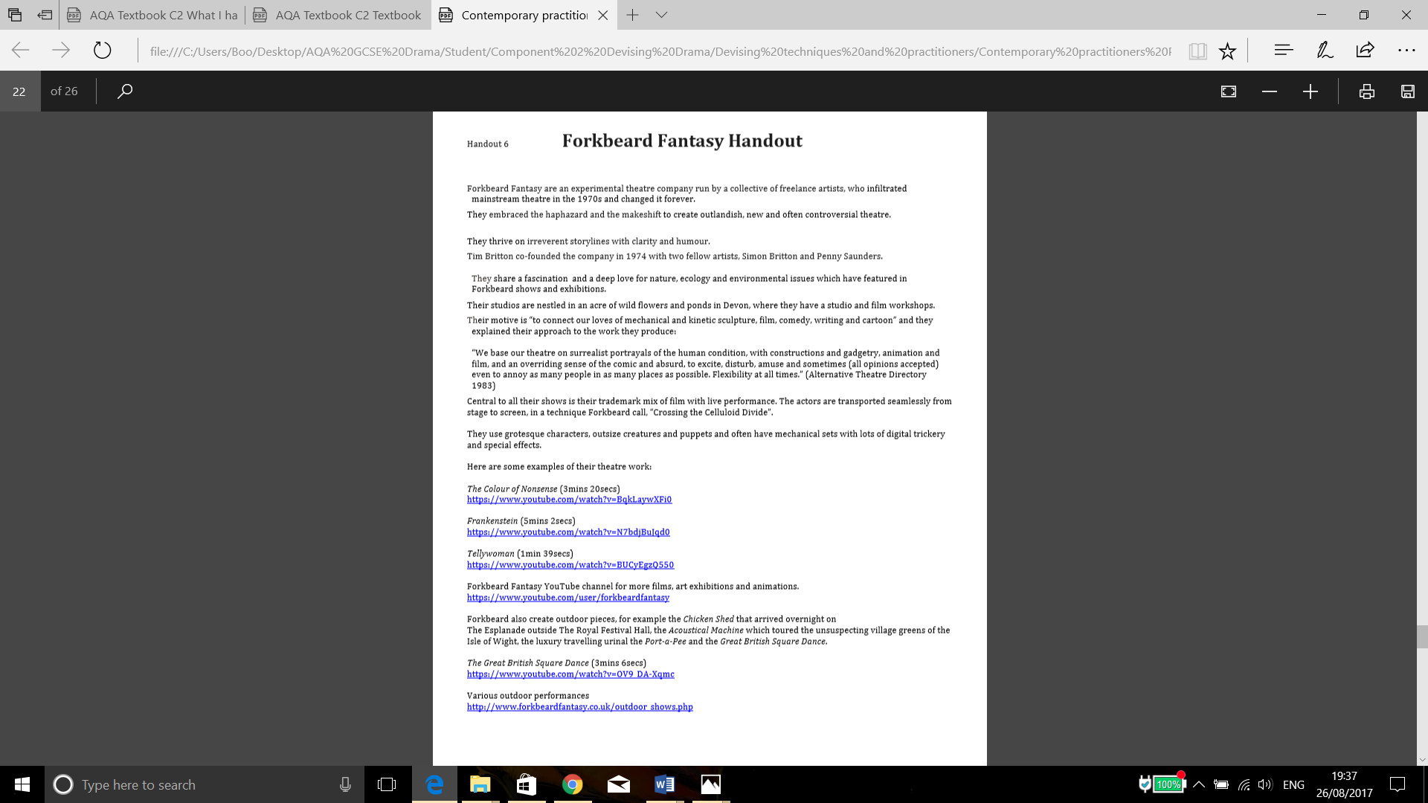
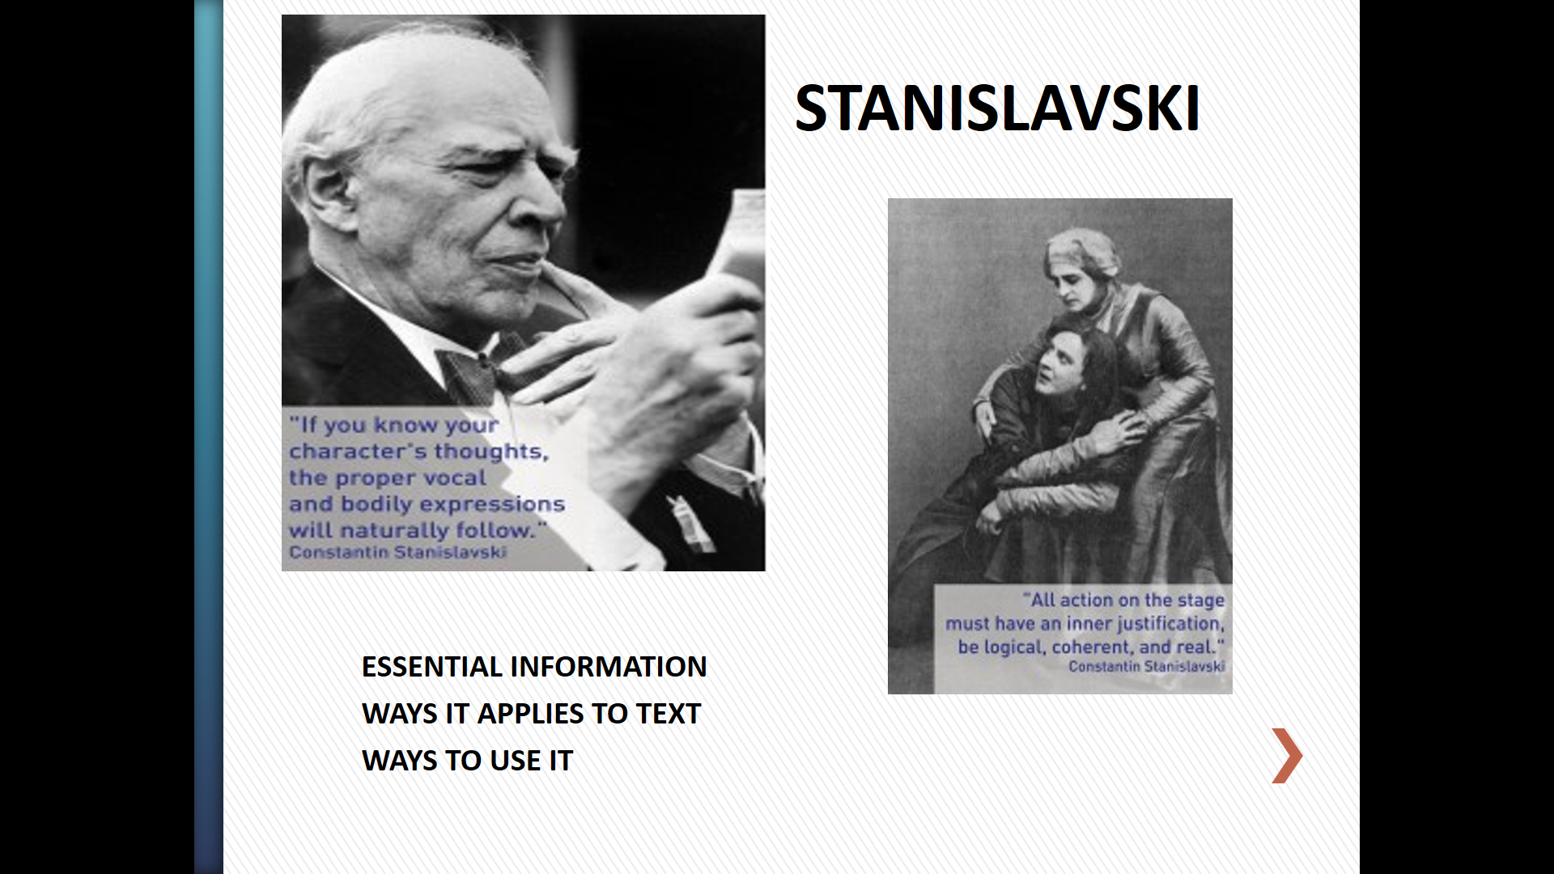

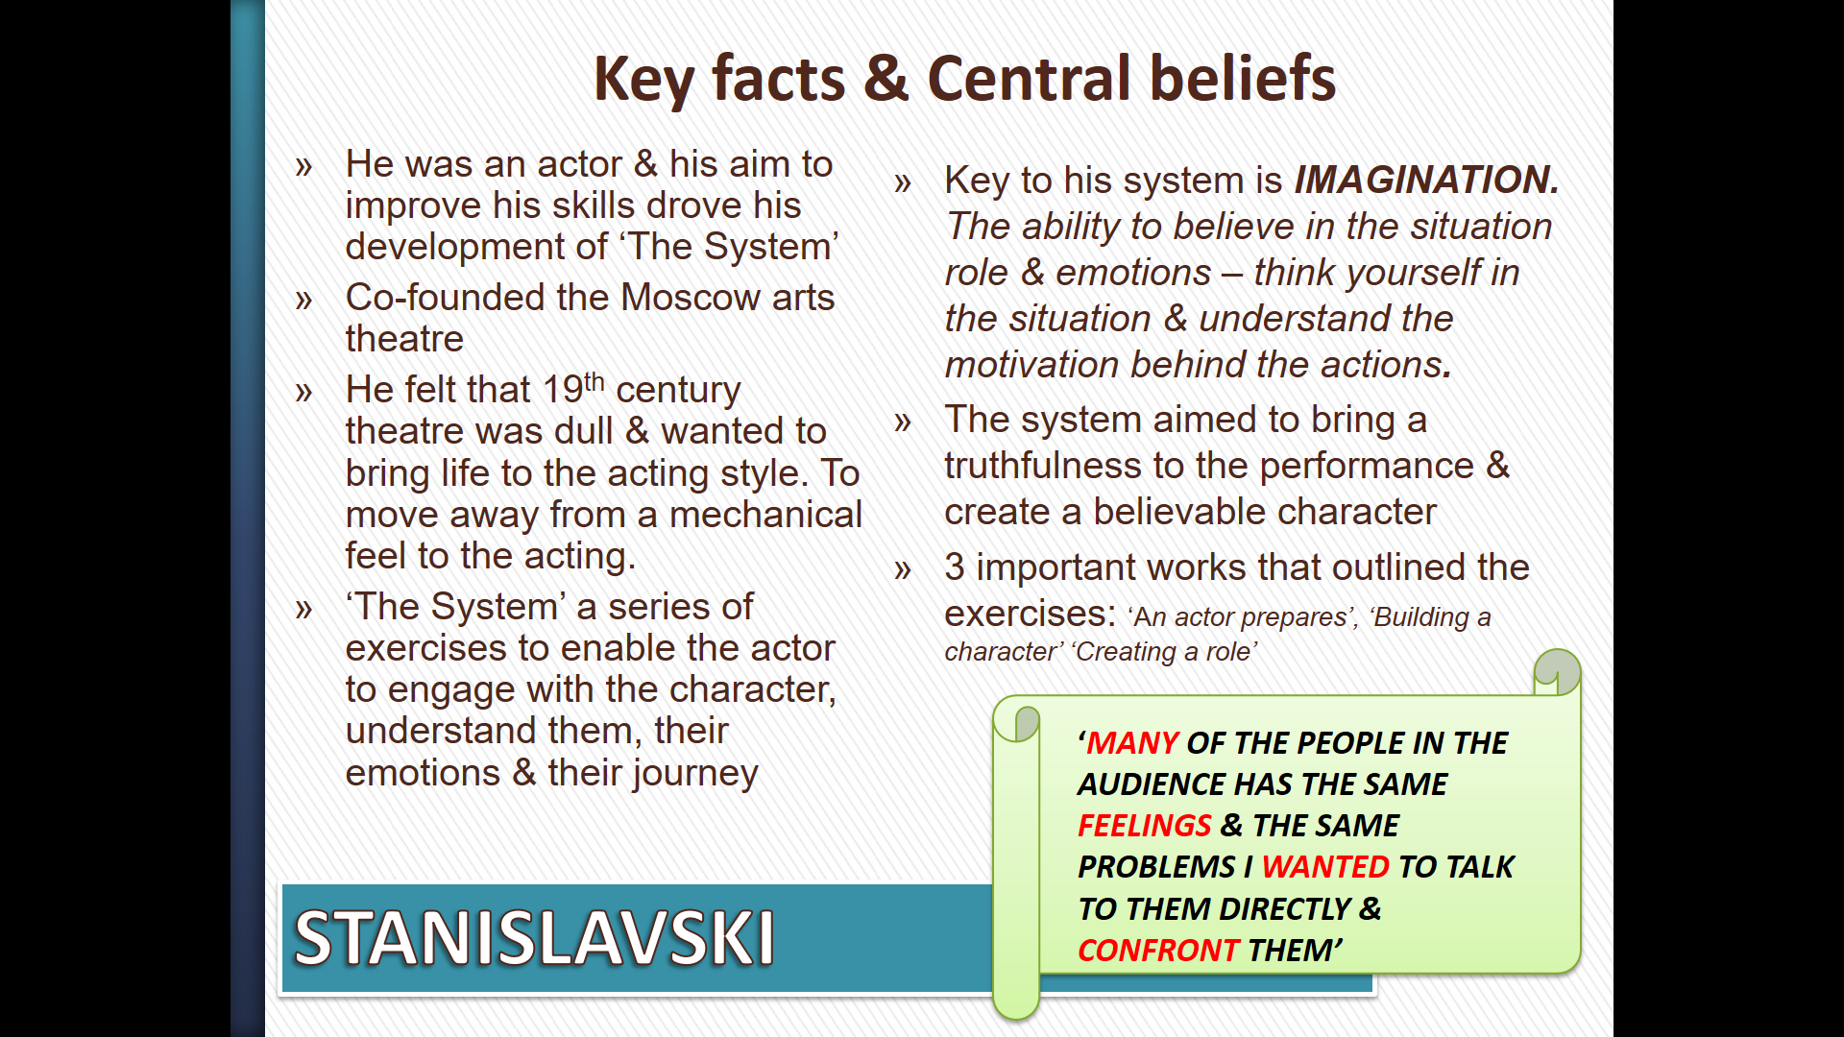

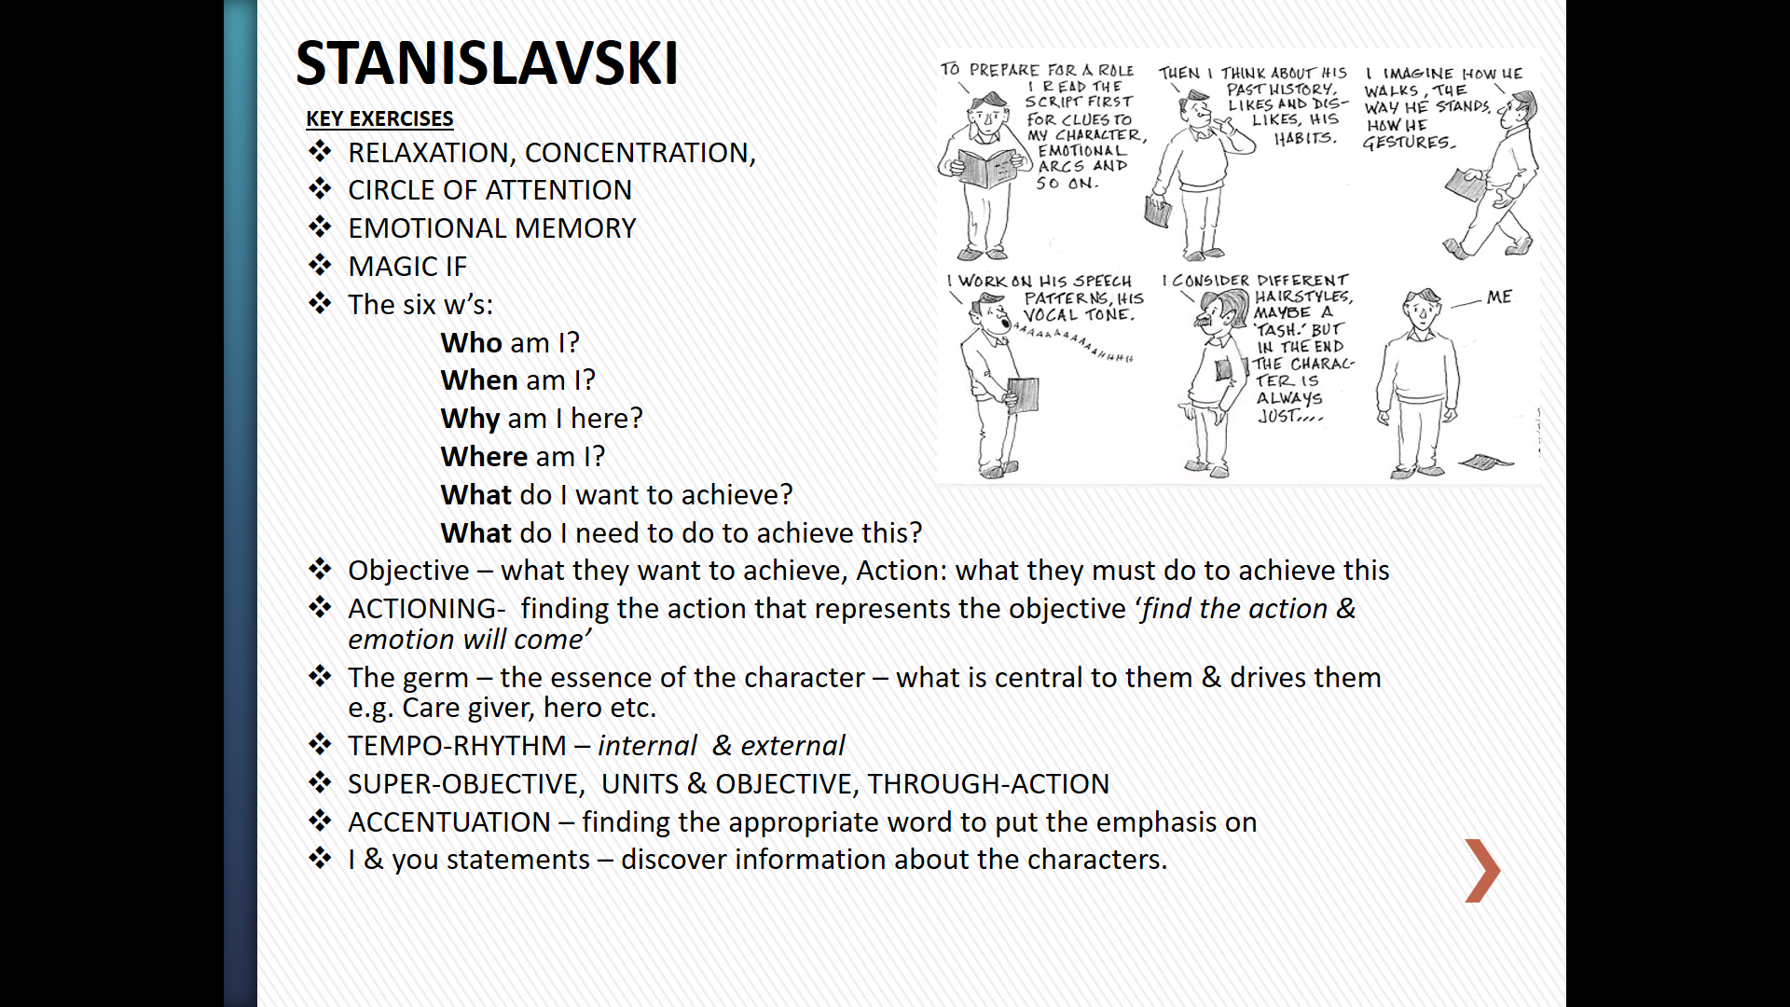

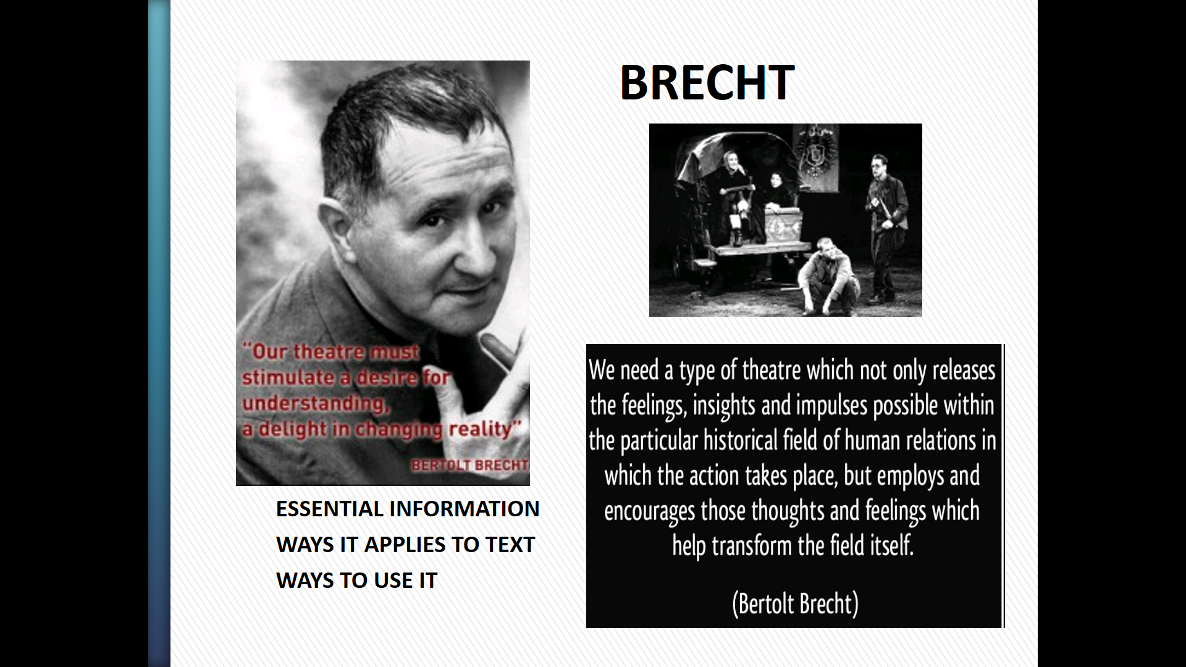
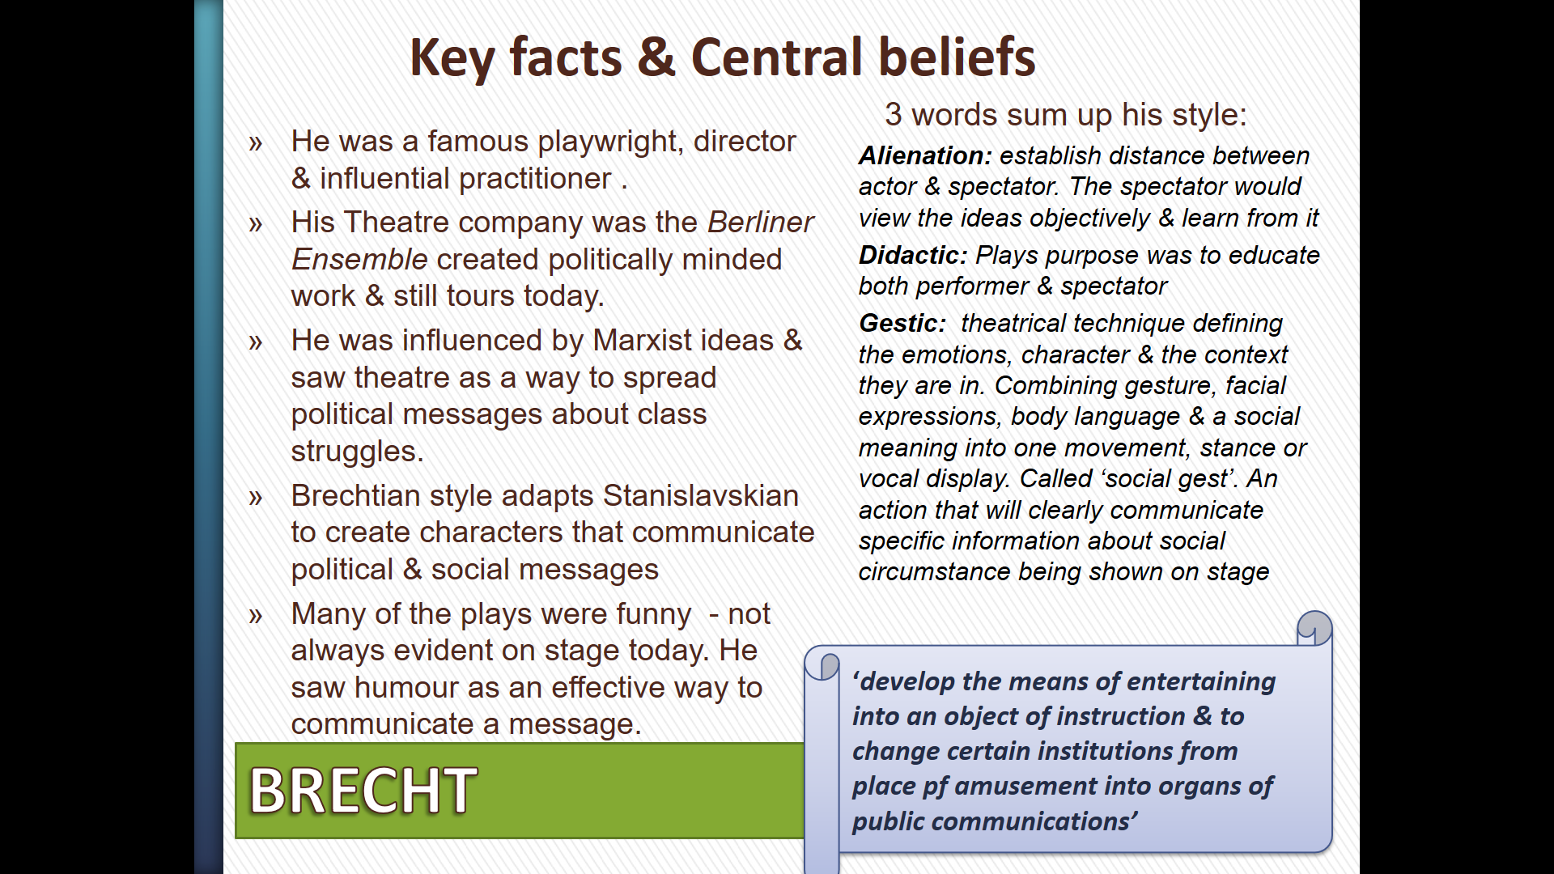

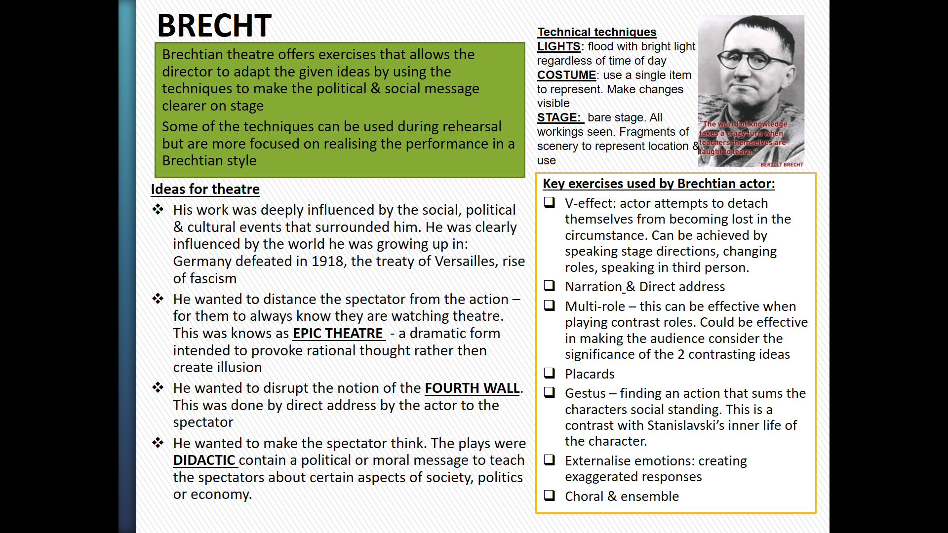
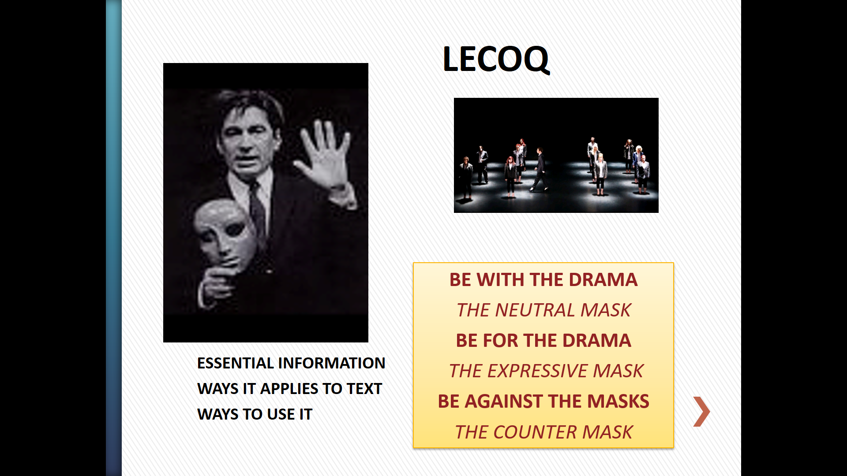

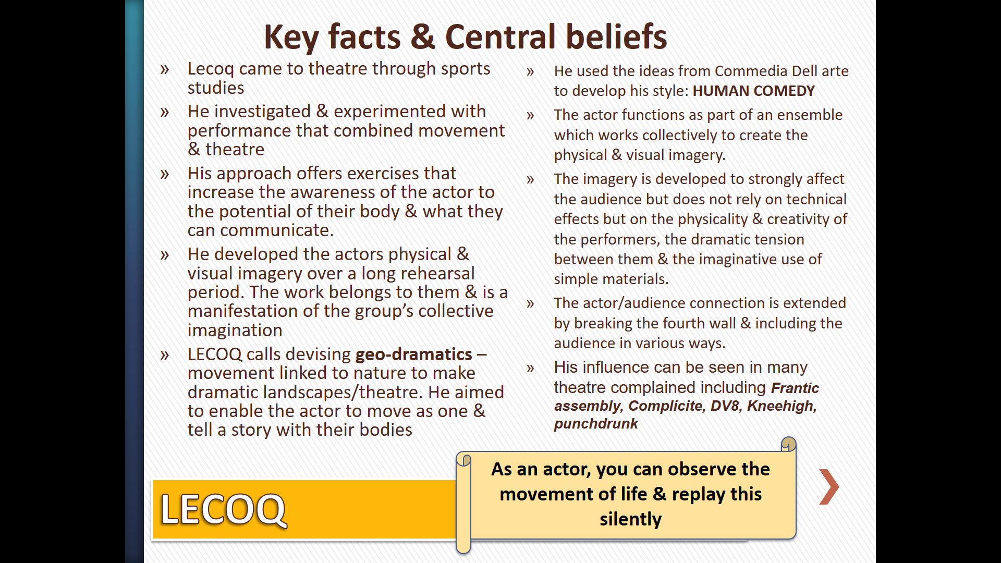
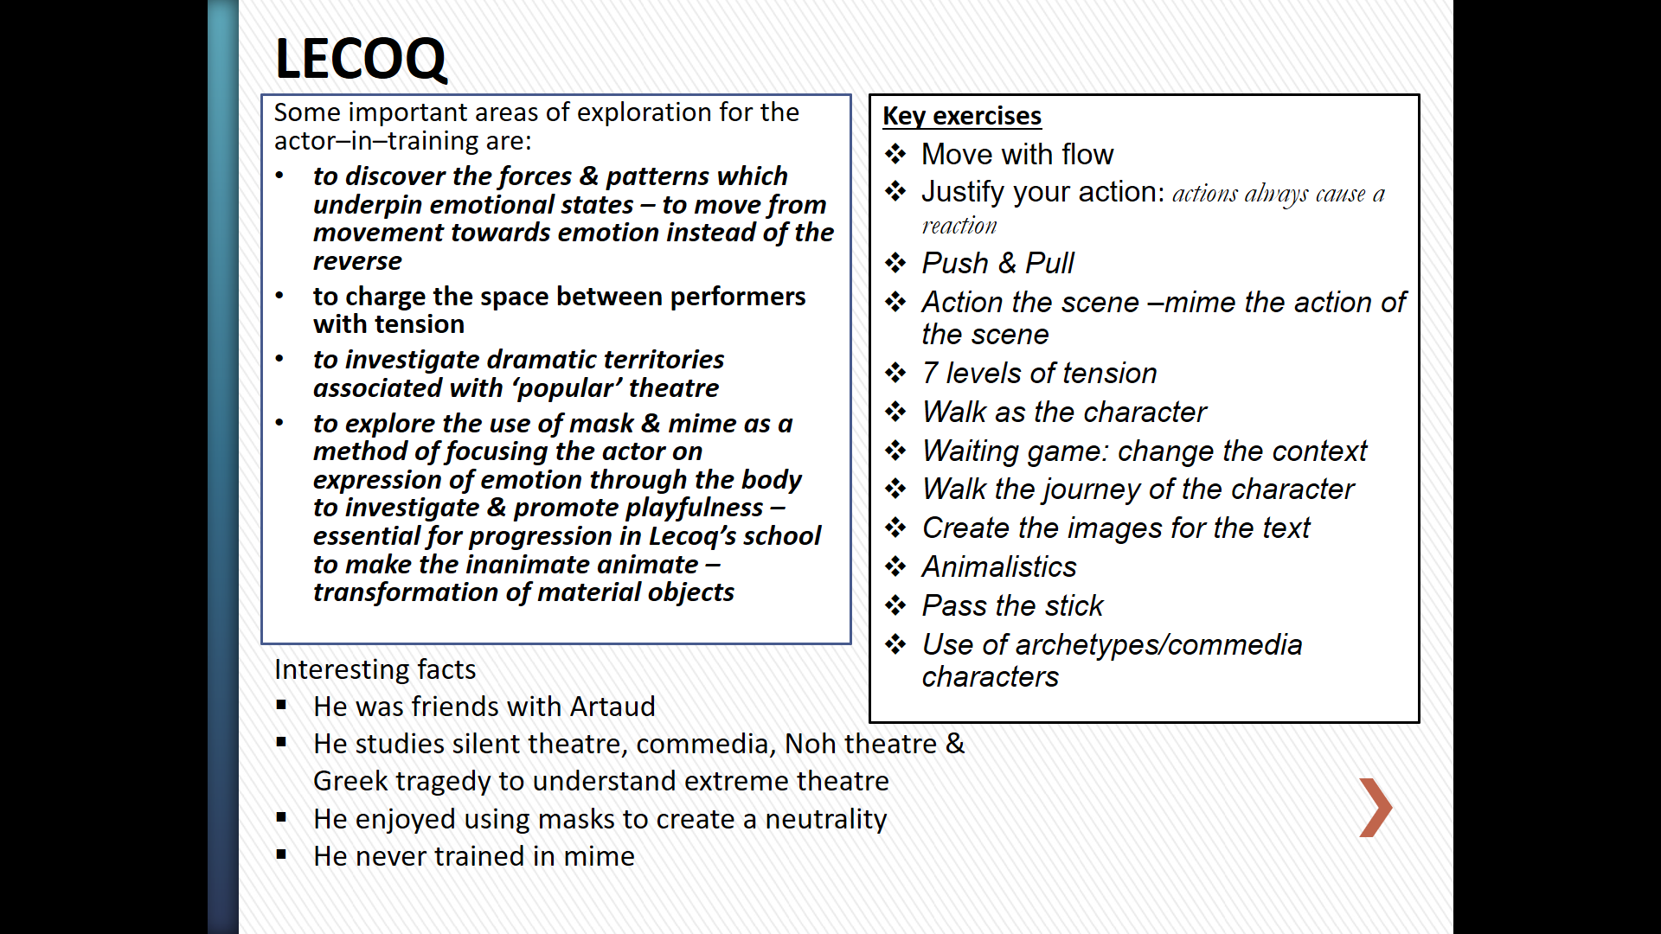

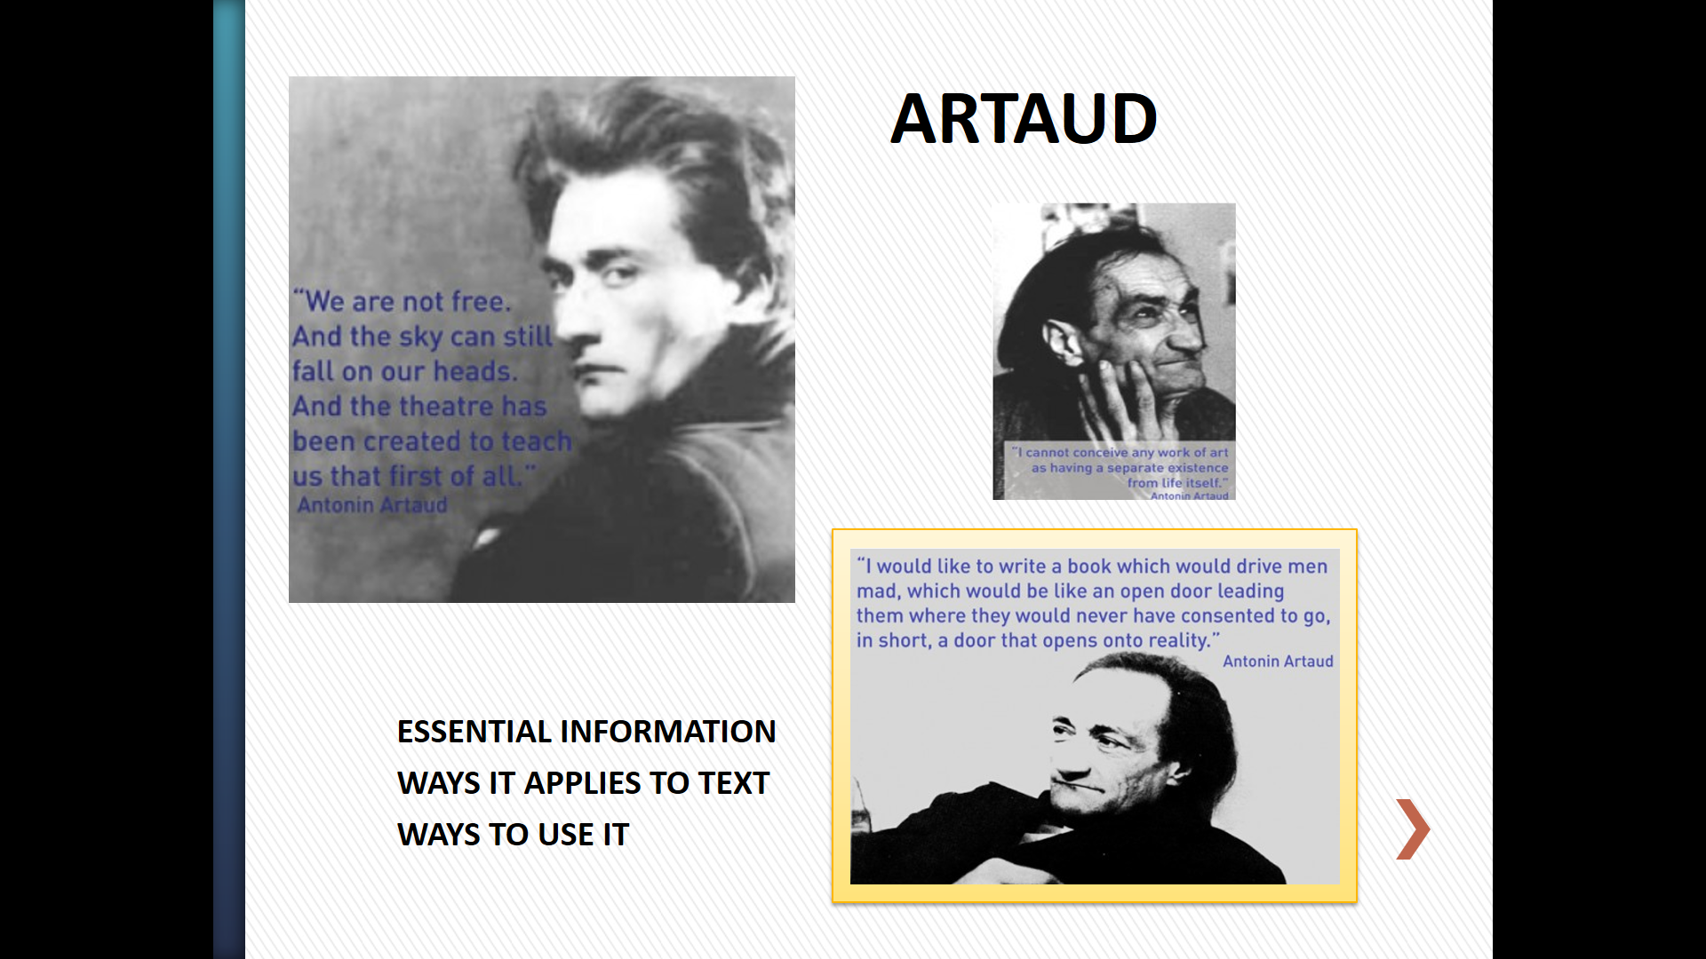
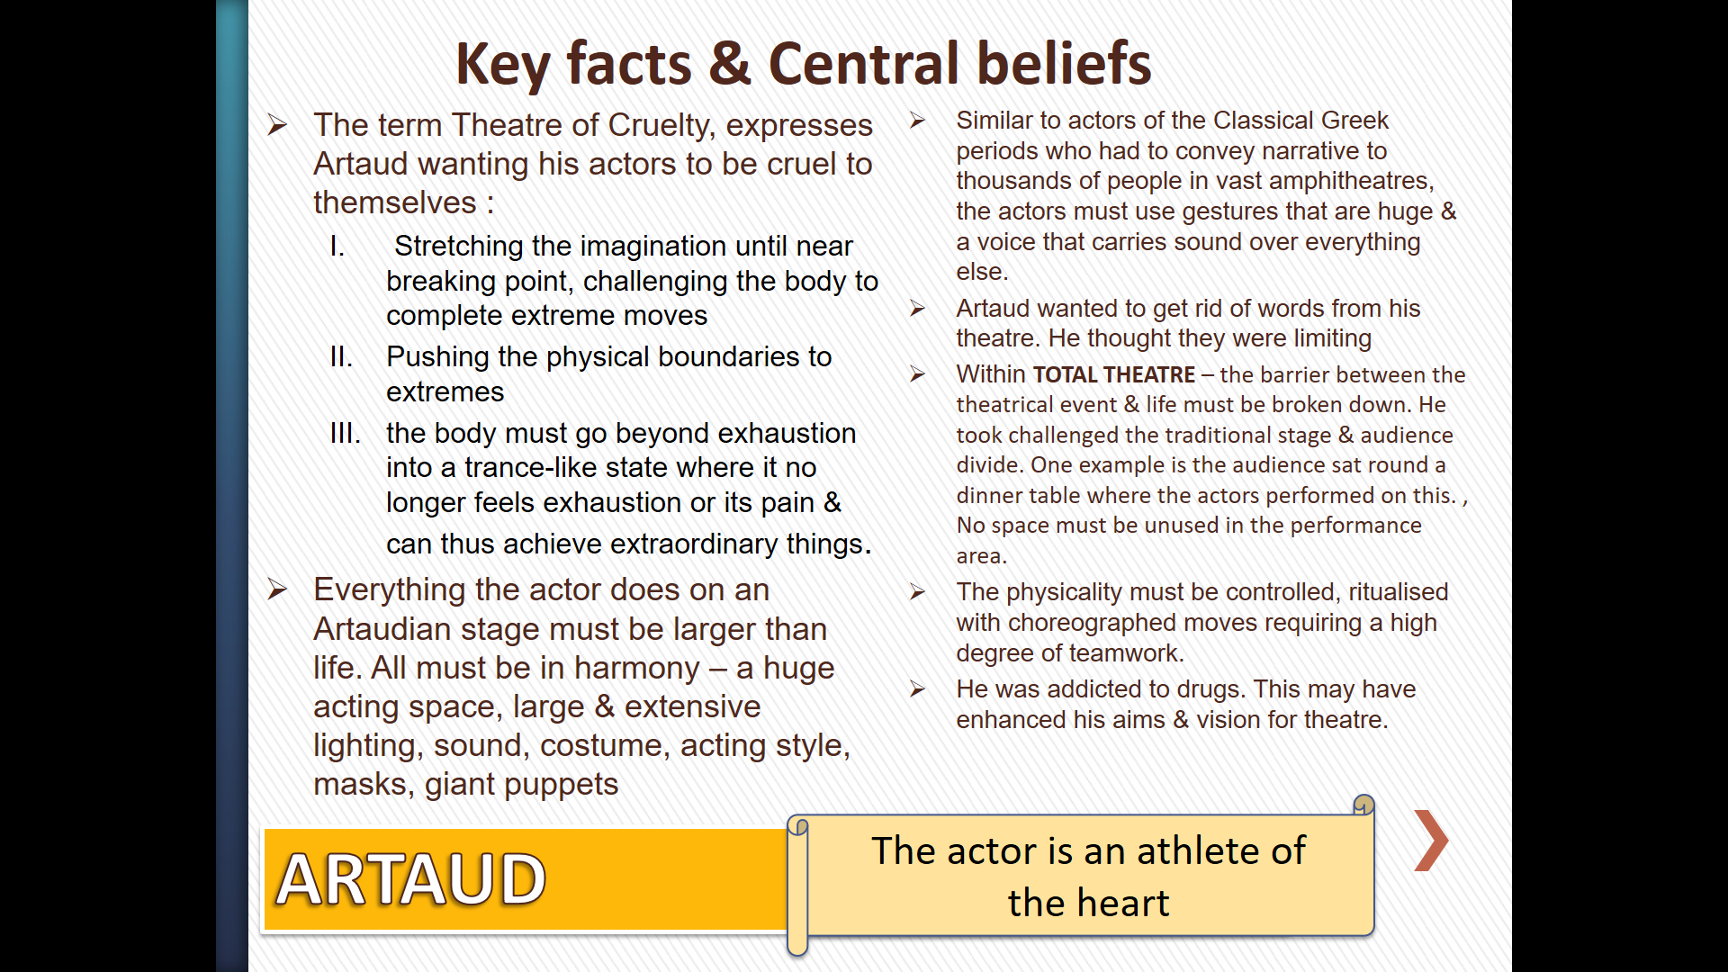

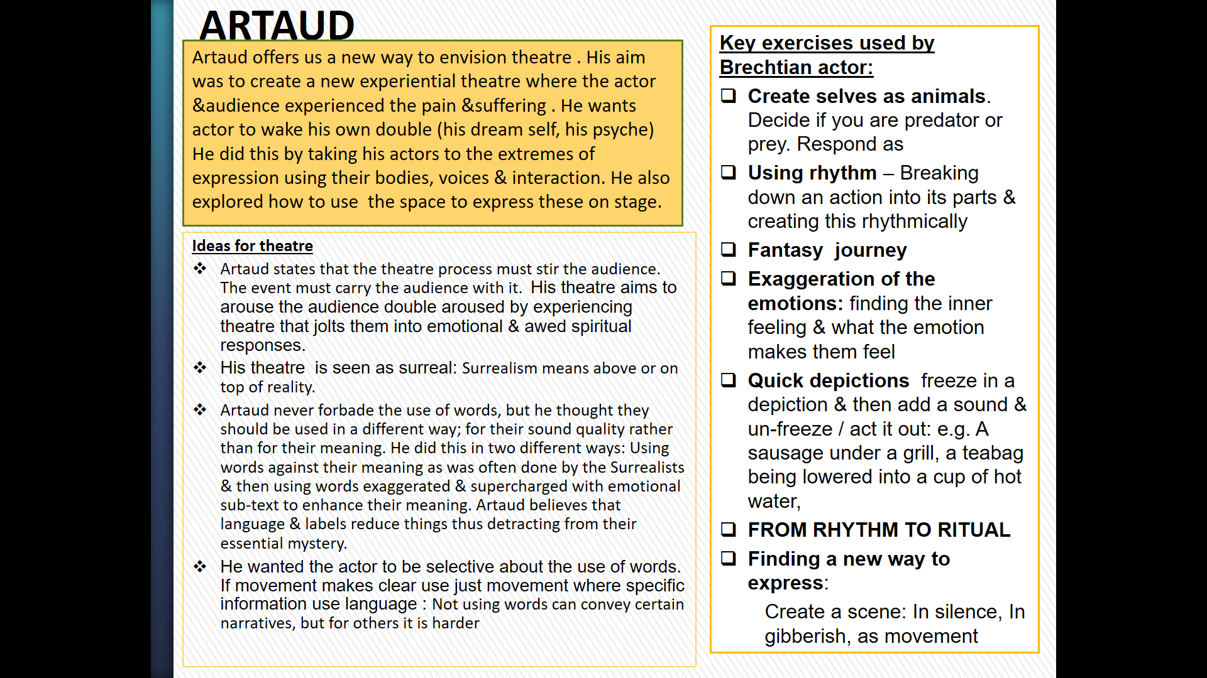
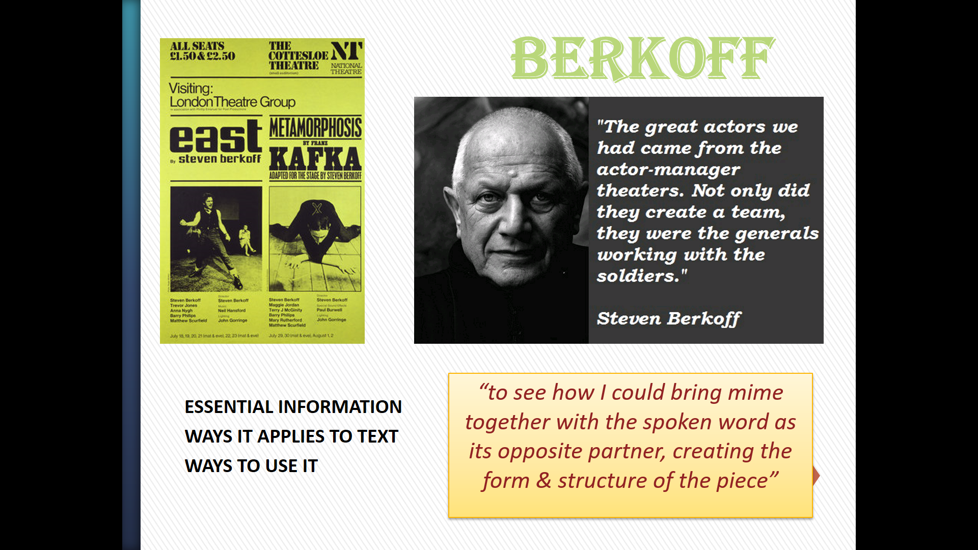

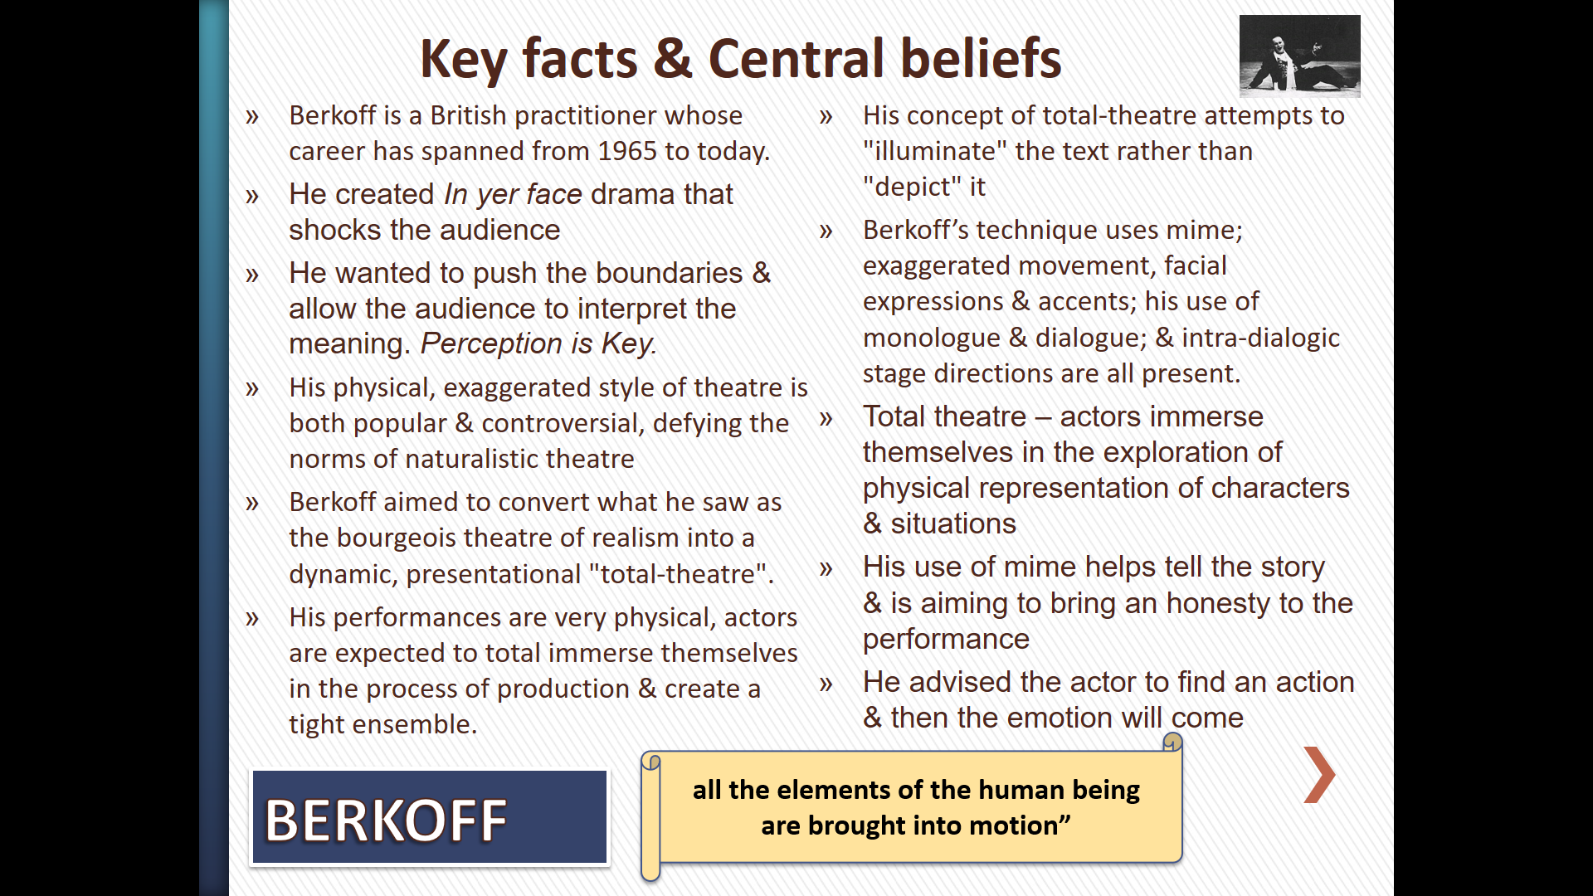

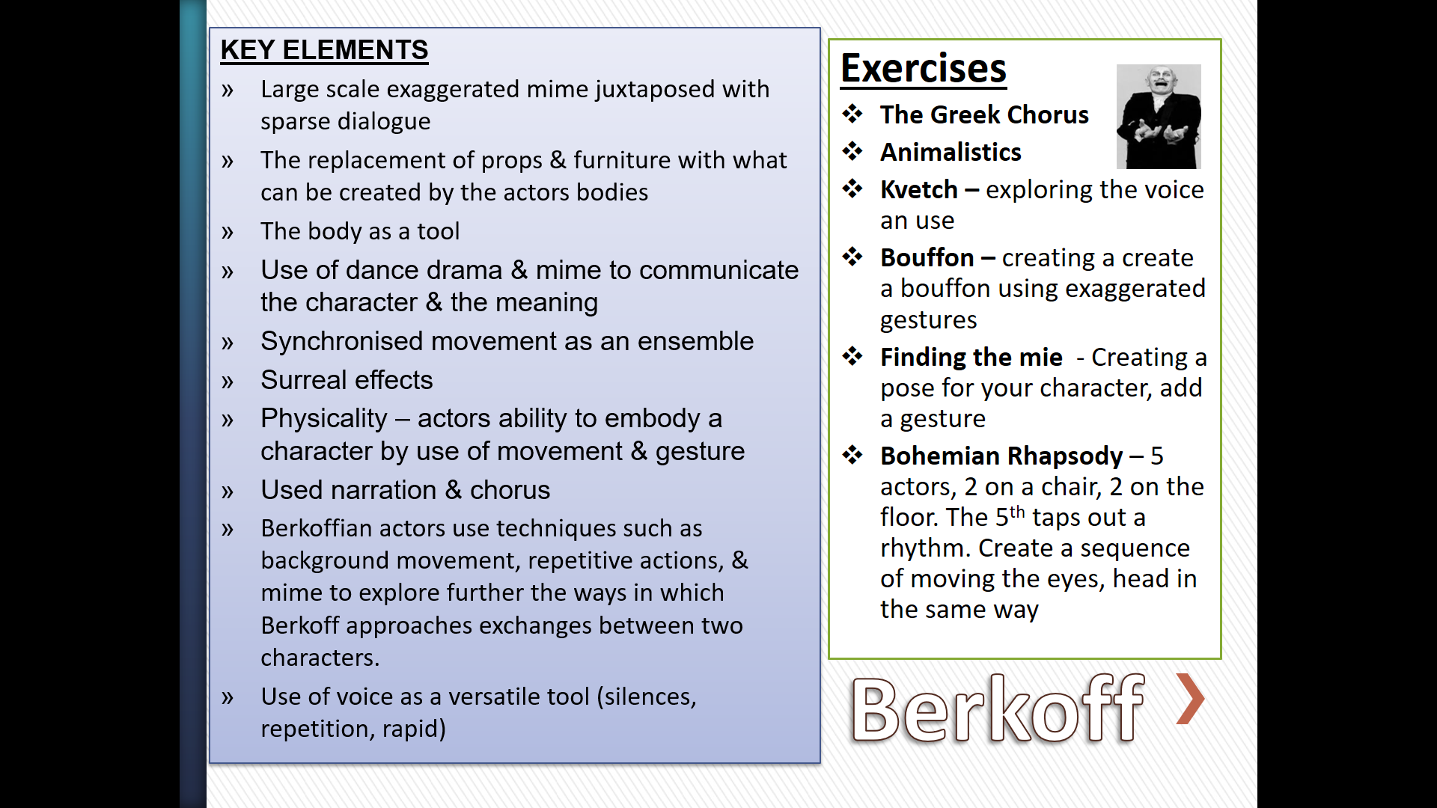

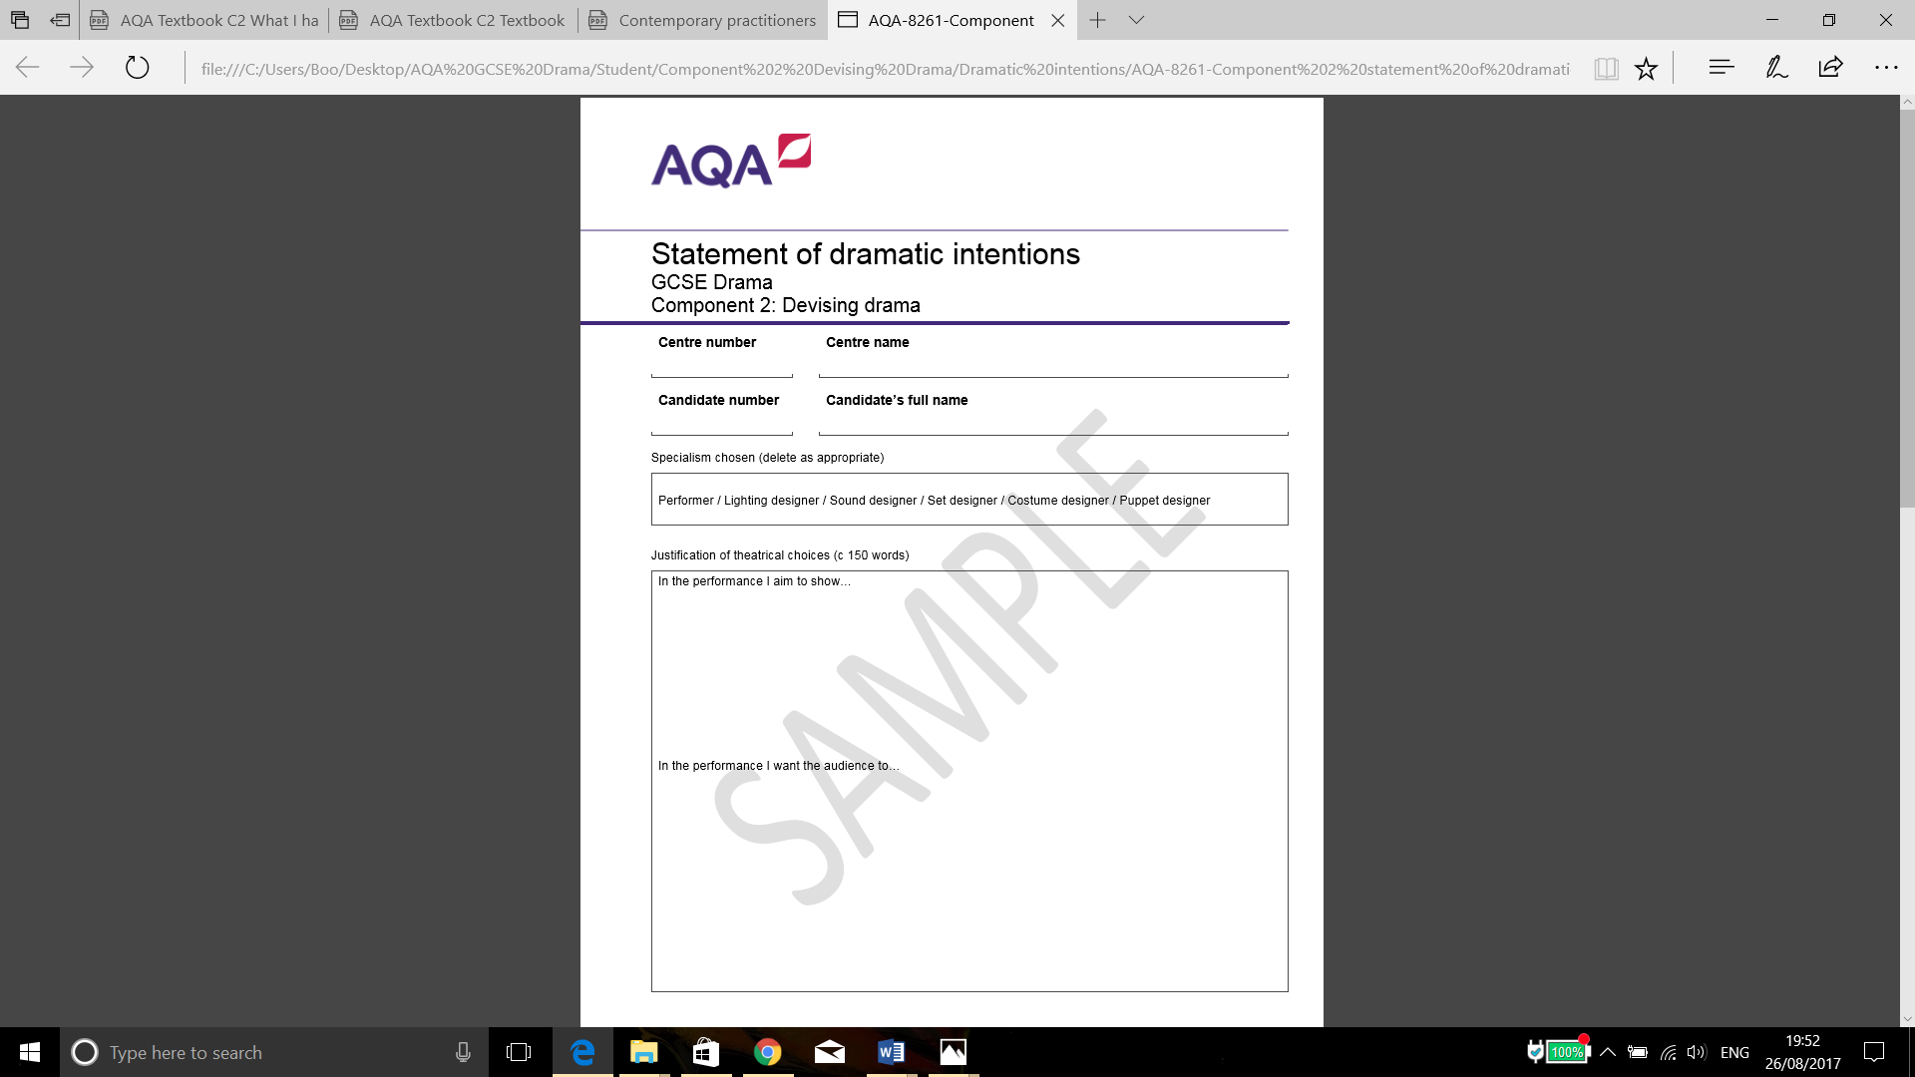
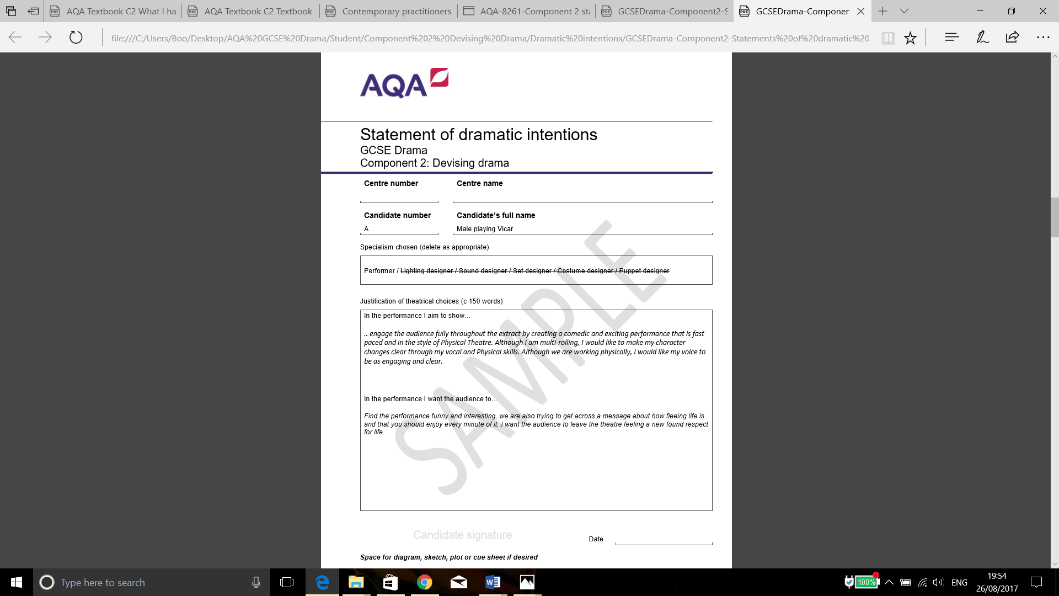
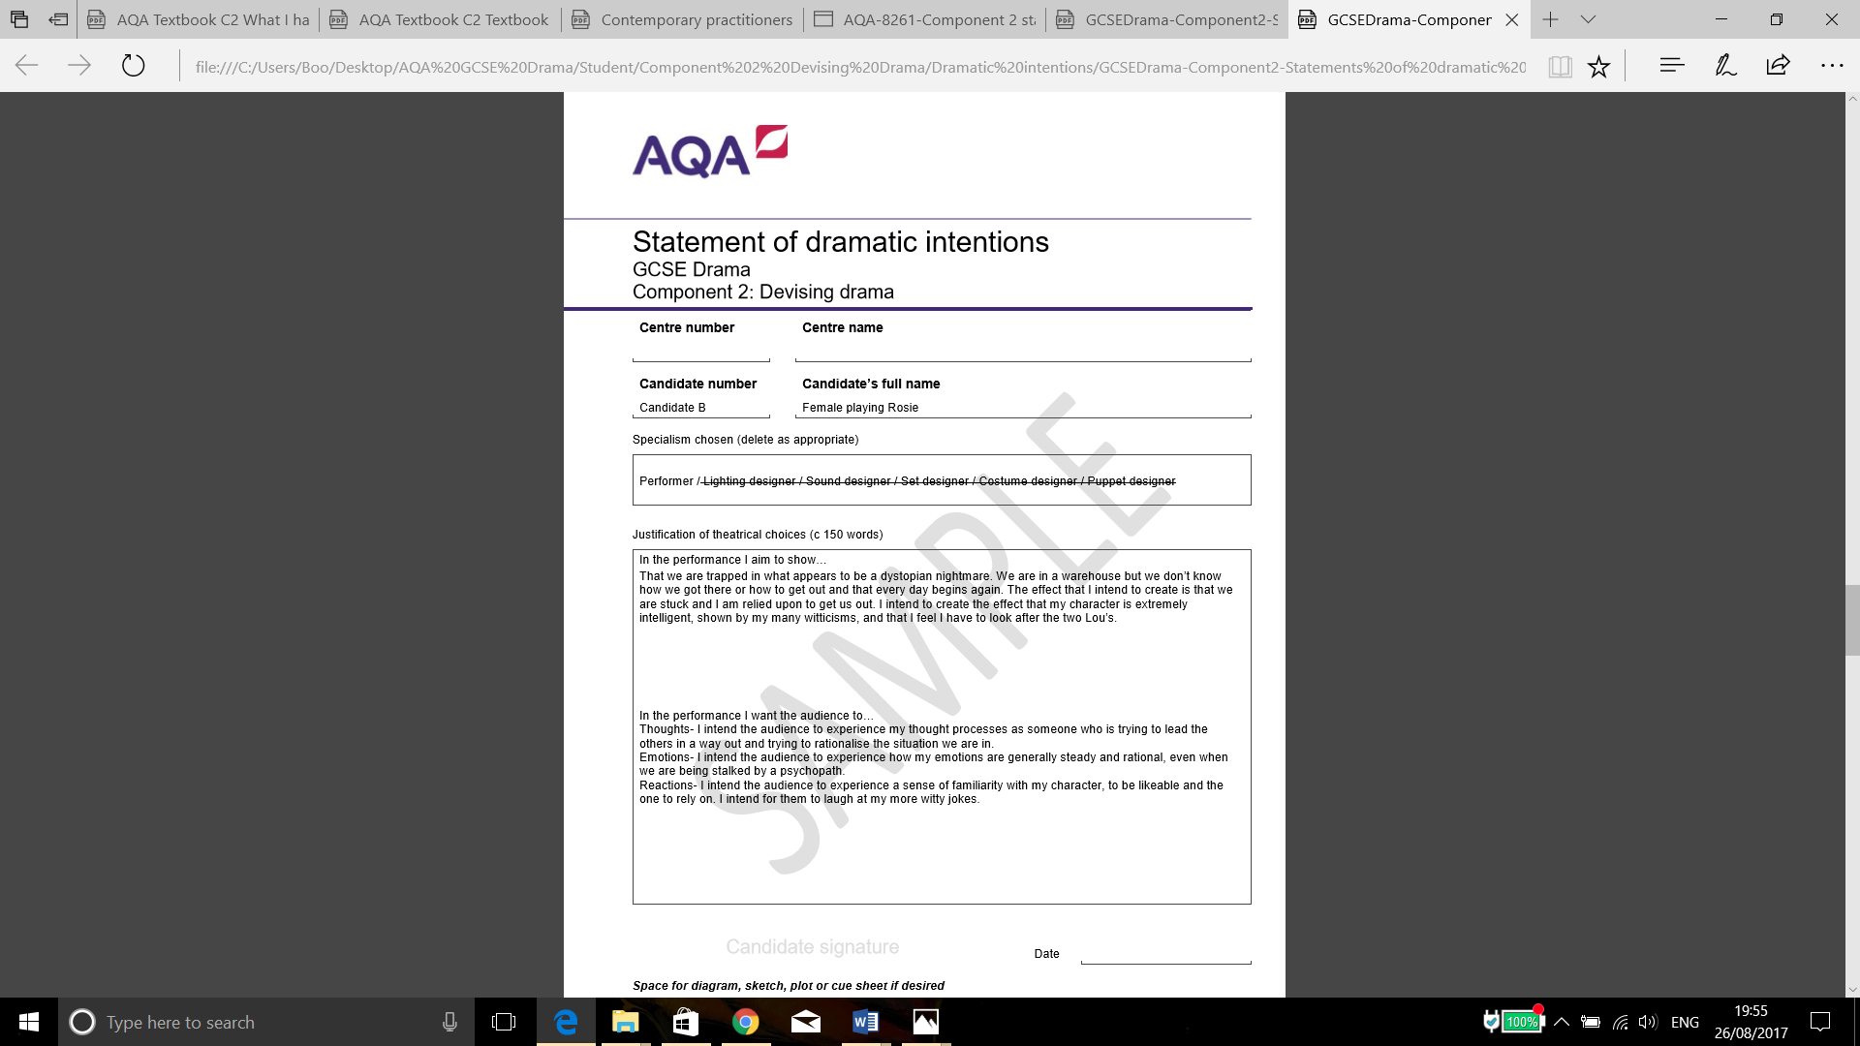
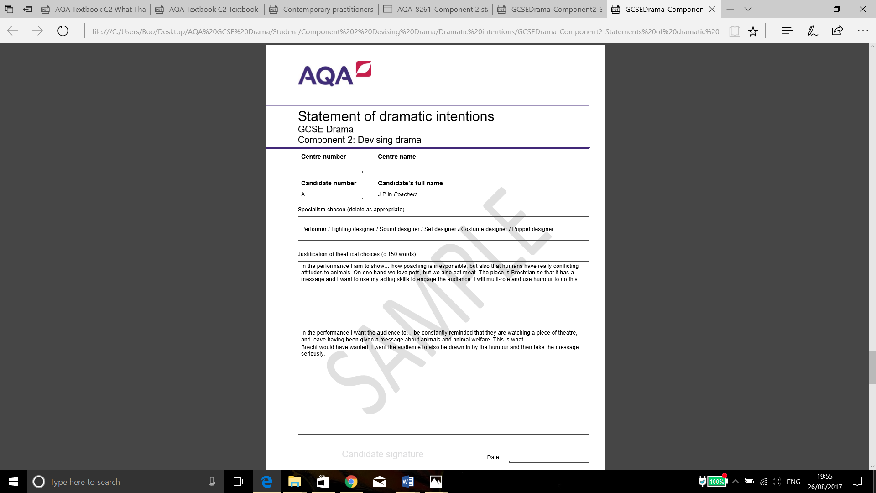
Statement of Dramatic Intentions
GCSE Drama
Component 2: Devising Drama

Name:
Specialism: Performer

In the performance I aim to show…
(Themes, message, individual role, performance skills, style, location, relationships)

_______________________________________________________________________________________
_______________________________________________________________________________________
_______________________________________________________________________________________
_______________________________________________________________________________________
______________________________________________________________________________________________________________________________________________________________________________
______________________________________________________________________________________
______________________________________________________________________________________________________________________________________________________________________________
______________________________________________________________________________________

______________________________________________________________________________________
_______________________________________________________________________________________

In the performance I want the audience to…
(Thoughts, emotions, feelings, reactions, changes, impact)

_______________________________________________________________________________________
_______________________________________________________________________________________
_______________________________________________________________________________________
_______________________________________________________________________________________
______________________________________________________________________________________________________________________________________________________________________________
______________________________________________________________________________________
______________________________________________________________________________________________________________________________________________________________________________
______________________________________________________________________________________

______________________________________________________________________________________

NEW GCSE Grades
New Grades | Old Grades
9 | A*  A
8 | A*  A
7 | A*  A
6 | B  C
5 | B  C
4 | B  C
3 | D  E  F  G
2 | D  E  F  G
1 | D  E  F  G
U | U

RULES FOR PRESENTATION OF THE DEVISING LOG
DEVISED LOG | EACH SECTION | TOTAL LIMIT
ENTIRELY WRITTEN | 400-600 WORDS | 2,500 WORDS
WRITTEN PLUS DRAWINGS, CUE SHEETS, DIAGRAMS ETC | 2-4 SIDES OF A4 | 15 SIDES OF A4

The devised performance must be between 5 and 20 minutes long.

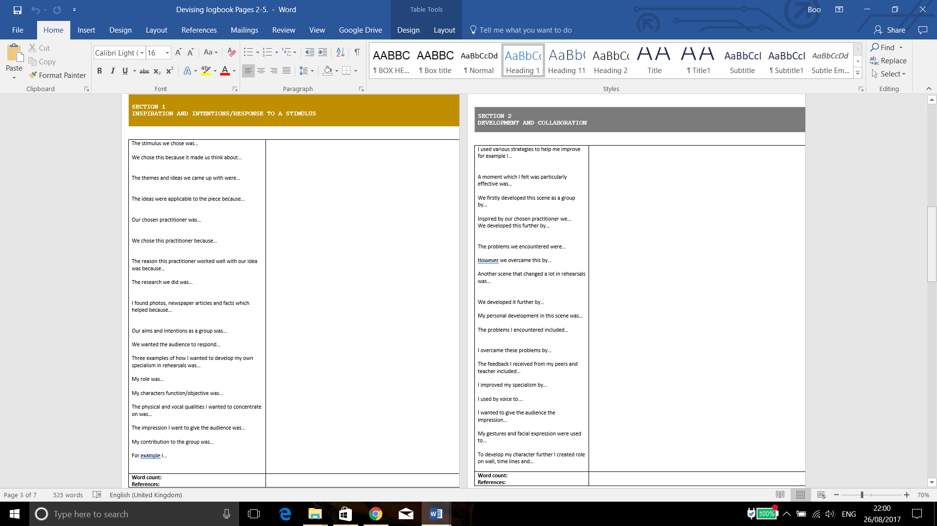
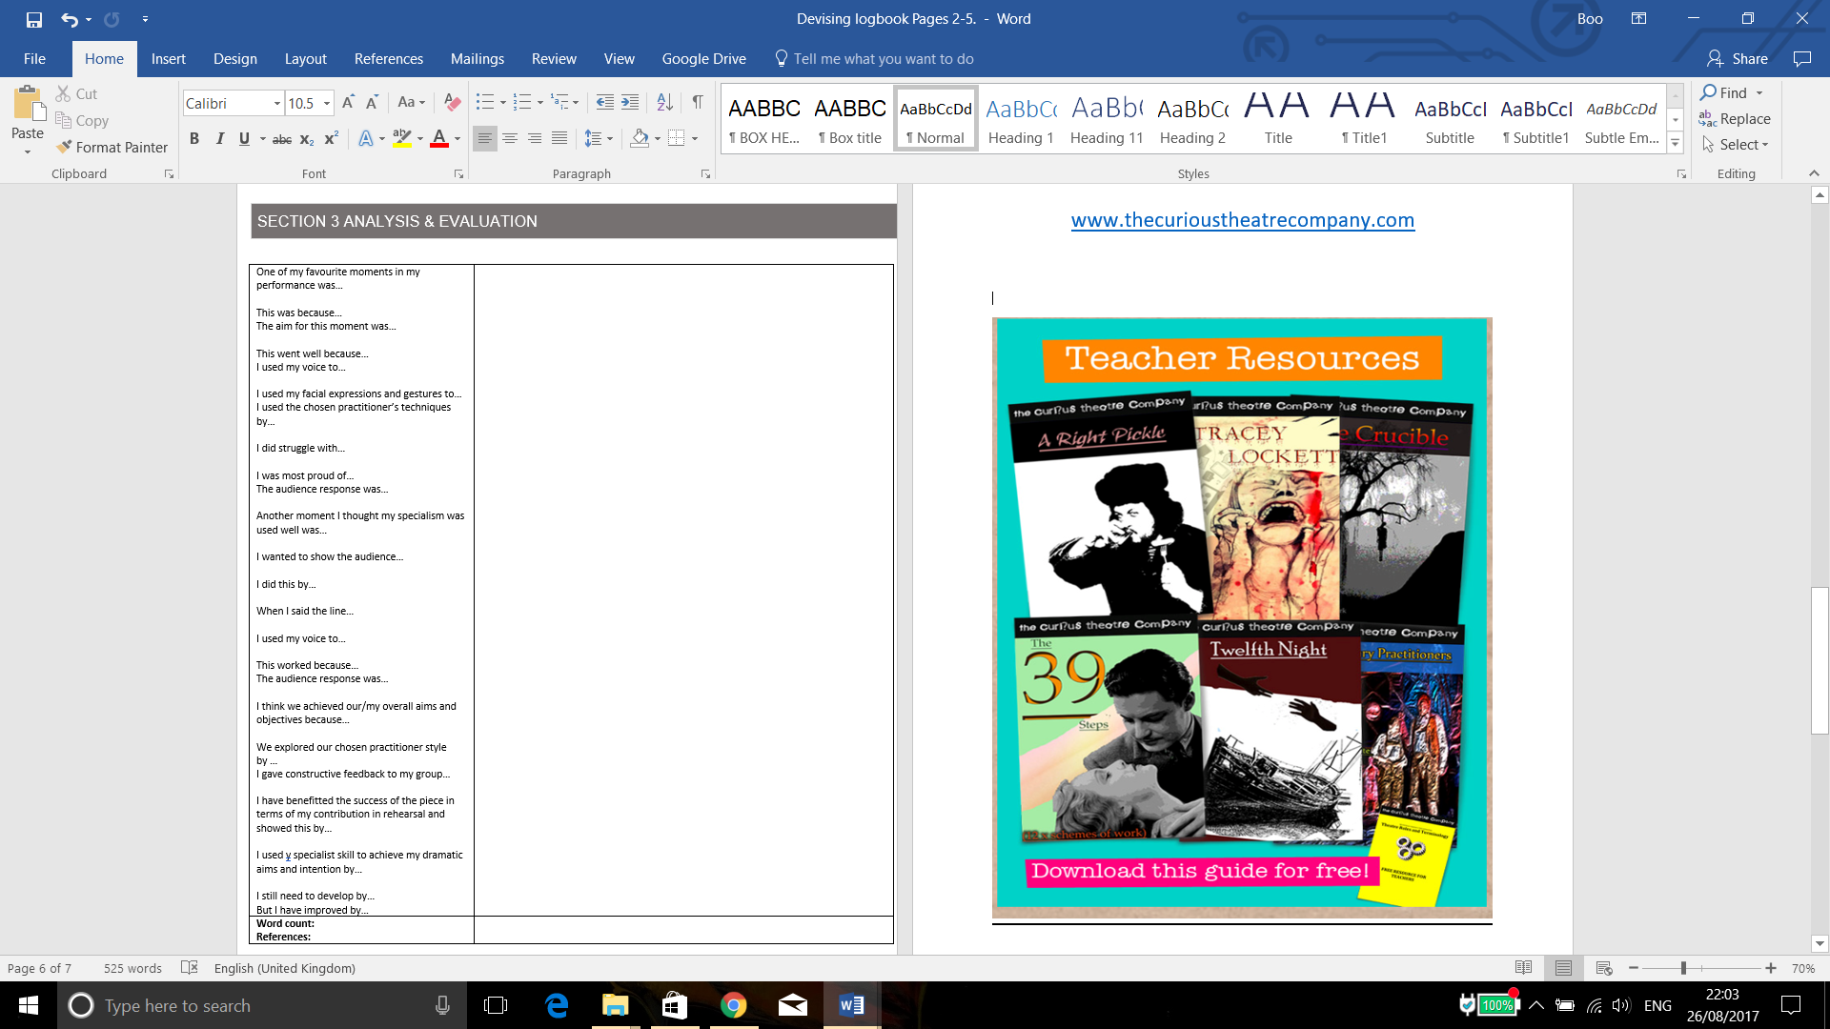
Devising Log
Section one: Response to stimulus
The stimuli that I and my group have chosen is the poem Dulce Et Decorum Est. Although we looked at many stimuli about WW1, we have chosen this stimulus because we believed that it would be the most effective one that we could base most ideas off of so that we could get lots of ideas and add them all into one more developed performance. We did also look at other stimuli including the Dulce Et Decorum Est poem, we looked at other poems from WW1, speeches of people living in WW1 and also we watched video clips to base some of our ideas off of. To help influence our ideas we did some research into the ranks in WW1 and how many men had a high rank and could control the other men. In WW1 the highest rank that you could be would be a Field-marshal who would be in charge of 2,000,000 men and had complete control of the men and determined whether the men would live or die. The lowest rank in WW1 would be the private who wouldn’t be in charge of anyone, had no power and would be told what to do and wouldn’t have any power to go against their commands.
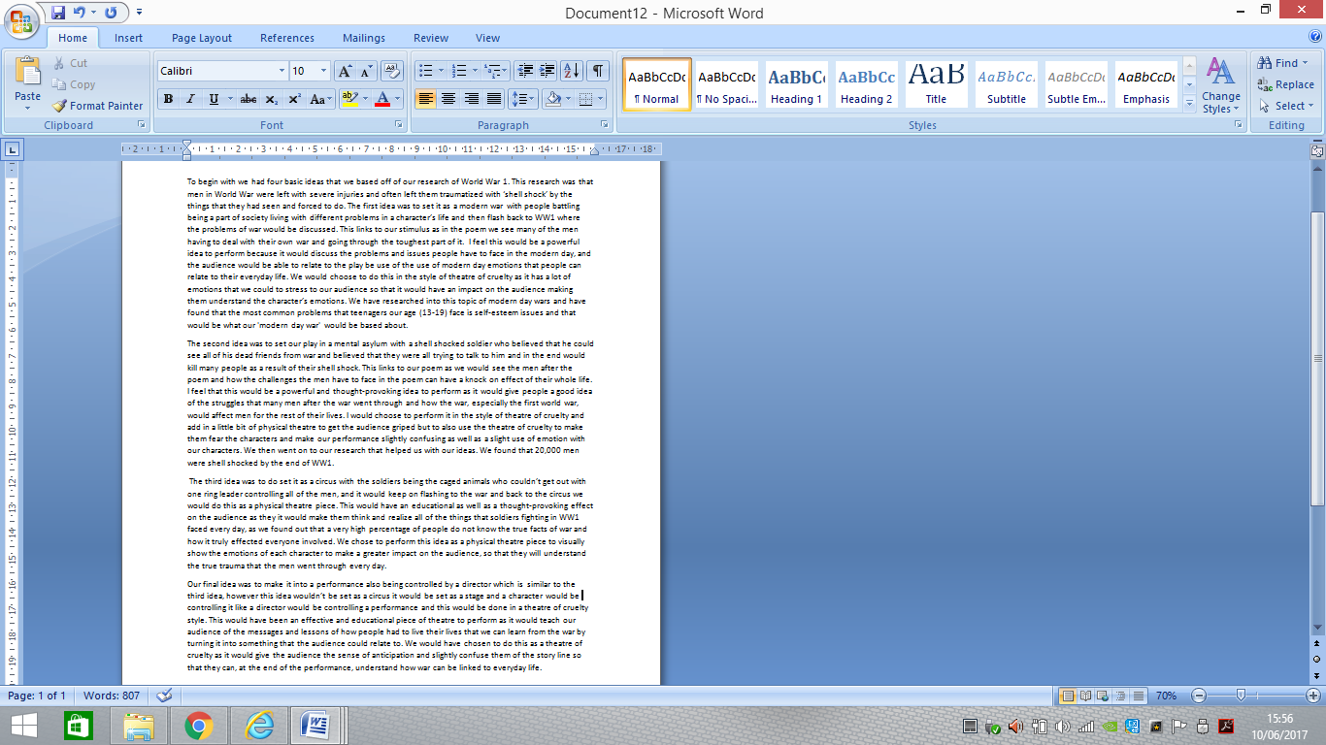
We wrote out our four potential ideas.

The idea that we have chosen is our third idea which was to set war as a circus with the soldiers represented by caged animals, controlled by the ringmaster just like the soldiers were controlled by the commander. We have chosen this idea because we believe that it has a lot of potential to high quality developed performance. We also chose it because we think that we could use both physical theatre and some theatre of cruelty to improve our performance further. This is relevant to our stimulus of war and in particularly relevant to our poem Dulce Et Decorum Est because it shows how the men in World War 1 were controlled and forced into things that they didn’t want to do just like people/animals are controlled and used in circuses. This has a strong link to our stimuli as the poem is all about the men going over the top and getting gassed on no man’s land and how they’re being made to go and die. Certain parts of the poem made us associate the soldiers with being dehumanized for example when it says 'Bent double, like old beggars under sacks, Knock-kneed, coughing like hags' and then further went on to remind us of animals being controlled to do something that they don’t want to do just like how the soldiers were being treated.
To get our ideas started off we annotated our stimuli which was the poem Dulce Et Decorum Est by Wilfred Owen. We did this to further develop our ideas and help with inspiration to get our main themes to base our four original ideas off of. From this we learnt that.
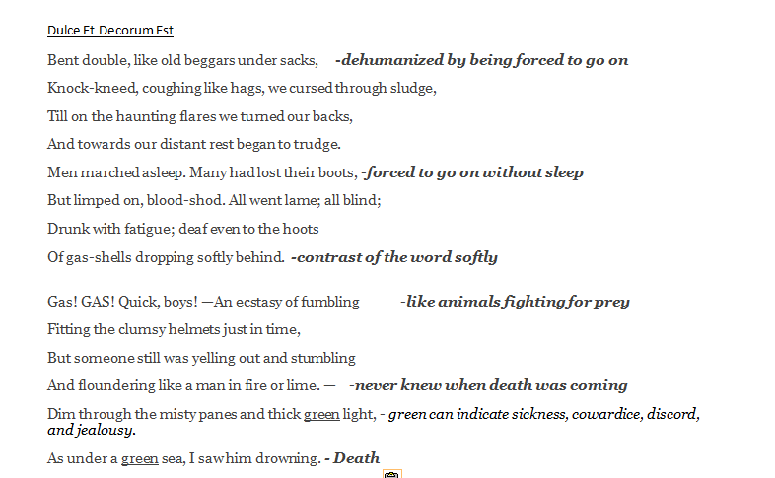
The themes and issues that we got off our annotated poem for our performance are control, force and loss. We intend to include them in our final performance by controlling our characters, using force against them to make them do things that they don’t want to do and show how loss can affect the characters all the way through the story. All of the themes of the stimuli are important to explore because it would give you more ideas to base your final performance off of and would then give you a further knowledge of our stimuli.
We have looked at many theatre practitioners and groups to inspire us to work out which styles would fit our performance best. Two of the main ones that we have looked at very closely and feel we have been inspired most is Artaud who created theatre of cruelty which is the main style that our play will be in, as well as the theatre group, Frantic Assembly who created the style of physical theatre which is where the story of a performance is shown through the movement of the body and is mostly performed with music. We watched a number of videos of their work on YouTube as well as taking part in workshops ourselves to help us understand their work and what it was and to help us further develop our ideas. We decided to use the styles created by these theatre practitioners because we felt like it was the styles that fit our story line the most but we also decided to use the work of these people because it was the type of performances that we found the most interesting and enjoyed the most so we wanted to make our play as gripping as we found other theatre of cruelty and physical theatre pieces that we have closely studied in preparation for creating our performance. We plan to meet these aims by very carefully choosing our semiotics and working together as a group to achieve our group goals.
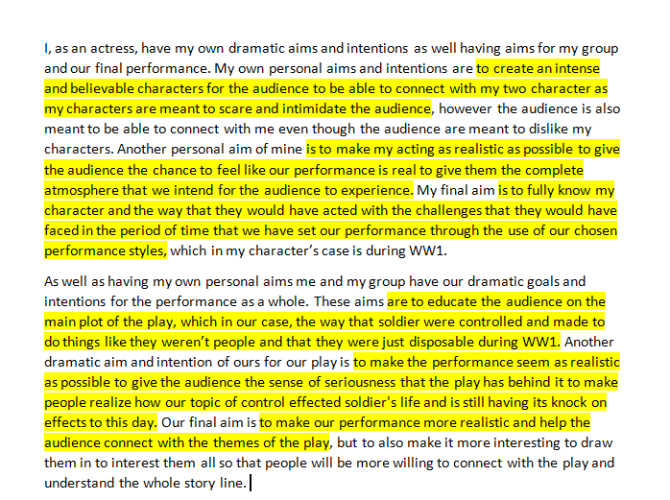
I wrote out mine and my groups intentions and how I intend to meet them to help bring structure to our rehearsals process.

Section 2: development and collaboration
The characters that I am playing in our performance are, in the war scenes, field marshal and in the circus scenes I’m playing the ring leader of all of the ‘freaks’. I am very controlling to all of the characters especially Demi’s character as she is the lowest ranking out of all of the characters. To further understand my characters we wrote out our objectives by Stanislavski and I learnt that my purpose in the play is to.
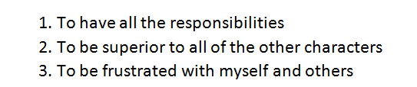

This developed how I present my character by me understanding my characters intentions and understand how they would react to certain things at certain times throughout the performance. Whilst developing my character we also did a role on the wall. This is where all of my characters true identity is in the inside of the man and his identity that people see is on the outside.
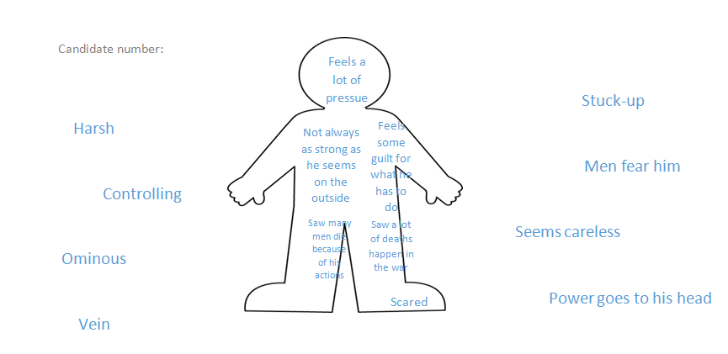
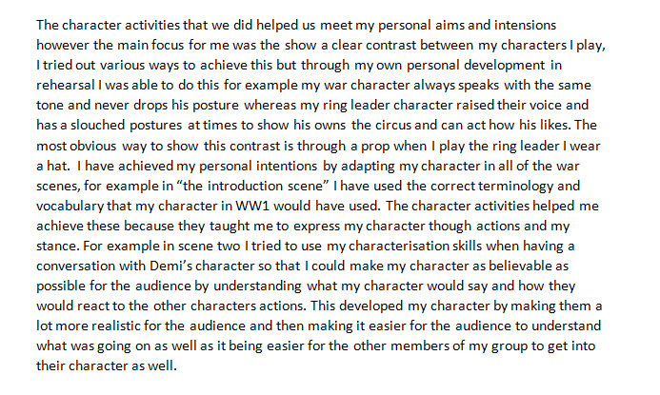
To show that my character is controlling and dominating I am going to always use a loud angered voice to scare my audience and make my character clear so that the other characters can react realistically to my actions. This has helped develop my character in the context of the play because it helps the other characters react to mine so that the audience can fully understand the concept of our play and the message of control that we are trying to show. I have used what I have learnt throughout the characterisation tasks to progress my character and getting the characterisation right. For example in the first scene the reaction of the other characters when my character comes in shows the audience the relationship between them all and how they fear my character. We experimented different ways to show this however with both characters we felt the most effective ways was for the other characters to not have eye contact with my and to only speak and move on command form my character.
I have kept a development log of how I have met my personal intentions
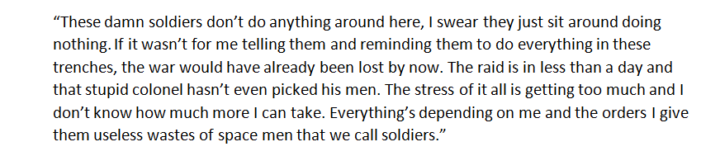
One of character building activities was to writing in role of our character for 3 minutes in our opening scene, and this what I wrote:

From this activity, I have learnt the actions and mindset of my character to then be able to make my character be more angry and aggressive to the other characters in the performance. It also gives me the ability to understand my character further so I can then exaggerate it for the audience so that they can understand the amounts of pressure that my character is under, and to understand my character more throughout the performance. For example in scene four, the 'killing scene' I used this exercise to help me give the audience a sense of what my character is going through and to show that I am under pressure so that they get to see another side of me as my true emotions are coming out.
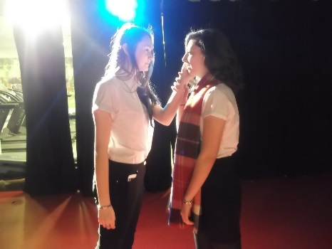
One scene that has changed the most whilst going through the process of trying to follow our chosen structure is the 'killing scene'. Whilst trying to create this scene the placement of where it would be placed around all of our other scenes has changed a few times because we have been trying it in different places to see where the past place for it would be for the greatest amount of drama and tension for the audience to experience. To start with this scene was originally set to be at the end of the whole performance, however after analyzing our performance we decided that that was not the most suitable place for it to go if we wanted to obtain greatest amount of tension build up possible. After realising this we went back and re-arranged all of our scenes practicing it with our 'killing scene' in different places. After taking our time and watching it over we decided that it would be best for us to have it half way through our piece and using a flashback to tell the rest if the story would be the best way to create the highest amount of tension for the audience to enjoy. Using both of our chosen styles has helped our group develop and refine our work. One specific example of this is when we are using physical theatre to show what are charters are thinking in their heads at certain times of the performance. This gives the audience a chance to really understand the characters and their emotions towards the other characters throughout the entire performance. Another example of this is when we use theatre of cruelty in the scene where I am going to kill Demi's character, in this scene we use a lot of loud screams and shouting throughout that scene to intimidate the audience and play with their emotions to allow them to feel the same pain and anger that the characters in the performance are using as well as interacting with the audience at times too. This has helped develop our performance because by communicating with the audience in this scene, it is adding another element to our performance making it more interesting for the audience. For example in the 'killing scene' and in the 'opening scene'.
There is many changes that we had to make during the rehearsal process, however one specific moment that had to be changed because of the performance styles that we have chosen is 'love scene' between my character and Demi's character. At first this scene was going to be performed as a sort of naturalistic scene, but once we had decided that we were going to add elements of physical theatre in our performance also we decided that it would be more effective and gripping if we performed it as a physical theatre piece. We went back over this scene and choreographed it so that we can show the love between both of the characters and the dejection, heartache and grief that Demi’s character is going through with each movement that we perform. Whilst rehearsing our performance we took into great consideration of our proxemics so that the audience can further understand the relationships between the characters. Throughout the performance we have used the spacing between each character to clearly show the audience the different relationships between each character. An example of this is between mine and Demi’s character as throughout the performance we have always had Demi’s character trying to get closer and closer to me as he is in love with me however you will also notice that my character is trying to avoid Demi’s character and have as much spacing between them as possible. This impacts the audience as they will notice the amount of spacing that we try to maintain throughout the play, making it easy for the audience to get a better understanding of the characters and the relationship that they have between one another but also links to our intention and theme of control.

Section 3: analysis and evaluation
In the final performance I think that our group has achieved all of our aims and intentions because we performed an educational play that was realistic for the audience so that they can connect to the characters to give them a wider understanding of what the men during WW1 had to go through. We did this by using real characters that were actually in both the war and the freak show during the First World War. We also performed a thought provoking abstract performance to add to the interest of the audience. We also wanted to use many different kinds of theatre to show all of our themes and issues in a way that would intrigue and interest the audience. We have successfully done this by using both theatre of cruelty and physical theatre for example when mine and Demi’s character did our physical theatre piece to further show the relationship that they both shared and I the final scene when I was integrating Demi’s character in the style of theatre of cruelty make it more interesting for the audience and to give them a real feeling of what it was like for the characters to make it as realistic as possible. I think we have successfully met all of our initial intentions by doing all of these in our final performance.

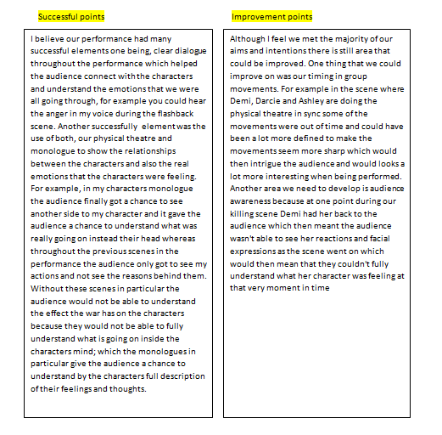
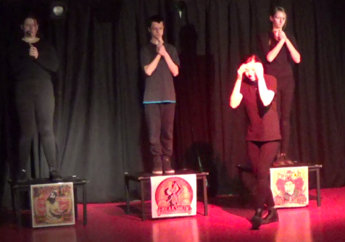
Overall in the end performance I think that I have met the majority of my personal aims and intentions by creating an intense and believable characters that could potentially scare and intimidate the audience at points in the performance, for example in the final scene when I killed Demi’s character. As well as this I also wanted to give the audience a change to be able to connect with my character even though they were meant to dislike my character. The audience had a chance to do this in my monologue scene when I had the chance to express my true feelings that my character had been hiding throughout the performance. Another one of my intentions was to create a realistic characters by making my acting realistic and by fully knowing my character and the way in which they would react to certain parts in the performance, which I tried my hardest to do by getting to know my character through characterization however it could be argued that I could have done this more which could have further enhanced the audiences interest in my characters and the other characters in my group. From reviewing my performance I believe I focused more on creating a realistic character for my ring leader character and the contrast to my war character wasn't always clear. I could have a deeper voice and more exaggerated movements to show how important and power men who are a high rank were in the War. I feel our performance had many successful elements through the feedback that we received from my peers and the rest of my group. For example showing the different ranks by using different levels was successful because it gave the audience a chance to know our characters ranks from the opening scene which also enhances my control that I have over the other characters to set the scene, which is shown here in scene 1.
To complete my evaluation I wrote out the successful points of our performance alongside one areas for improvement.

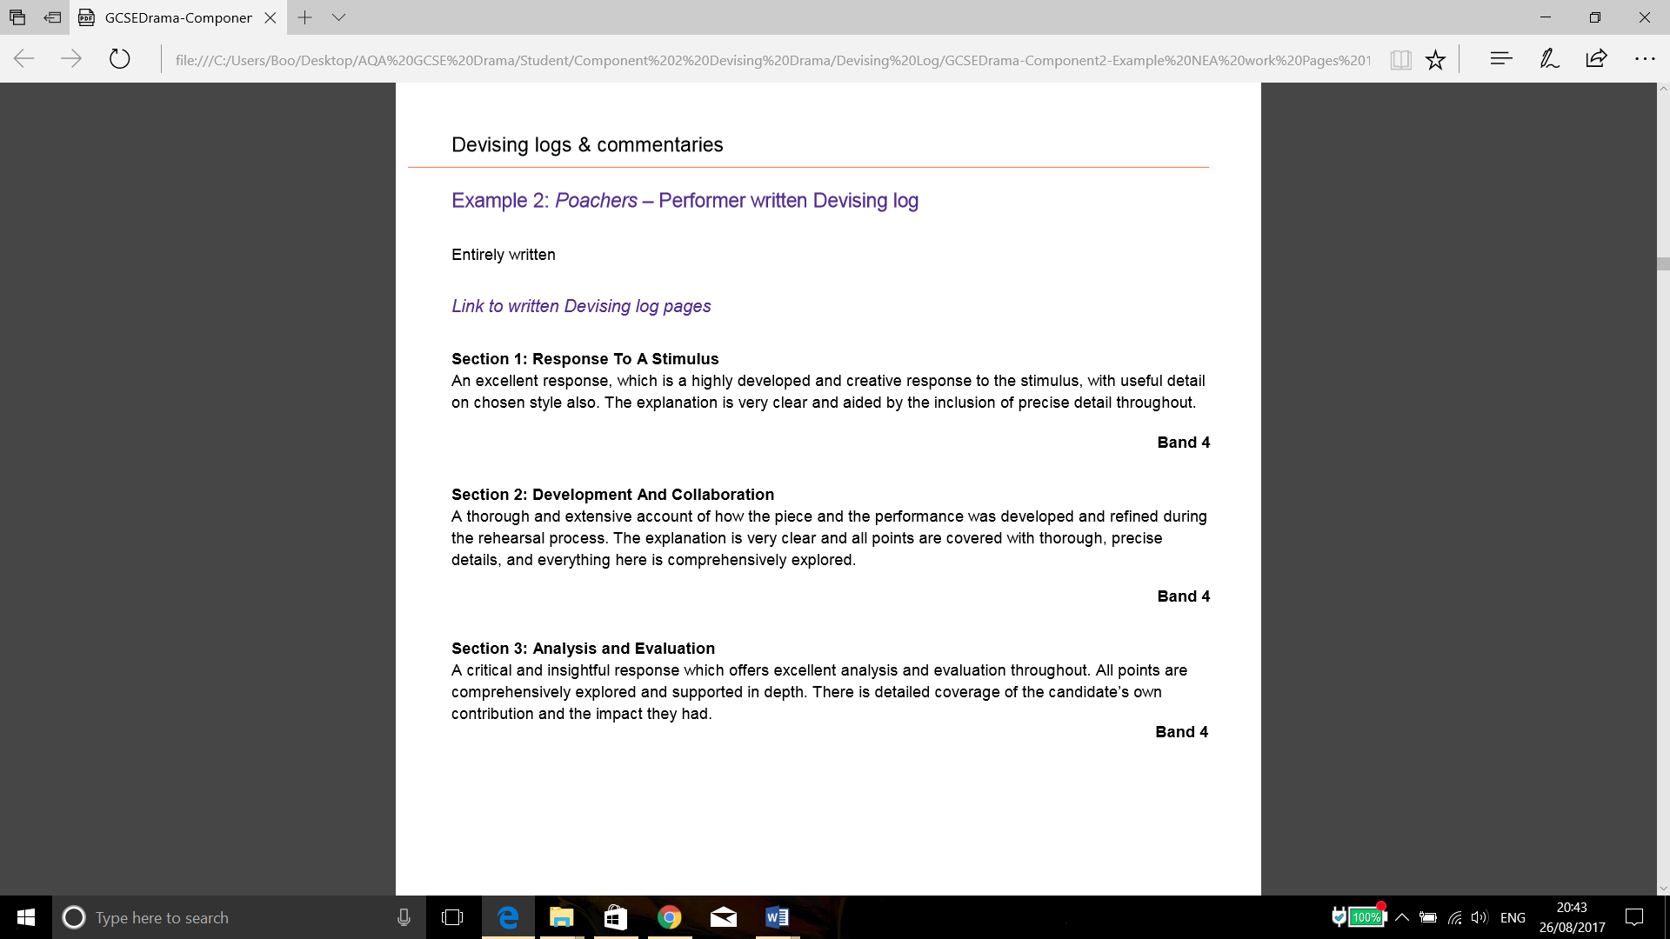
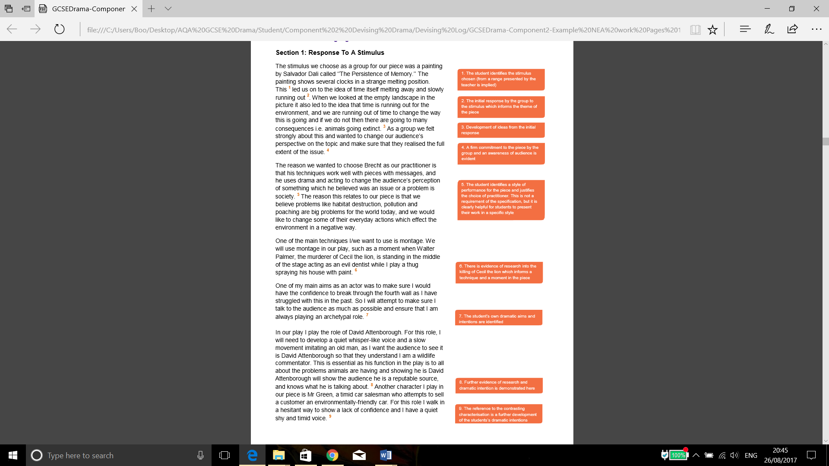
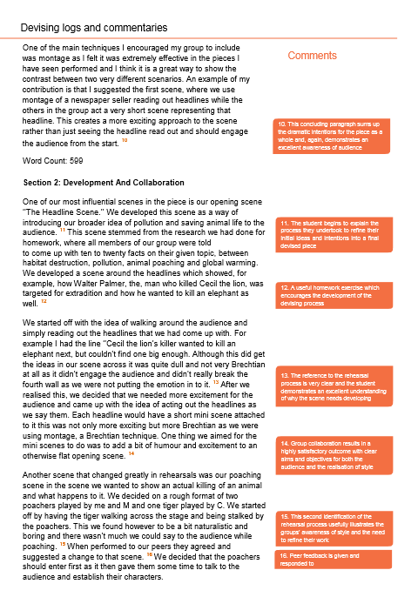
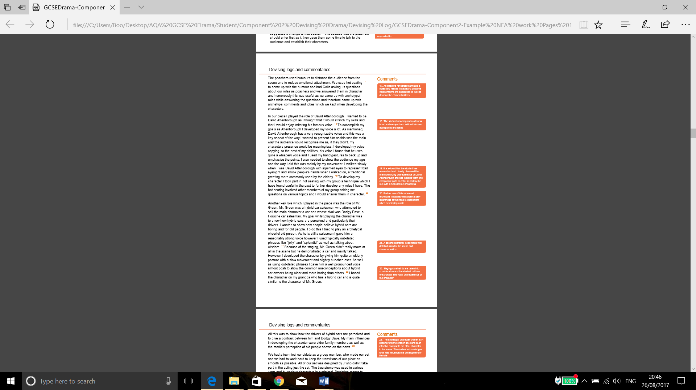
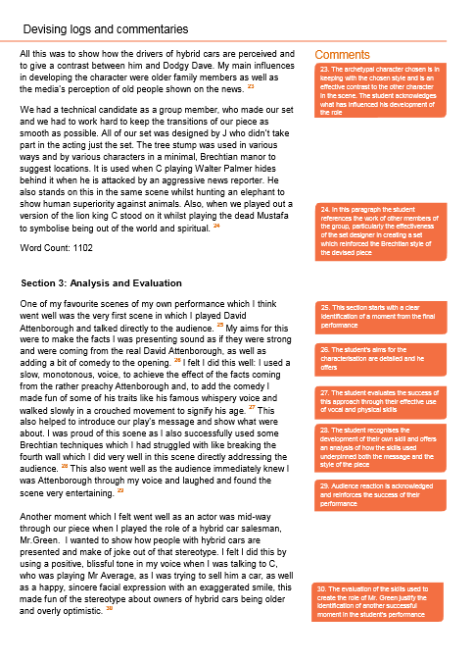
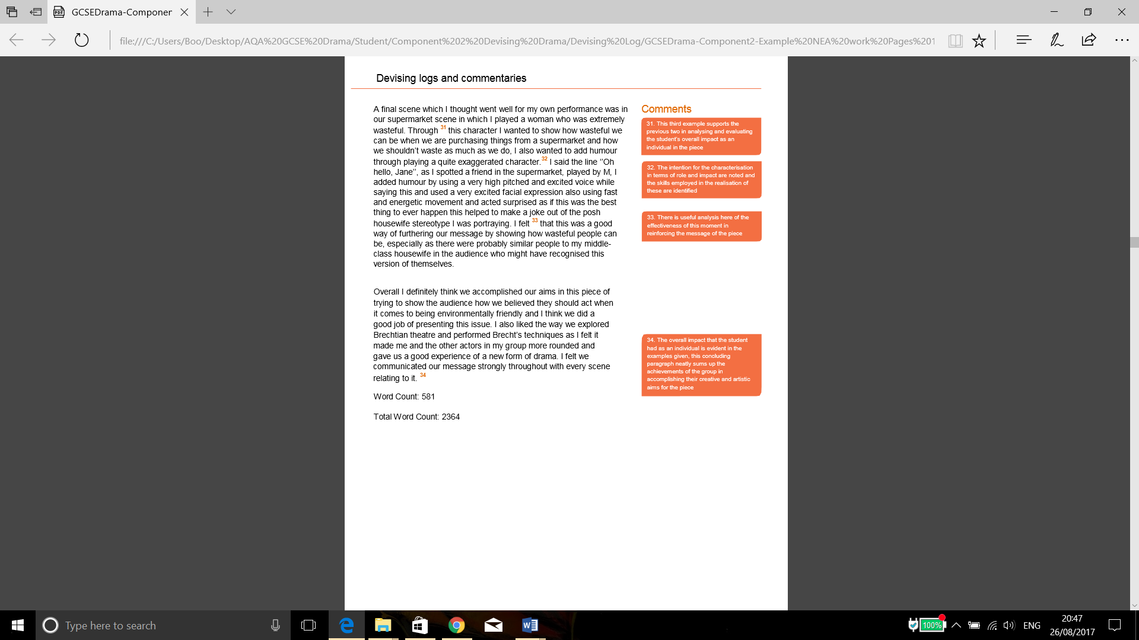
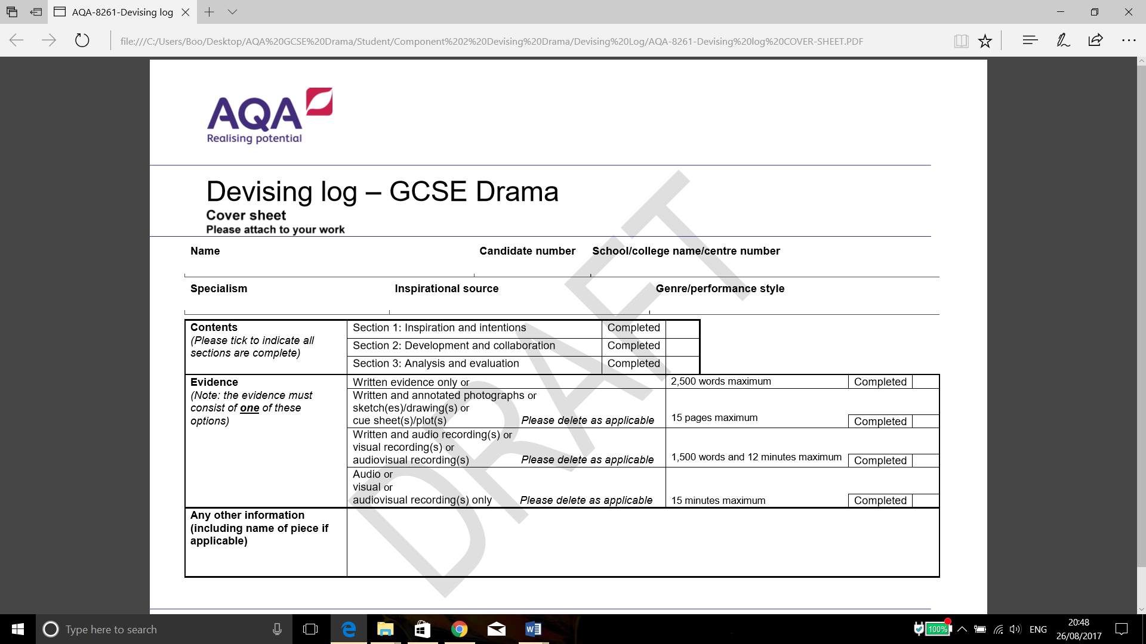
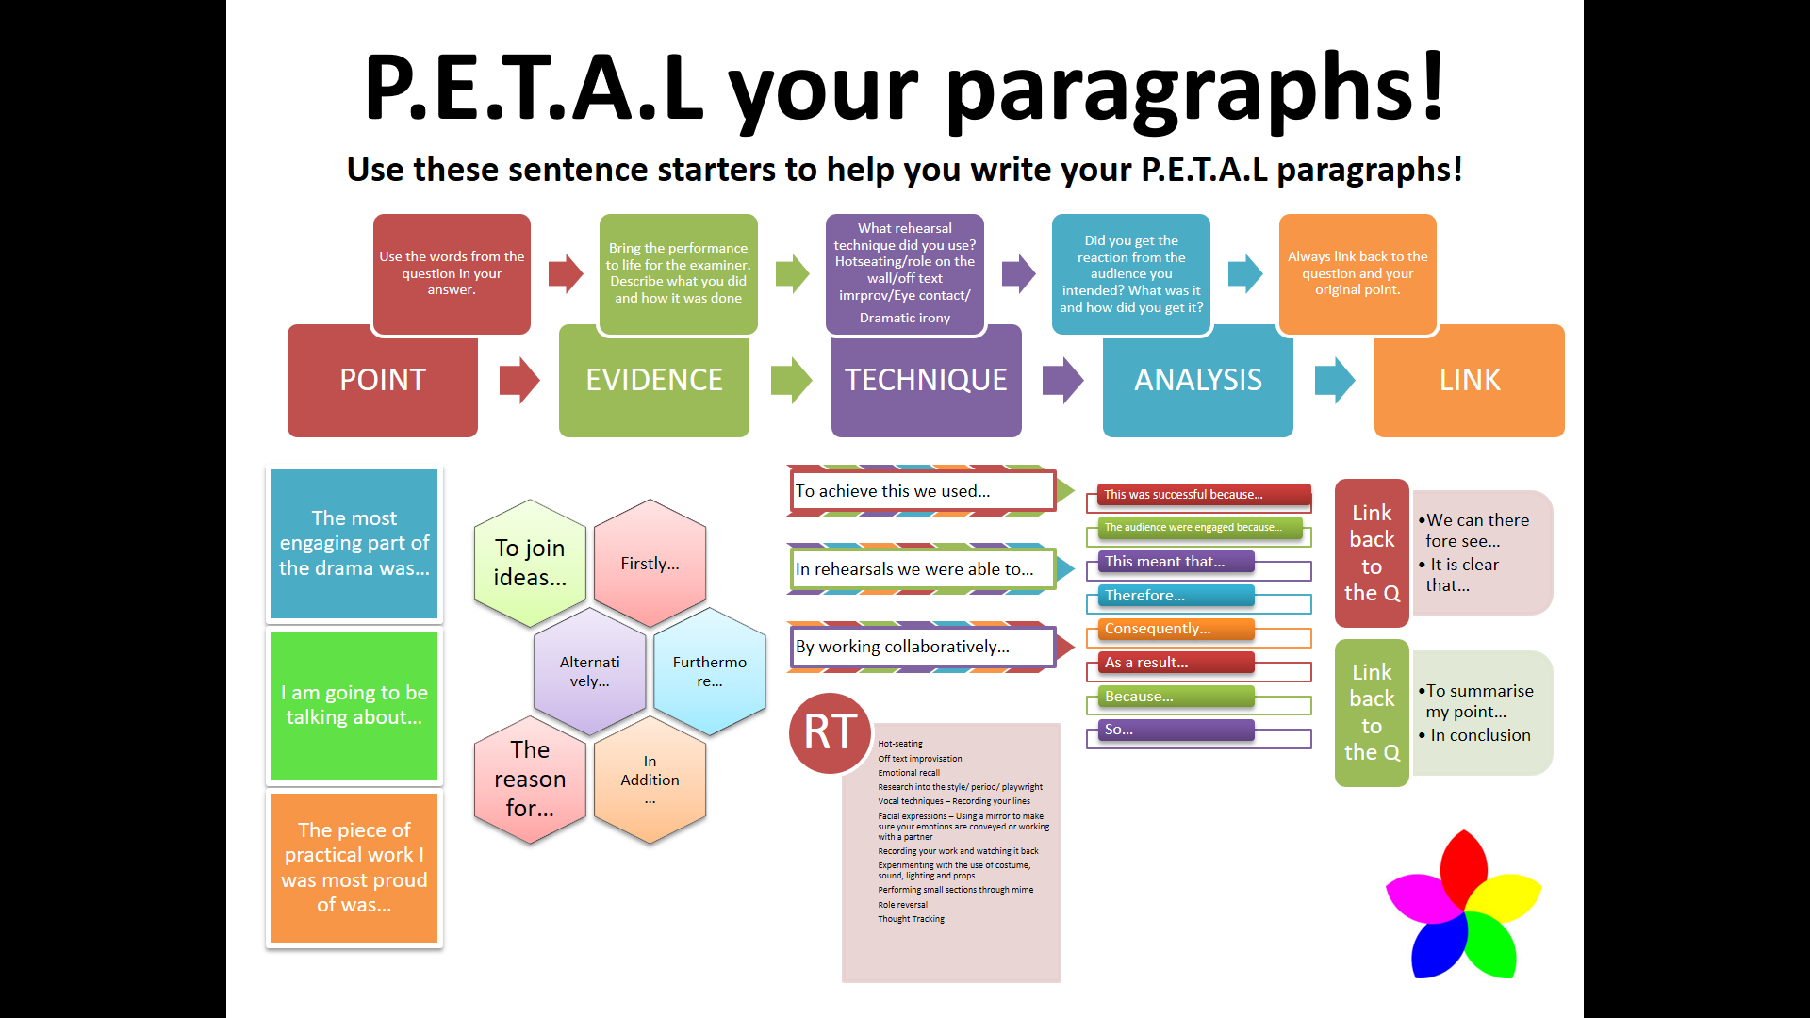

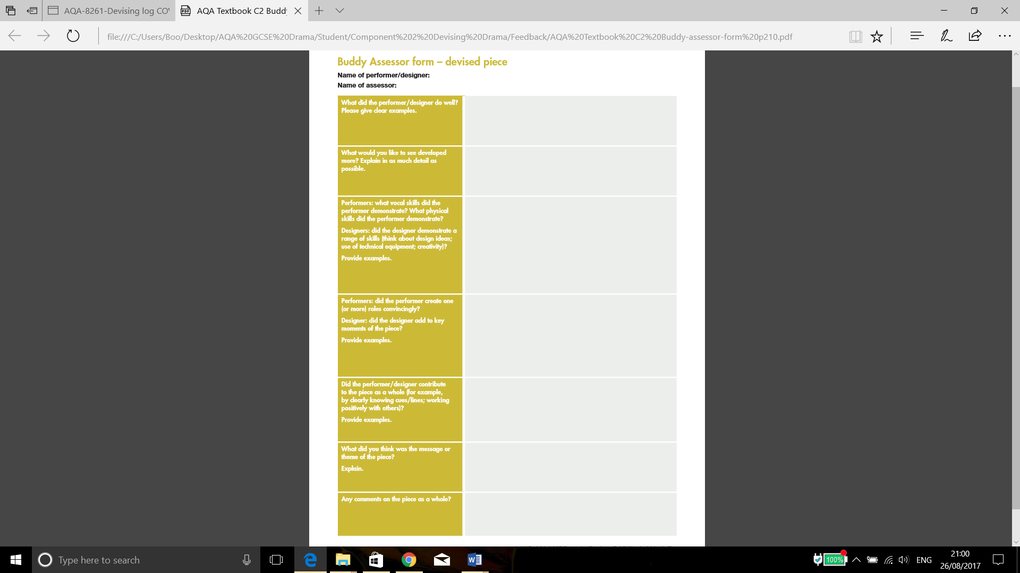
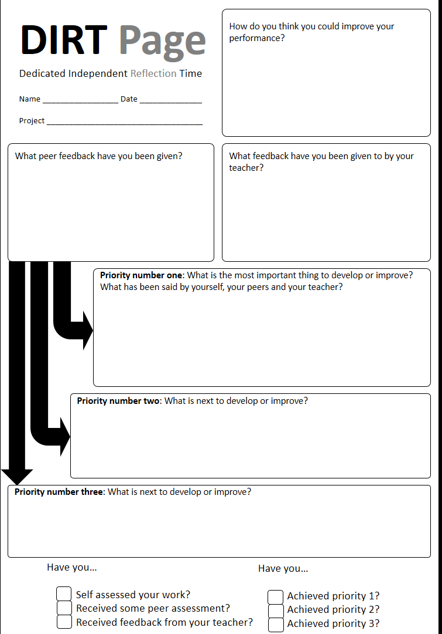
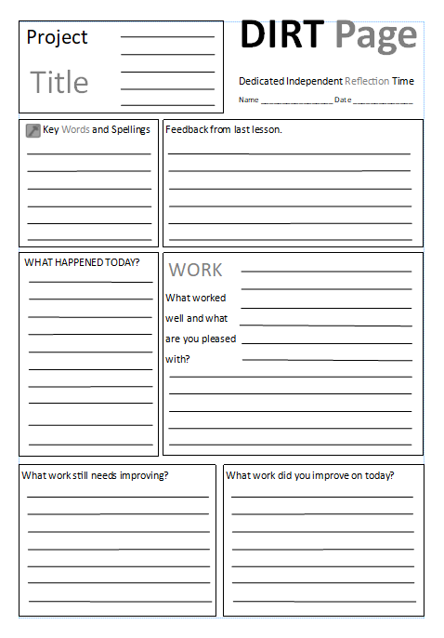
AQA Devising Drama – Component 2

Candidate name: ____________________________________________________________

Candidate number:___________________________________________________________

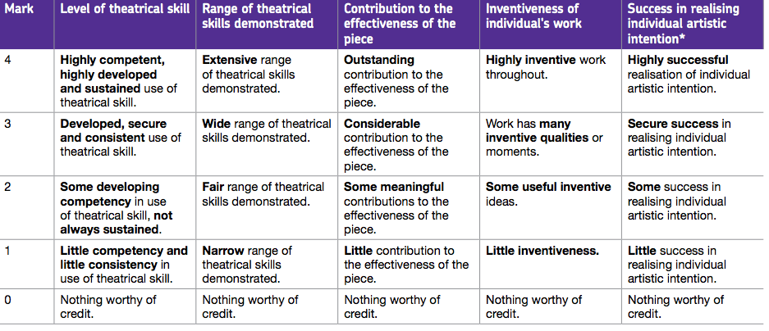
Role: Performer

Comments: _________________________________________________________________

__________________________________________________________________________

__________________________________________________________________________

WWW: ___________________________________________________________________

__________________________________________________________________________

__________________________________________________________________________

EBI: ______________________________________________________________________

__________________________________________________________________________

__________________________________________________________________________

Level of theatrical skill | Range of theatrical skills demonstrated | Contribution to the effectiveness of the piece | Inventiveness of individuals work | Success in realising artistic intention.
