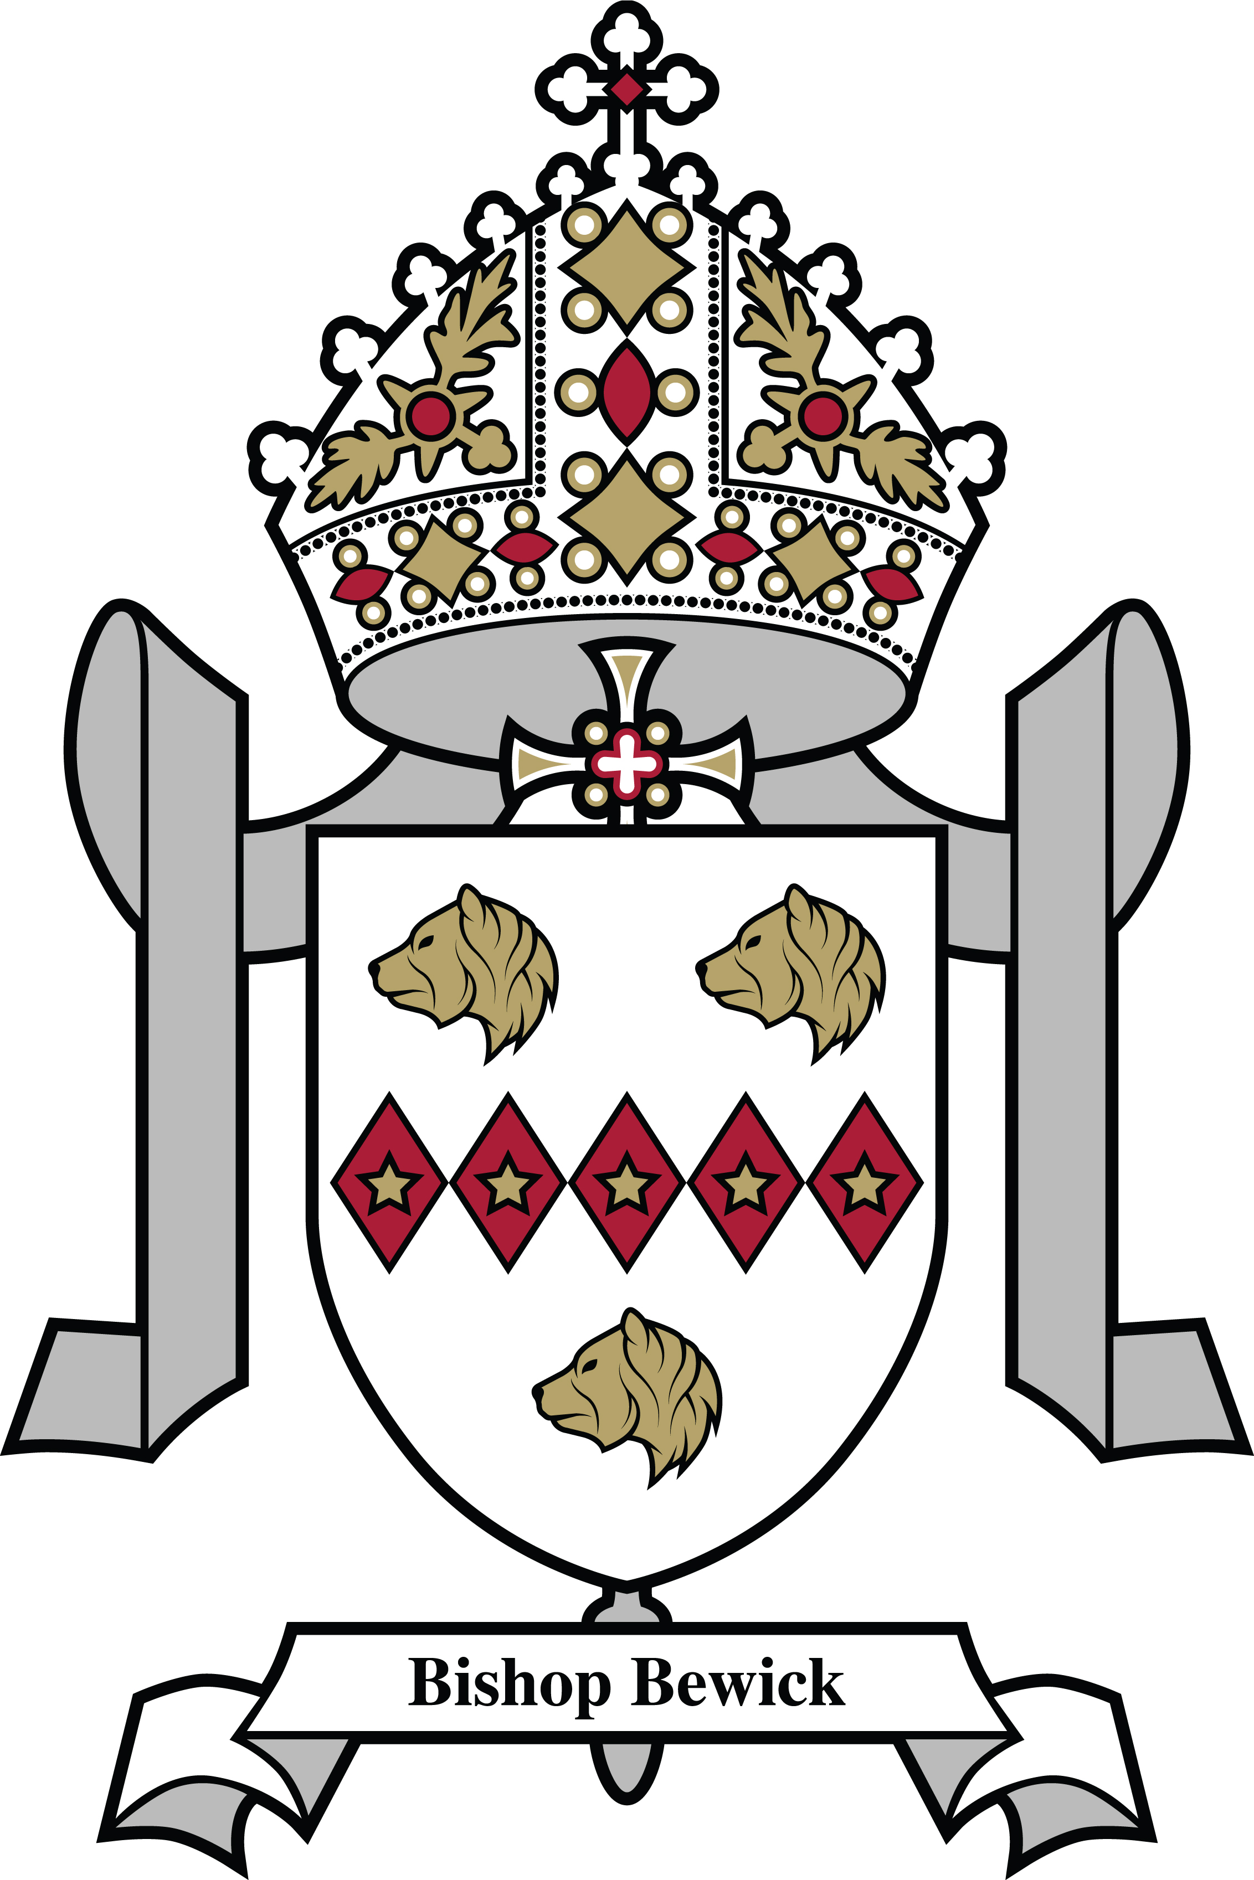
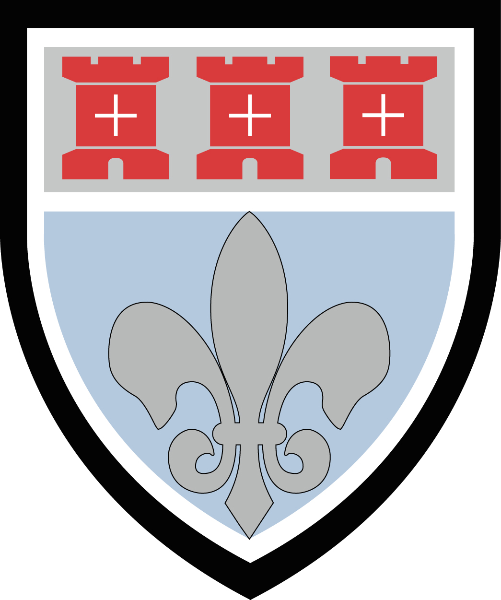
St Mary’s Catholic School
Newcastle upon Tyne
Headteacher: E Patterson. NOR c.1435

Deputy Head of Religious Education x 2 Positions
Full-time
Permanent
Main or Upper Pay Range
TLR 2b £5351
Required for September 2024

The Governors wish to appoint one and possibly two excellent Deputy Heads of Religious Education to contribute to the leadership of our flourishing RE department. The successful candidates will work with the Head of Department, and the other Deputy Head of Department, to build on the existing strengths of the department, to ensure that achievement, teaching, the curriculum and leadership and management, all remain first-class, at each Key Stage. As a member of the leadership team of the RE department, the successful candidate will require the necessary skills and experience, or in the case of less experienced teachers, the potential to develop these, to provide leadership, motivation and training for teachers in the department. Training and unstinting support will be given to the successful candidates. This is a wonderful opportunity for someone wishing to join an outstanding department and a highly successful, positive and forward thinking school.

St Mary’s is a very popular and happy school, rated Outstanding by the Diocese and Ofsted. We became an academy in 2013 and enjoy outstanding facilities in a new building, which opened in 2011. We joined the Bishop Bewick Catholic Education Trust in June 2020. We are also very popular with parents and are one of the most over-subscribed schools in the North-east. The roll has grown from around 1100 five years ago to almost 1440 by September 2023, with 5 main school year groups of around 240 and a Sixth Form of approximately 260 students. We expect the Sixth Form to continue to grow in the next couple of years, as larger and strongly academic year groups continue to move into Sixth Form.

At St Mary’s, Religious Education is a well-established and highly respected department with excellent results. Recent highlights include:-

- 37% of pupils in GCSE Religious Studies achieved a Grade 7-9 in 2023, with 77% achieving a Grade 4 or higher – all significantly above the national average and included an impressive 29 Grade 9’s.
- 48% achieved Grade 7-9 in 2022, with 91% Grade 4+
- 100% of A Level Religious Studies pupils achieved Grade A*-C in 2023.
- 63% achieved at least a B in 2023, with 72% in 2022.

Leadership, teaching and the climate for learning in Religious Education are all outstanding, as they are across the whole school.

Above all, the Governors wish to appoint two Deputy Heads of RE with:-
- A clear commitment to nurturing and promoting the school’s distinctive ethos
- A passion for providing the best possible holistic education for all students
- A commitment to maximising achievement through excellence in teaching and learning
- An excellent track record as a classroom teacher
- The ability to promote a love of learning Religious Education in our students

Application packs are available to download from our school website, or by e-mailing the Director of Finance and Support Services, louise.douds@st-marys.newcastle.sch.uk. If you require any further information about the post, please do not hesitate to contact Danielle Largue, Deputy Headteacher on 0191 215 3260.

Closing date: 9.00am on Monday 11th December 2023. Interviews are likely to be held the following week.
The school is fully committed to safeguarding and the welfare of children and young people. This post is subject to an enhanced DBS check and an online search for shortlisted candidates, as part of our due diligence.

