A-level Religious Education
(Philosophy, Ethics and Christianity)
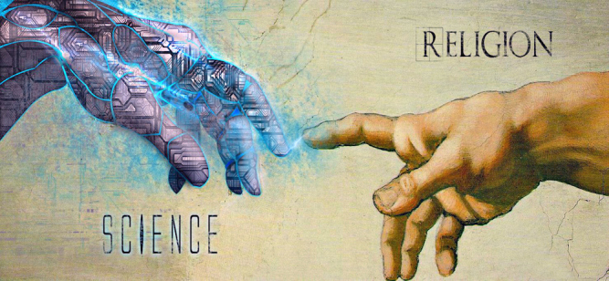

Bridging Course - Week 3




St Mary’s Catholic School
A-level Religious Education Bridging Course
Review of Week 1
In Week 1 you looked at Religious Experience, the types and various arguments for these experiences resulting from God. We considered the counter arguments that they could be the result of illusions or humans simply being mistaken. A strong argument provided against Religious Experiences is from Persinger and the God-helmet which suggests that the brain can be stimulated into creating Religious Experiences for a person.

Review of Week 2
Last week we remained with Philosophy but moved onto the Design Argument. You looked at Paley’s Analogy of the Watch in more depth and more focus was given to the scholars who have provided challenges to such an argument. The key questions considered were – Does the Universe show evidence of a designer? What kind of designer could this be? Could the Universe simply have been chance? Can we be certain that a designer exists or is it just probable? How has science tried to answer this question of design and has it proved religion wrong?

Focus of Week 3
We are now moving to the Christianity Paper to explore one of the units of work which looks at the scientific challenges made against religion. We will look at the challenges from science that took place over the centuries and what impact these had on religion. We will look at a debate which took place between Francis Collins and Richard Dawkins and the arguments that they both put forward relating to the relationship between Science and Religion.

The following work requires a lot of reading, and some of the ideas might be challenging to understand on first reading. Remember to take regular breaks, go back to any of the tasks after some time away, and try your best. Your Religious Education Teacher will go over the following with you in lessons, early in Year 12.

- You are now going to begin preparatory work relevant for Paper 3 of the A-level. Paper 3 is an exam that focuses on various elements within Christianity. You have already studied some of the topics at GCSE which will give you a good foundation on which to build your knowledge.

We are going to move onto challenges that Science has against Religion.

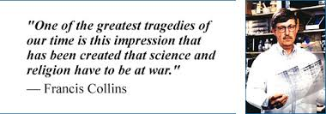

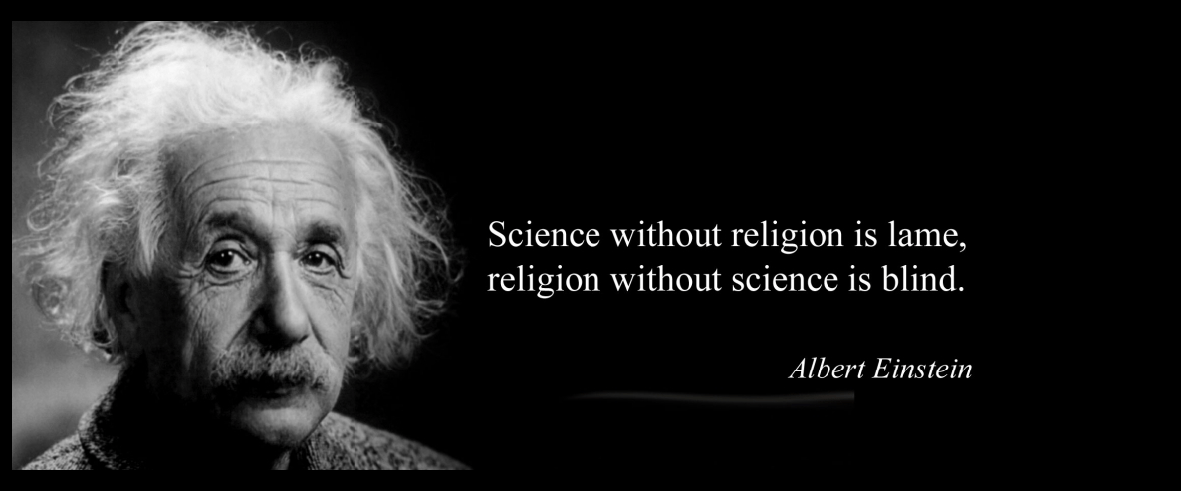

- Have a look at the quotes above. What is each one saying? Do you agree with the quotes? Give two reasons to support you answer.

Consider these questions:
- Which do approach do you think offers more evidence and answers? Science or Religion?
- Think about the methods that a scientist uses to reach a conclusion. What are they? What evidence does a scientist use? What are the problems with science / scientific experiments? Does Science hold all the answers?
- What does religion offer? How does a person come to have faith? Richard Dawkins called having faith in God, “Blind-faith. A process of non-thinking.” Do you agree with him? What reasons would you give for your response to what Richard Dawkins says?

2. Read this information.
Exploring the distinction between religion and science
The terms science and religion are fairly new terms in the history of western thought. Before the nineteenth century, theologians like Aquinas used terms that meant worship or orthodoxy. Furthermore, science was referred to as natural philosophy. Scientific answers were often sought after by members of the clergy. The distinction between science and religion is a fairly new one. Karl Popper (1959) claimed that scientific hypotheses (unlike religious ones) are in principle falsifiable.
One way to distinguish between science and religion is the claim that science concerns the natural world, whereas religion concerns both the natural and the supernatural. Scientific explanations do not appeal to supernatural entities such as gods or angels (fallen or not), or to non-natural forces (like miracles or karma). For example, neuroscientists typically explain our thoughts in terms of brain states, not by reference to an immaterial soul or spirit.

- Complete these questions / tasks relating to the information above.
- Explain Karl Popper’s distinction between science and religion. How does this relate to other aspects of this course? (Think Philosophy)
- What are the benefits of involving faith groups in the pursuit of scientific knowledge?
- What are the possible problems?
- Should they be separated?

- We are now going to look at the different scientific challenges against religion that have taken place over the centuries. Read each one and highlight key information.
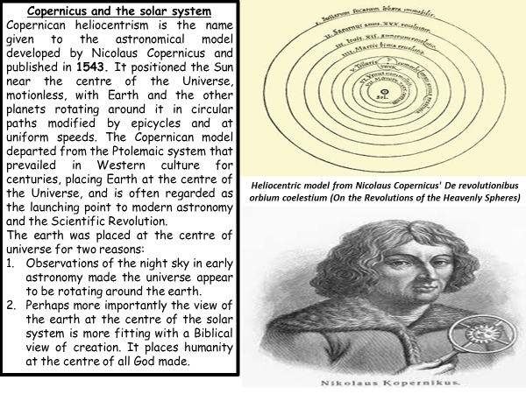

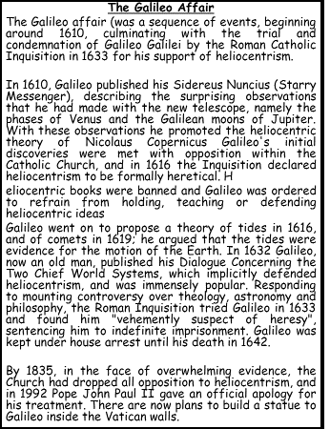

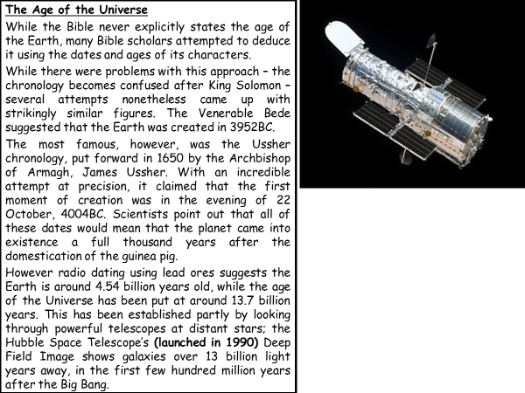

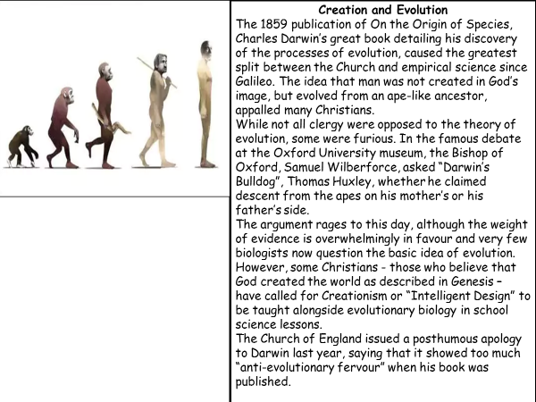

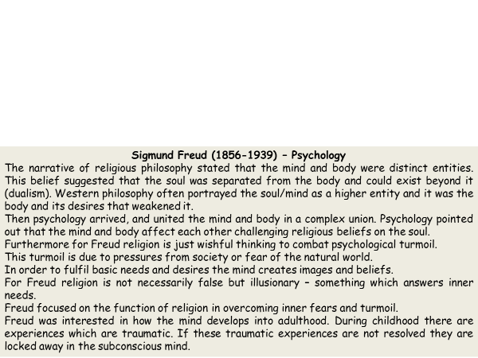

- You are now going to design a timeline showing the historical developments in science that have challenged religious beliefs.
For each point on your timeline include:
- Explanation of the development in science
- How and why this development challenged aspects of Christian beliefs


- Watch the debate on The Big Questions. It asks whether or not evidence undermines Religion. Watch the first fifteen minutes of this debate and record three reasons for and against the statement.
https://www.youtube.com/watch?v=mOe747BtMQA

- We are now going to evaluate the strengths and weaknesses of the challenges to religion. We will specifically be looking at Francis Collins and Richard Dawkins.
Some key terms which may help you are these:
Intelligent design - Intelligent design refers to a scientific research program as well as a community
of scientists, philosophers and other scholars who seek evidence of design in
nature.

Empirical evidence – information n acquired by observation or experimentation. This data is recorded
and analysed by scientists and is a central process as part of the scientific
method.

- Francis Collins
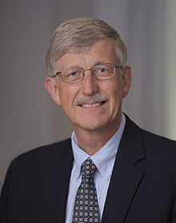
By graduate school Collins considered himself an atheist. However, dealing with dying patients led him to question his religious views, and he investigated various faiths. He familiarized himself with the evidence for and against God in cosmology, and used Mere Christianity by C. S. Lewis as a foundation to re-examine his religious view. He eventually came to a conclusion and became a Christian during a hike on a fall afternoon. He has described himself as a "serious Christian “
Importantly to this topic, Collins is an incredibly successful scientist. He has been elected to the Institute of Medicine and the National Academy of Sciences, and has received the Presidential Medal of Freedom and the National Medal of Science.
Collins also has written a number of books on science, medicine, and religion, including the New York Times bestseller, The Language of God: A Scientist Presents Evidence for Belief.

Watch this clip and explain why Collins believes in God in at least 35 words.
https://www.youtube.com/watch?v=obEBR5MbhNU

- Why do you think people are surprised by the idea of a scientist with religion belief? Give at least three reasons to answer this question

- Now you are going to read a debate which took place for Time Magazine between Collins and Dawkins. Get yourself two different colours. Highlight with one colour the arguments given for religion. With the other colour highlight all the arguments given against religion.

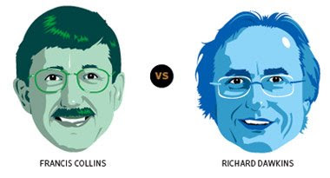

Collins and Dawkins Debate: Can Religion withstand scientific criticisms?
TIME: Professor Dawkins, if one truly understands science, is God then a delusion, as your book title suggests?
DAWKINS: The question of whether there exists a supernatural creator, a God, is one of the most important that we have to answer. I think that it is a scientific question. My answer is no.
TIME: Dr. Collins, you believe that science is compatible with Christian faith.
COLLINS: Yes. God's existence is either true or not. But calling it a scientific question implies that the tools of science can provide the answer. From my perspective, God cannot be completely contained within nature, and therefore God's existence is outside of science's ability to really weigh in.
TIME: Stephen Jay Gould, a Harvard paleontologist, famously argued that religion and science can coexist, because they occupy separate, airtight boxes. You both seem to disagree.
COLLINS: Gould sets up an artificial wall between the two worldviews that doesn't exist in my life. Because I do believe in God's creative power in having brought it all into being in the first place, I find that studying the natural world is an opportunity to observe the majesty, the elegance, the intricacy of God's creation.
DAWKINS: I think that Gould's separate compartments was a purely political ploy to win middle-of-the-road religious people to the science camp. But it's a very empty idea. There are plenty of places where religion does not keep off the scientific turf. Any belief in miracles is flat contradictory not just to the facts of science but to the spirit of science.
TIME: Professor Dawkins, you think Darwin's theory of evolution does more than simply contradict the Genesis story.
DAWKINS: Yes. For centuries, the most powerful argument for God's existence from the physical world was the so-called argument from design: Living things are so beautiful and elegant and so apparently purposeful, they could only have been made by an intelligent designer. But Darwin provided a simpler explanation. His way is a gradual, incremental improvement starting from very simple beginnings and working up step by tiny incremental step to more complexity, more elegance, more adaptive perfection. Each step is not too improbable for us to countenance, but when you add them up cumulatively over millions of years, you get these monsters of improbability, like the human brain and the rain forest. It should warn us against ever again assuming that because something is complicated, God must have done it.
COLLINS: I don't see that Professor Dawkins' basic account of evolution is incompatible with God's having designed it.
TIME: When would this have occurred?
COLLINS: By being outside of nature, God is also outside of space and time. Hence, at the moment of the creation of the universe, God could also have activated evolution, with full knowledge of how it would turn out, perhaps even including our having this conversation. The idea that he could both foresee the future and also give us spirit and free will to carry out our own desires becomes entirely acceptable.
DAWKINS: I think that's a tremendous cop-out. If God wanted to create life and create humans, it would be slightly odd that he should choose the extraordinarily roundabout way of waiting for 10 billion years before life got started and then waiting for another 4 billion years until you got human beings capable of worshipping and sinning and all the other things religious people are interested in.
COLLINS: Who are we to say that that was an odd way to do it? I don't think that it is God's purpose to make his intention absolutely obvious to us. If it suits him to be a deity that we must seek without being forced to, would it not have been sensible for him to use the mechanism of evolution without posting obvious road signs to reveal his role in creation?
TIME: Both your books suggest that if the universal constants, the six or more characteristics of our universe, had varied at all, it would have made life impossible. Dr. Collins, can you provide an example?
COLLINS: The gravitational constant, if it were off by one part in a hundred million million, then the expansion of the universe after the Big Bang would not have occurred in the fashion that was necessary for life to occur. When you look at that evidence, it is very difficult to adopt the view that this was just chance. But if you are willing to consider the possibility of a designer, this becomes a rather plausible explanation for what is otherwise an exceedingly improbable event--namely, our existence.
DAWKINS: People who believe in God conclude there must have been a divine knob twiddler who twiddled the knobs of these half-dozen constants to get them exactly right. The problem is that this says, because something is vastly improbable, we need a God to explain it. But that God himself would be even more improbable. Physicists have come up with other explanations. One is to say that these six constants are not free to vary. Some unified theory will eventually show that they are as locked in as the circumference and the diameter of a circle. That reduces the odds of them all independently just happening to fit the bill. The other way is the multiverse way. That says that maybe the universe we are in is one of a very large number of universes. The vast majority will not contain life because they have the wrong gravitational constant or the wrong this constant or that constant. But as the number of universes climbs, the odds mount that a tiny minority of universes will have the right fine-tuning.
COLLINS: This is an interesting choice. Barring a theoretical resolution, which I think is unlikely, you either have to say there are zillions of parallel universes out there that we can't observe at present or you have to say there was a plan. I actually find the argument of the existence of a God who did the planning more compelling than the bubbling of all these multiverses. So Occam's razor--Occam says you should choose the explanation that is most simple and straightforward--leads me more to believe in God than in the multiverse, which seems quite a stretch of the imagination.
DAWKINS: I accept that there may be things far grander and more incomprehensible than we can possibly imagine. What I can't understand is why you invoke improbability and yet you will not admit that you're shooting yourself in the foot by postulating something just as improbable, magicking into existence the word God.
COLLINS: My God is not improbable to me. He has no need of a creation story for himself or to be fine-tuned by something else. God is the answer to all of those "How must it have come to be" questions.
DAWKINS: I think that's the mother and father of all cop-outs. It's an honest scientific quest to discover where this apparent improbability comes from. Now Dr. Collins says, "Well, God did it. And God needs no explanation because God is outside all this." Well, what an incredible evasion of the responsibility to explain. Scientists don't do that. Scientists say, "We're working on it. We're struggling to understand."
COLLINS: Certainly science should continue to see whether we can find evidence for multiverses that might explain why our own universe seems to be so finely tuned. But I do object to the assumption that anything that might be outside of nature is ruled out of the conversation. That's an impoverished view of the kinds of questions we humans can ask, such as "Why am I here?", "What happens after we die?", "Is there a God?" If you refuse to acknowledge their appropriateness, you end up with a zero probability of God after examining the natural world because it doesn't convince you on a proof basis. But if your mind is open about whether God might exist, you can point to aspects of the universe that are consistent with that conclusion.
DAWKINS: To me, the right approach is to say we are profoundly ignorant of these matters. We need to work on them. But to suddenly say the answer is God--it's that that seems to me to close off the discussion.
TIME: Could the answer be God?
DAWKINS: There could be something incredibly grand and incomprehensible and beyond our present understanding.
COLLINS: That's God.
DAWKINS: Yes. But it could be any of a billion Gods. It could be God of the Martians or of the inhabitants of Alpha Centauri. The chance of its being a particular God, Yahweh, the God of Jesus, is vanishingly small--at the least, the onus is on you to demonstrate why you think that's the case.
TIME: The Book of Genesis has led many conservative Protestants to oppose evolution and some to insist that the earth is only 6,000 years old.
COLLINS: There are sincere believers who interpret Genesis 1 and 2 in a very literal way that is inconsistent, frankly, with our knowledge of the universe's age or of how living organisms are related to each other. St. Augustine wrote that basically it is not possible to understand what was being described in Genesis. It was not intended as a science textbook. It was intended as a description of who God was, who we are and what our relationship is supposed to be with God. Augustine explicitly warns against a very narrow perspective that will put our faith at risk of looking ridiculous. If you step back from that one narrow interpretation, what the Bible describes is very consistent with the Big Bang.
DAWKINS: Physicists are working on the Big Bang, and one day they may or may not solve it. However, what Dr. Collins has just been--may I call you Francis?
COLLINS: Oh, please, Richard, do so.
DAWKINS: What Francis was just saying about Genesis was, of course, a little private quarrel between him and his Fundamentalist colleagues ...
COLLINS: It's not so private. It's rather public. [Laughs.]
DAWKINS: ... It would be unseemly for me to enter in except to suggest that he'd save himself an awful lot of trouble if he just simply ceased to give them the time of day. Why bother with these clowns?
COLLINS: Richard, I think we don't do a service to dialogue between science and faith to characterize sincere people by calling them names. That inspires an even more dug-in position. Atheists sometimes come across as a bit arrogant in this regard, and characterizing faith as something only an idiot would attach themselves to is not likely to help your case.
TIME: Dr. Collins, the Resurrection is an essential argument of Christian faith, but doesn't it, along with the virgin birth and lesser miracles, fatally undermine the scientific method, which depends on the constancy of natural laws?
COLLINS: If you're willing to answer yes to a God outside of nature, then there's nothing inconsistent with God on rare occasions choosing to invade the natural world in a way that appears miraculous. If God made the natural laws, why could he not violate them when it was a particularly significant moment for him to do so? And if you accept the idea that Christ was also divine, which I do, then his Resurrection is not in itself a great logical leap.
TIME: Doesn't the very notion of miracles throw off science?
COLLINS: Not at all. If you are in the camp I am, one place where science and faith could touch each other is in the investigation of supposedly miraculous events.
DAWKINS: If ever there was a slamming of the door in the face of constructive investigation, it is the word miracle. To a medieval peasant, a radio would have seemed like a miracle. All kinds of things may happen which we by the lights of today's science would classify as a miracle just as medieval science might a Boeing 747. Francis keeps saying things like "From the perspective of a believer." Once you buy into the position of faith, then suddenly you find yourself losing all of your natural skepticism and your scientific--really scientific--credibility. I'm sorry to be so blunt.
COLLINS: Richard, I actually agree with the first part of what you said. But I would challenge the statement that my scientific instincts are any less rigorous than yours. The difference is that my presumption of the possibility of God and therefore the supernatural is not zero, and yours is.
TIME: Dr. Collins, you have described humanity's moral sense not only as a gift from God but as a signpost that he exists.
COLLINS: There is a whole field of inquiry that has come up in the last 30 or 40 years--some call it socio-biology or evolutionary psychology--relating to where we get our moral sense and why we value the idea of altruism, and locating both answers in behavioural adaptations for the preservation of our genes. But if you believe, and Richard has been articulate in this, that natural selection operates on the individual, not on a group, then why would the individual risk his own DNA doing something selfless to help somebody in a way that might diminish his chance of reproducing? Granted, we may try to help our own family members because they share our DNA. Or help someone else in expectation that they will help us later. But when you look at what we admire as the most generous manifestations of altruism, they are not based on kin selection or reciprocity. An extreme example might be Oskar Schindler risking his life to save more than a thousand Jews from the gas chambers. That's the opposite of saving his genes. We see less dramatic versions every day. Many of us think these qualities may come from God--especially since justice and morality are two of the attributes we most readily identify with God.
DAWKINS: Can I begin with an analogy? Most people understand that sexual lust has to do with propagating genes. Copulation in nature tends to lead to reproduction and so to more genetic copies. But in modern society, most copulations involve contraception, designed precisely to avoid reproduction. Altruism probably has origins like those of lust. In our prehistoric past, we would have lived in extended families, surrounded by kin whose interests we might have wanted to promote because they shared our genes. Now we live in big cities. We are not among kin nor people who will ever reciprocate our good deeds. It doesn't matter. Just as people engaged in sex with contraception are not aware of being motivated by a drive to have babies, it doesn't cross our mind that the reason for do-gooding is based in the fact that our primitive ancestors lived in small groups. But that seems to me to be a highly plausible account for where the desire for morality, the desire for goodness, comes from.
COLLINS: For you to argue that our noblest acts are a misfiring of Darwinian behaviour does not do justice to the sense we all have about the absolutes that are involved here of good and evil. Evolution may explain some features of the moral law, but it can't explain why it should have any real significance. If it is solely an evolutionary convenience, there is really no such thing as good or evil. But for me, it is much more than that. The moral law is a reason to think of God as plausible--not just a God who sets the universe in motion but a God who cares about human beings, because we seem uniquely amongst creatures on the planet to have this far-developed sense of morality. What you've said implies that outside of the human mind, tuned by evolutionary processes, good and evil have no meaning. Do you agree with that?
DAWKINS: Even the question you're asking has no meaning to me. Good and evil--I don't believe that there is hanging out there, anywhere, something called good and something called evil. I think that there are good things that happen and bad things that happen.
COLLINS: I think that is a fundamental difference between us. I'm glad we identified it.
TIME: Dr. Collins, I know you favour the opening of new stem-cell lines for experimentation. But doesn't the fact that faith has caused some people to rule this out risk creating a perception that religion is preventing science from saving lives?
COLLINS: Let me first say as a disclaimer that I speak as a private citizen and not as a representative of the Executive Branch of the United States government. The impression that people of faith are uniformly opposed to stem-cell research is not documented by surveys. In fact, many people of strong religious conviction think this can be a morally supportable approach.
TIME: But to the extent that a person argues on the basis of faith or Scripture rather than reason, how can scientists respond?
COLLINS: Faith is not the opposite of reason. Faith rests squarely upon reason, but with the added component of revelation. So such discussions between scientists and believers happen quite readily. But neither scientists nor believers always embody the principles precisely. Scientists can have their judgment clouded by their professional aspirations. And the pure truth of faith, which you can think of as this clear spiritual water, is poured into rusty vessels called human beings, and so sometimes the benevolent principles of faith can get distorted as positions are hardened.
DAWKINS: For me, moral questions such as stem-cell research turn upon whether suffering is caused. In this case, clearly none is. The embryos have no nervous system. But that's not an issue discussed publicly. The issue is, Are they human? If you are an absolutist moralist, you say, "These cells are human, and therefore they deserve some kind of special moral treatment." Absolutist morality doesn't have to come from religion but usually does.
We slaughter nonhuman animals in factory farms, and they do have nervous systems and do suffer. People of faith are not very interested in their suffering.
COLLINS: Do humans have a different moral significance than cows in general?
DAWKINS: Humans have more moral responsibility perhaps, because they are capable of reasoning.
TIME: Do the two of you have any concluding thoughts?
COLLINS: I just would like to say that over more than a quarter-century as a scientist and a believer, I find absolutely nothing in conflict between agreeing with Richard in practically all of his conclusions about the natural world, and also saying that I am still able to accept and embrace the possibility that there are answers that science isn't able to provide about the natural world--the questions about why instead of the questions about how. I'm interested in the whys. I find many of those answers in the spiritual realm. That in no way compromises my ability to think rigorously as a scientist.
DAWKINS: My mind is not closed, as you have occasionally suggested, Francis. My mind is open to the most wonderful range of future possibilities, which I cannot even dream about, nor can you, nor can anybody else. What I am sceptical about is the idea that whatever wonderful revelation does come in the science of the future, it will turn out to be one of the particular historical religions that people happen to have dreamed up. When we started out and we were talking about the origins of the universe and the physical constants, I provided what I thought were cogent arguments against a supernatural intelligent designer. But it does seem to me to be a worthy idea. Refutable--but nevertheless grand and big enough to be worthy of respect. I don't see the Olympian gods or Jesus coming down and dying on the Cross as worthy of that grandeur. They strike me as parochial. If there is a God, it's going to be a whole lot bigger and a whole lot more incomprehensible than anything that any theologian of any religion has ever proposed
- Design a table and summarise the arguments that Francis Collins and Richard Dawkins put forward relating to the question of can religion withstand scientific criticisms?

5. Bringing all of your work together complete these exam style questions using the guidance you have been given. It is these answers that will be marked and detailed feedback given.
Explore the scientific challenges to religion (8)
Guidance for answering this style of question:
- This question is asking you to show your knowledge of the scientific challenges to religion.
- The question does not need any evaluation as it is simply about knowledge and what you know.
- You will need 4 paragraphs. Each paragraph is to give a challenge to religion and then explore with detail what that challenge was and who it was brought by.

Evaluate the strengths and weaknesses of the belief that science alone can explain the universe. (30 marks)
Guidance for answering this style of question:
- This question is asking you to show your knowledge of the scientific challenges to religion and which one has the strongest evidence to provide answers to key questions.
- You will need to not only mention the scientific challenges but also the methods that Science uses showing the strengths and weaknesses of these. For example, a scientist could have bias in what they are looking for and so imagine that they see what they want to see. Or, a scientist could be mistaken in reading some results.
- What does religion bring to the debate? Refer back to the quote by Einstein at the start of this booklet. How could you use this argument in your answer?
- Refer to scholars in your answer and you can, of course, research some of your own scholars.
- As this answer is worth 30 marks, it will need to be a lengthy answer and so roughly you are looking about 6 sides. The exam board say that this answer with it being 30 marks should have 30 minutes spent on it. See how much you can write in 30 minutes (do not include the time it takes you to research points, quotes etc. to help you write this answer!)

