**St Mary’s Catholic School: A Level Music**

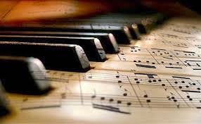



**Bridging Course – Week 1**

**Entry Requirements for Studying A-level Music?**

* Students are expected to achieve at least a grade 6 in GCSE Music.
* Students who have enjoyed their GCSE Music, and who are keen performers, composers and appraisers.
* Students who enjoy the study of an extremely wide variety of musical genres and styles.
* Students who love a lively debate and discussion in lessons, and who are willing, and able, to share their ideas.
* Students who enjoy planning and writing essays evaluating the work of many and varied composers and artists.

**What to expect from A-level Music:**

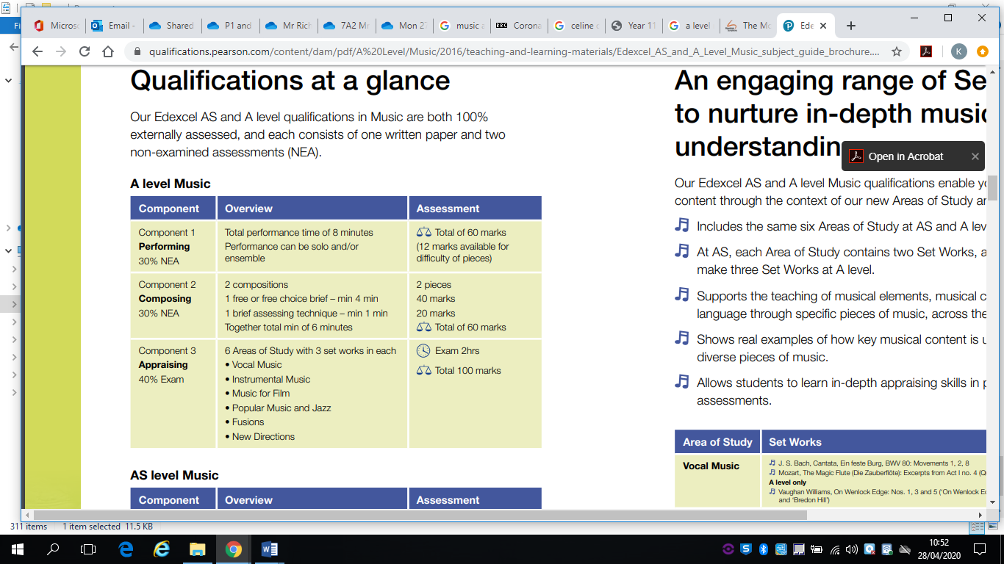

*This bridging course will introduce you to one of the Areas of Study from the Appraising part of the A level Qualification. Students who are expecting to study Music at A-level, and are likely to meet the entry requirements, must complete the bridging course fully and thoroughly, to the best of their ability. You should complete all work on paper and keep it in a file, in an ordered way. You will submit it to your teacher in September. All of the work will be reviewed and selected work will be assessed, and you will be given feedback on it. This work will be signalled to you. If you do not have access to the internet, please contact the school and appropriate resources will be sent to you.*

***If you are thinking about studying Music at A-level you should attempt this work to see whether or not you think studying a subject like this is right for you. If you later decide to study Music, you must ensure you complete this work in full. This work should be completed after you have read and completed the Study Skills work that all of Year 12 should complete.***

## **In order to begin this preparatory work for A Level Music you will first revise some key terminology that you have discussed in Year 9 to Year 11. Research the following key words and write as detailed a definition for each one as you can:**

|  |
| --- |
| **Leitmotif** |
| **Soundtrack** |
| **Theme Song** |
| **Mickey-Mousing** |
| **Concord/Discord** |
| **(Chromatic) Sequencing** |
| **Storyboard** |
| **‘Borrowed’ Music** |
| **Music-Spotting** |
| **Interval of a 5th** |
| **Click Tracks/Timing, Theme** |
| **Sound Effects** |
| **Motif** |
| **Timbre/Sonority** |
| **Musical Clichés** |
| **Diegetic and Non-Diegetic Music** |

## **2) As you will see from the overview of work, you will this week be looking at the origins of film music, starting with Music from Silent Films. Read the article below and make detailed notes on what you discover. Guidance for writing notes can be found in the study skills booklet on the website should you need it.**

**MUSIC IN SILENT FILM**

Film music was largely live in the silent cinema but its practice was specific to the various cultures and nations where it was heard. In the United States phonograph, recordings were sometimes used in early film exhibition; in Japan the tradition of live narration extended throughout the silent period. The notion of pairing film and music had a number of antecedents, among them the nineteenth-century stage melodrama. The conventional explanation for the use of music in silent film is functional: music drowned out the noise of the projector as well as talkative audiences. But long after the projector and the audience were quieted, music remained. Music eventually became so indispensable a part of the film experience that not even the advent of mechanically produced sound could silence it (although for a few years it looked as though it might). Film is, after all, a technological process, producing larger-than-life, two-dimensional, largely black and white, and silent images. Accepting them as "real" requires a leap of faith. Music, with its melody, harmony, and instrumental colour (not to mention the actual presence of live musicians), fleshes out those images, lending them credibility. Further, music distracts audiences from the unnaturalness of the medium. Adorno and Eisler even posit that film music works as a kind of exorcism, protecting audiences from the "ghostly" effigies confronting them on the screen and helping audiences, unaccustomed to the modernity of such sights, "absorb the shock"

The history of musical accompaniment in Silent Film has yet to be fully written, but this important work has begun. Martin Marks, a musicologist and silent film accompanist, finds that original scores existed as early as the 1890s. The scholar Rick Altman shows that in the crucial early periods of silent film exhibition, continuous musical accompaniment was not the normative practice, and he provides compelling evidence that accompaniment was often intermittent and sometimes non-existent. The film industry began to standardize musical accompaniment around between 1908 and 1912, the same period that saw film's solidification as a narrative form and the conversion of viewing spaces from small, cramped nickelodeons to theatrical auditoriums. Upgrading musical accompaniment was an important part of this transformation; attempts to encourage the use of film music and monitor its quality can be traced to this era. Trade publications began to include music columns that often ridiculed problematic accompaniment; theatre owners became more discriminating in hiring and paying musicians; and audiences came to expect continuous musical accompaniment.

Initially, accompanists, left to their own devices and untrained in their craft, improvised. Therefore, the quality of musical accompaniment varied widely. The single most important device in the standardization of film music was the cue sheet, a list of musical selections fitted to the individual film. The most sophisticated of them contained actual excerpts of music timed to fit each scene and cued to screen action to keep the accompanist on track. As early as 1909, Edison studios circulated cue sheets for their films. Other studios, trade publications, and entrepreneurs began doing the same. Musical encyclopaedias appeared, containing vast inventories of music, largely culled from the classics of nineteenth-century western European art music and supplemented by original compositions. Encyclopaedias like Giuseppi Becce's influential Kinobibliothek (1919) indexed every type of on-screen situation accompanists might face. J. S. Zamecnik (1872–1953) composed the Sam Fox Moving Picture Music series (1913–1923). It included not only a generic "Hurry Music," but "Hurry Music (for struggles)", "Hurry Music (for duels)"; and "Hurry Music (for mob or fire scenes)." Even treachery was customised for villains, ruffians, smugglers, or conspirators. Erno Rapee's Encyclopedia of Music for Pictures (1925) offers music for scenes from Abyssinia to Zanzibar (and everything in between). Popular music of the day was also featured in silent film: in illustrated songs during the earliest periods of film exhibition; as ballyhoo blaring from phonographs to lure passers-by into cinemas; and in "Follow the Bouncing Ball" sing-alongs, popular in the 1920s. It is not surprising that popular music crossed over into accompaniment.

Much more work needs to be done on the impact of geography (neighbourhood vs. downtown settings; the urbanized east coast vs. the less populated western states) and ethnicity and race (the place of folk traditions, ragtime, jazz) on musical accompaniment. By the teens, however, silent film accompaniment had developed into a profession, and the piano emerged as the workhorse of the era. The 1920s saw the development of the mammoth theatrical organ, like the Mighty Wurlitzer, and motion picture orchestras, contracted by the owners of magnificent urban picture palaces. Orchestral scores, music transcribed for the orchestra, developed during the late silent era.

Wagnerian opera and Wagner's theory of the Gesamtkunstwerk (total artwork) were early influences on accompanists. Wagner argued that music in opera should not be privileged over other elements and should be composed in accordance with the dramatic needs of the story. Accompanists envisioned film music as performing the same function. Especially influential was Wagner's use of the leitmotif, an identifying musical passage, often a melody, associated through repetition with a particular character, place, emotion, or even abstract idea. Silent film accompanists often used the leitmotif to unify musical accompaniment, and during the period of film's transformation into a narrative form, leitmotifs became an important device for clarifying the story and helping audiences keep track of characters. However, Eisler and Adorno, among other critics, argued that the leitmotif was inappropriate for such short art forms as films.

Spurred by reconstructions in the 1970s of silent film scores by scholar-conductors such as Gillian Anderson and by screenings of the restoration of Abel Gance's Napoléon , silent film has enjoyed a resurgence. The rebirth of the silent film with musical accompaniment has made it possible for audiences today to feel something of the all-encompassing nature of the silent film experience.

## **3) Watch this Silent Movie by Charlie Chaplin – *The Lion Cage,* a short scene from the longer film, *The Circus.* Chaplin wrote, produced and directed this film and gained his first Academy Award for it. You may need to watch it several times in order to complete the questions below: (The full video of the circus is also available on YouTube should you want to watch more of it and evaluate further the musical success of it)**

<https://www.youtube.com/watch?v=7d8lg2dSlME>

* Choose four specific points in the clip (giving the timing and the action that takes place) and describe in detail how the musical features mirror what is taking place on screen.

1……………………………………………………………………………………………………………………………………………………………………………………………………………………………………………………………………………………………………………………………………………………………………………………………………………………………………………2……………………………………………………………………………………………………………………………………………………………………………………………………………………………………………………………………………………………………………………………………………………………………………………………………………………………………………

3……………………………………………………………………………………………………………………………………………………………………………………………………………………………………………………………………………………………………………………………………………………………………………………………………………………………………………4……………………………………………………………………………………………………………………………………………………………………………………………………………………………………………………………………………………………………………………………………………………………………………………………………………………………………………

* What is meant by the term ‘hit – point’ Find two examples of these in the video.

…………………………………………………………………………………………………………………………………………………………………………………………………………………………………………………………………………………………………………………………………………………………………………………………………………………………………………………………………………………………………………………………………………………………………………………………………………………………………………………………………………………………………………………………………………………………………………………………………………………………………………………………………………………………….

* The accompaniment to the action is described as **non-diegetic sound**. Why is this clip a successful example of this?

………………………………………………………………………………………………………………………………………………………………………………………………………………………………………………………………………………………………………………………………………………………………………………………………………………………………………………………………………………………………………………………………………………………………………………………………

* In the clip which of the musical elements, in your opinion (e.g. tempo, dynamics) provide the most successful features of mirroring the on screen action – remember to say why you think this is.

………………………………………………………………………………………………………………………………………………………………………………………………………………………………………………………………………………………………………………………………………………………………………………………………………………………………………………………………………………………………………………………………………………………………………………………………

**Extension:** Are there any features of the music that you think could be improved in order to better mirror the on screen action? Say what these are and what you would do to achieve this?

……………………………………………………………………………………………………………………………………………………………………………………………………………………………………………………………………………………………………………………………………………………………………………………………………………………………………………………………………………………………………………………………………………………………………………………………………………………………………………………………………………………………………………………………………………………………………………………………………………………………………………………………………………………………..

## 4) **Read the article below on one of Hollywood’s most famous film music composers. You can also listen to several videos from some of the most famous films he orchestrated at the link below:** [**https://bachtrack.com/article-korngold-hollywood-film-month**](https://bachtrack.com/article-korngold-hollywood-film-month)

In this article, the duel scene in The Many Adventures of Robin Hood is described as a wonderful example of programme music (music that tells a story, mirrors the action etc). The video of that scene can be found at the above link. Watch the video and you are then going to evaluate what makes the music so successful. *Much like the essay questions, you completed at GCSE level in Section B of the paper.*

## **5) Evaluate the use of Orchestration, Tempo, Dynamics and Texture in Korngold’s Duel Scene from ‘The New Adventures of Robin Hood’ in relation to the portrayal of the on-screen action (15) – This is 3 more marks more than a GCSE essay but I am asking you to comment on one more musical element as you will see!**

With the middle name Wolfgang, perhaps Erich Korngold was destined to be a composer from the start. Born in Brno (then Austria-Hungary, now the Czech Republic) in 1897, he was the son of Dr Julius Korngold, music critic at the Neue Freie Presse. He was a genuine Wunderkind composer. When he played his cantata Gold for Mahler in 1909, Mahler dubbed him “a musical genius” and recommended he study with Zemlinsky. His first orchestral work was written at the age of 14 and his first full length opera, Die tote Stadt, when he was 23. Korngold’s music earned praise from both Puccini and Richard Strauss, scores written in an opulent compositional style, yet for a long time that style was later dismissed as ‘Hollywood’

The reason for that barb was that Korngold was one of the great – if not the greatest – composers for film and his style became synonymous with what came to be expected from a Hollywood film score. If you listen to his early concert works, the musical language Korngold used in his film scores wasn’t that different – sweeping melodies, with rich, lush harmonies to the fore – and that style was aped by other composers writing for the silver screen.

The young Korngold had been involved in arranging operettas for performances in the 1920s, including successful adaptations of Die Fledermaus and La belle Hélène with Max Reinhardt. In 1934, Reinhardt invited him to come to Hollywood to adapt Mendelssohn’s score for a film version of A Midsummer Night’s Dream – Reinhardt’s only completed sound film.

Initially invited for six to eight weeks, the project took nearly six months to complete. This time was spent in learning the craft of fitting music to film. On seeing a reel, he asked a technician how long one foot of film was: “Twelve inches,” came the laconic reply. “No, how long does it last on screen?” This was the first time anyone had asked such a technical question and nobody immediately knew the answer. On finding it lasted two thirds of a second, Korngold apparently smiled, “Ah, exactly the same length of time as the first two measures of Mendelssohn’s ‘Scherzo’!”

Creating the score was a three-stage process. Korngold made preliminary recordings, then conducted the studio orchestra for complicated simultaneous ‘takes’ as film was shot, as well as recording other insertions after the film had been cut. He even ‘conducted’ actors speaking their lines so they would synchronise with the score. While Korngold composed some bridging music in the style of Mendelssohn, he also adapted music from other works, such as the Scottish Symphony and the Songs without Words.

This experience held Korngold in good stead when he was invited back the following year, writing scores for Paramount and Warner Bros. His approach to composing film scores was, essentially, that of writing “operas without singing”, providing leitmotifs for the different characters. His first original film score was Captain Blood, an Errol Flynn swashbuckler about an imprisoned doctor and his fellow prisoners who escape and become pirates.

He had to learn to compose at great speed, often being given no more than seven weeks to produce a score. For Captain Blood, he had just three weeks and raided a couple of Liszt’s tone poems for some of the action scenes. Here are Errol Flynn and Basil Rathbone fighting a duel:

After the Anschluss, Korngold moved his family permanently to the United States, vowing not to compose concert works again until Hitler was removed from power. Indeed, he used income from his film composing to support his friends and colleagues who had fled Europe. The Adventures of Robin Hood was his first score as a US exile and it won him an Oscar… the first time an Academy Award had been given to the composer as opposed to the studio’s music department.

Errol Flynn was again the dashing hero, with Olivia de Havilland as Maid Marian and Basil Rathbone as Sir Guy of Gisbourne. Of Korngold’s eighteen film scores, Robin Hood is his masterpiece. Korngold knew that, as usual, time would be of the essence once he got to Hollywood, so put in hours of preparation. His father suggested that one of his early concert works – Sursum Corda – could provide useful material and its trumpet theme gives his score to Robin Hood its flavour. He also used music from his one act opera Die Kathrin, while the “March of the Merry Men” is based on a theme Korngold had written for an adaptation of an operetta Roses from Florida.

The duel between Robin Hood and Sir Guy is one of the best choreographed swordfights in Hollywood history, with Korngold’s score matching the screenplay blow for blow:

Other historical romances followed, including the popular Elizabeth and Essex. The Sea Hawk (1940) was Korngold’s last swashbuckler and featured one of his longest and most elaborate scores. Again, it starred Errol Flynn as an English privateer defending England on the eve of the Spanish Armada.

Korngold became an American citizen in 1943, being based in Los Angeles, but by 1945 and the end of the war, he had grown disillusioned with writing for film and wanted to return to composing for the concert hall. He was stung by accusations of having ‘sold out’ to Hollywood. Ironically, having used some of his earlier concert music to inspire some of his film scores, the tables were now turned and the influence of his film music can de deciphered in his later compositions. Cannily, Korngold had ensured his studio contract had allowed him to keep the copyright of everything he had written.

In his gorgeous Violin Concerto, for example, Korngold drew on his score to Another Dawn (1937) in the first movement, Anthony Adverse (1936) in the Romanze and The Prince and the Pauper (1937) in the dashing finale.

Korngold didn’t return to Austria until 1949, but his later works didn’t meet with initial success, especially back in Vienna. Did the critics turn their noses up at his music because of his Hollywood success? Had Viennese public taste moved on? Today, thankfully, Korngold’s concert music is justly as celebrated in its own right, while his film scores continue to dazzle.

