

St. Mary’s English Department

Year 7:

Work to support

academic progress

Last term you read texts from the dystopia genre and this term you are studying Shakespeare’s The Tempest and a selection of poetry.

Dystopia
- Read the extract from Gemma Malley’s The Declaration
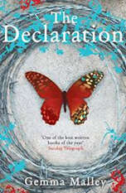
- Complete the tasks below

The Declaration by Gemma Malley
The Declaration was first published in 2008. It is set in a dystopian future in the 22nd century in which humanity has cured all illness and aspires to eternal life.
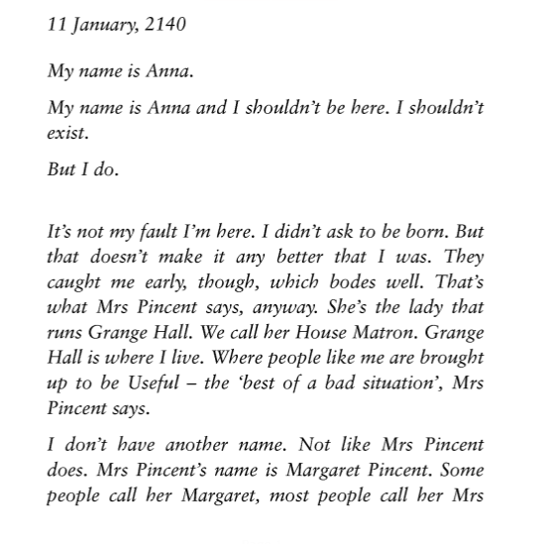

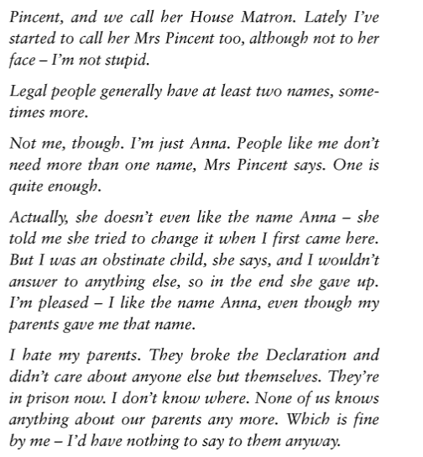

Questions on comprehension and inference
- What is Grange Hall?
- Why might Anna be living at Grange Hall?
- What does Anna mean by “people like me”?
- What is different about Anna’s name to other characters mentioned in the story?
- What might The Declaration be?

Questions on the writer’s methods
- Why does the writer choose to only give Anna a first name and not a surname? What significance does this have? What might this suggest about Anna’s position in society?
- Why does the writer withhold information about The Declaration at the start of the novel? What effect does this have?

The Tempest
Complete the tasks below:

- Read Ariel’s song from The Tempest

Ariel sings.
Come unto these yellow sands,
And then take hands:
Courtsied when you have and kiss’d
The wild waves whist:
Foot it featly here and there;
And, sweet sprites, the burthen bear…
Full fathom five thy father lies;
Of his bones are coral made;
Those are pearls that were his eyes:
Nothing of him that doth fade,
But doth suffer a sea-change
Into something rich and strange.
Sea-nymphs hourly ring his knell:

- Look up and learn the definition to the following words:
- Featly
- Burden
- Fathom (measurement)
- Knell
- At this point is the play, Ariel is singing to Ferdinand about his father Alonso. In your own words, what does Ariel say has happened to Ferdinand’s father?
- Ariel implies that Alonso is becoming part of the sea. What lines suggest this?
- More challenging question – How does Shakespeare create a sense of mystery in Ariel’s song?
- Written task:
Write the words to a song as Ariel, enticing sailors to visit the magical island.
You should write a minimum of three verses and include:
- a rhyme scheme
- extended metaphor
- you could also include a chorus/repeated refrain

