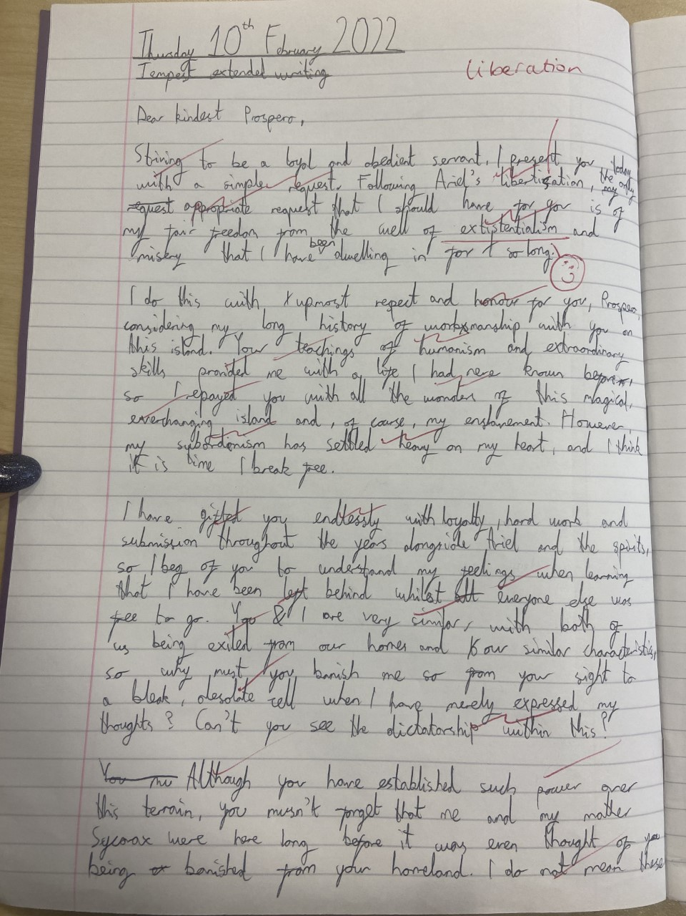
Judiciously selected examples and ideas are selected from the text to support the argument, making it persuasive and powerful. It is a highly emotive piece of work.
The student is able to recognise the counter-argument and is able to challenge this so that writing is convincing.
The student is able to write in a formal style. Spelling, punctuation and grammar is almost always accurate and sentences are varied.
The student begins their writing by demonstrating a clear awareness of the form and task. They use ambitious vocabulary and are able to write with sophistication.

