Quotations are selected judiciously to support the student’s argument.

The student is able to demonstrate an extremely detailed knowledge of the play. This then enables them to answer the question thoroughly. Ideas are insightful and at times, assured.

The language is closely analysed and the effect on the audience is considered in an impressive and confident way.

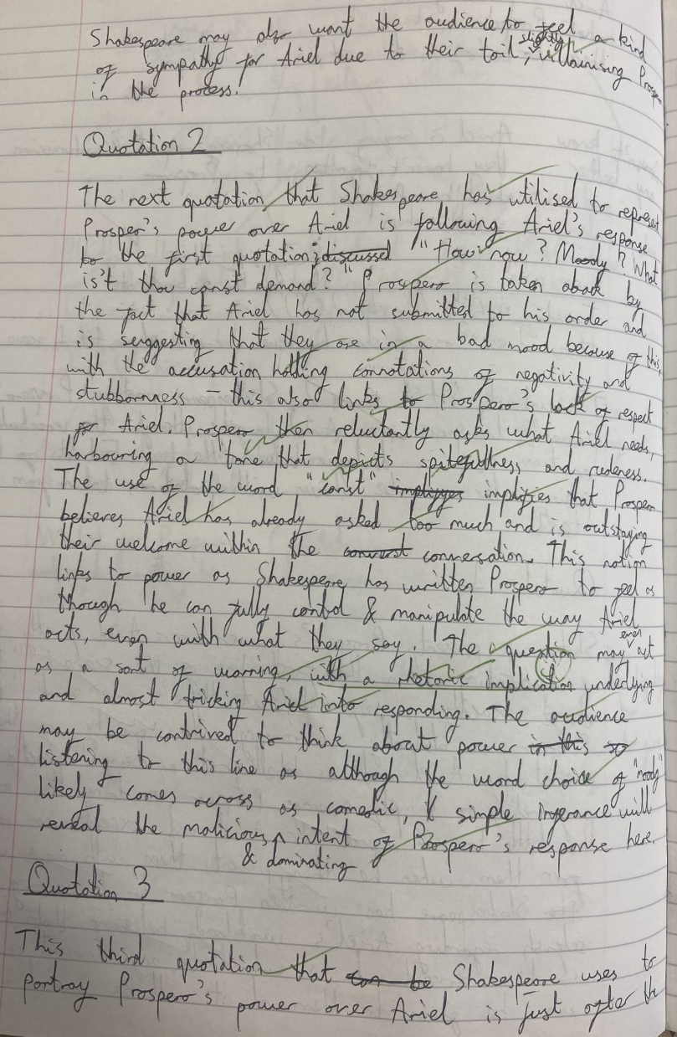

Vocabulary used to express ideas is sophisticated and ideas are explained coherently. The student is able to build a line of argument.

