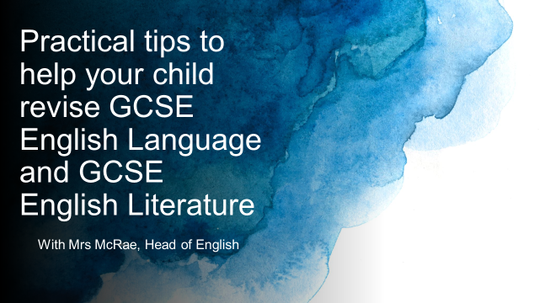


Year 11 Information Evening 2023
A guide to using this evening’s materials

GCSE English Language Section A
All resources can be found in the Year 11 Teams Tile in the Revision channel.
The following information provides advice to help your child respond to an unseen extract and prepares them for Paper 1 Section A. It correlates to the GCSE English Language Paper 1 Further Reading Booklet. There are similar tasks and questions for Paper 2 in the GCSE English Language Paper 2 Further Reading Booklet.

- Read the unseen extract closely. Use the questions in the table below to help you think about the meaning and methods:
Who  Who is narrating the extract? Is this narrator unreliable or limited in any way?  What type of narrator is the writer using? Why might this be important?  Who else is in the extract? How are the characters connected? | What  What is happening in the extract?  What importance might these events have?  What do we think might have taken place before it?  What do we think might take place after it?
Where  Where is the extract set?  Is the setting urban or rural?  Is the setting very busy and crowded or is it isolated?  What is the weather like in the extract? | When  When is the extract taking place?  Is the extract taking place in the daytime or night time? Why might this be important?  How much time passes during the extract?

- Use the exam-style questions below:
- Can I list four things about something/someone in the text?
- Can I identify a range of language features and explore their effect in detail?
- Can I identify a range of structural features and explore their effect in detail?
- Can I explore the way that the whole text is structured?
- Can I think about the way that the text changes from the beginning, middle and end?
- Can I form a detailed, personal opinion about the text and explore how the writer makes me respond this way?

Paper 1 example unseen extract.
This extract is taken from the opening of a novel.
It was November. Although it was not yet late, the sky was dark when I turned into Laundress Passage. Father had finished for the day, switched off the shop lights and closed the shutters; but so I would not come home to darkness he had left on the light over the stairs to the flat. Through the glass in the door it cast a foolscap rectangle of paleness onto the wet pavement, and it was while I was standing in that rectangle, about to turn my key in the door, that I first saw the letter. Another white rectangle, it was on the fifth step from the bottom, where I couldn't miss it.
I closed the door and put the shop key in its usual place behind Bailey's Advanced Principles of Geometry. Poor Bailey. No one has wanted his fat gray book for thirty years. Sometimes I wonder what he makes of his role as guardian of the bookshop keys. I don't suppose it's the destiny he had in mind for the masterwork that he spent two decades writing.
A letter. For me. That was something of an event. The crisp-cornered envelope, puffed up with its thickly folded contents, was addressed in a hand that must have given the postman a certain amount of trouble. Although the style of the writing was old-fashioned, with its heavily embellished capitals and curly flourishes, my first impression was that it had been written by a child. The letters seemed untrained. Their uneven strokes either faded into nothing or were heavily etched into the paper. There was no sense of flow in the letters that spelled out my name. Each had been undertaken separately -- M A R G A R E T L E A -- as a new and daunting enterprise. But I knew no children. That is when I thought, It is the hand of an invalid.
It gave me a queer feeling. Yesterday or the day before, while I had been going about my business, quietly and in private, some unknown person -- some stranger -- had gone to the trouble of marking my name onto this envelope. Who was it who had had his mind's eye on me while I hadn't suspected a thing?
Still in my coat and hat, I sank onto the stair to read the letter. (I never read without making sure I am in a secure position. I have been like this ever since the age of seven when, sitting on a high wall and reading The Water Babies, I was so seduced by the descriptions of underwater life that I unconsciously relaxed my muscles. Instead of being held buoyant by the water that so vividly surrounded me in my mind, I plummeted to the ground and knocked myself out. I can still feel the scar under my fringe now. Reading can be dangerous.)
I opened the letter and pulled out a sheaf of half a dozen pages, all written in the same laborious script. Thanks to my work, I am experienced in the reading of difficult manuscripts. There is no great secret to it. Patience and practice are all that is required. That and the willingness to cultivate an inner eye. When you read a manuscript that has been damaged by water, fire, light or just the passing of the years, your eye needs to study not just the shape of the letters but other marks of production. The speed of the pen. The pressure of the hand on the page. Breaks and releases in the flow. You must relax. Think of nothing. Until you wake into a dream where you are at once a pen flying over vellum and the vellum itself with the touch of ink tickling your surface. Then you can read it. The intention of the writer, his thoughts, his hesitations, his longings and his meaning. You can read as clearly as if you were the very candlelight illuminating the page as the pen speeds over it. to add text
Not that this letter was anything like as challenging as some. It began with a curt "Miss Lea"; thereafter the hieroglyphs resolved themselves quickly into characters, then words, then sentences.
This is what I read:

The tasks above will help your child prepare for GCSE English Language Paper 1. There are similar tasks and extracts for Paper 2 in the GCSE English Language Paper 2 Further Reading Booklet.
GCSE English Language Section B
All resources can be found in the Year 11 Teams Tile in the Revision channel.
The following information provides advice to help your child respond to an unseen writing task and prepares them for Paper 1 Section B. It correlates to the GCSE English Language Paper 1 Further Reading Booklet. There are similar tasks for Paper 2 in the GCSE English Language Paper 2 Further Reading Booklet.

Example descriptive writing task:
Write a description of a winter’s day as suggested by this picture:
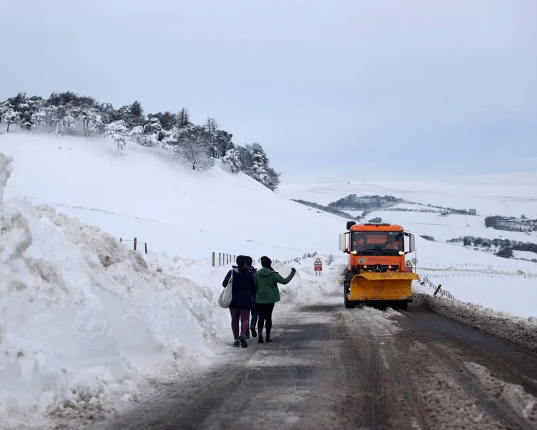
1. Practise writing the first sentence of each paragraph using our suggested structure. This will help to develop an overall sense of structure and direction to your writing
Paragraph 1: Zoom out
Describe the whole scene as a zoom out.
It was a white world: cold, monochrome, yet beautiful.

Paragraph 2: Zoom in
Describe a small detail.
Compact drifts of snow were heaped upon the roadside in vast, porcelain mountains.

Paragraph 3: Outside
Describe the sounds and smells of the scene.
The air was sharp. The world was muffled.

Paragraph 4: Inside
Describe what your character is thinking.
The loud trundle of a snowplough rumbled across the moor, disturbing the quiet.

Paragraph 5: Zoom out – link to the opening but make it different. Repeat a word or a phrase.
Describe the scene when everyone has gone home and make a contrast.
It was a dark world now that the sun had faded: cold, monochrome and black.

- Develop one or more of these sentences into full paragraphs to practise building a description.

The tasks above will help your child prepare for GCSE English Language Paper 1 Section B. There are similar tasks for Paper 2 Section B in the GCSE English Language Paper 2 Further Reading Booklet.
GCSE English Literature

All resources can be found in the Year 11 Teams Tile in the Revision channel.
General revision strategies for GCSE English Literature:

- Make sure you know your texts. Read plot summaries to help cement your knowledge.
- Learn and test your knowledge of quotations. Use the 'look, say, cover, write, check' approach.
- Place quotations on flashcards. Practise grouping them by character, theme, event or method.
- Mind map themes in each text. Link each theme to characters, events, quotations and contextual information.
- List contextual information relevant to each text and link this to a quotation.
- For the poetry anthology, practise grouping poems and quotations, considering similarities and differences.

GCSE English Literature: Paper 1

The following information provides advice to help your child revise GCSE English Literature Paper 1. For this exam they will write two essays: one on Shakespeare’s Macbeth and another on Dickens’ A Christmas Carol. For both texts they will be given an extract and will need to write about the extract and the text as a whole. Students can use the Macbeth and A Christmas Carol extract booklets to revise this paper.

Example A Christmas Carol question:

Read the following extract from Stave 5 of A Christmas Carol and then answer the question that follows. At this point in the novella, Scrooge has returned from his journey with the ghosts and wakes up in his own bed on Christmas morning. ​
​
“They are not torn down,” cried Scrooge, folding one of his bed-curtains in his arms, “they are not torn down, rings and all. They are here—I am here—the shadows of the things that would have been, may be dispelled. They will be. I know they will!”​
His hands were busy with his garments all this time; turning them inside out, putting them on upside down, tearing them, mislaying them, making them parties to every kind of extravagance.​
“I don’t know what to do!” cried Scrooge, laughing and crying in the same breath; and making a perfect Laocoön of himself with his stockings. “I am as light as a feather, I am as happy as an angel, I am as merry as a schoolboy. I am as giddy as a drunken man. A merry Christmas to everybody! A happy New Year to all the world. Hallo here! Whoop! Hallo!”​
He had frisked into the sitting-room, and was now standing there: perfectly winded.​
“There’s the saucepan that the gruel was in!” cried Scrooge, starting off again, and going round the fireplace. “There’s the door, by which the Ghost of Jacob Marley entered! There’s the corner where the Ghost of Christmas Present, sat! There’s the window where I saw the wandering Spirits! It’s all right, it’s all true, it all happened. Ha ha ha!”​
Really, for a man who had been out of practice for so many years, it was a splendid laugh, a most illustrious laugh. The father of a long, long line of brilliant laughs!​
“I don’t know what day of the month it is!” said Scrooge. “I don’t know how long I’ve been among the Spirits. I don’t know anything. I’m quite a baby. Never mind. I don’t care. I’d rather be a baby. Hallo! Whoop! Hallo here!”​
He was checked in his transports by the churches ringing out the lustiest peals he had ever heard. Clash, clang, hammer; ding, dong, bell. Bell, dong, ding; hammer, clang, clash! Oh, glorious, glorious!​
Running to the window, he opened it, and put out his head. No fog, no mist; clear, bright, jovial, stirring, cold; cold, piping for the blood to dance to; Golden sunlight; Heavenly sky; sweet fresh air; merry bells. Oh, glorious! Glorious!​
​
Starting with this extract, explain how Dickens presents the importance of transformation ​
Write about: ​
• how Dickens presents transformation in this extract ​
• how Dickens presents transformation in the novella as a whole. ​

- Read the extract​

- What has happened before and after the extract?​ How does this extract act as a pivotal point for the focus of the question?​
​
- Annotate the extract using the following questions:​
- Where can I identify the focus of the question in the extract?​
- How is the focus of the question presented in the extract?​
- What methods are used?​

- What social/cultural/historical context is applicable here?​ What was happening at the time the text was written that has influenced the author?

- Make links to quotations from outside of the extract. Where is the focus of the question continued and/or contrasted in the text as a whole?

Example questions and extracts are available on Teams for both Macbeth and A Christmas Carol.

GCSE English Literature Paper 2

The following information provides advice to help your child revise GCSE English Literature Paper 2 and helps them prepare for the Unseen Poetry section. Students can use the Unseen Poetry booklet to help them revise this section.

Example Unseen Poetry question:

When we were gymnasts
by Emily Ballou

Remember when you turned cartwheels
in the schoolyard.
And danced down the length
of the fallen tree, four inches wide
that crossed the creek
one foot in front of the other
and pivoted into the leaves?
And somersaulted down the long green hill.
And bent over backwards to see the world inverted.
And bounced on the bed.
And twisted yourself into pretzels with supple ease.
And hung from your knees on the climbing frame
until your hair stood on end?
Do you remember how it felt, then
to tread the thin line of things
to spring into the air with nobody looking
to dangle from the branches of trees
to balance on one leg, in arabesque
to be without gravity?
To tumble and get up again. It never hurts. And do it all again.
And as you leapt off the swings
thudding down two feet in the dirt
the birds gave you perfect tens.

In ‘When we were gymnasts’ how does the poetry present memories of a fun and carefree childhood?

- Read the question first. This will help you understand the meaning of the poem.

- Read the poem, carefully at least twice. What is the 'story' of the poem?

- Identify and explore at least four different methods used by the writer, linking back to the question.
These could be:
- Start
- End
- Title
- Tone

Please keep in mind that GCSE English Literature Paper 2 also includes a section on the Modern Text and the Poetry Anthology. Students should use the revision methods suggested on page 8 to help them revise these sections.

