2. Using equations: PHYSICS
Here are some worked examples from all sciences that will help you!
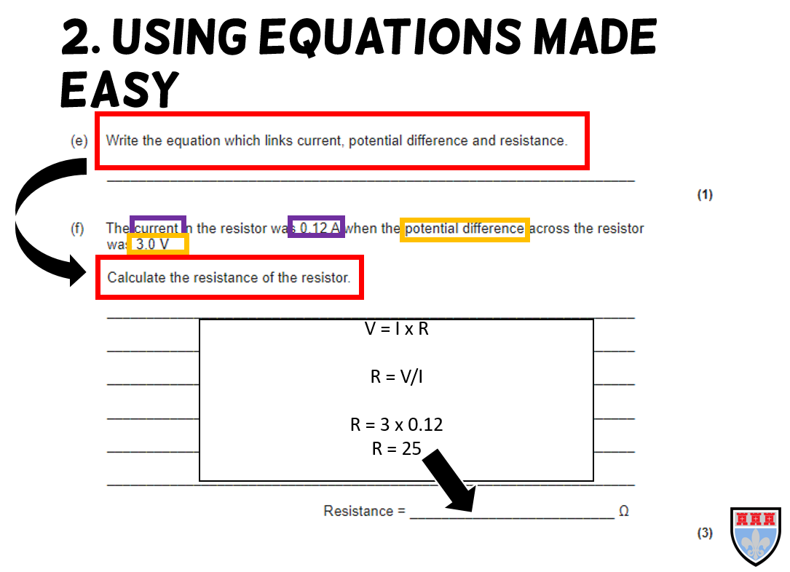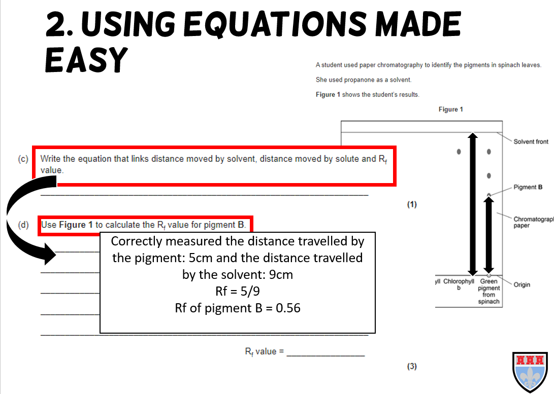

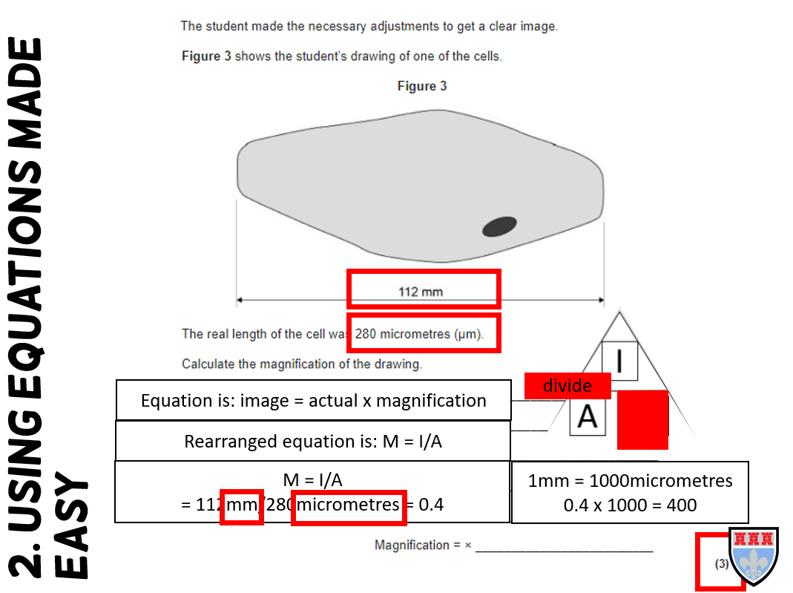

Now try the questions and self-assess them using the mark schemes, ask your teacher if you are still unsure!

Q1.
Figure 1 shows water being heated. Eventually the water changed into steam.
Figure 1
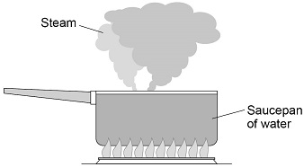
(a) Complete the sentences.
Choose answers from the box.
Each answer may be used once, more than once or not at all.

greater than less than the same as
The distance between the particles in steam is __________________________ the
distance between the particles in liquid water.
The density of steam is __________________________ the density of liquid water.
(2)
Figure 2 shows how the temperature of the water varied with time.
Figure 2
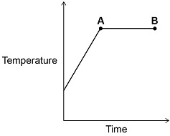
(b) What is the name of the process that is taking place between points A and B?
Give a reason for your answer.
Process ____________________________________________________________
Reason ____________________________________________________________
___________________________________________________________________
(2)
(c) A mass of 0.063 kg of water was turned into steam.
The specific latent heat of vaporisation of water is 2 260 000 J/kg
Calculate the thermal energy transferred to the water to turn it into steam.
Use the equation:
thermal energy for a change of state = mass ×specific latent heat
___________________________________________________________________
___________________________________________________________________
___________________________________________________________________
Energy = ___________________________ J
(2)
(d) The mass of the steam was 0.063 kg
The volume of the steam was 0.105 m³
Calculate the density of steam.
Use the equation:
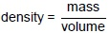
Choose the unit from the box.

kg m³ / kg kg / m³
___________________________________________________________________
___________________________________________________________________
___________________________________________________________________
Density = ________________________ Unit __________________
(3)
(Total 9 marks)
Q2.
The following figure shows a person sliding down a zip wire.
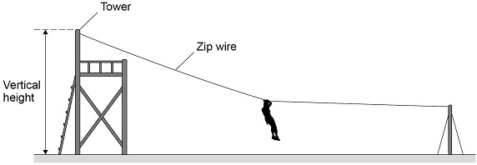
(a) Describe how the vertical height of the tower could be measured accurately.
___________________________________________________________________
___________________________________________________________________
___________________________________________________________________
___________________________________________________________________
(2)
(b) When using the zip wire, the person moved through a vertical height of 2.0 m
The person has a mass of 45 kg
gravitational field strength = 9.8 N/kg
Calculate the change in gravitational potential energy of the person.
Use the equation:
gravitational potential energy = mass × gravitational field strength × height
___________________________________________________________________
___________________________________________________________________
___________________________________________________________________
___________________________________________________________________
Change in gravitational potential energy = _______________________ J
(2)
(c) Give three factors that affected the kinetic energy of the person as she reached the bottom of the zip wire.
1 _________________________________________________________________
___________________________________________________________________
2 _________________________________________________________________
___________________________________________________________________
3 _________________________________________________________________
___________________________________________________________________
(3)
(Total 7 marks)
Q3.
Figure 1 shows a circuit diagram.
Figure 1
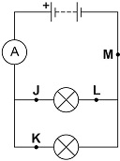
(a) In which position could a switch be placed so that both lamps can be switched on or off at the same time?
Tick (✓) one box.

J |  | K |  | L |  | M
(1)
(b) Draw the circuit symbol for a switch in the box below.

(1)
(c) In 30 seconds, 24 coulombs of charge flow through the battery.
Calculate the current in the battery.
Use the equation:
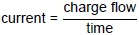
___________________________________________________________________
___________________________________________________________________
___________________________________________________________________
___________________________________________________________________
Current = ___________________________ A
(2)
(d) There is a potential difference of 3.6 V across the battery.
Calculate the energy transferred by the battery when 60 coulombs of charge flows through the battery.
Use the equation:
energy transferred = charge flow × potential difference
___________________________________________________________________
___________________________________________________________________
___________________________________________________________________
___________________________________________________________________
Energy transferred = ___________________________ J
(2)
A student built Circuit X and Circuit Y shown in Figure 2.
The components used in each circuit were identical.
Figure 2
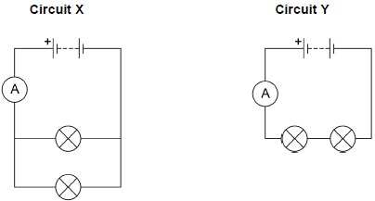
(e) How would the reading on the ammeter in Circuit Y compare to the reading on the ammeter in Circuit X?
Tick (✓) one box.

The reading in Y would be higher.
The reading in Y would be lower.
The readings would be the same.
(1)
(f) How does the total resistance of Circuit Y compare with the total resistance of Circuit X?
Tick (✓) one box.

The total resistance of Y is greater.
The total resistance of Y is less.
The total resistance is the same.
(1)
The student built another circuit which is shown in Figure 3.
Figure 3
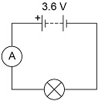
(g) Write down the equation which links current, potential difference and resistance.
___________________________________________________________________
(1)
(h) There is a potential difference of 3.6 V across the lamp in Figure 3.
The current through the lamp is 0.80 A
Calculate the resistance of the lamp.
___________________________________________________________________
___________________________________________________________________
___________________________________________________________________
Resistance = ___________________________ Ω
(3)
(Total 12 marks)
Q4.
Light bulbs are labelled with a power input.
(a) What does power input mean?
Tick (✓) one box.

The charge transferred each second by the bulb.
The current through the bulb.
The energy transferred each second to the bulb.
The potential difference across the bulb.
(1)
(b) Write down the equation which links current, potential difference and power.
___________________________________________________________________
(1)
(c) A light bulb has a power input of 40 W
The mains potential difference is 230 V
Calculate the current in the light bulb.
___________________________________________________________________
___________________________________________________________________
___________________________________________________________________
Current = ________________________________ A
(3)
The following table shows information about three different light bulbs.

Light bulb | Total power input in watts | Useful power output in watts | Efficiency
P | 6.0 | 5.4 | 0.90
Q | 40 | 2.0 | 0.05
R | 9.0 | X | 0.30
(d) Write down the equation which links efficiency, total power input and useful power output.
___________________________________________________________________
(1)
(e) Calculate the value of X in the table above.
___________________________________________________________________
___________________________________________________________________
___________________________________________________________________
___________________________________________________________________
X = ___________________________ W
(3)
(f) In addition to power input, light bulbs should also be labelled with the rate at which they emit visible light.
Suggest why.
___________________________________________________________________
___________________________________________________________________
___________________________________________________________________
___________________________________________________________________
(2)
(Total 11 marks)
Q5.
The diagram below shows a ripple tank that a student used to investigate water waves.
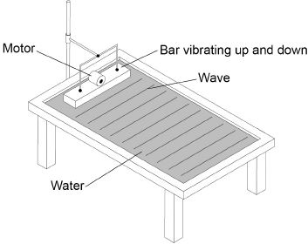
(a) The student adjusted the speed of the motor so that the bar hit the water more times each second.
What happened to the frequency of the waves produced?
Tick one box.

Decreased
Did not change
Increased
(1)
(b) Describe how the frequency of the water waves in the ripple tank can be measured.
___________________________________________________________________
___________________________________________________________________
___________________________________________________________________
___________________________________________________________________
(2)
(c) The student measured the frequency of the water waves as 5 hertz.
Calculate the period of the water waves.
Use the equation:
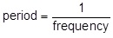
Choose the unit.

metres | metres / second | seconds
___________________________________________________________________
___________________________________________________________________
___________________________________________________________________
___________________________________________________________________
Period = ____________________ Unit = ____________________
(3)
(Total 6 marks)
Q6.
(a) Which one of the following is not an electromagnetic wave?
Tick one box.

Gamma rays | 
Sound
Ultraviolet
X-rays
(1)
(b) What type of electromagnetic wave do our eyes detect?
___________________________________________________________________
(1)
(c) What is a practical use for infrared waves?
Tick one box.

Cooking food
Energy efficient lamps
Medical imaging
Satellite communications
(1)
Scientists have detected radio waves emitted from a distant galaxy.
Some of the radio waves from the distant galaxy have a frequency of 1 200 000 000 hertz.
(d) Which is the same as 1 200 000 000 hertz?
Tick one box.

1.2 gigahertz
1.2 kilohertz
1.2 megahertz
1.2 millihertz
(1)
(e) Radio waves travel through space at 300 000 kilometres per second (km/s).
How is 300 000 km/s converted to metres per second (m/s)?
Tick one box.

300 000 ÷ 1000 = 300 m/s
300 000 × 1000 = 300 000 000 m/s
300 000 + 1000 = 301 000 m/s
300 000 – 1000 = 299 000 m/s
(1)
(f) Write the equation which links frequency, wavelength and wave speed.
___________________________________________________________________
(1)
(g) Calculate the wavelength of the radio waves emitted from the distant galaxy.
Give your answer in metres.
___________________________________________________________________
___________________________________________________________________
___________________________________________________________________
wavelength = ____________________ m
(3)
(Total 9 marks)

Mark schemes
Q1.
(a) greater than
1
less than
1
in this order only
(b) boiling
ignore evaporation
1
temperature is constant
allow temperature remains the same
1
(c)
a correct answer that rounds to 140 000 (J) scores 2 marks
E = 0.063 × 2 260 000
1
E = 140 000 (J)
allow 142 380 (J)
1
(d)
an answer of 0.6 scores 2 marks
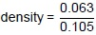
1
density = 0.6
1
kg / m³
1
[9]
Q2.
(a) use a tape measure
allow use a metre rule
allow use a laser measure
1
one person holding the top and another person holding the bottom
or
use a set square to ensure tape measure is vertical
allow use a plumb-line to ensure tape measure is vertical
or
take repeat readings and calculate a mean
1
(b) E_{p} = 45 × 9.8 × 2.0
an answer of 880 (J) or 882 (J) scores 2 marks
1
E_{p} = 880 (J)
1
(c) any 3 from:
• change in vertical height
• mass / weight
• speed / velocity
• air resistance or drag
allow body position
allow wind
• friction (between zip line and pulley)
• gradient / angle (of the zip wire)
• length of zip wire
ignore gravitational field strength
3
[7]
Q3.
(a) M
1
(b)
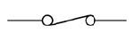
or
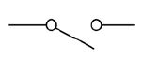
1
(c)
an answer of 0.8 (A) scores 2 marks
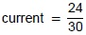
1
current = 0.80 (A)
1
(d)
an answer of 216 (J) scores 2 marks
E = 60 × 3.6
1
E = 216 (J)
1
(e) The reading in Y would be lower
1
(f) The total resistance of Y is greater
1
(g) potential difference = current × resistance
or
V = IR
1
(h)
an answer of 4.5 (Ω) scores 3 marks
3.6 = 0.80 × R
1
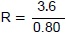
1
R = 4.5 (Ω)
1
[12]
Q4.
(a) The energy transferred each second to the bulb.
1
(b) power = potential difference × current
or
P = VI
1
(c)
an answer of 0.17 (A) scores 3 marks
40 = I × 230
1
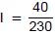
1
I = 0.17 (A)
a correct answer that rounds to 0.17 (A) scores 3 marks
1
(d)
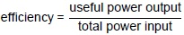
1
(e)
an answer of 2.7 (W) scores 3 marks
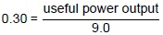
1
useful power output = 0.30 × 9.0
1
useful power output = 2.7 (W)
1
(f) bulbs also transfer thermal energy
allow light bulbs emit infrared radiation as well as visible light
ignore so people know how bright the bulb is
1
the efficiency of the light bulb also needs to be considered
allow the cost to power the light bulb depends on the efficiency
allow to see how much energy is wasted
1
[11]
Q5.
(a) increased
1
(b) (count) how many waves pass a point
1
in one second
this is dependent on the first mark point being awarded
1
or
(count) number of waves that pass a point in a given time
allow a specific time for a given time
or
(count) number of waves that are produced in a given time (1)
and divide by that time in seconds
this is dependent on the first mark point being awarded
allow an answer in terms of measuring the frequency of the vibrating bar
(c) 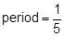
1
period = 0.2
1
seconds / s
1
[6]
Q6.
(a) sound
1
(b) (visible) light
1
(c) cooking food
1
(d) 1.2 gigahertz
1
(e) 300 000 × 1000 = 300 000 000 m/s
1
(f) wave speed = frequency × wavelength
allow v = f λ
1
(g) 300 000 000 = 1200 000 000 × λ
an answer of 0.25 scores 3 marks
1
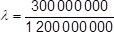
allow ecf from (e)
1
λ = 0.25 (m)
1
[10]

