2. Using equations: CHEMISTRY
Here are some worked examples from all sciences that will help you!
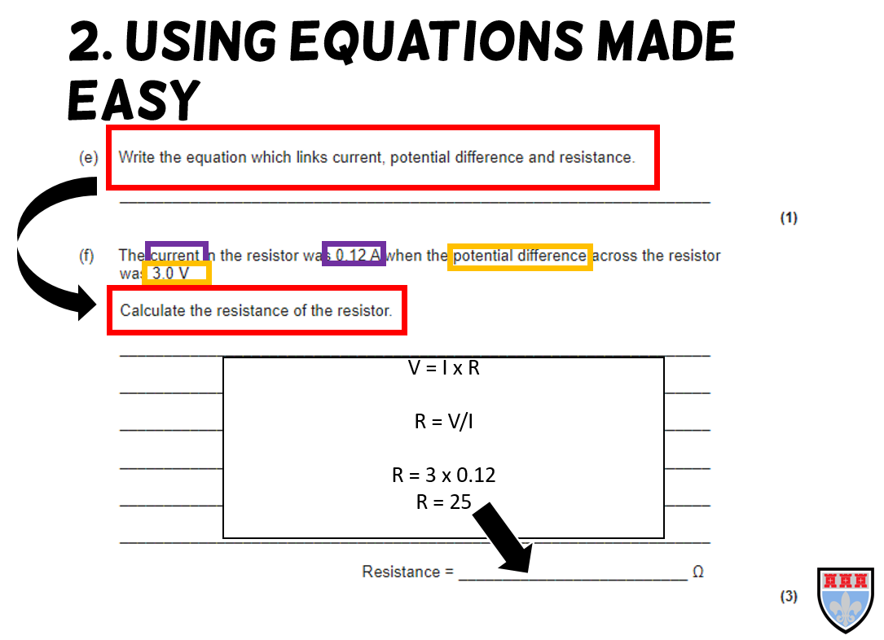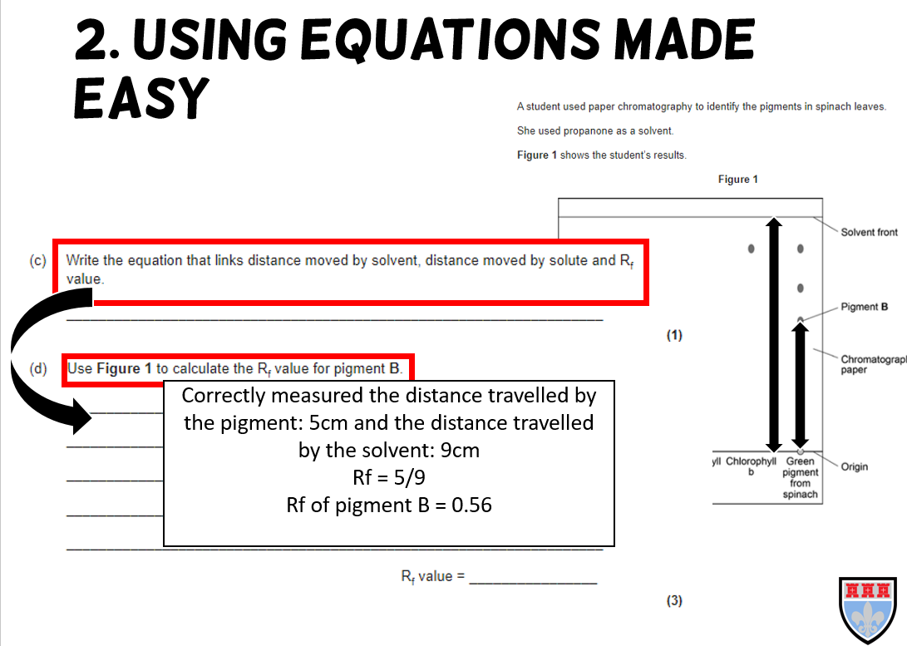

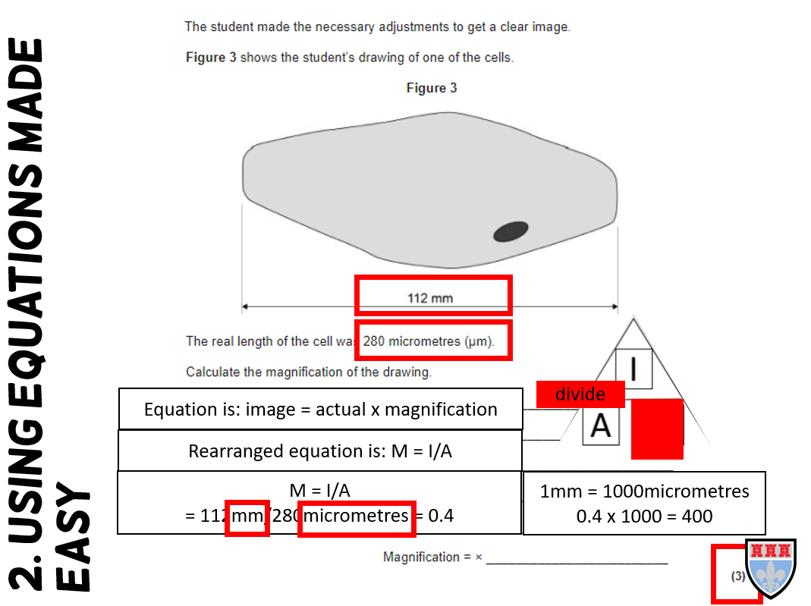

Now try the questions and self-assess them using the mark schemes, ask your teacher if you are still unsure!

Q1.
This question is about the structure of the atom.
(a) Complete the sentences.
Choose answers from the box.
Each word may be used once, more than once, or not at all.

electron |  | ion |  | neutron
 | nucleus |  | proton
The centre of the atom is the _______________________ .
The two types of particle in the centre of the atom are the proton
and the _______________________ .
James Chadwick proved the existence of the _______________________ .
Niels Bohr suggested particles orbit the centre of the atom. This type of particle
is the _______________________ .
The two types of particle with the same mass are the neutron
and the _______________________ .
(5)
The table below shows information about two isotopes of element X.

 | Mass number | Percentage (%) abundance
Isotope 1 | 63 | 70
Isotope 2 | 65 | 30
(b) Calculate the relative atomic mass (A_{r}) of element X using the equation:
Use the table above.
Give your answer to 1 decimal place.
___________________________________________________________________
___________________________________________________________________
___________________________________________________________________
___________________________________________________________________
A_{r} = _________________
(2)
(c) Suggest the identity of element X.
Use the periodic table.
Element X is _______________________________________________________
(1)
(d) The radius of an atom of element X is 1.2 × 10⁻¹⁰ m
The radius of the centre of the atom is 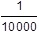 the radius of the atom.
Calculate the radius of the centre of an atom of element X.
Give your answer in standard form.
___________________________________________________________________
___________________________________________________________________
___________________________________________________________________
___________________________________________________________________
Radius = ___________________ m
(2)
(Total 10 marks)
Q2.
Polymers are used to make fabrics.
Table 1 shows some properties of two polymers.
Table 1

Property | Polymer J | Polymer K
Density in g/cm³ | 0.9 | 1.4
Melting point in °C | 165 | 260
Flame resistance | Poor | Good
Water absorption | Low | High
(a) Polymer fabrics are used to make firefighter uniforms.
Complete Table 2 by deciding for each property whether polymer J or polymer K is best for firefighter uniforms.
Use Table 1.
Density has been completed for you.
Tick three boxes.
Table 2

Property | Polymer J | Polymer K
Density in g/cm³ | ✓
Melting point in °C
Flame resistance
Water absorption
(2)
(b) A firefighter uniform made from polymer J has a mass of 6.0 kg
Calculate the mass of a uniform of the same size made from polymer K.
Use Table 1 and the equation:
___________________________________________________________________
___________________________________________________________________
___________________________________________________________________
Mass of uniform made from polymer K = ______________________ kg
(2)
(c) Polymers J and K are both thermosoftening polymers.
Polymer L is a thermosetting polymer.
Why would polymer L be better than polymers J and K for firefighter uniforms?
Tick one box.

Polymer L burns easily | 
Polymer L does not biodegrade
Polymer L will not melt
(1)
Polymers J and K are made from crude oil.
In the past, firefighter uniforms were made from wool.
Wool is obtained from sheep.
(d) Why are many fabrics made from polymers instead of wool?
Tick one box.

Polymers are man-made
Polymers are more hard-wearing
Wool is more easily available
Wool is more flame resistant
(1)
(e) Why is wool more sustainable than polymers J and K for making firefighter uniforms?
___________________________________________________________________
___________________________________________________________________
___________________________________________________________________
___________________________________________________________________
(2)
(Total 8 marks)
Q3.
Read the article.

Problem food colourings
Scientists say they have evidence that some
food colourings cause hyperactive behaviour in
young children.
These food colourings are added to some sweets.
W, X, Y and Z are food colourings that may cause hyperactive behaviour in young children.
A scientist used chromatography to see if these food colourings were used in two sweets, S and P.
The results are shown on the chromatogram.
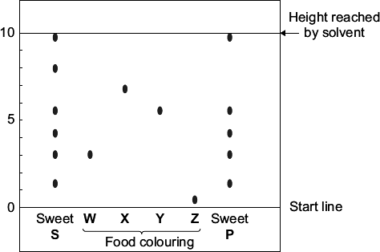
(a) Food colourings, such as W, X, Y and Z, are added to some sweets.
Suggest one reason why.
___________________________________________________________________
___________________________________________________________________
(1)
(b) In chromatography, the R_{f} value = 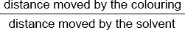
Use the scale on the chromatogram to help you to answer this question.

Which food colouring, W, X, Y or Z, has an R_{f} value of 0.7?
(1)
(c) From the chromatogram, what conclusions can the scientist make about the colourings in sweets S and P?
___________________________________________________________________
___________________________________________________________________
___________________________________________________________________
___________________________________________________________________
___________________________________________________________________
___________________________________________________________________
___________________________________________________________________
___________________________________________________________________
___________________________________________________________________
(3)
(Total 5 marks)
Q4.
Iron is an essential part of the human diet. Iron(II) sulfate is sometimes added to white bread flour to provide some of the iron in a person’s diet.
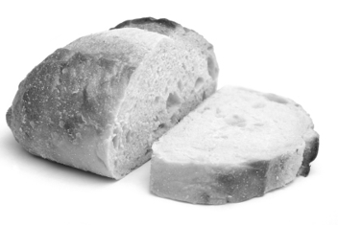
(a) The formula of iron(II) sulfate is FeSO₄
Calculate the relative formula mass (M_{r}) of FeSO₄
Relative atomic masses: O = 16; S = 32; Fe = 56.
___________________________________________________________________
___________________________________________________________________
The relative formula mass (M_{r}) = _______________
(2)
(b) What is the mass of one mole of iron(II) sulfate? Remember to give the unit.
_______________
(1)
(c) What mass of iron(II) sulfate would be needed to provide 28 grams of iron?
Remember to give the unit.
_______________
(1)
(Total 4 marks)

Mark schemes
Q1.
(a) nucleus
1
neutron
1
neutron
1
electron
1
proton
1
must be in this order
(b) 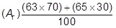
1
= 63.6
1
an answer of 63.6 scores 2 marks
(c) copper / Cu
allow ecf from answer to question (b)
1
(d) 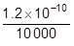
or
1.2 × 10⁻¹⁰ × 1 × 10⁻⁴
1
= 1.2 × 10⁻¹⁴ (m)
1
an answer of 1.2 × 10⁻¹⁴ (m) scores 2 marks
a correct answer not in standard form scores 1 mark
[10]
Q2.
(a)
property | J | K
density in g/cm³
melting point in °C |  | ✓
flame resistance |  | ✓
water absorption | ✓
three correct = 2 marks
one or two correct = 1 mark
2
(b) 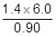
1
= 9.3 (kg)
allow 9.3(333…)(kg)
1
an answer of 9.3(333… )(kg) scores 2 marks
(c) polymer L will not melt
1
(d) polymers are more hard-wearing
1
(e) any two from:
• (wool / sheep) renewable
allow wool grows back, etc.
• (wool) will not run out
ignore (wool is) readily available
• (crude oil) non-renewable
allow finite
• (crude oil) will run out
ignore references to cost
ignore properties from tables 1 and 2
2
[8]
Q3.
(a) (improve) appearance
allow add colour
allow these food colourings have not been proven to cause hyperactive behaviour in young children
do not accept taste / flavour / preservatives
ignore reference to E-numbers
1
(b) X
1
(c) any three from:
• S contains six / 6 colourings
• P contains five / 5 colourings
if neither of first 2 bullet points given allow 1 mark for S contains more colours than P or converse
• both S and P contain the same
five / 5 colourings
• both contain W and Y
• both sweets (may) cause hyperactivity
ignore unsafe
• neither contain X and Z
3
[5]

Q4.
(a) 152 correct answer with or without working = 2 marks
56 + 32 + (4 ×16) gains 1 mark
ignore any units
2
(b) 152g(rams)
ecf from the answer to (a) and g
must have unit g / gram / gramme / grams etc
accept g / mol or g per mole or g mole^{–1} or g/mol or g per mol or g mol^{–1}
do not accept g m
do not accept G
1
(c) 76(g)
ecf from their answer to (a) or (b) divided by 2
ignore units
1
[4]

