2. Using equations: BIOLOGY
Here are some worked examples from all sciences that will help you!

Now try the questions and self-assess them using the mark schemes, ask your teacher if you are still unsure!

Q1.
Figure 1 shows the production of sperm cells in humans.
Figure 1
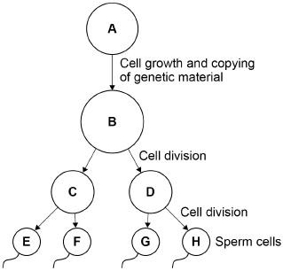
(a) Cell A is a normal body cell.
How many chromosomes are there in cell A?
Tick (✓) one box.

23 |  | 46 |  | 48 |  | 92
(1)
(b) What is the mass of DNA in cell E?
Tick (✓) one box.

A quarter of the mass of the DNA in cell A
Half the mass of the DNA in cell A
The same mass as the DNA in cell A
Twice the mass of the DNA in cell A
(1)
(c) What type of cell division produces sperm cells?
Tick (✓) one box.

Binary fission
Differentiation
Meiosis
(1)
(d) Sometimes there are errors in copying the genetic material.
What term describes an error in the genetic material?
Tick (✓) one box.

Absorption
Fertilisation
Mitosis
Mutation
(1)
(e) A woman has three children, aged 4, 6 and 9 years.
Why are the children not genetically identical?
___________________________________________________________________
___________________________________________________________________
___________________________________________________________________
___________________________________________________________________
(2)
In sexual reproduction, a sperm cell fuses with an egg cell to form a new single cell.
An embryo develops from the single cell.
The cell divides three times to produce the embryo.
(f) How many cells are there in the embryo after three cell divisions?
Tick (✓) one box.

3 |  | 6 |  | 8 |  | 9
(1)
Figure 2 shows a different human embryo.
Figure 2
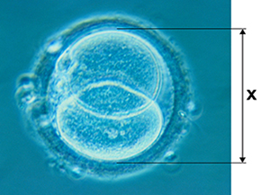
(g) Measure image length X on Figure 2.
Give your answer in millimetres (mm).
X = _____________________________ mm
(1)
(h) The image in Figure 2 has been magnified × 500
Calculate the real length of the embryo.
Use the equation:
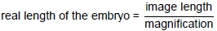
Give your answer in micrometres (µm).
1 mm = 1000 µm
___________________________________________________________________
___________________________________________________________________
___________________________________________________________________
___________________________________________________________________
Real length of the embryo = _____________________________ µm
(3)
(i) The embryo may not implant in the lining of the uterus.
The embryo will then be lost from the woman’s body several days later.
Explain why the woman may not notice this has happened.
___________________________________________________________________
___________________________________________________________________
___________________________________________________________________
___________________________________________________________________
(2)
(Total 13 marks)
Q2.
Plants are made up of cells, tissues and organs.
(a) Draw one line from each level of organisation to the correct plant part.

Level of organisation |  | Plant part
 |  | Leaf
Organ |  | Root hair
 |  | Spongy mesophyll
Tissue |  | Vacuole
 |  | Xylem
(2)
Figure 1 shows a plant cell drawn to scale.
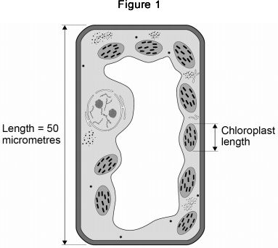
(b) Where in a plant would the cell in Figure 1 be found?
Tick one box.

Epidermis
Palisade mesophyll
Phloem
Xylem
(1)
(c) Calculate the length of the chloroplast labelled in Figure 1.
___________________________________________________________________
___________________________________________________________________
___________________________________________________________________
___________________________________________________________________
Length = ____________________ micrometres
(2)
(d) Cells in plant roots do not photosynthesise.
Give one reason why.
___________________________________________________________________
___________________________________________________________________
(1)
(e) As a plant grows, new root hair cells are formed from unspecialised cells.
How does an unspecialised cell become a new root hair cell?
Tick one box.

Differentiation
Metabolism
Transpiration
Transport
(1)
Scientists can clone plants using tissue culture.
Figure 2 shows the process of tissue culture.
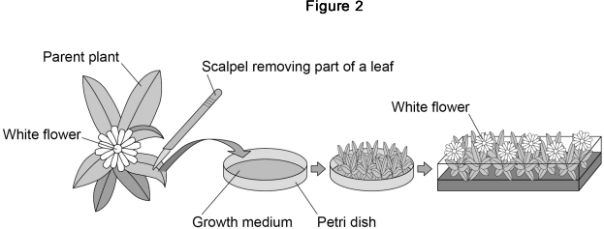
(f) Why might scientists want to clone plants?
Tick one box.

To create new species of plants.
To introduce variation into plants.
To protect endangered plants from extinction.
To reduce disease resistance in plants.
(1)
(g) What is the advantage of cloning plants using tissue culture?
Tick one box.

No special equipment is needed.
Plants can be produced quickly.
The flowers are all different colours.
The offspring are all genetically different.
(1)
(h) The growth medium in Figure 2 helps the plants to grow.
Name one substance in the growth medium.
___________________________________________________________________
___________________________________________________________________
(1)
(Total 10 marks)
Q3.
The image below shows some muscle cells from the wall of the stomach, as seen through a light microscope.
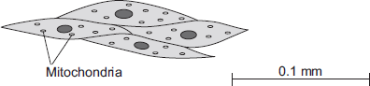
(a) Describe the function of muscle cells in the wall of the stomach.
___________________________________________________________________
___________________________________________________________________
___________________________________________________________________
___________________________________________________________________
(2)
(b) The figure above is highly magnified.
The scale bar in the figure above represents 0.1 mm.
Use a ruler to measure the length of the scale bar and then calculate the magnification of the figure above.
___________________________________________________________________
___________________________________________________________________
___________________________________________________________________
___________________________________________________________________
Magnification = _______________ times
(2)
(c) The muscle cells in Figure above contain many mitochondria.
What is the function of mitochondria?
___________________________________________________________________
___________________________________________________________________
___________________________________________________________________
___________________________________________________________________
(2)
(d) The muscle cells also contain many ribosomes. The ribosomes cannot be seen in the figure above.
(i) What is the function of a ribosome?
______________________________________________________________
______________________________________________________________
(1)
(ii) Suggest why the ribosomes cannot be seen through a light microscope.
______________________________________________________________
______________________________________________________________
(1)
(Total 8 marks)

Mark schemes
Q1.
(a) 46
1
(b) half the mass of the DNA in cell A
1
(c) meiosis
1
(d) mutation
1
(e) any two from:
• different egg / sperm each time
• genes from two parents
• each gamete / egg / sperm has different alleles / genes / DNA / genetic information
ignore different chromosomes
ignore the children have different genes / alleles
2
(f) 8
1
(g) 40
allow in range 39 to 41
1
(h)
an answer of 80 scores 3 marks
allow ecf from part (g) for 3 marks
an answer of 0.08 scores 2 marks
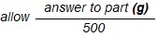
1
× 1000
1
80
an answer from mp1 but not × 1000 scores 2 marks
1
(i) embryo is (very) small
1
(so) embryo not seen / felt
or
lost in normal menstrual flow
ignore not noticed
1
[13]
Q2.
(a)
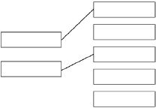
additional line from a level of organisation negates the mark for that level of organisation
2
(b) palisade mesophyll
1
(c)
1
6 / 6.25 / 6.3 (micrometres)
1
an answer of 6 / 6.25 / 6.3 scores 2 marks
(d) they have no chloroplasts / chlorophyll
allow they are underground
allow they don’t get (access to) light
allow (because) photosynthesis needs light
allow they can’t absorb light
ignore ‘sun’
ignore ‘it is dark’
1
(e) differentiation
1
(f) to protect endangered plants from extinction
1
(g) plants can be produced quickly
1
(h) any one from:
• glucose / sugars / starch
• amino acids / protein
• hormones
allow named hormones e.g. auxin
• ions / minerals
allow magnesium / nitrate
• vitamins
allow named vitamins e.g. vitamin B
• water
allow H₂O / H2O
ignore oxygen / carbon dioxide / agar / nutrients / fertiliser
1
[10]
Q3.
(a) contract / shorten
ignore relax
do not allow expand
1
to churn / move / mix food
accept peristalsis / mechanical digestion
ignore movement unqualified
1
(b) 400
acceptable range 390-410
allow 1 mark for answer in range of 39 to 41
allow 1 mark for answer in range of 3900 to 4100
2
(c) to transfer energy for use
allow to release / give / supply / provide energy
do not allow to ‘make’ / ߢproduce’ / ‘create’ energy
allow to make ATP
ignore to store energy
1
by (aerobic) respiration or from glucose
do not allow anaerobic
energy released for respiration = max 1 mark
1
(d) (i) to make protein / enzyme
ignore ‘antibody’ or other named protein
1
(ii) too small / very small
allow light microscope does not have sufficient magnification / resolution
allow ribosomes are smaller than mitochondria
ignore not sensitive enough
ignore ribosomes are transparent
1
[8]

