4. Graphs: PHYSICS
Here are some worked examples from all sciences that will help you!
Tip: the independent variable (the one you change) is always on the x axis! In this case the organism!
Tip: the dependent variable (the one you measure) is always on the y axis! In this case the biomass in g! Don’t forget your units!

Tip: you always do a bar chart when one set of data is a thing or category and then the other is continous (numbers)

Tip: when drawing a line of best fit, try and hit as many of the points as possible, you are trying to show the trend. This can also be a curve sometimes!

Now try the questions and self-assess them using the mark schemes, ask your teacher if you are still unsure!

Q1.
A student carried out an investigation to determine the spring constant of a spring.
The table below gives the data obtained by the student.

Force in N | Extension in cm
0 | 0.0
2 | 3.5
4 | 8.0
6 | 12.5
8 | 16.0
10 | 20.0
(a) Describe a method the student could have used to obtain the data given in the table above.
Your answer should include any cause of inaccuracy in the data.
Your answer may include a labelled diagram.
.........
(6)
(b) The student measured the extension for five different forces rather than just measuring the extension for one force.
Suggest why.
___________________________________________________________________
___________________________________________________________________
(1)
The diagram below shows some of the data obtained by the student.
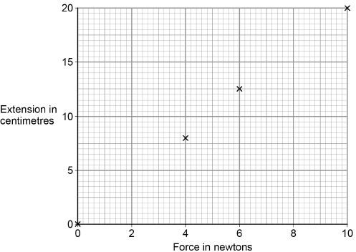
(c) Complete the diagram above by plotting the missing data from the table above.
Draw the line of best fit.
The table above is repeated here to help you answer this question.

Force in N | Extension in cm
0 | 0.0
2 | 3.5
4 | 8.0
6 | 12.5
8 | 16.0
10 | 20.0
(2)
(d) Write down the equation that links extension, force and spring constant.
___________________________________________________________________
(1)
(e) Calculate the spring constant of the spring that the student used.
Give your answer in newtons per metre.
___________________________________________________________________
___________________________________________________________________
___________________________________________________________________
___________________________________________________________________
Spring constant = ______________________ N/m
(4)
(f) Hooke’s Law states that:
‘The extension of an elastic object is directly proportional to the force applied, provided the limit of proportionality is not exceeded.’
The student concluded that over the range of force used, the spring obeyed Hooke’s Law.
Explain how the data supports the student’s conclusion.
___________________________________________________________________
___________________________________________________________________
___________________________________________________________________
___________________________________________________________________
(2)
(Total 16 marks)
Q2.
(a) Radioactive sources that emit alpha, beta or gamma radiation can be dangerous.
What is a possible risk to health caused by using a radioactive source?
___________________________________________________________________
___________________________________________________________________
(1)
(b) In an experiment, a teacher put a 2 mm thick lead sheet in front of a radioactive source.
She used a detector and counter to measure the radiation passing through the lead
sheet in one minute.
She then put different numbers of lead sheets, each 2 mm thick, in front of the radioactive source and measured the radiation passing through in one minute.
The apparatus the teacher used is shown in Figure 1.
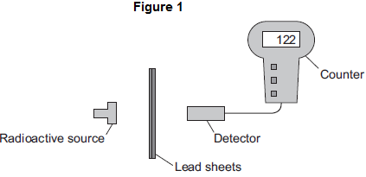
(i) When using a radioactive source in an experiment, how could the teacher reduce the risk to her health?
Suggest one way.
______________________________________________________________
______________________________________________________________
(1)
(ii) The number recorded on the counter is actually higher than the amount of radiation detected from the source.
Complete the following word equation.

The number recorded on the counter | = | The amount of radiation detected from the source | + | ___________________ radiation
(1)
(c) The readings taken by the teacher are plotted in Figure 2.
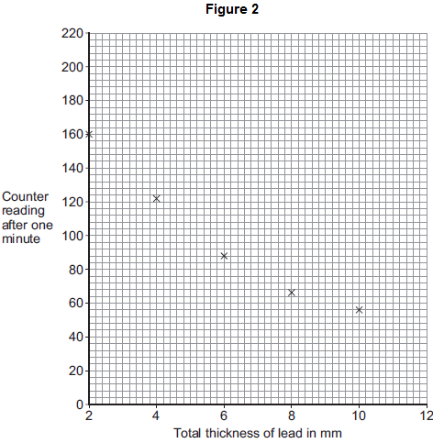
(i) Draw a line of best fit to complete Figure 2.
(1)
(ii) How does the amount of radiation absorbed by the lead change as the total thickness of the lead is increased?
______________________________________________________________
______________________________________________________________
(1)
(iii) Use Figure 2 to estimate the reading on the counter when the total thickness of the lead is increased to 12 mm.
Estimated counter reading = _____________________
(1)
(d) What type of radiation was emitted from the radioactive source?
Draw a ring around the correct answer.

alpha | beta | gamma
Give a reason for your answer.
___________________________________________________________________
___________________________________________________________________
(2)
(Total 8 marks)
Q3.
An investigation was carried out to show how thinking distance, braking distance and stopping distance are affected by the speed of a car.
The results are shown in the table.

Speed  in metres  per second | Thinking  distance  in metres | Braking  distance in  metres | Stopping  distance  in metres
10 | 6 | 6 | 12
15 | 9 | 14 | 43
20 | 12 | 24 | 36
25 | 15 | 38 | 53
30 | 18 | 55 | 73
(a) Draw a ring around the correct answer to complete each sentence.

As speed increases, thinking distance | decreases.  increases.  stays the same.

As speed increases, braking distance | decreases.  increases.  stays the same.
(2)
(b) One of the values of stopping distance is incorrect.
Draw a ring around the incorrect value in the table.
Calculate the correct value of this stopping distance.
___________________________________________________________________
Stopping distance = ________________ m
(2)
(c) (i) Using the results from the table, plot a graph of braking distance against speed.
Draw a line of best fit through your points.
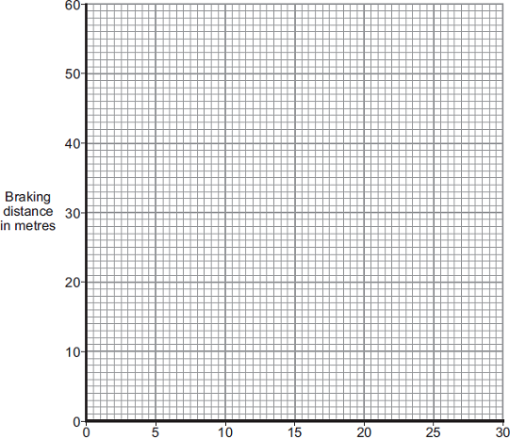
Speed in metres per second
(3)
(ii) Use your graph to determine the braking distance, in metres, at a speed of 22 m / s.
Braking distance = ________________ m
(1)
(d) The speed–time graph for a car is shown below.
While travelling at a speed of 35 m / s, the driver sees an obstacle in the road at time t = 0. The driver reacts and brakes to a stop.
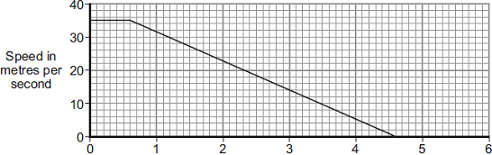
Time in seconds
(i) Determine the braking distance.
______________________________________________________________
______________________________________________________________
______________________________________________________________
______________________________________________________________
Braking distance = ________________ m
(3)
(ii) If the driver was driving at 35 m / s on an icy road, the speed–time graph would be different.
Add another line to the speed–time graph above to show the effect of travelling at 35 m / s on an icy road and reacting to an obstacle in the road at time t = 0.
(3)
(e) A car of mass 1200 kg is travelling with a velocity of 35 m / s.
(i) Calculate the momentum of the car.
Give the unit.
______________________________________________________________
______________________________________________________________
______________________________________________________________
Momentum = _____________________
(3)
(ii) The car stops in 4 seconds.
Calculate the average braking force acting on the car during the 4 seconds.
______________________________________________________________
______________________________________________________________
Force = ________________ N
(2)
(Total 19 marks)
Q4.
A student investigates how the current flowing through a filament lamp changes with the voltage across it.
She is given a filament lamp and connecting wires.
She decides to use a 15V power supply, a variable resistor, an ammeter, a voltmeter and a switch.
(a) Complete the circuit diagram to show how she should set up the circuit.

(4)
(b) The student obtains the following results.

VOLTAGE (V) | 0.0 | 3.0 | 5.0 | 7.0 | 9.0 | 11.0
CURRENT (A) | 0.0 | 1.0 | 1.4 | 1.7 | 1.9 | 2.1
(i) Plot a graph of current against voltage.
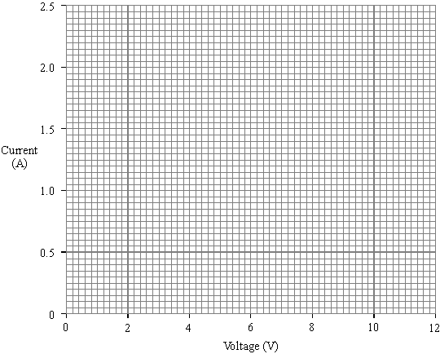
(3)
(ii) Use your graph to find the current when the voltage is 10V.
Current __________ A
(1)
(iii) Use your answer to (ii) to calculate the resistance of the lamp when the voltage is 10V.
______________________________________________________________
______________________________________________________________
______________________________________________________________
Resistance __________ Ω
(2)
(c) (i) What happens to the resistance of the lamp as the current through it increases?
______________________________________________________________
(ii) Explain your answer.
______________________________________________________________
______________________________________________________________
______________________________________________________________
(2)
(Total 12 marks)
Q5.
Figure 1 shows a magnet moving into a coil of wire. This movement causes a reading on the voltmeter.
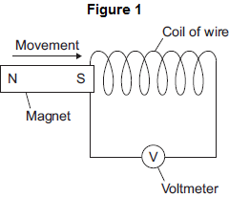
(a) Use the correct word from the box to complete the sentence.

generated | induced | produced
Moving the magnet into the coil of wire causes a reading on the voltmeter because a
potential difference is __________________________ across the ends of the wire.
(1)
(b) A student investigated how the number of turns on the coil of wire affects the maximum voltmeter reading. The student changed the number of turns on the coil of wire, then moved the magnet into the coil. The student recorded the maximum voltmeter reading.
To obtain valid data, suggest two variables that the student should control in this investigation.
1. _________________________________________________________________
___________________________________________________________________
2. _________________________________________________________________
___________________________________________________________________
(2)
(c) The student’s results are shown in Figure 2.
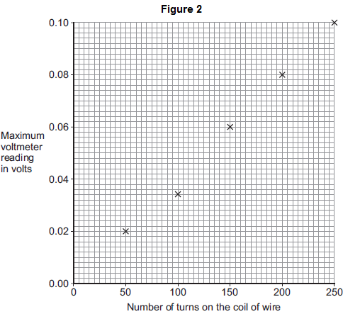
(i) One of the results is anomalous.
Suggest a reason for the anomalous result.
______________________________________________________________
(1)
(ii) Draw a line of best fit on Figure 2.
(1)
(d) A data-logger can automatically record and store data.
It may have been better for the student to have used a data-logger in his investigation rather than a voltmeter.
Suggest one reason why.
___________________________________________________________________
___________________________________________________________________
(1)
(Total 6 marks)

Mark schemes
Q1.
(a) Level 3: The method would lead to the production of a valid outcome. All key steps are identified and logically sequenced.
5−6
Level 2: The method would not necessarily lead to a valid outcome. Most steps are identified, but the method is not fully logically sequenced.
3−4
Level 1: The method would not lead to a valid outcome. Some relevant steps are identified, but links are not made clear.
1−2
No relevant content
0
Indicative content
set up a clamp stand with a clamp
hang the spring from the clamp
use a second clamp and boss to fix a (half) metre ruler alongside the spring
record the metre ruler reading that is level with the bottom of the spring
hang a 2 N weight from the bottom of the spring
record the new position of the bottom of the spring
calculate the extension of the spring
measure the extension of the spring
add further weights to the spring so the force increases 2 N at a time up to 10 N
for each new force record the position of the bottom of the spring and calculate / measure the extension
possible source of inaccuracy
not fixing the ruler in position but simply holding the ruler next to the spring
not clamping the ruler vertical
misjudging the position of the bottom of the spring
parallax error
allow any other sensible suggestion that could reasonably lead to inaccuracy in the data
allow a description that would increase accuracy
repeating the measurements is insufficient
(b) to identify any anomalous results
allow calculate an average for the spring constant
or
to reduce the effect of random error
allow (more) accurate
to obtain an average is insufficient
to be able to draw a graph is insufficient
1
(c) both points plotted correctly
1
correct line of best fit drawn
to pass through (0,0) and (10,20)
1
(d) force = spring constant × extension
allow F = ke
1
(e) extension = 0.2
allow 0.035 / 0.08 / 0.125 / 0.16
1
10 = k × 0.2
force value must match extension
this mark may be awarded if e is in cm
1
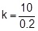
allow correct transformation of their chosen values
this mark may be awarded if e is in cm
1
k = 50
an answer 0.5 scores 3 marks
1
an answer of 50 scores 4 marks
(f) the line is straight
allow the line does not curve
1
and passes through the origin
this mark is dependent on scoring the first mark
allow a correct description of direct proportionality for 2 marks
ignore the line shows they are directly proportional
1
[16]
Q2.
(a) cell damage or cancer
accept kills / mutates cells
radiation poisoning is insufficient
ionising is insufficient
1
(b) (i) any one from:
• use tongs to pick up source
• wear gloves
• use (lead) shielding
• minimise time (of exposure)
• maximise distance (between source and teacher).
accept any other sensible and practical suggestion
ignore reference to increasing / decreasing the number / thickness of lead sheets
1
(ii) background
1
(c) (i) curve drawn from point 2,160
do not accept straight lines drawn from dot to dot
1
(ii) (also) increases
less radiation passes through is insufficient
1
(iii) 50
accept any value from 40 to 56 inclusive
1
(d) gamma
1
only gamma (radiation) can pass through lead
accept alpha and beta cannot pass through lead
a general property of gamma radiation is insufficient
1
[8]
Q3.
(a) increases
1
increases
1
(b) 23 (m)
accept 43 circled for 1 mark
accept 9 + 14 for 1 mark
2
(c) (i) all points correctly plotted
all to ± ½ small square
one error = 1 mark
two or more errors = 0 marks
2
line of best fit
1
(ii) correct value from their graph (± ½ small square)
1
(d) (i) 70
½ × 35 × 4 gains 2 marks
attempt to estimate area under the graph for 1 mark
3
(ii) line from (0.6,35)
1
sloping downwards with a less steep line than the first line
1
cutting time axis at time > 4.6 s
accept cutting x-axis at 6
1
(e) (i) 42 000
1200 × 35 gains 1 mark
2
kgm / s
Ns
1
(ii) 10 500 (N)
42 000 / 4 gains 1 mark
alternatively:
a = 35 / 4 = 8.75 m / s²
F = 1200 × 8.75
2
[19]
Q4.
(a) 4 symbols correct accept
(accept for bulb; lose 1 mark if line through symbols, lose 1 mark if circuit incorrect, switch may be open or closed)
(allow or )
gains 1 mark
4
but
all correct
gains 2 marks
ammeter in series with lamp
for one mark
voltmeter in parallel with lamp / lamp and switch / lamp, switch and ammeter
for one mark
(b) (i) 5 points correctly plotted
allow (0, 0) correct if graph goes through the origin even if no × or O
gains 1 mark
but
6 points correctly plotted
gains 2 marks
smooth curve through points – not straight line / curve + straight line
for one mark
3
(ii) 2 (A)
allow 0.05 (½ square) from candidates’ graph
for one mark
1
(iii) R = V / I or R = 10 / 2
gains 1 mark
but
R = 5 (Ohms) ecf
gains 2 marks
2
(c) (i) resistance increases
for one mark
(ii) temperature (of filament) has increased / filament gets hot
for one mark
2
[12]
Q5.
(a) induced
1
(b) any two from:
• use the same (strength) magnet
same size magnet is insufficient
• the speed that the magnet is moved
accept movement of the magnet
• the area of the turns
same type / length of wire is insufficient
• the magnetic pole being moved towards the coil (of wire).
use the same voltmeter is insufficient
2
(c) (i) voltmeter misread
or
number of turns miscounted
result misread is insufficient
human error is insufficient
allow the magnet was moved at a (slightly) different speed (into the coil) than for the other readings
allow spacing between the turns had changed
1
(ii) line of best fit passing through all points except (100, 0.034)
line does not need to go back to origin
1
(d) any one from:
• can re-check data / readings.
accept can go back to data
• can take more readings (in a given time)
can store data is insufficient
• easier to identify maximum value.
automatically records data is insufficient
accept is more accurate
accept eliminates human error
1
[6]

