4. Graphs: CHEMISTRY
Here are some worked examples from all sciences that will help you!
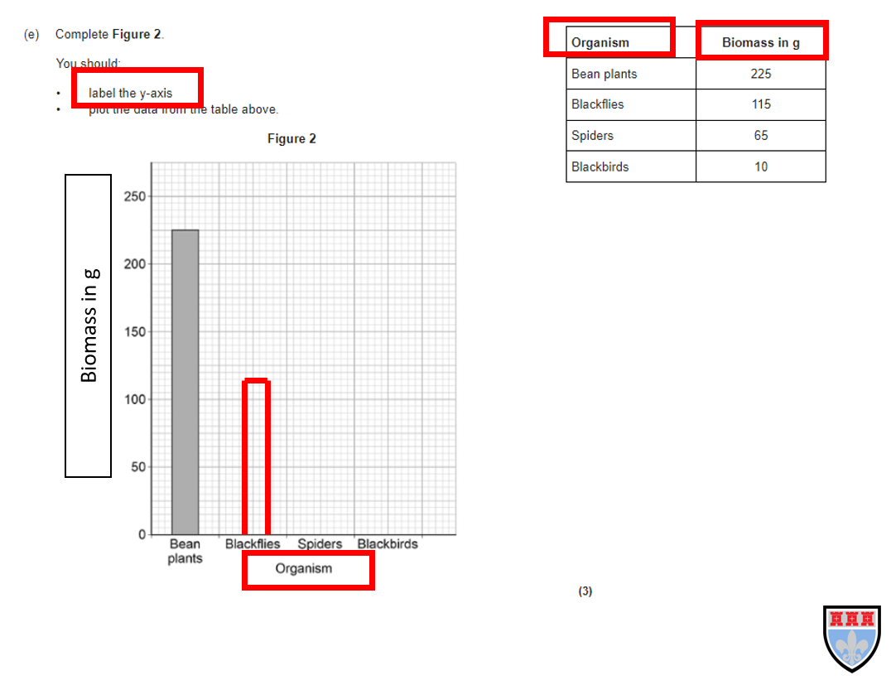
Tip: the independent variable (the one you change) is always on the x axis! In this case the organism!
Tip: the dependent variable (the one you measure) is always on the y axis! In this case the biomass in g! Don’t forget your units!

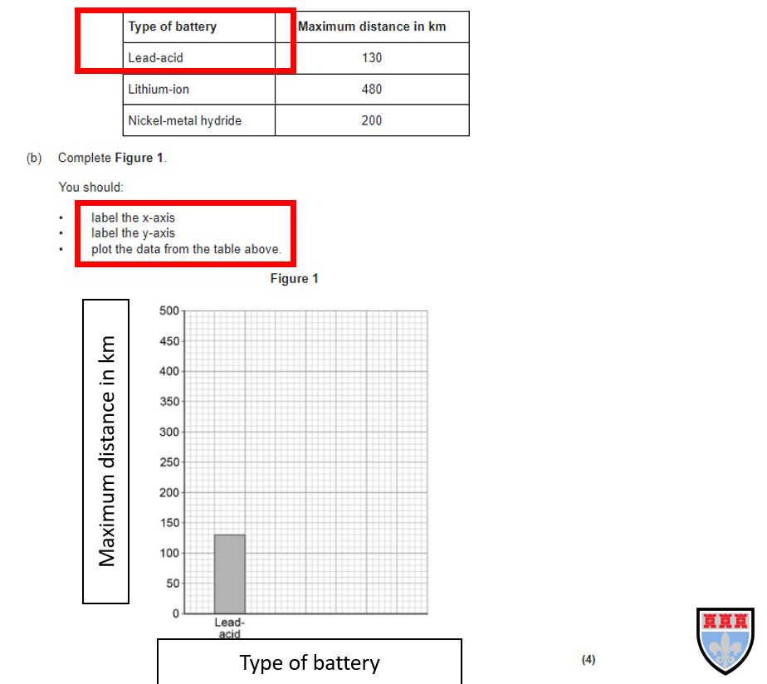
Tip: you always do a bar chart when one set of data is a thing or category and then the other is continous (numbers)

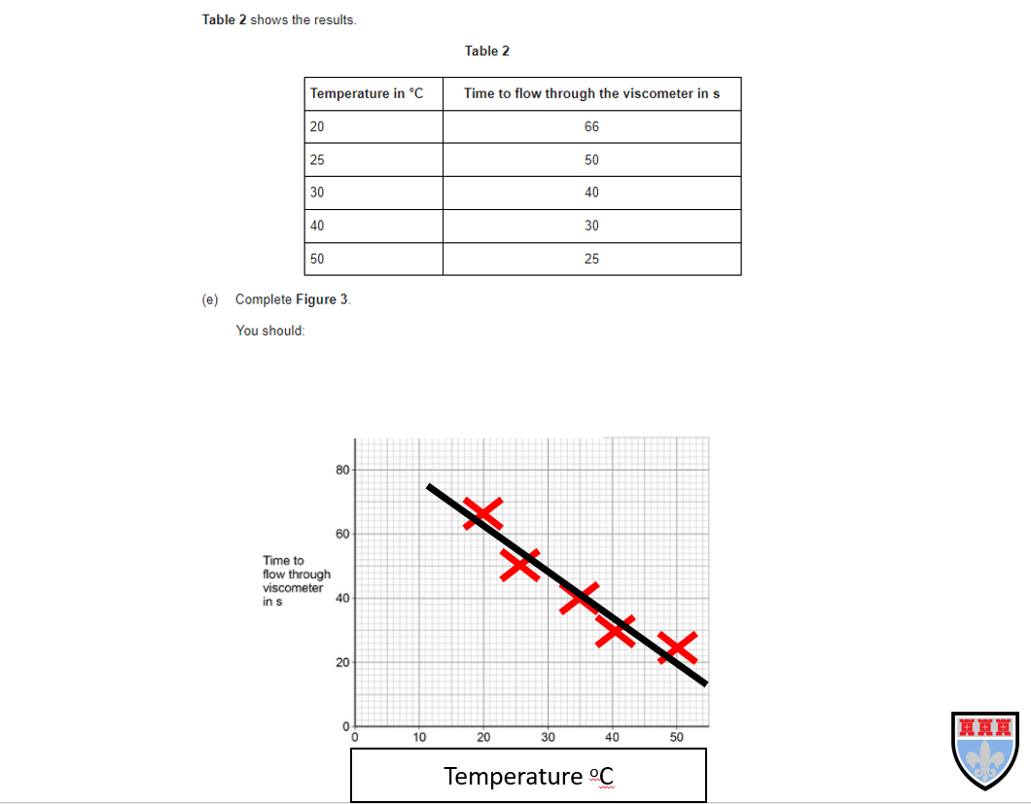
Tip: when drawing a line of best fit, try and hit as many of the points as possible, you are trying to show the trend. This can also be a curve sometimes!

Now try the questions and self-assess them using the mark schemes, ask your teacher if you are still unsure!

Q1.
This question is about rate of reaction.
A student investigated the rate of the reaction between magnesium and dilute hydrochloric acid.
The equation for the reaction is:
Mg(s) + 2 HCl(aq) → MgCl²(aq) + H2(g)
(a) Which state symbol in the equation for the reaction does not represent one of the three states of matter?
___________________________________________________________________
(1)
The student determined the rate of production of hydrogen gas.
(b) What two pieces of measuring apparatus could the student use to find the rate of production of hydrogen gas?
1 _________________________________________________________________
2 _________________________________________________________________
(2)
The following table shows the results of the investigation.

Time in s | Rate of production of gas in cm³/s
10 | 6.9
20 | 3.9
30 | 2.0
40 | 0.9
50 | 0.3
60 | 0.0
(c) Plot the data from the table on the graph below.
You should draw a line of best fit.
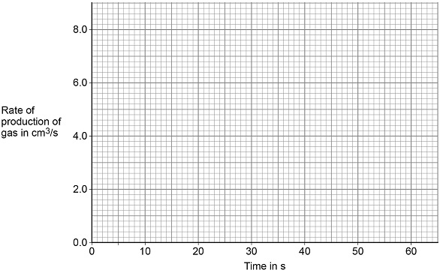
(3)
(d) Give three conclusions that can be drawn about the rate of reaction between magnesium and dilute hydrochloric acid in this investigation.
Use data from the graph and the table above.
1 _________________________________________________________________
___________________________________________________________________
2 _________________________________________________________________
___________________________________________________________________
3 _________________________________________________________________
___________________________________________________________________
(3)
(e) The student repeated the investigation using dilute hydrochloric acid at a higher temperature.
All the other variables were kept the same.
Which two statements are correct?
Tick (✓) two boxes.

More bubbles were produced in the first 10 seconds. | 
The activation energy for the reaction was higher.
The magnesium was used up more quickly.
The reaction finished at the same time.
The total volume of gas collected was greater.
(2)
(Total 11 marks)
Q2.
This question is about energy changes in reactions.
(a) Ammonium nitrate dissolves in water.
The change is endothermic.
Which piece of equipment uses this change?
Tick (✓) one box.

Hand warmer
Self-heating can
Sports injury pack
(1)
A student investigated the temperature change in the reaction between dilute sulfuric acid and potassium hydroxide solution.
This is the method used.
1. Measure 25 cm³ of potassium hydroxide solution into a glass beaker.
2. Add 5 cm³ of dilute sulfuric acid.
3. Stir the solution.
4. Measure the temperature of the solution.
5. Repeat steps 2 to 4 until a total of 30 cm³ of dilute sulfuric acid has been added.
(b) Figure 1 shows part of the scales of four thermometers, A, B, C and D.
Figure 1
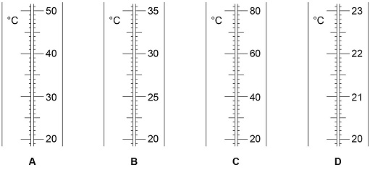
The student wanted to measure the temperature to a resolution of 0.1 °C
Which thermometer should the student use?
Tick (✓) one box.

A |  | B |  | C |  | D
(1)
(c) Energy is lost to the surroundings during the reaction.
What type of error does this cause in the results?
(1)
Tick (✓) one box.

Human error
Random error
Systematic error
Zero error
(1)
(d) The student used a glass beaker for the reaction.
Name a container the student could use instead of the glass beaker to improve the accuracy of the results.
___________________________________________________________________
___________________________________________________________________
(1)
(e) The following table shows the student’s results.

Volume of dilute sulfuric acid added in cm³ | Temperature in °C
5 | 21.2
10 | 22.0
15 | 22.8
20 | 23.6
25 | 24.4
30 | 25.2
Plot the data from the table on Figure 2.
You should:
• draw a line of best fit
• extend your line of best fit to the y-axis.
Figure 2
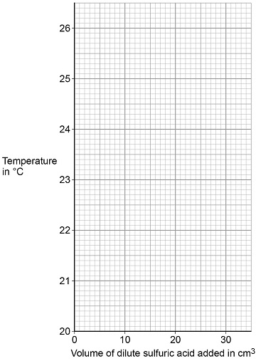
(4)
(f) The intercept on the y-axis of Figure 2 shows the starting temperature of the potassium hydroxide solution.
Give the starting temperature of the potassium hydroxide solution.
Starting temperature = _________________________°C
(1)
(g) Another student repeated the investigation and obtained an anomalous result.
This result was lower than expected.
What could have caused the anomalous result?
Tick (✓) two boxes.

The mixture was not stirred.
The temperature in the room increased.
The thermometer was not accurate.
Too little sulfuric acid was added.
Too much potassium hydroxide solution was used.
(2)
(Total 11 marks)
Q3.
A student investigated the temperature change in displacement reactions between metals and copper sulfate solution.
This is the method used.
1. Measure 50 cm³ of the copper sulfate solution into a polystyrene cup.
2. Record the starting temperature of the copper sulfate solution.
3. Add the metal and stir the solution.
4. Record the highest temperature the mixture reaches.
5. Calculate the temperature increase for the reaction.
6. Repeat steps 1-5 with different metals.
(a) Draw one line from each type of variable to the name of the variable in the investigation.
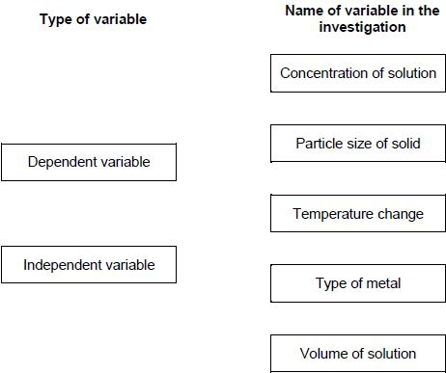
(2)
(b) The student used a polystyrene cup and not a glass beaker.
Why did this make the investigation more accurate?
Tick one box.

Glass is breakable
Glass is transparent
Polystyrene is a better insulator
Polystyrene is less dense
(1)
The table below shows the student’s results.

Metal | Temperature increase in °C
Magnesium | 38
Nickel | 8
Zinc | 16
(c) Complete Figure 1.
Use data from the table above.
Figure 1
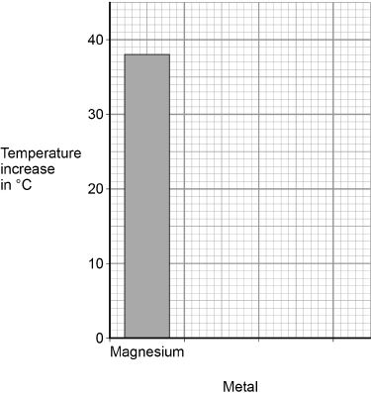
(2)
(d) The student concluded that the reactions between the metals and copper sulfate solution are endothermic.
Give one reason why this conclusion is not correct.
___________________________________________________________________
___________________________________________________________________
(1)
(e) The temperature increase depends on the reactivity of the metal.
Write the metals magnesium, nickel and zinc in order of reactivity.
Use the table above.
Most reactive _________________________
_________________________
Less reactive _________________________
(1)
(f) Y is an unknown metal.
Describe a method to find the position of Y in the reactivity series in Question (e)
___________________________________________________________________
___________________________________________________________________
___________________________________________________________________
___________________________________________________________________
___________________________________________________________________
___________________________________________________________________
___________________________________________________________________
___________________________________________________________________
(3)
Figure 2 shows the reaction profile for the reaction between zinc and copper sulfate solution.
Figure 2
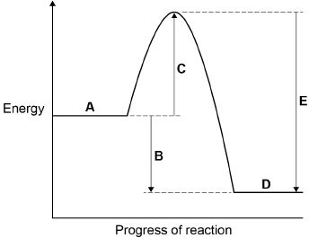
(g) Which letter represents the products of the reaction?
Tick one box.
(1)
(h) Which letter represents the activation energy?
Tick one box.
(1)
(Total 12 marks)
Q4.
This question is about elements in Group 1.
A teacher burns sodium in oxygen.
(a) Complete the word equation for the reaction.
sodium + oxygen ⟶ ___________________
(1)
(b) What is the name of this type of reaction?
Tick one box.

Decomposition
Electrolysis
Oxidation
Precipitation
(1)
(c) The teacher dissolves the product of the reaction in water and adds universal indicator.
The universal indicator turns purple.
What is the pH value of the solution?
Tick one box.
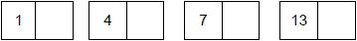
(1)
(d) The solution contains a substance with the formula NaOH
Give the name of the substance.
___________________________________________________________________
(1)
(e) All alkalis contain the same ion.
What is the formula of this ion?
Tick one box.

H⁺
Na⁺
OH⁻
O²⁻
(1)
(f) A solution of NaOH had a concentration of 40 g/dm³
What mass of NaOH would there be in 250 cm³ of the solution?
___________________________________________________________________
___________________________________________________________________
___________________________________________________________________
___________________________________________________________________
Mass = ______________________ g
(2)
(g) The melting points of the elements in Group 1 show a trend.
The table below shows the atomic numbers and melting points of the Group 1 elements.

Element | Atomic number | Melting point in °C
Lithium | 3 | 181
Sodium | 11 | 98
Potassium | 19 | 63
Rubidium | 37 | X
Caesium | 55 | 29
Plot the data from the table on the graph below.
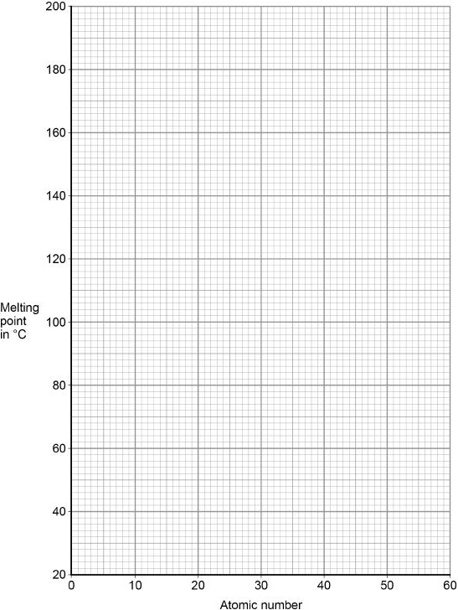
(2)
(h) Predict the melting point, X, of rubidium, atomic number 37
Use the graph above.
Melting point = ______________________ °C
(1)
(Total 10 marks)
Q5.
A student investigated how concentration affects the rate of reaction between magnesium and hydrochloric acid.
This is the method used.
1. Place hydrochloric acid in a conical flask.
2. Add magnesium powder.
3. Collect the gas produced in a gas syringe.
4. Measure the volume of gas every 40 seconds for 160 seconds.
5. Repeat steps 1-4 three more times.
6. Repeat steps 1-5 with hydrochloric acid of a higher concentration.
(a) Figure 1 shows a gas syringe.
Figure 1
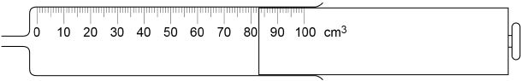
What is the volume of gas in the syringe?
Volume = ______________________ cm³
(1)
(b) Which two variables should the student keep the same to make the investigation a fair test?
Tick two boxes.

Concentration of hydrochloric acid
Mass of magnesium powder
Temperature of hydrochloric acid
Time for reaction to end
Volume of gas collected
(2)
The table below shows the student’s results for the experiment with hydrochloric acid of a lower concentration.

Time in seconds | Volume of gas collected in cm³
Time in seconds | Test 1 | Test 2 | Test 3 | Test 4 | Mean
0 | 0 | 0 | 0 | 0 | 0
40 | 46 | 30 | 47 | 49 | X
80 | 78 | 83 | 83 | 82 | 82
120 | 98 | 94 | 96 | 95 | 96
160 | 100 | 100 | 100 | 100 | 100
(c) Calculate mean value X in the table above.
Do not include the anomalous result in your calculation.
Give your answer to 2 significant figures.
___________________________________________________________________
___________________________________________________________________
___________________________________________________________________
X = ______________________ cm³
(2)
(d) Plot the data from the table above on Figure 2.
You should include your answer to Question (c).
You do not need to draw a line of best fit.
Figure 2
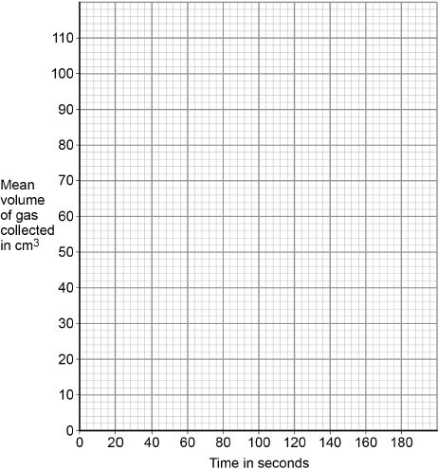
(2)
Figure 3 shows results of the experiment with the hydrochloric acid of a higher concentration.
Figure 3
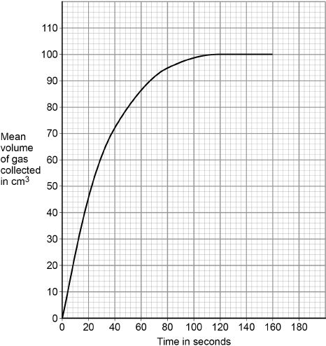
(e) Calculate the mean rate of reaction between 0 and 50 seconds.
Use Figure 3 and the equation:
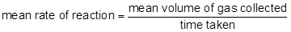
___________________________________________________________________
___________________________________________________________________
___________________________________________________________________
Mean rate of reaction = ______________________ cm³/s
(2)
(f) Describe how the rate of reaction changes between 0 and 160 seconds.
Use Figure 3.
___________________________________________________________________
___________________________________________________________________
___________________________________________________________________
___________________________________________________________________
___________________________________________________________________
___________________________________________________________________
(3)
(g) The student concludes that the rate of reaction is greater when the concentration of hydrochloric acid is higher.
Why is the rate of reaction greater when the concentration of hydrochloric acid is higher?
Tick two boxes.

The particles are moving faster
The particles have more energy
The surface area of magnesium is smaller
There are more particle collisions each second
There are more particles in the same volume
(2)
(h) The student tests the gas produced by bubbling it through limewater.
No change is seen in the limewater.
Give one conclusion the student can make about the gas.
___________________________________________________________________
___________________________________________________________________
(1)
(i) The student tests the gas produced using a burning splint.
Name the gas the student is testing for.
Give the result of a positive test for this gas.
Name of gas ________________________________________________________
Result _____________________________________________________________
___________________________________________________________________
(2)
(Total 17 marks)

Mark schemes
Q1.
(a) (aq)
allow aqueous / aq
1
(b) (gas) syringe
allow measuring cylinder (and water trough)
allow balance
1
stopclock / stopwatch
allow timer / clock / watch
1
(c) all points plotted correctly
allow a tolerance of ± ½ a small square
allow at least 3 points plotted correctly for 1 mark.
2
line of best fit
allow correctly drawn line of best fit for incorrectly plotted points
1
(d) (rate) decreases
allow slows down
1
(rate decreases) more slowly as time increases
allow (rate decreases) at a non-linear rate
1
(rate) becomes zero at 60 s
allow the reaction stops at 60 s
allow ecf from part (c)
1
(e) more bubbles were produced in the first 10 seconds
1
the magnesium was used up more quickly
1
[11]
Q2.
(a) sports injury pack
1
(b) D
1
(c) systematic error
1
(d) polystyrene cup
allow other insulating containers
1
(e) all six points plotted correctly
allow a tolerance of ± ½ a small square
allow 1 mark for at least 3 points plotted correctly
2
line of best fit
ignore extrapolation to y-axis
1
line extrapolated correctly to y-axis
1
(f) 20.4 (°C)
allow ecf from part (e)
allow a tolerance of ± ½ a small square
1
(g) the mixture was not stirred
1
too little sulfuric acid was added
1
[11]
Q3.
(a)
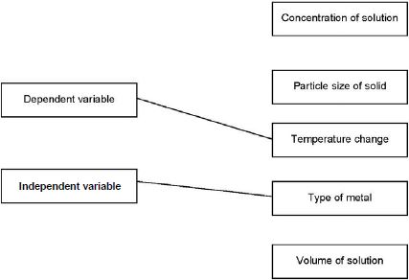
allow one mark if answers are reversed
1
1
(b) polystyrene is a better insulator
1
(c) both bars labelled
1
both bars correctly plotted
allow tolerance of ±½ small square
ignore width and spacing of bars
if no other mark scored, allow 1 mark for any one bar correctly plotted and labelled
1
(d) temperature increases
allow (because) energy / ‘heat’ is transferred to the surroundings
or
temperature does not decrease
energy / ‘heat’ is not taken in from the surroundings
allow the energy of the products is less than the energy of the reactants
1
(e) (most reactive)
magnesium
(zinc)
nickel
this order only
1
(f) suitable method described
1
the observations / measurements required to place in order
1
an indication of how results would be used to place the unknown metal in the reactivity series
1
approaches that could be used:
approach 1:
add the unknown metal to copper sulfate solution (1)
measure temperature change (1)
place the metals in order of temperature change (1)
approach 2:
add the metal to salt solutions of the other metals
or
heat the metal with oxides of the other metals (1)
measure temperature change (only if salt solutions used)
or
observe whether a chemical change occurs (1)
compare temperature change or whether there is a reaction to place in correct order (1)
approach 3:
add all of the metals to an acid (1)
measure temperature change or means of comparing rate of reaction (1)
place the metals in order of temperature change or rate of reaction (1)
approach 4:
set up electrochemical cells with the unknown metal as one electrode and each of the other metals as the other electrode (1)
measure the voltage of the cell (1)
place the metals in order of voltage (1)
(g) D
1
(h) C
1
[12]
Q4.
(a) sodium oxide
allow Na₂O
1
(b) oxidation
1
(c) 13
1
(d) sodium hydroxide
1
(e) OH⁻
1
(f) 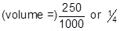
or 0.25 (dm³)
1
or
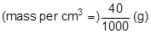
or 0.04 (g)
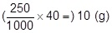
1
an answer of 10 (g) scores 2 marks
(g) all points correct
allow a tolerance of ±½ a small square
allow 1 mark for 3 points correct
ignore any attempt at a line of best fit
2
(h) 39 °C
allow any value from 34 to 46 (°C)
1
[10]
Q5.
(a) 83 (cm³)
allow 83.0 / 83.00
1
(b) mass of magnesium powder
1
temperature of hydrochloric acid
1
(c) 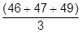
allow 47.3(333) (cm³) for 1 mark
1
= 47 (cm³) (2 sf)
an answer of 43 (cm³) scores 1 mark
1
an answer of 47 (cm³) scores 2 marks
(d) all points plotted correctly
(inc 0,0)
allow a tolerance of ±½ a square
allow ecf from question (c)
ignore line
allow 1 mark for four points plotted correctly
2
(e)
allow 80 ± 2
1
= 1.6 (cm³/s)
allow 1.60 ± 0.04
1
an answer of 1.6 (cm³/s) scores 2 marks
(f) rate is greatest at start
allow rate is faster at start
1
(then) rate decreases
allow (then) rate slows down
1
reaction stops
1
(g) there are more particle collisions each second
1
there are more particles in the same volume
1
(h) (gas is) not carbon dioxide
ignore does not react with limewater
1
(i) hydrogen
allow H₂
1
pop sound
1
[17]

