4. Graphs: BIOLOGY
Here are some worked examples from all sciences that will help you!
Tip: the independent variable (the one you change) is always on the x axis! In this case the organism!
Tip: the dependent variable (the one you measure) is always on the y axis! In this case the biomass in g! Don’t forget your units!

Tip: you always do a bar chart when one set of data is a thing or category and then the other is continous (numbers)

Tip: when drawing a line of best fit, try and hit as many of the points as possible, you are trying to show the trend. This can also be a curve sometimes!

Now try the questions and self-assess them using the mark schemes, ask your teacher if you are still unsure!

Q1.
This question is about leaves.
(a) Complete the sentences.
Choose answers from the box.

epidermis phloem palisade mesophyll
waxy cuticle xylem
The layer of cells lining the upper surface and lower surface of a
leaf is the __________________________________.
The part of the leaf where most photosynthesis occurs
is the ________________________________________.
Water is transported to the leaf in the ____________________________________.
(3)
Water is lost through small openings on the lower surface of plant leaves.
These small openings are called stomata.
Figure 1 shows two stomata on the lower surface of a leaf.
Figure 1
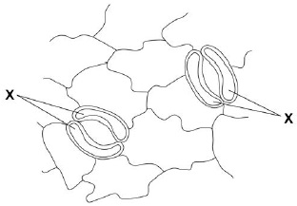
(b) The cells labelled X control the width of the stomata.
What are the cells labelled X?
Tick (✓) one box.

Guard cells | 
Mesophyll cells
Root hair cells
Stem cells
(1)
(c) What is the function of the stomata?
Tick (✓) one box.

To allow light into the leaf
To let carbon dioxide into the leaf
To let sugars out of the leaf
To protect the leaf from pathogens
(1)
(d) How is water lost from a leaf?
Tick (✓) one box.

By evaporation
By respiration
By translocation
(1)
A student investigated the volume of water lost from two plants.
The plants were different species.
Figure 2 shows the student’s results.
Figure 2
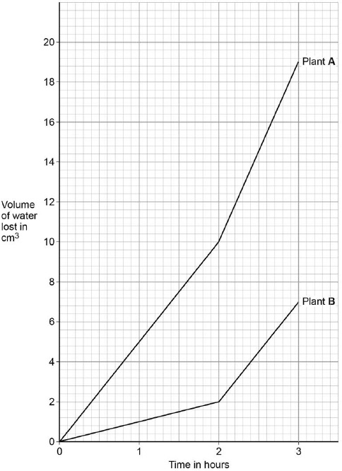
(e) Calculate the difference in the volume of water lost by plant A compared to plant B in the first hour.
___________________________________________________________________
___________________________________________________________________
Difference in volume = ____________________ cm³
(2)
(f) What could cause plant A to lose water at a faster rate than plant B?
Tick (✓) one box.

Plant A has fewer stomata per leaf.
Plant A is smaller.
Plant A has more leaves.
Plant A has smaller leaves.
(1)
(g) After the first 2 hours, both plants were moved to a new room.
Suggest one reason why both plants lost water at a faster rate in the new room.
___________________________________________________________________
___________________________________________________________________
(1)
(h) Some plants have adaptations to stop them from being eaten by animals.
Figure 3 shows part of a holly plant.
Figure 3

Describe one way the holly plant is adapted to stop it being eaten by animals.
___________________________________________________________________
___________________________________________________________________
(1)
(Total 11 marks)
Q2.
This question is about photosynthesis.
(a) Complete the word equation for photosynthesis:
__________________ + __________________ → __________________ + oxygen
(2)
A student investigated photosynthesis using pondweed.
Figure 1 shows the apparatus the student used.
Figure 1
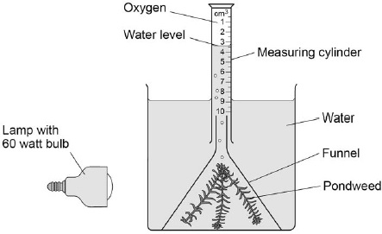
This is the method used.
1. Set up the apparatus as shown in Figure 1.
2. Switch on the lamp.
3. After 20 minutes, record the volume of oxygen collected in the measuring cylinder.
4. Repeat steps 1–3 using bulbs of different power output.
(b) What was the independent variable in the investigation?
Tick (✓) one box.

Power output of bulb
Rate of photosynthesis
Time to collect oxygen
Volume of oxygen collected
(1)
(c) Suggest two ways the method could be improved so the results would be more valid.
1 _________________________________________________________________
___________________________________________________________________
2 _________________________________________________________________
___________________________________________________________________
(2)
The table below shows the student’s results.

Power output of bulb in watts | Volume of oxygen collected in 20 minutes in cm³ | Rate of photosynthesis in cm³/hour
60 | 0.5 | 1.5
100 | 0.8 | 2.4
150 | 1.1 | X
200 | 1.2 | 3.6
250 | 1.2 | 3.6
(d) Calculate value X in the table above.
___________________________________________________________________
___________________________________________________________________
X = _____________________ cm³/hour
(1)
(e) Complete Figure 2.
You should:
• label the x-axis
• use a suitable scale
• plot the data from the table above and your answer to part (d)
• draw a line of best fit.
Figure 2
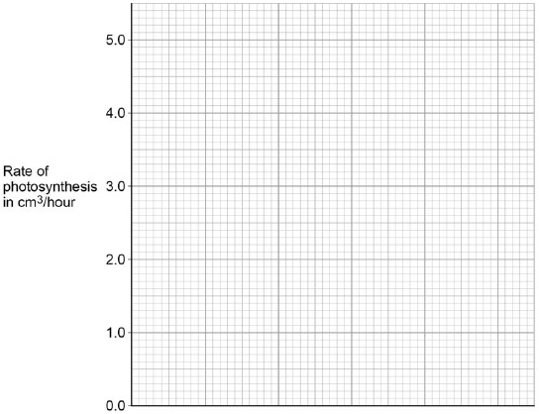
(4)
(f) Determine the expected rate of photosynthesis with a bulb of power output 75 watts.
Use Figure 2.
___________________________________________________________________
Rate of photosynthesis at 75 watts = ______________________cm³/hour
(1)
(g) Which graph shows the effect of temperature on the rate of photosynthesis?
Tick (✓) one box.
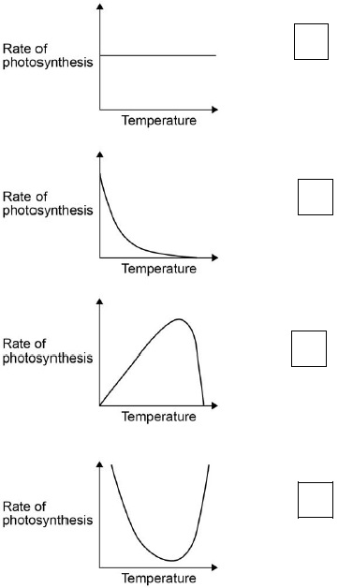
(1)
(Total 12 marks)
Q3.
Metabolism is the sum of all the chemical reactions in the cells of the body.
One metabolic reaction is the formation of lipids.
(a) Give one other metabolic reaction in cells.
___________________________________________________________________
___________________________________________________________________
(1)
Table 1 shows the mean metabolic rate of humans of different ages.
Table 1

Age in years | Mean metabolic rate in kJ/m²/hour
Age in years | Males | Females
5 | 53 | 53
15 | 45 | 42
25 | 39 | 35
35 | 37 | 35
45 | 36 | 35
(b) What two conclusions can be made from the data in Table 1?
Tick two boxes.

As age increases, mean metabolic rate of males and females increases.
Males have a higher metabolic rate than females after five years of age.
The mean metabolic rate of females decreases faster than males up to 25 years of age.
The mean metabolic rate of males and females decreases more quickly after the age of 35.
There is no relationship between age and mean metabolic rate.
(2)
(c) Calculate the percentage decrease in the mean metabolic rate of males between 5 years and 45 years of age.
Use the equation:
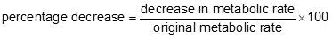
Give your answer to 3 significant figures.
___________________________________________________________________
___________________________________________________________________
___________________________________________________________________
___________________________________________________________________
Percentage decrease = ___________________
(3)
Regular exercise can increase metabolic rate.
Two people did five minutes of gentle exercise from rest.
Table 2 shows the effect of the exercise on their heart rates.
Table 2

Time in minutes | Heart rate in beats per minute
Time in minutes | Person R | Person S
0 (at rest) | 60 | 78
1 | 76 | 100
2 | 85 | 110
3 | 91 | 119
4 | 99 | 129
5 | 99 | 132
(d) Describe two differences in the response of person R and person S to the exercise.
Use information from Table 2.
1. _________________________________________________________________
___________________________________________________________________
2. _________________________________________________________________
___________________________________________________________________
(2)
(e) Complete the line graph below for person S.
You should:
• add the scale to the x axis
• label the x axis.
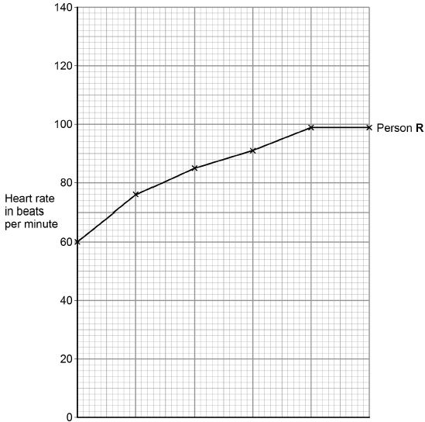
(4)
(f) After five minutes of exercise, the heart rate of person S was 132 beats per minute. When person S rested, his heart rate decreased steadily at a rate of 12 beats every minute.
Calculate how much time it would take the heart rate of person S to return to its resting rate.
___________________________________________________________________
___________________________________________________________________
___________________________________________________________________
Time = ___________________ minutes
(2)
(g) A student made the following hypothesis about the heart rate of smokers and non-smokers during exercise.
“During exercise, the heart rate of smokers increases more than
the heart rate of non-smokers.”
Design an investigation that would allow you to test this hypothesis.
___________________________________________________________________
___________________________________________________________________
___________________________________________________________________
___________________________________________________________________
___________________________________________________________________
___________________________________________________________________
___________________________________________________________________
___________________________________________________________________
___________________________________________________________________
___________________________________________________________________
___________________________________________________________________
___________________________________________________________________
___________________________________________________________________
___________________________________________________________________
___________________________________________________________________
___________________________________________________________________
___________________________________________________________________
___________________________________________________________________
___________________________________________________________________
(6)
(Total 20 marks)
Q4.
After a meal rich in carbohydrates, the concentration of glucose in the small intestine changes.
The table below shows the concentration of glucose at different distances along the small intestine.

Distance along the small intestine in cm | Concentration of glucose in mol dm⁻³
100 | 50
300 | 500
500 | 250
700 | 0
(a) At what distance along the small intestine is the glucose concentration highest?
______________________ cm
(1)
(b) Use the data in the table to plot a bar chart on the graph below.
• Label the y-axis.
• Choose a suitable scale.
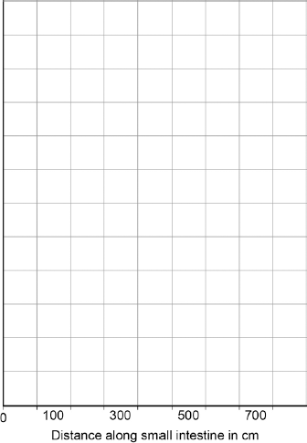
(4)
(c) Look at the graph above.
Describe how the concentration of glucose changes as distance increases along the small intestine.
___________________________________________________________________
___________________________________________________________________
___________________________________________________________________
___________________________________________________________________
(2)
(d) Explain why the concentration of glucose in the small intestine changes between 100 cm and 300 cm.
___________________________________________________________________
___________________________________________________________________
___________________________________________________________________
___________________________________________________________________
___________________________________________________________________
___________________________________________________________________
(2)
(e) Explain why the concentration of glucose in the small intestine changes between 300 cm and 700 cm.
___________________________________________________________________
___________________________________________________________________
___________________________________________________________________
___________________________________________________________________
___________________________________________________________________
___________________________________________________________________
___________________________________________________________________
___________________________________________________________________
(3)
(Total 12 marks)

Mark schemes
Q1.
(a) epidermis
palisade mesophyll
allow palisade / mesophyll
xylem
3
(b) guard cells
1
(c) to let carbon dioxide into the leaf
1
(d) by evaporation
1
(e)
an answer of 4 (cm³) scores 2 marks
evidence of correct graph readings (5 and 1)
allow in range 4.8 to 5.2 and 0.8 to 1.2
1
4 (cm³)
allow correct subtraction from their graph readings
allow their calculated value from readings in the range 4.6 to 5.4 and 0.6 to 1.4
1
(f) plant A has more leaves
1
(g) any one from:
(the new room was)
• windier
• warmer
• drier / less humid
• brighter
answers must be comparative
allow sunnier
ignore more sun
1
(h) any one from:
• spikes / points / thorns / sharp
• poisonous / toxic
• brightly coloured berries
• leaves are tough / leathery
or
leaves are hard to chew
ignore reference to predators eating holly
allow unpleasant taste
1
[11]
Q2.
(a)
words take precedence over symbols
LHS:
1
carbon dioxide and water
RHS:
glucose
1
allow correct symbols (ignore balancing)
in any order
do not accept starch
ignore carbohydrates / sugar
(b) power output of bulb
1
(c) any two from:
• repeat and calculate a mean
or
repeat and to eliminate anomalies
ignore do a control experiment unqualified
• control the (water) temperature
allow a method of controlling (water) temperature
• control the concentration of carbon dioxide
allow a method of controlling carbon dioxide concentration
• control the distance of the bulb from the pondweed
• control the mass / length / species / age of the pondweed
allow use the same piece of pondweed
• give pondweed time to equilibrate
allow do experiment with the bulb off / in the dark
2
(d) 3.3 (cm³/hour)
1
(e)
max 3 marks for bar chart
correct scale and axis labelled
1
all points plotted correctly
allow points plotted to within ± ½ small square
allow 3 or 4 correct plots for 1 mark
allow correct plot from incorrect value calculated in part (d)
2
correct curved line of best fit
ignore line extended beyond 60 / 250 (W)
ignore line joined point to point with straight lines
1
(f) correct answer from their line drawn on Figure 2
allow ± ½ small square tolerance
allow 1.8 / 1.9 if no line of best fit or incorrect graph is drawn
1
(g)
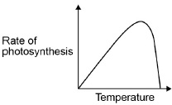
1
[12]
Q3.
(a) any one from:
• respiration
• formation of proteins
• formation / breakdown of glycogen
• breakdown of (excess) protein or formation of urea
• photosynthesis or formation of glucose / starch (in plants)
ignore formation of carbohydrates
1
allow other correct reference to metabolic reactions in cells
ignore reference to digestion
(b) males have a higher metabolic rate than females after five years of age
1
the mean metabolic rate of females decreases faster than males up to 25 years of age
1
each additional tick negates a mark
(c) 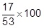
1
32.075472…
allow correct rounding of this to at least 4 significant figures
1
32.1
allow a correct reduction to 3 significant figures from an incorrect calculation for marking point 2
1
an answer of 32.1 scores 3 marks
(d) any two from:
allow converse
• (person) R heart rate rose / increased more slowly than (person) S
• (person) R heart rate levelled off whereas (person) S continued to increase
• (person) R heart rate rose less (overall / after 5 minutes of exercise) than S
allow correct use of figures
e.g. R increased (overall) by 39 bpm / 65% and S by 54 bpm / 69%
ignore lack of units
2
(e) correct scale and axis labelled
allow min(s)
do not accept ‘m’
the zero is not required on the x-axis
1
all points plotted correctly (to within ± ½ square)
allow 4 or 5 correct plots for 1 mark
2
line joined point to point or correct curved line of best fit
1
(f) 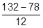
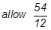
allow sequential deductions of 12 four or five times
1
4.5 (minutes) / 4½ minutes / 4 minutes 30 seconds / 4:30
do not accept 4:50 or 4 minutes 50 seconds
1
an answer of 4.5 minutes scores 2 marks
(g) Level 3: The method would lead to the production of a valid outcome. All key steps are identified and logically sequenced.
5−6
Level 2: The method would not necessarily lead to a valid outcome. Most steps are identified, but the method is not fully logically sequenced.
3−4
Level 1: The method would not lead to a valid outcome. Some relevant steps are identified, but links are not made clear.
1−2
No relevant content
0
Indicative content
• two groups of people − non-smokers and smokers
• have at least five people in each group or large groups
• get each person to do (named) exercise
• controlled variables:
− same number of people in each group or large groups
− same gender
− same level of activity / exercise
− same age
− no health issues / illnesses
− same type of exercise
− same time for exercise
• record heart rate for each person before and after exercise
• calculate increase in heart rate for each person after exercise
• compare results for each group
for level 3, students should refer to at least 5 smokers and 5 non-smokers, carrying out exercise with control variables and a means of determining an increase in heart rate
for level 2, students should refer to ‘groups’ of smokers and non-smokers exercising
[20]
Q4.
(a) 300
1
(b) suitable scale on y-axis
1
label y-axis
1
4 bars drawn correctly
allow 1 mark for 3 correct bars
2
(c) increases from 50 to 500
1
then decreases from 500 to 0
1
(d) carbohydrates broken down / digested into sugars
1
broken down by carbohydrase or amylase
1
(e) absorption of glucose
1
into blood
1
by active transport
allow diffusion
1
[12]

