3. Planning experiments: PHYSICS
Here are some worked examples from all sciences that will help you!
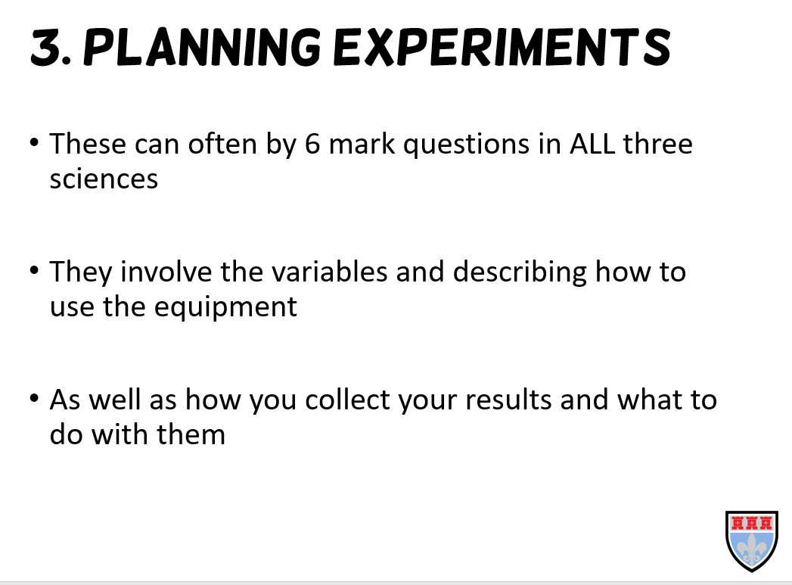
Tip: the independent variable is the one you change, this should only be one thing!
Tip: the dependent variable is the one you measure, this is normally only one thing, but it can be two. For example, measuring current and potential difference to work out resistance.
Tip: the control variables are the ones you keep the saeme, you should have lots of these, they will esnure you get valid, accurate results. Some common ones are: same volume, same mass, same surface area, same acid, same distance etc.
Here are three examples, one from each science. You will notice that they are very similar!

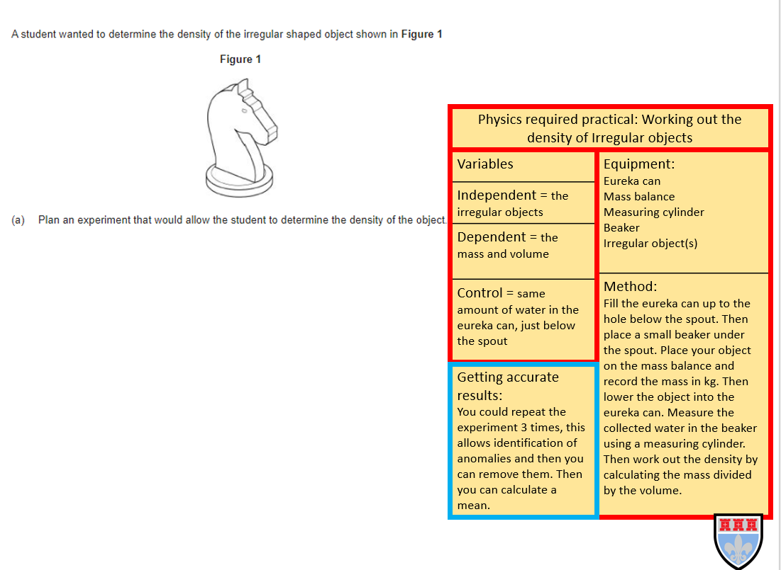
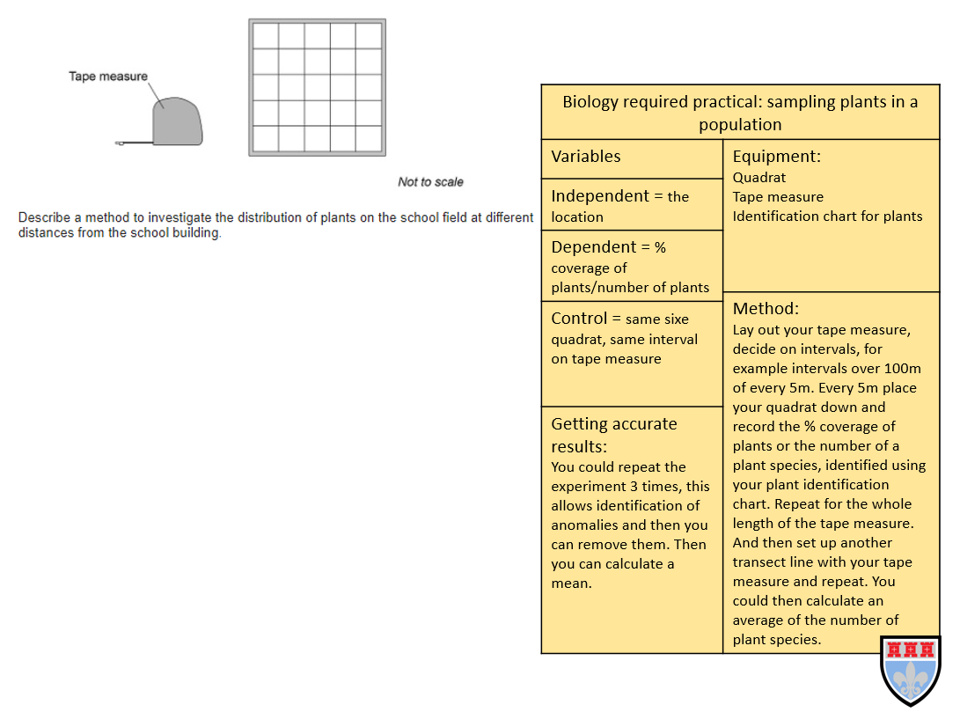
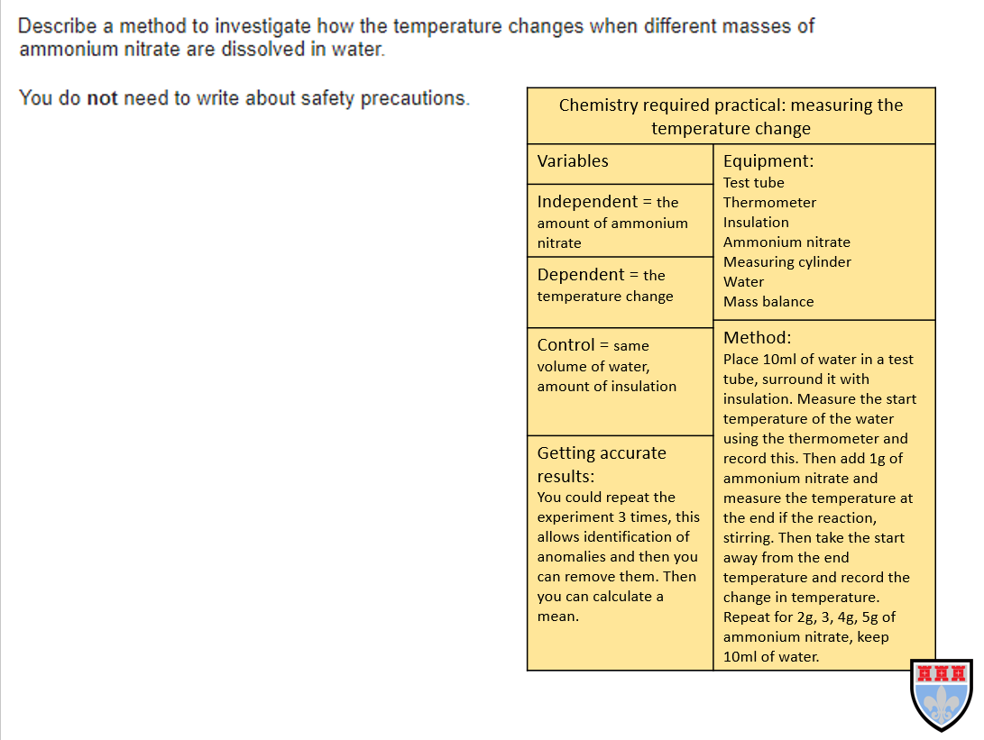

Now try the questions and self-assess them using the mark schemes, ask your teacher if you are still unsure!
Q1.
A student investigated how the resistance of a piece of nichrome wire varies with length.
Figure 1 shows part of the circuit the student used.
Figure 1
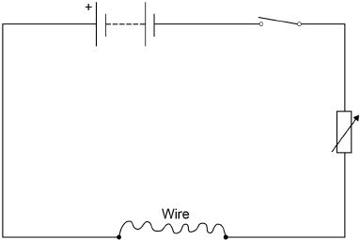
(a) Complete Figure 1 by adding an ammeter and a voltmeter.
Use the correct circuit symbols.
(3)
(b) Describe how the student would obtain the data needed for the investigation.
Your answer should include a risk assessment for one hazard in the investigation.
___________________________________________________________________
___________________________________________________________________
___________________________________________________________________
___________________________________________________________________
___________________________________________________________________
___________________________________________________________________
___________________________________________________________________
___________________________________________________________________
___________________________________________________________________
___________________________________________________________________
___________________________________________________________________
___________________________________________________________________
(6)
(c) Why would switching off the circuit between readings have improved the accuracy of the student’s investigation?
Tick one box.

The charge flow through the wire would not change. | 
The potential difference of the battery would not increase.
The power output of the battery would not increase.
The temperature of the wire would not change.
(1)
(d) The student used crocodile clips to make connections to the wire.
They could have used a piece of equipment called a ‘jockey’.
Figure 2 shows a crocodile clip and a jockey in contact with a wire.
Figure 2
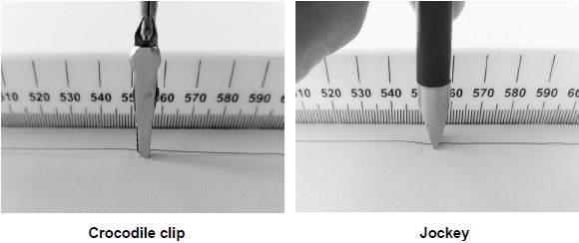
How would using the jockey have affected the accuracy and resolution of the student’s results compared to using the crocodile clip?
Tick two boxes.

The accuracy of the student’s results would be higher.
The accuracy of the student’s results would be lower.
The accuracy of the student’s results would be the same.
The resolution of the length measurement would be higher.
The resolution of the length measurement would be lower.
The resolution of the length measurement would be the same.
(2)
(Total 12 marks)
Q2.
The data given in the table below was obtained from an investigation into the refraction of light at an air to glass boundary.

 | Angle of incidence | Angle of refraction
 | 20° | 13°
 | 30° | 19°
 | 40° | 25°
 | 50° | 30°
Describe an investigation a student could complete in order to obtain similar data to that given in the table above.
Your answer should consider any cause of inaccuracy in the data.
A labelled diagram may be drawn as part of your answer.
_______________________________________________________________________
_______________________________________________________________________
_______________________________________________________________________
_______________________________________________________________________
_______________________________________________________________________
_______________________________________________________________________
_______________________________________________________________________
_______________________________________________________________________
_______________________________________________________________________
_______________________________________________________________________
(Total 6 marks)
Q3.
(a) Figure 1 shows the position of three types of wave in the electromagnetic spectrum.
Figure 1

A | Microwaves | B | Visible light | C | D | Gamma rays
Which letter represents infrared in the electromagnetic spectrum?
Tick (✓) one box.

A |  | B |  | C |  | D
(1)
(b) What is infrared used for?
Tick (✓) one box.

Electrical heating
Energy efficient lamps
Satellite communications
Sun tanning
(1)
An infrared camera produces a colour image. Different colours show different temperatures.
People emit infrared radiation. Figure 2 shows how the colour of the image of a person on an infrared camera depends on the person’s body temperature.
Figure 2
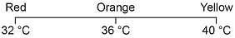
(c) Complete the sentence.
Choose the answer from the box.

orange red yellow
The image produced by an infrared camera of a person with a body temperature of
37 °C is mainly _________________________ .
(1)
(d) Rescue workers use infrared cameras to search for people trapped under rubble after an earthquake.
How does the image of a trapped person change if the person’s body temperature drops from 37 °C to 33 °C?
___________________________________________________________________
___________________________________________________________________
___________________________________________________________________
(1)
A student investigated how the type of surface affects the amount of infrared the surface radiates.
Figure 3 shows the equipment used.
Figure 3
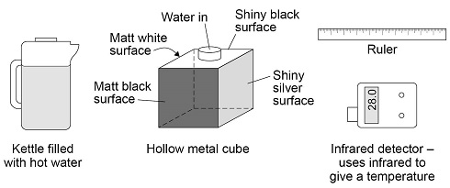
(e) Complete the sentence.
Choose the answer from the box.

a control the dependent the independent
In this investigation the type of surface is ___________________________ variable.
(1)
(f) Describe how the equipment shown in Figure 3 would be used to compare the infrared radiation emitted from the vertical surfaces of the cube.
___________________________________________________________________
___________________________________________________________________
___________________________________________________________________
___________________________________________________________________
___________________________________________________________________
___________________________________________________________________
___________________________________________________________________
___________________________________________________________________
(3)
The table below shows the results.

Type of surface | Temperature in °C
Matt black | 68.0
Matt white | 65.5
Shiny black | 66.3
Shiny silver | 28.0
(g) What is the resolution of the infrared detector?
Tick (✓) one box.

0.1 °C
1.0 °C
1.7 °C
68.0 °C
(1)
The bar chart in Figure 4 shows two of the results.
Figure 4
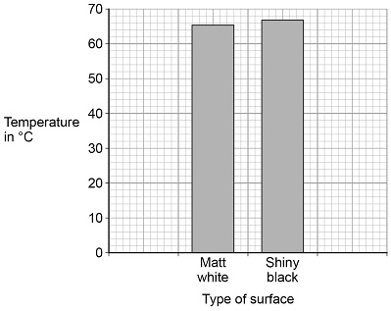
(h) Complete the bar chart to show all of the results.
(3)
(i) Give one conclusion that can be made from the results.
___________________________________________________________________
___________________________________________________________________
___________________________________________________________________
(1)
(Total 13 marks)
Q4.
A student investigated the cooling effect of evaporation.
She used the equipment (datalogger and probe) shown in Figure 1 to measure how the temperature of a liquid changed as the liquid evaporated.
Figure 1
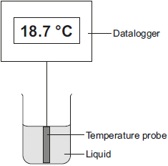
(a) Which type of variable was the temperature in this investigation?
Tick (✔) one box.

Tick (✔)
control
dependent
independent
(1)
(b) Before the investigation started, the student checked the accuracy of three different temperature probes. The student put the probes in a beaker of boiling water that had a temperature of 100.0 °C.
The readings from the three temperature probes are shown in Figure 2.
Figure 2
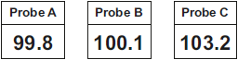
Which one of the temperature probes, A, B or C, was least accurate?
Write the correct answer in the box.
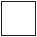
Give a reason for your answer.
___________________________________________________________________
___________________________________________________________________
(2)
(c) Figure 3 shows how the temperature recorded changed during the investigation.
Figure 3
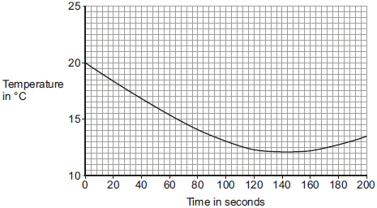
(i) Use Figure 3 to determine the lowest temperature recorded as the liquid evaporated.
Temperature = ______ °C
(1)
(ii) Use Figure 3 to determine how long it took for all the liquid to evaporate.
Give a reason for your answer.
Time = ________ seconds
Reason: __________________________________________________
______________________________________________________________
(2)
(iii) How would increasing the starting temperature of the liquid above 20 °C affect the rate of evaporation of the liquid?
______________________________________________________________
______________________________________________________________
(1)
(Total 7 marks)
Q5.
Figure 1 shows two iron nails hanging from a bar magnet.
The iron nails which were unmagnetised are now magnetised.
Figure 1
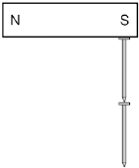
(a) Complete the sentence.
Use a word from the box.

forced | induced | permanent
The iron nails have become _____________________ magnets.
(1)
(b) Each of the three metal bars in Figure 2 is either a bar magnet or a piece of unmagnetised iron.
The forces that act between the bars when different ends are placed close together are shown by the arrows.
Figure 2
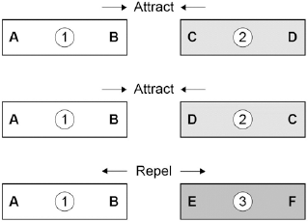
Which one of the metal bars is a piece of unmagnetised iron?

Tick one box.
Bar 1 | 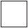
Bar 2
Bar 3
Give the reason for your answer.
___________________________________________________________________
___________________________________________________________________
(2)
(c) A student investigated the strength of different fridge magnets by putting small sheets of paper between each magnet and the fridge door.
The student measured the maximum number of sheets of paper that each magnet was able to hold in place.
Why was it important that each small sheet of paper had the same thickness?
___________________________________________________________________
___________________________________________________________________
___________________________________________________________________
(1)
(d) Before starting the investigation the student wrote the following hypothesis:
‘The bigger the area of a fridge magnet the stronger the magnet will be.’
The student’s results are given in the table below.

Fridge  magnet | Area of  magnet  in mm² | Number of sheets of paper held
A | 40 | 20
B | 110 | 16
C | 250 | 6
D | 340 | 8
E | 1350 | 4
Give one reason why the results from the investigation do not support the student’s hypothesis.
___________________________________________________________________
___________________________________________________________________
(1)
(Total 5 marks)
Q6.
A student carried out an investigation to determine the spring constant of a spring.
The table below gives the data obtained by the student.

Force in N | Extension in cm
0 | 0.0
2 | 3.5
4 | 8.0
6 | 12.5
8 | 16.0
10 | 20.0
(a) Describe a method the student could have used to obtain the data given in the table above.
Your answer should include any cause of inaccuracy in the data.
Your answer may include a labelled diagram.
.........
(6)
(b) The student measured the extension for five different forces rather than just measuring the extension for one force.
Suggest why.
___________________________________________________________________
___________________________________________________________________
(1)
The diagram below shows some of the data obtained by the student.
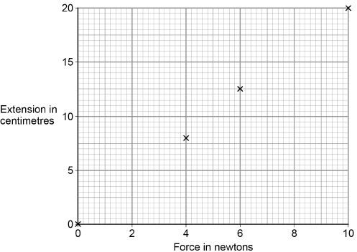
(c) Complete the diagram above by plotting the missing data from the table above.
Draw the line of best fit.
The table above is repeated here to help you answer this question.

Force in N | Extension in cm
0 | 0.0
2 | 3.5
4 | 8.0
6 | 12.5
8 | 16.0
10 | 20.0
(2)
(d) Write down the equation that links extension, force and spring constant.
___________________________________________________________________
(1)
(e) Calculate the spring constant of the spring that the student used.
Give your answer in newtons per metre.
___________________________________________________________________
___________________________________________________________________
___________________________________________________________________
___________________________________________________________________
Spring constant = ______________________ N/m
(4)
(f) Hooke’s Law states that:
‘The extension of an elastic object is directly proportional to the force applied, provided the limit of proportionality is not exceeded.’
The student concluded that over the range of force used, the spring obeyed Hooke’s Law.
Explain how the data supports the student’s conclusion.
___________________________________________________________________
___________________________________________________________________
___________________________________________________________________
___________________________________________________________________
(2)
(Total 16 marks)

Mark schemes
Q1.
(a) ammeter and voltmeter symbols correct
1
voltmeter in parallel with wire
1
ammeter in series with wire
1
(b) Level 3: The method would lead to the production of a valid outcome. All key steps are identified and logically sequenced.
5−6
Level 2: The method would not necessarily lead to a valid outcome. Most steps are identified, but the method is not fully logically sequenced.
3−4
Level 1: The method would not lead to a valid outcome. Some relevant steps are identified, but links are not made clear.
1−2
No relevant content
0
Indicative content
• length measured
• length varied
• current measured
• potential difference measured
• repeat readings
• calculate resistance for each length
• 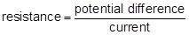
• plot a graph of resistance against length
• hazard: high current
• may cause wire to melt / overheat
• may cause burns (to skin)
• use low currents
(c) the temperature of the wire would not change
1
(d) the accuracy of the student’s results would be higher
1
the resolution of the length measurement would be higher
1
[12]
Q2.
Level 3 (5–6 marks):
A detailed and coherent plan covering all the major steps is provided. The steps in the method are logically ordered. The method would lead to the production of valid results.
A source of inaccuracy is provided.
Level 2 (3–4 marks):
The bulk of a method is described with mostly relevant detail. The method may not be in a completely logical sequence and may be missing some detail.
Level 1 (1–2 marks):
Simple statements are made. The response may lack a logical structure and would not lead to the production of valid results.
0 marks:
No relevant content.
Indicative content
place a glass block on a piece of paper
draw around the glass block and then remove from the paper
draw a line at 90° to one side of the block (the normal)
use a protractor to measure and then draw a line at an angle of 20° to the normal
replace the glass block
using a ray box and slit point the ray of light down the drawn line
mark the ray of light emerging from the block
remove the block and draw in the refracted ray
measure the angle of refraction with a protractor
repeat the procedure for a range of values of the angle of incidence
possible source of inaccuracy
the width of the light ray
which makes it difficult to judge where the centre of the ray is
[6]
Q3.
(a) B
1
(b) electrical heating
1
(c) orange
allow a correct answer indicated in the box provided the answer space is blank
1
(d) becomes (more) red
allow changes from mainly orange to mainly red
1
(e) the independent
allow a correct answer indicated in the box provided the answer space is blank
1
(f) pour (hot) water into the (hollow metal) cube
1
point the IR detector at each / a side and take a reading
allow point the IR detector at the cube and take a reading
allow IR detector touching the surface and take a reading
allow take the temperature for take a reading
1
keep the detector the same distance from each surface
1
(g) 0.1°C
1
(h) one bar drawn to 68.0 (°C)
ignore the position of the bars on the x-axis
1
one bar drawn to 28.0 (°C)
1
tallest bar labelled Matt black and shortest bar labelled Shiny silver
1
(i) any one from:
• (matt) black is the best emitter
• shiny silver is the worst emitter
allow matt white and shiny black are (almost) the same at emitting
allow black is a good emitter
allow silver is a poor emitter
allow an answer in terms of highest / lowest temperature
ignore any reference to absorption / reflection
1
[13]
Q4.
(a) dependent
1
(b) (probe) C
allow 103.2
1
largest difference between reading and actual temperature
reason only scores if C chosen
accept larger
it is 3.2 greater is insufficient
comparing C with only one other probe is insufficient
1
(c) (i) 12(°C)
accept a value between 12.0 and 12.2 inclusive
1
(ii) 140 (seconds)
accept an answer between 130 and 150 inclusive
1
temperature starts to rise
only scores if time mark awarded
accept the temperature was lowest (at this time)
1
(iii) increase
accept faster (rate)
1
[7]
Q5.
(a) induced
1
(b) bar 2
1
(the same end) of bar 1 attracts both ends of bar 2
or
only two magnets can repel so cannot be bar 1 or bar 3
1
(c) so the results for each magnet can be compared
or
so there is only one independent variable
fair test is insufficient
allow different thickness of paper would affect number of sheets each magnet could hold
accept it is a control variable
1
(d) because the magnet with the biggest area was not the strongest
accept any correct reason that confirms the hypothesis is wrong eg smallest magnet holds more sheets than the largest
1
[5]
Q6.
(a) Level 3: The method would lead to the production of a valid outcome. All key steps are identified and logically sequenced.
5−6
Level 2: The method would not necessarily lead to a valid outcome. Most steps are identified, but the method is not fully logically sequenced.
3−4
Level 1: The method would not lead to a valid outcome. Some relevant steps are identified, but links are not made clear.
1−2
No relevant content
0
Indicative content
set up a clamp stand with a clamp
hang the spring from the clamp
use a second clamp and boss to fix a (half) metre ruler alongside the spring
record the metre ruler reading that is level with the bottom of the spring
hang a 2 N weight from the bottom of the spring
record the new position of the bottom of the spring
calculate the extension of the spring
measure the extension of the spring
add further weights to the spring so the force increases 2 N at a time up to 10 N
for each new force record the position of the bottom of the spring and calculate / measure the extension
possible source of inaccuracy
not fixing the ruler in position but simply holding the ruler next to the spring
not clamping the ruler vertical
misjudging the position of the bottom of the spring
parallax error
allow any other sensible suggestion that could reasonably lead to inaccuracy in the data
allow a description that would increase accuracy
repeating the measurements is insufficient
(b) to identify any anomalous results
allow calculate an average for the spring constant
or
to reduce the effect of random error
allow (more) accurate
to obtain an average is insufficient
to be able to draw a graph is insufficient
1
(c) both points plotted correctly
1
correct line of best fit drawn
to pass through (0,0) and (10,20)
1
(d) force = spring constant × extension
allow F = ke
1
(e) extension = 0.2
allow 0.035 / 0.08 / 0.125 / 0.16
1
10 = k × 0.2
force value must match extension
this mark may be awarded if e is in cm
1
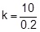
allow correct transformation of their chosen values
this mark may be awarded if e is in cm
1
k = 50
an answer 0.5 scores 3 marks
1
an answer of 50 scores 4 marks
(f) the line is straight
allow the line does not curve
1
and passes through the origin
this mark is dependent on scoring the first mark
allow a correct description of direct proportionality for 2 marks
ignore the line shows they are directly proportional
1
[16]

