3. Planning experiments: CHEMISTRY
Here are some worked examples from all sciences that will help you!
Tip: the independent variable is the one you change, this should only be one thing!
Tip: the dependent variable is the one you measure, this is normally only one thing, but it can be two. For example, measuring current and potential difference to work out resistance.
Tip: the control variables are the ones you keep the saeme, you should have lots of these, they will esnure you get valid, accurate results. Some common ones are: same volume, same mass, same surface area, same acid, same distance etc.
Here are three examples, one from each science. You will notice that they are very similar!

Now try the questions and self-assess them using the mark schemes, ask your teacher if you are still unsure!
Q1.
This question is about lithium carbonate.
Lithium carbonate is used in medicines.
The figure shows a tablet containing lithium carbonate.
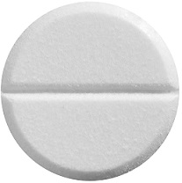
(a) Lithium carbonate contains lithium ions and carbonate ions.
A student tested the tablet for lithium ions and for carbonate ions.
The student used:
• a metal wire
• dilute hydrochloric acid
• limewater.
Plan an investigation to show the presence of lithium ions and of carbonate ions in the tablet.
You should include the results of the tests for the ions.
___________________________________________________________________
___________________________________________________________________
___________________________________________________________________
___________________________________________________________________
___________________________________________________________________
___________________________________________________________________
___________________________________________________________________
___________________________________________________________________
___________________________________________________________________
___________________________________________________________________
___________________________________________________________________
___________________________________________________________________
(6)
(b) The tablet also contains other substances.
The substances in tablets are present in fixed amounts.
What name is given to mixtures like tablets?
___________________________________________________________________
(1)
(c) The tablet has a mass of 1.20 g and contains 700 mg of lithium carbonate.
Calculate the percentage by mass of lithium carbonate in this tablet.
___________________________________________________________________
___________________________________________________________________
___________________________________________________________________
___________________________________________________________________
Percentage by mass of lithium carbonate = ________________________%
(3)
(Total 10 marks)
Q2.
Soluble salts are formed by reacting metal oxides with acids.
(a) Give one other type of substance that can react with an acid to form a soluble salt.
___________________________________________________________________
(1)
(b) Calcium nitrate contains the ions Ca²⁺ and NO₃⁻
Give the formula of calcium nitrate.
___________________________________________________________________
(1)
(c) Describe a method to make pure, dry crystals of magnesium sulfate from a metal oxide and a dilute acid.
___________________________________________________________________
___________________________________________________________________
___________________________________________________________________
___________________________________________________________________
___________________________________________________________________
___________________________________________________________________
___________________________________________________________________
___________________________________________________________________
___________________________________________________________________
___________________________________________________________________
___________________________________________________________________
___________________________________________________________________
___________________________________________________________________
___________________________________________________________________
___________________________________________________________________
___________________________________________________________________
___________________________________________________________________
___________________________________________________________________
___________________________________________________________________
___________________________________________________________________
(6)
(Total 8 marks)
Q3.
A student makes a hypothesis:
‘When different salt solutions are electrolysed with inert electrodes, the product at the negative electrode is always a metal’.
(a) Describe how you would test this hypothesis in the laboratory.
You should:
• draw a labelled diagram of the apparatus
• give the independent variable
• describe what you would see at the negative electrode if the hypothesis is true.
Diagram

Independent variable _________________________________________________
___________________________________________________________________
Observation _________________________________________________________
___________________________________________________________________
(5)
(b) The student’s hypothesis is only partially correct.
Explain why the product at the negative electrode is not always a metal.
___________________________________________________________________
___________________________________________________________________
___________________________________________________________________
___________________________________________________________________
(2)
(c) Predict the product at the positive electrode in the electrolysis of:
• sodium chloride solution
• copper sulfate solution.
Sodium chloride solution _______________________________________________
Copper sulfate solution ________________________________________________
(2)
(Total 9 marks)
Q4.
A student investigated displacement reactions of metals.
The student added different metals to copper sulfate solution and measured the temperature change.
The more reactive the metal is compared with copper, the bigger the temperature change.
The apparatus the student used is shown in Figure 1.
Figure 1
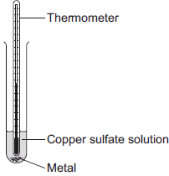
(a) State three variables that the student must control to make his investigation a fair test.
1. _________________________________________________________________
2. _________________________________________________________________
3. _________________________________________________________________
(3)
(b) Figure 2 shows the thermometer in one experiment before and after the student added a metal to the copper sulfate solution.
Figure 2

Before adding metal | After adding metal
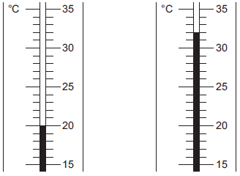
Use Figure 2 to complete Table 1.
Table 1

Temperature before adding metal in °C | ________
Temperature after adding metal in °C | ________
Change in temperature in °C | ________
(3)
(c) The student repeated the experiment three times with each metal.
Table 2 shows the mean temperature change for each metal.
Table 2

Metal | Mean temperature change in °C
Cobalt | 4.5
Gold | 0.0
Magnesium | 10.0
Nickel | 3.0
Silver | 0.0
Tin | 1.5
(i) On Figure 3, draw a bar chart to show the results.
Figure 3
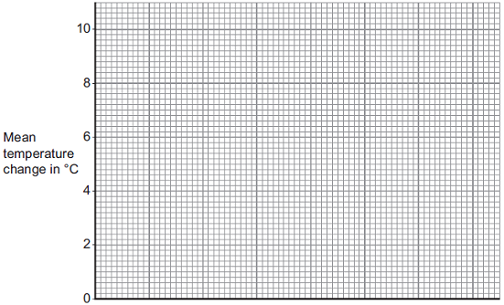
(3)
(ii) Why is a line graph not a suitable way of showing the results?
______________________________________________________________
______________________________________________________________
(1)
(iii) Use the results to work out which metal is the most reactive.
Give a reason for your answer.
Most reactive metal _________________________
Reason _______________________________________________________
______________________________________________________________
(2)
(iv) Explain why there was no temperature change when silver metal was added to the copper sulfate solution.
______________________________________________________________
______________________________________________________________
______________________________________________________________
______________________________________________________________
(2)
(v) It is not possible to put all six metals in order of reactivity using these results.
Suggest how you could change the experiment to be able to put all six metals into order of reactivity.
______________________________________________________________
______________________________________________________________
______________________________________________________________
______________________________________________________________
______________________________________________________________
(2)
(Total 16 marks)

Mark schemes
Q1.
(a) Level 3: The design/plan would lead to the production of a valid outcome. All key steps are identified and logically sequenced.
5–6
Level 2: The design/plan would not necessarily lead to a valid outcome. Most steps are identified, but the plan is not fully logically sequenced.
3–4
Level 1: The design/plan would not lead to a valid outcome. Some relevant steps are identified, but links are not made clear.
1–2
No relevant content
0
Indicative content
lithium:
• crush tablets or dissolve tablet (in water or acid)
• clean wire
• place on wire
• place in (roaring / blue / non-luminous) flame
• observe flame colour
• crimson flame
carbonate:
• add hydrochloric acid
• effervescence / fizzing
• bubble gas through limewater
• limewater becomes cloudy
(b) formulation(s)
1
(c)
an answer of 58.3333333 (%) correctly rounded to at least 2 significant figures scores 3 marks
1.20 g = 1200 mg
or
700 mg = 0.700 g
1
allow correct use of incorrectly or not converted values from step1
1
= 58.3 (%)
allow 58.3333333 (%) correctly rounded to at least 2 significant figures
1
[10]
Q2.
(a) any one from:
• metal
• (metal) hydroxide
allow ammonium hydroxide
• (metal) carbonate
allow ammonium carbonate
• alkali
allow soluble base
allow ammonia
1
allow named example
allow correct formula
ignore base
(b) Ca(NO₃)₂
allow Ca²⁺(NO₃⁻)₂
1
(c) Level 3: The method would lead to the production of a valid outcome. All key steps are identified and logically sequenced.
5−6
Level 2: The method would not necessarily lead to a valid outcome. Most steps are identified, but the method is not fully logically sequenced.
3−4
Level 1: The method would not lead to a valid outcome. Some relevant steps are identified, but links are not made clear.
1−2
No relevant content
0
Indicative content
• use magnesium oxide and sulfuric acid
• add sulfuric acid to a beaker
• warm sulfuric acid
• add magnesium oxide
• stir
• continue adding until magnesium oxide is in excess
• filter
• using a filter paper and funnel
• to remove excess magnesium oxide
• heat solution in an evaporating basin
• to crystallisation point
• leave to crystallise
• pat dry with filter paper
credit may be given for diagrams
[8]
Q3.
(a) (diagram)
complete circuit with power supply
1
test solution in beaker or other appropriate apparatus
1
electrodes
allow carbon, platinum or inert electrodes
1
(independent variable)
salt solutions (with different metal ions)
1
(observation)
solid / metal deposit on the negative electrode
1
(b) (sometimes) hydrogen is produced
1
(because) the metal is more reactive than hydrogen
1
(c) chlorine
1
oxygen
1
[9]
Q4.
(a) any three from:
• concentration of (salt) solution
• volume of (salt) solution
ignore amount of solution
• initial temperature (of the solution)
ignore room temperature
• surface area / form of metal
• moles of metal
allow mass / amount
ignore time
ignore size of tube
3
(b) 20
1
32
1
12
allow ecf
1
(c) (i) four bars of correct height
tolerance is + / - half square
3 correct for 1 mark
2
bars labelled
1
(ii) one variable is non-continuous / categoric
accept qualitative or discrete
accept no values between the metals
1
(iii) magnesium
1
because biggest temperature change
accept gives out most energy
ignore rate of reaction
dependent on first mark
1
(iv) does not react / silver cannot displace copper
1
because silver not more reactive (than copper) or silver below copper in reactivity series
do not accept silver is less reactive than copper sulfate
1
(v) replace the copper sulfate
could be implied
1
with any compound of a named metal less reactive than copper
allow students to score even if use an insoluble salt
1
[16]
[10]

