3. Planning experiments: BIOLOGY
Here are some worked examples from all sciences that will help you!
Tip: the independent variable is the one you change, this should only be one thing!
Tip: the dependent variable is the one you measure, this is normally only one thing, but it can be two. For example, measuring current and potential difference to work out resistance.
Tip: the control variables are the ones you keep the saeme, you should have lots of these, they will esnure you get valid, accurate results. Some common ones are: same volume, same mass, same surface area, same acid, same distance etc.
Here are three examples, one from each science. You will notice that they are very similar!

Now try the questions and self-assess them using the mark schemes, ask your teacher if you are still unsure!
Q1.
A student investigated respiration in yeast.
This is the method used.
1. Add 5 cm³ of a yeast and water mixture to each measuring cylinder.
2. Add different masses of sugar to each measuring cylinder.
3. Mix the contents of each measuring cylinder gently for 5 seconds.
4. Put the measuring cylinders in a water bath at 25 °C
5. Over the next 20 minutes, record the maximum volume the foam reaches in each measuring cylinder.
The figure below shows the student’s results.
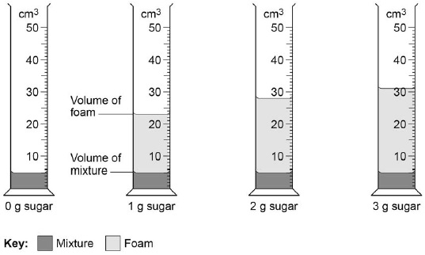
(a) Which two variables did the student control in the method?
Tick (✓) two boxes.

Mass of sugar | 
pH of the mixture
Temperature
Volume of foam
Volume of yeast and water
(2)
The following table shows the results.

Mass of sugar in g | Maximum  volume in cm³
0 | 5
1 | 23
2 | X
3 | 31
(b) What is value X in the table?
Use the figure above.
X = ____________________ cm³
(1)
In the investigation, the yeast respires and releases a gas which causes the foam to rise.
(c) Which gas causes the foam to rise?
Tick (✓) one box.

Carbon dioxide
Hydrogen
Nitrogen
Oxygen
(1)
(d) What conclusion can you make about the relationship between the mass of sugar used and the volume of gas produced?
___________________________________________________________________
___________________________________________________________________
___________________________________________________________________
___________________________________________________________________
(1)
(e) Why was no foam produced in the mixture with 0 g of sugar?
___________________________________________________________________
___________________________________________________________________
(1)
(f) Why was the measuring cylinder with 0 g of sugar included in the investigation?
___________________________________________________________________
___________________________________________________________________
(1)
(g) The top of the mixture can be covered with a layer of oil after step 3 in the method.
Suggest why the layer of oil stops the yeast respiring aerobically.
___________________________________________________________________
___________________________________________________________________
(1)
(h) What other substance is produced during anaerobic respiration in yeast?
Tick (✓) one box.

Ethanol
Hydrochloric acid
Lactic acid
Water
(1)
(Total 9 marks)
Q2.
This question is about photosynthesis.
(a) Complete the word equation for photosynthesis:
__________________ + __________________ → __________________ + oxygen
(2)
A student investigated photosynthesis using pondweed.
Figure 1 shows the apparatus the student used.
Figure 1
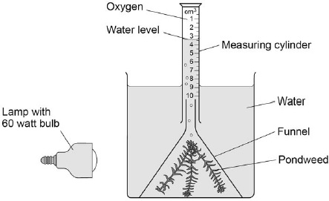
This is the method used.
1. Set up the apparatus as shown in Figure 1.
2. Switch on the lamp.
3. After 20 minutes, record the volume of oxygen collected in the measuring cylinder.
4. Repeat steps 1–3 using bulbs of different power output.
(b) What was the independent variable in the investigation?
Tick (✓) one box.

Power output of bulb
Rate of photosynthesis
Time to collect oxygen
Volume of oxygen collected
(1)
(c) Suggest two ways the method could be improved so the results would be more valid.
1 _________________________________________________________________
___________________________________________________________________
2 _________________________________________________________________
___________________________________________________________________
(2)
The table below shows the student’s results.

Power output of bulb in watts | Volume of oxygen collected in 20 minutes in cm³ | Rate of photosynthesis in cm³/hour
60 | 0.5 | 1.5
100 | 0.8 | 2.4
150 | 1.1 | X
200 | 1.2 | 3.6
250 | 1.2 | 3.6
(d) Calculate value X in the table above.
___________________________________________________________________
___________________________________________________________________
X = _____________________ cm³/hour
(1)
(e) Complete Figure 2.
You should:
• label the x-axis
• use a suitable scale
• plot the data from the table above and your answer to part (d)
• draw a line of best fit.
Figure 2
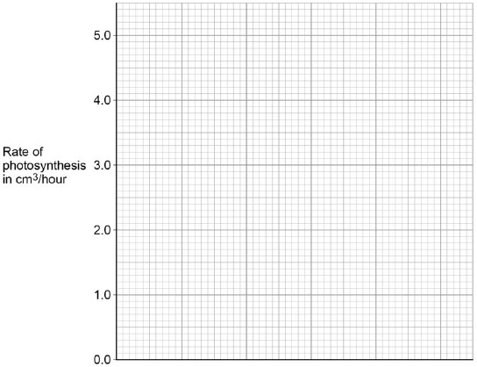
(4)
(f) Determine the expected rate of photosynthesis with a bulb of power output 75 watts.
Use Figure 2.
___________________________________________________________________
Rate of photosynthesis at 75 watts = ______________________cm³/hour
(1)
(g) Which graph shows the effect of temperature on the rate of photosynthesis?
Tick (✓) one box.
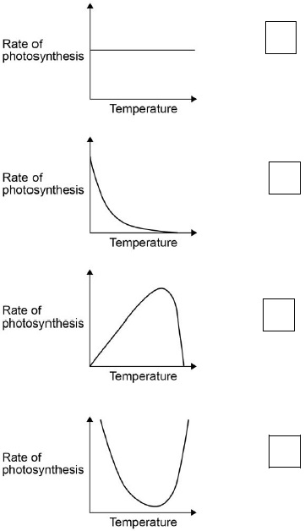
(1)
(Total 12 marks)
Q3.
Metabolism is the sum of all the chemical reactions in the cells of the body.
One metabolic reaction is the formation of lipids.
(a) Give one other metabolic reaction in cells.
___________________________________________________________________
___________________________________________________________________
(1)
Table 1 shows the mean metabolic rate of humans of different ages.
Table 1

Age in years | Mean metabolic rate in kJ/m²/hour
Age in years | Males | Females
5 | 53 | 53
15 | 45 | 42
25 | 39 | 35
35 | 37 | 35
45 | 36 | 35
(b) What two conclusions can be made from the data in Table 1?
Tick two boxes.

As age increases, mean metabolic rate of males and females increases.
Males have a higher metabolic rate than females after five years of age.
The mean metabolic rate of females decreases faster than males up to 25 years of age.
The mean metabolic rate of males and females decreases more quickly after the age of 35.
There is no relationship between age and mean metabolic rate.
(2)
(c) Calculate the percentage decrease in the mean metabolic rate of males between 5 years and 45 years of age.
Use the equation:
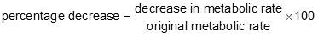
Give your answer to 3 significant figures.
___________________________________________________________________
___________________________________________________________________
___________________________________________________________________
___________________________________________________________________
Percentage decrease = ___________________
(3)
Regular exercise can increase metabolic rate.
Two people did five minutes of gentle exercise from rest.
Table 2 shows the effect of the exercise on their heart rates.
Table 2

Time in minutes | Heart rate in beats per minute
Time in minutes | Person R | Person S
0 (at rest) | 60 | 78
1 | 76 | 100
2 | 85 | 110
3 | 91 | 119
4 | 99 | 129
5 | 99 | 132
(d) Describe two differences in the response of person R and person S to the exercise.
Use information from Table 2.
1. _________________________________________________________________
___________________________________________________________________
2. _________________________________________________________________
___________________________________________________________________
(2)
(e) Complete the line graph below for person S.
You should:
• add the scale to the x axis
• label the x axis.
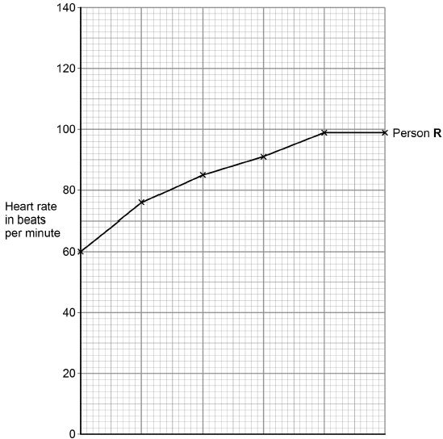
(4)
(f) After five minutes of exercise, the heart rate of person S was 132 beats per minute. When person S rested, his heart rate decreased steadily at a rate of 12 beats every minute.
Calculate how much time it would take the heart rate of person S to return to its resting rate.
___________________________________________________________________
___________________________________________________________________
___________________________________________________________________
Time = ___________________ minutes
(2)
(g) A student made the following hypothesis about the heart rate of smokers and non-smokers during exercise.
“During exercise, the heart rate of smokers increases more than
the heart rate of non-smokers.”
Design an investigation that would allow you to test this hypothesis.
___________________________________________________________________
___________________________________________________________________
___________________________________________________________________
___________________________________________________________________
___________________________________________________________________
___________________________________________________________________
___________________________________________________________________
___________________________________________________________________
___________________________________________________________________
___________________________________________________________________
___________________________________________________________________
___________________________________________________________________
___________________________________________________________________
___________________________________________________________________
___________________________________________________________________
___________________________________________________________________
___________________________________________________________________
___________________________________________________________________
___________________________________________________________________
(6)
(Total 20 marks)
Q4.
Two students investigated reflex action times.
This is the method used.
1. Student A sits with his elbow resting on the edge of a table.
2. Student B holds a ruler with the bottom of the ruler level with the thumb of Student A.
3. Student B drops the ruler.
4. Student A catches the ruler and records the distance.
5. Steps 1 to 4 are then repeated.
The same method was also used with Student A dropping the ruler and Student B catching the ruler.
(a) Give two variables the students controlled in their investigation.
1. _________________________________________________________________
2. _________________________________________________________________
(2)
(b) Figure 1 shows one of the results for the Student A.
Figure 1
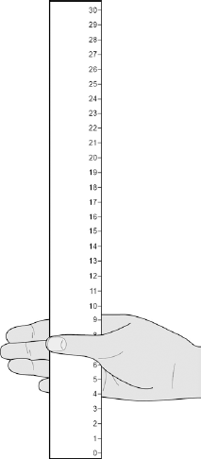
What is the reading shown in Figure 1?
___________________________________________________________________
Reading on ruler = ___________________________ cm
(1)
(c) Table 1 shows the students’ results.
Table 1

Test  number | Distance ruler dropped in cm
Test  number | Student A | Student B
1 | 9 | 12
2 | 2 | 13
3 | 6 | 13
4 | 7 | 9
5 | 7 | 8
Mean | 7 | X
Circle the anomalous result in Table 1 for Student A.
(1)
(d) What is the median result for Student B?

Tick one box.
8 | 
11
12
13
(1)
(e) Calculate the value of X in Table 1.
___________________________________________________________________
Mean distance ruler dropped = __________________ cm
(1)
(f) Figure 2 shows the scale used to convert distance of the ruler drop to reaction time.
Figure 2
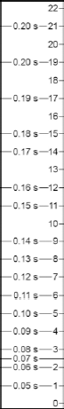
Calculate how much faster the reaction time of Student A was compared to Student B.
Use Figure 2 and Table 1.
___________________________________________________________________
Answer = _____________ s
(2)
(g) What improvement could the students make to the method so the results are more valid?

Tick one box.
Use alternate hands when catching the ruler
Carry out more repeats
Use a longer ruler for catching
Use more than two students to collect results
(1)
(h) Student A carried out a second investigation to see the effect of caffeine on the reflex action.
Table 2 shows his results.
Table 2

Test  number | Distance ruler dropped in cm
Test  number | Without caffeine | With caffeine
1 | 9 | 5
2 | 6 | 5
3 | 9 | 4
4 | 6 | 7
5 | 10 | 4
Mean | 8 | 5
Give one conclusion about the effect of caffeine on reflex actions.
___________________________________________________________________
___________________________________________________________________
(1)
(Total 10 marks)

Mark schemes
Q1.
(a) temperature
1
volume of yeast and water
1
(b) 28
1
(c) carbon dioxide
1
(d) the greater the mass of sugar, the greater the volume of foam / gas produced
allow reference to weight / amount of sugar
allow reference to amount of foam / gas
allow positive correlation
ignore names of gases
ignore directly proportional
1
(e) no respiration occurs
or
sugar / glucose is needed for respiration
ignore no reaction occurs
1
(f) for comparison / to compare
allow as a control (experiment)
allow as a base line
do not accept as a control variable
or
to check that no other factor / variable is influencing the results
allow answers in the context of the investigation e.g. to prove that the results obtained were due to the sugar (and nothing else)
or
to ensure validity
ignore fair test / accuracy
1
(g) (it) stops the oxygen / air getting in / through
ignore (it) stops the oxygen / air getting out
ignore gases unqualified
1
(h) ethanol
1
[9]
Q2.
(a)
words take precedence over symbols
LHS:
1
carbon dioxide and water
RHS:
glucose
1
allow correct symbols (ignore balancing)
in any order
do not accept starch
ignore carbohydrates / sugar
(b) power output of bulb
1
(c) any two from:
• repeat and calculate a mean
or
repeat and to eliminate anomalies
ignore do a control experiment unqualified
• control the (water) temperature
allow a method of controlling (water) temperature
• control the concentration of carbon dioxide
allow a method of controlling carbon dioxide concentration
• control the distance of the bulb from the pondweed
• control the mass / length / species / age of the pondweed
allow use the same piece of pondweed
• give pondweed time to equilibrate
allow do experiment with the bulb off / in the dark
2
(d) 3.3 (cm³/hour)
1
(e)
max 3 marks for bar chart
correct scale and axis labelled
1
all points plotted correctly
allow points plotted to within ± ½ small square
allow 3 or 4 correct plots for 1 mark
allow correct plot from incorrect value calculated in part (d)
2
correct curved line of best fit
ignore line extended beyond 60 / 250 (W)
ignore line joined point to point with straight lines
1
(f) correct answer from their line drawn on Figure 2
allow ± ½ small square tolerance
allow 1.8 / 1.9 if no line of best fit or incorrect graph is drawn
1
(g)
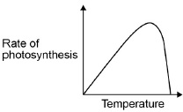
1
[12]
Q3.
(a) any one from:
• respiration
• formation of proteins
• formation / breakdown of glycogen
• breakdown of (excess) protein or formation of urea
• photosynthesis or formation of glucose / starch (in plants)
ignore formation of carbohydrates
1
allow other correct reference to metabolic reactions in cells
ignore reference to digestion
(b) males have a higher metabolic rate than females after five years of age
1
the mean metabolic rate of females decreases faster than males up to 25 years of age
1
each additional tick negates a mark
(c) 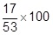
1
32.075472…
allow correct rounding of this to at least 4 significant figures
1
32.1
allow a correct reduction to 3 significant figures from an incorrect calculation for marking point 2
1
an answer of 32.1 scores 3 marks
(d) any two from:
allow converse
• (person) R heart rate rose / increased more slowly than (person) S
• (person) R heart rate levelled off whereas (person) S continued to increase
• (person) R heart rate rose less (overall / after 5 minutes of exercise) than S
allow correct use of figures
e.g. R increased (overall) by 39 bpm / 65% and S by 54 bpm / 69%
ignore lack of units
2
(e) correct scale and axis labelled
allow min(s)
do not accept ‘m’
the zero is not required on the x-axis
1
all points plotted correctly (to within ± ½ square)
allow 4 or 5 correct plots for 1 mark
2
line joined point to point or correct curved line of best fit
1
(f) 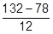
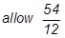
allow sequential deductions of 12 four or five times
1
4.5 (minutes) / 4½ minutes / 4 minutes 30 seconds / 4:30
do not accept 4:50 or 4 minutes 50 seconds
1
an answer of 4.5 minutes scores 2 marks
(g) Level 3: The method would lead to the production of a valid outcome. All key steps are identified and logically sequenced.
5−6
Level 2: The method would not necessarily lead to a valid outcome. Most steps are identified, but the method is not fully logically sequenced.
3−4
Level 1: The method would not lead to a valid outcome. Some relevant steps are identified, but links are not made clear.
1−2
No relevant content
0
Indicative content
• two groups of people − non-smokers and smokers
• have at least five people in each group or large groups
• get each person to do (named) exercise
• controlled variables:
− same number of people in each group or large groups
− same gender
− same level of activity / exercise
− same age
− no health issues / illnesses
− same type of exercise
− same time for exercise
• record heart rate for each person before and after exercise
• calculate increase in heart rate for each person after exercise
• compare results for each group
for level 3, students should refer to at least 5 smokers and 5 non-smokers, carrying out exercise with control variables and a means of determining an increase in heart rate
for level 2, students should refer to ‘groups’ of smokers and non-smokers exercising
[20]
Q4.
(a) any two from:
• drop the ruler from the same height
• use the same / dominant hand each time
• thumb same distance from ruler at the start
• use same type / weight of ruler
• drop the ruler without any force each time
• keep arm resting on the edge of the table
2
(b) 8
allow 8.0
1
(c) 2 (in test number 2)
1
(d) 12
1
(e) (12 + 13 + 13 + 9 + 8 / 5 =) 11
1
(f) 0.15 − 0.12 (s)
1
0.03 (s)
allow 0.03 (s) with no working shown for 2 marks
1
(g) carry out more repeats
1
(h) caffeine speeds up reflex actions
or
reduces reaction time
1
[10]

