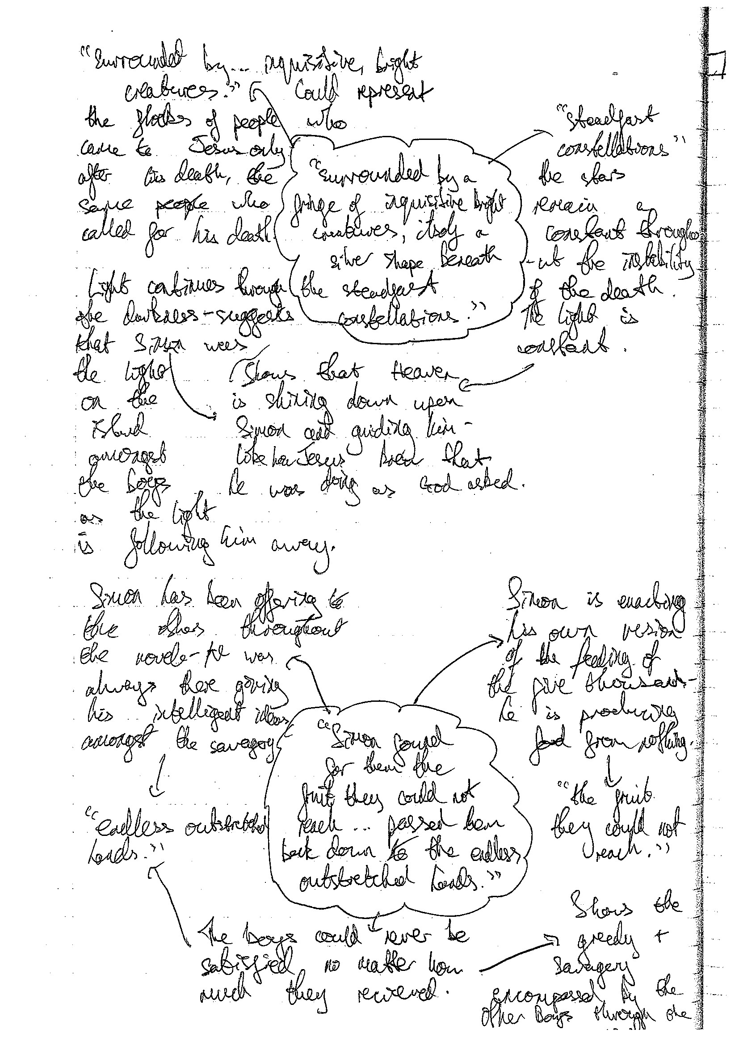
This student makes precise and insightful links between a text and its wider context. They are able to draw on religious allusions to inform their understanding and argument about Lord of the Flies.
Judicious quotations have been selected to plan a mature and coherent analysis.
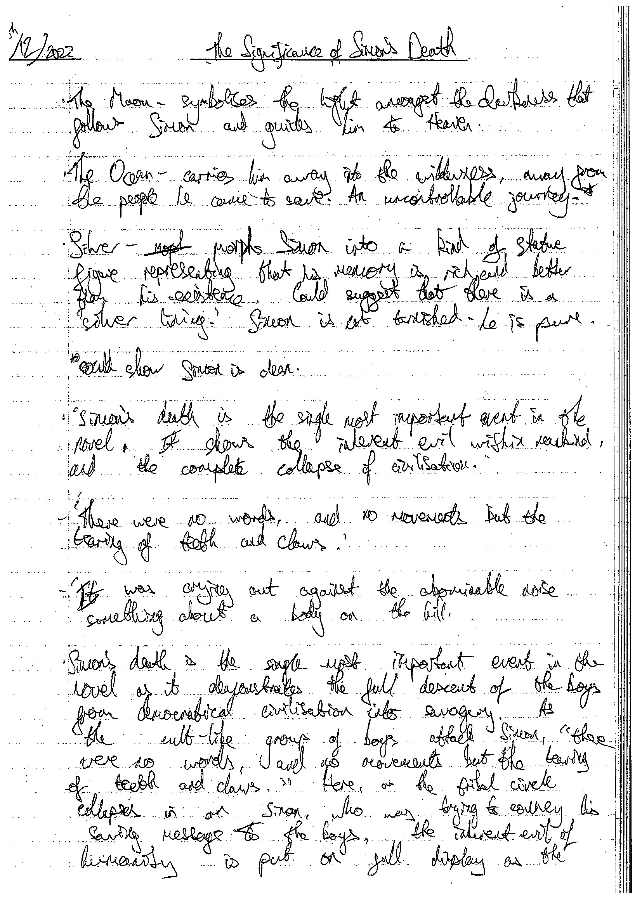
The student uses their accurate knowledge of social context and their detailed knowledge of the text to inform their answer. By doing so, their argument is thorough and assured.
The student has continued to plan in depth on this page to ensure their answer will be precice and structured with a clear line of argument.
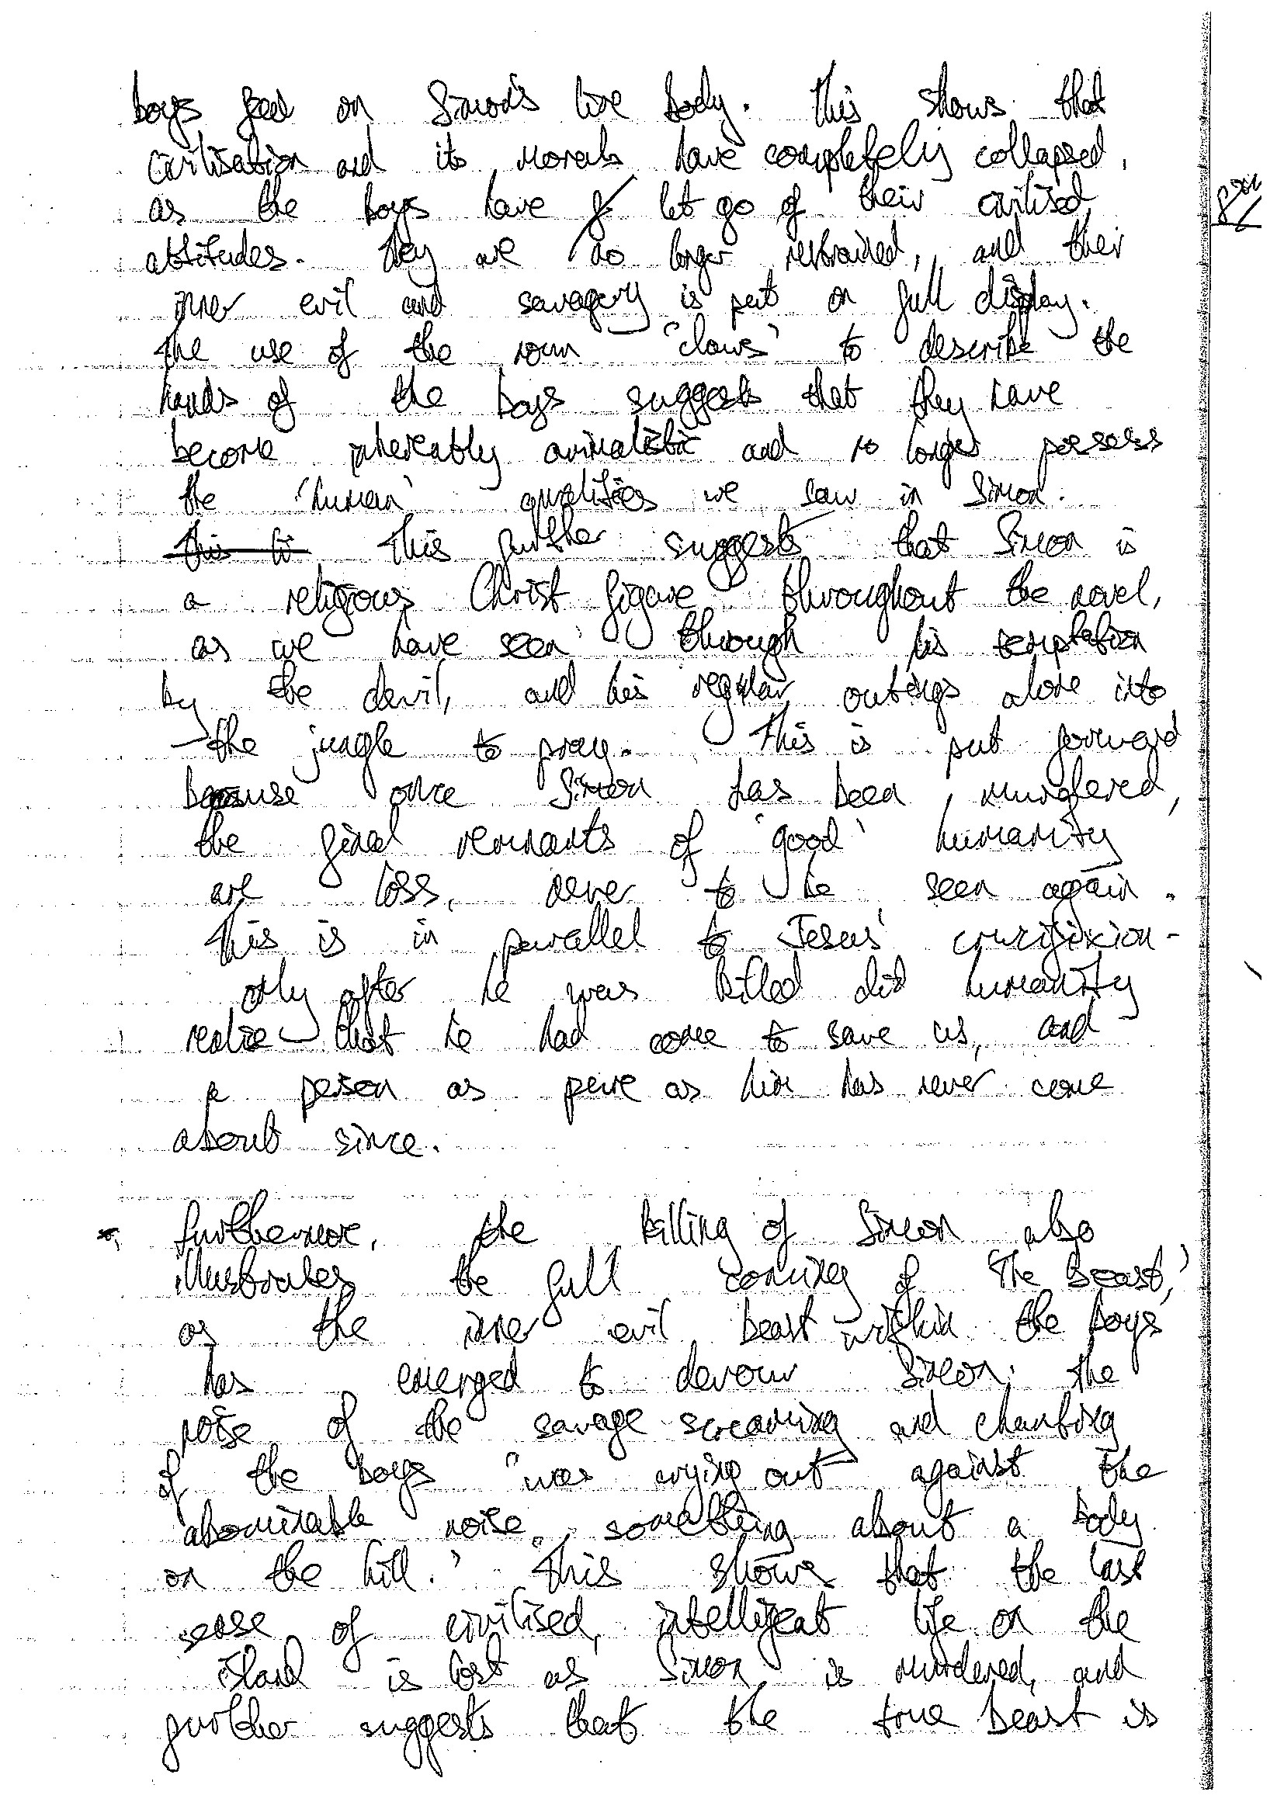
The line of argument is tightly controlled and the student has been able to build an incredibly coherent and precise analysis.
Methods are analysed meticulously. The student links their ideas into their understanding of the text as a whole. This demonstrates an impressive awareness of the structure of the text and the significance of this.

