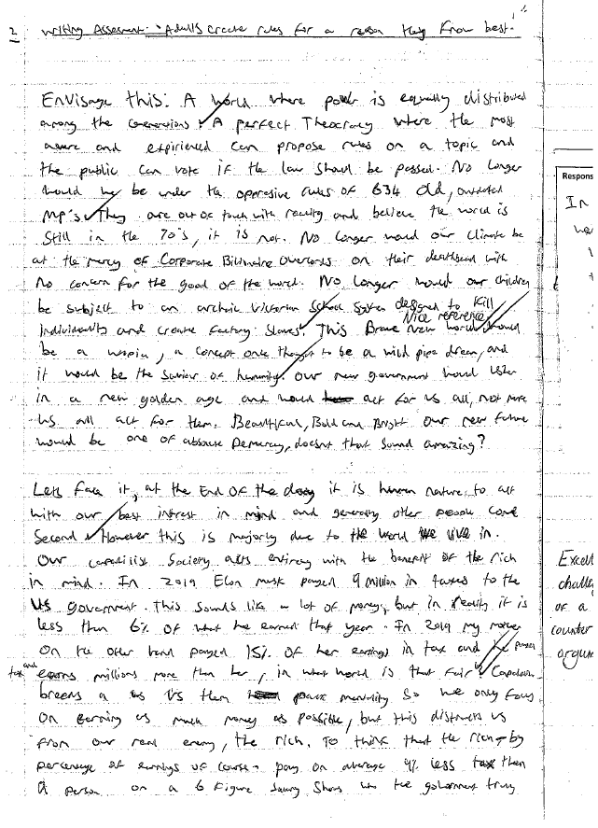
A wide range of mature and judiciously selected examples are drawn upon to support a developed and tightly controlled argument.
The student begins their speech in a highly entertaining way, writing with sophistication and flair.
Recognises and challenges the counter argument to ensure that writing is convincing.
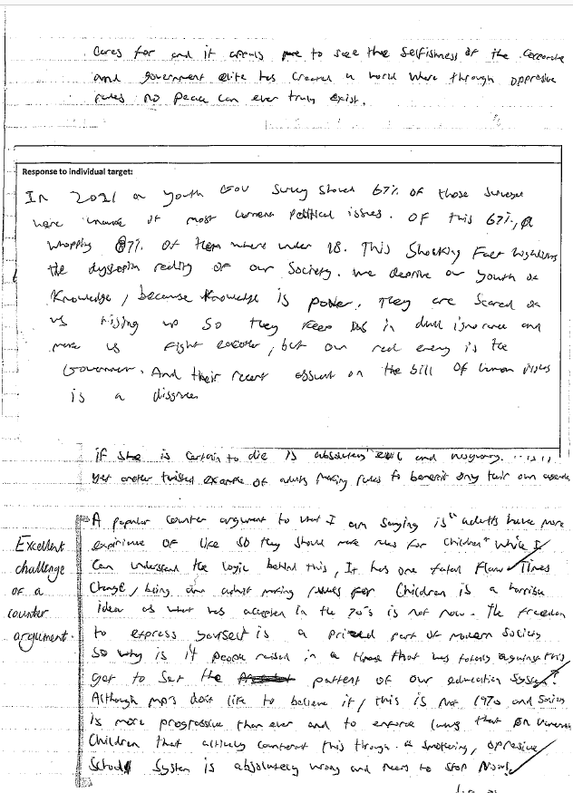

The student is reflective and is able to respond fully to feedback given in order to make further progress.

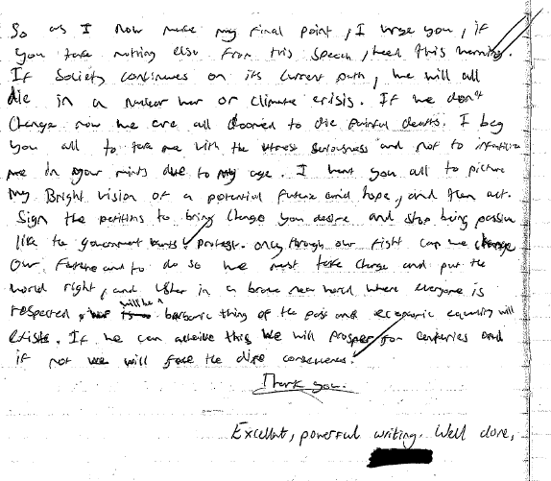
Throughout the speech, the student has been able to use ambitious vocabulary and varied sentence structures. The spelling and grammar is almost always accurate.
A thorough understanding of the task is shown. The student is able to tailor their writing carefully to match the form, purpose and audience.
The student is able to craft a powerful, emotive ending. The speech is compelling as well as engaging and entertaining to read.

