Read the following sources, about gas attacks, and complete the table with what you can learn from the sources.
Source 1: History of the Great War: Medical Services p.134, published in 1931
“The first German gas attack on 22nd April 1915 took the British completely by surprise, and throughout the year the troops were subject to this new form of warfare. Hospital returns for British troops show 12,792 admissions for gas poisoning during 1915, of whom 307 were fatal. The prevention and treatment of this new type of casualty were problems which demanded, and received, immediate attention, not only in 1915 but throughout subsequent (future) development of gas warfare.”

Source 2: Gassed by the war artist, John Singer Sargent, 1918
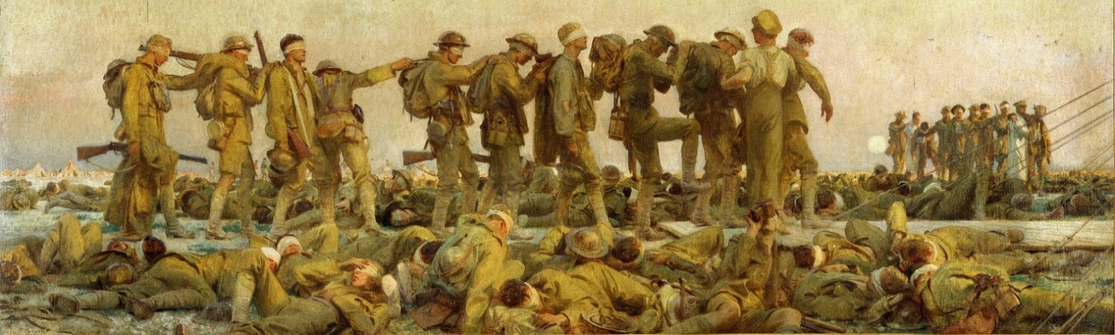
Source 3: From Lifeline – A British Casualty Clearing Station on the Western Front 1918 by Iain Gordon, p.57
“Gas was the weapons which soldiers feared most. Contact with the skin caused large, intensely painful blisters filled with a yellow fluid. If more than half the victim’s body was affected, a slow, agonising death after four or five days of suffering was almost inevitable. [However] most gas poisoning was less severe, but nevertheless required several weeks of treatment and convalescence (recovery)… [I]f mustard gas was inhaled, it would cause bleeding and blistering of the lungs, which if they survived would cause problems later in life.”
Question: What can you learn from each of the sources about gas warfare?
Source | What can we learn?
One
Two
Three

