Cambridge Technical level 3: Business
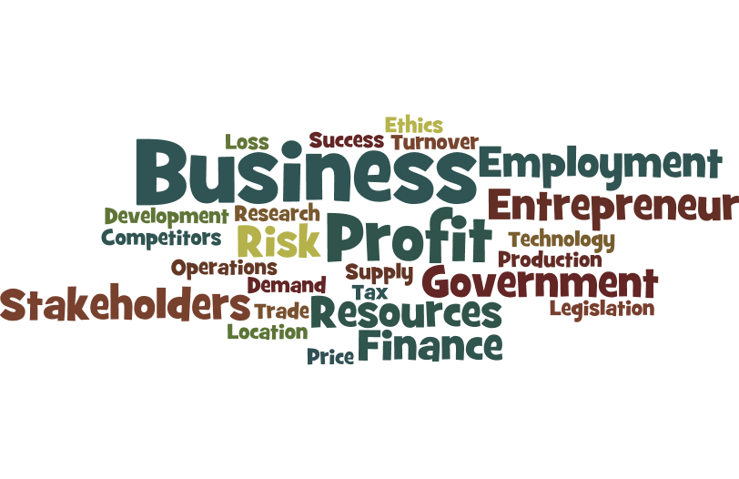

Bridging Course - Week 2
(For Single and Double award students)




St Mary’s Catholic School
Cambridge Technicals: Business

Week 1 Re-cap
- State the entry requirements of the course you have selected.
- State 3 skills you will need to succeed on this course.
- Can you state how many units you will need to complete on your selected pathway? (single or double award)
- Can you state how many exams you will have on your selected course?
- Can you state how many times you can re-sit these exams?
- Can you state at least 3 units/topics you will study?
- What are 3 types of business ownership?
- What is an example of a business objective?
- The NHS are part of what sector?
- What is limited liability?
Organisation

Being organised is vital. The start of 6th form might seem very tough, however if you are organised you will easily get through this initial period and go on to secure the best grade possible. You will be provided with a lot of content over your 3-4 subjects and across several teachers. In Business (Single and double awards) you will be receiving work from Mr Holmes and Mrs Shields. You will have notes, support materials, tests etc to utilise over 5 units (single award) or 10 (Double award). Therefore you must set up a filing system (Physical and electronic). We will organise the electronic version in September (You may want to invest in a memory stick). Where possible get yourself an A4 leaver arch file and some file dividers (at least 10 sections).

Unit 1 - LO1

As you now know unit 1 is the most valuable unit (worth double points). It covers many aspects of business theory. There are 8 Learning objectives to cover (LOB’s).

Log onto: https://www.businessed.co.uk/index.php/home/theory/cambtec/cambtec-l3-theory#unit-1-the-business-environment.

Read through the 14 PowerPoints making introductory notes on each of the key areas. This could be in the form of a Mind map for instance.

Activity 2: Wider research task

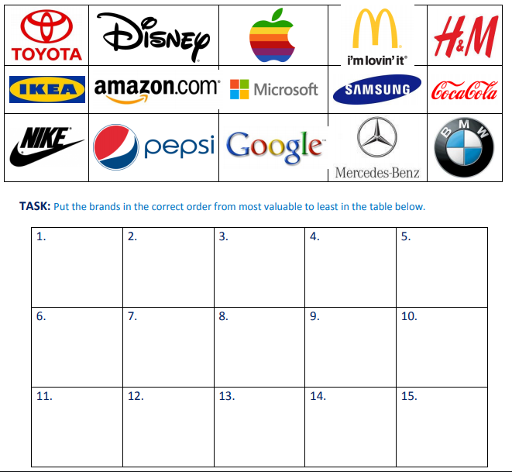
Global Brands Quiz - Below are some of the top 30 most valuable global brands in 2019 according to Inter brand. However they are not in the correct order.

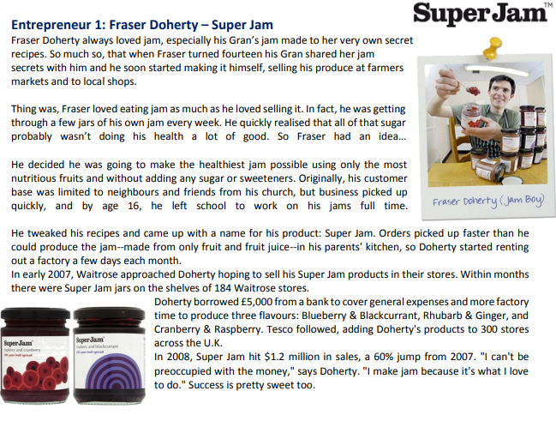
Activity 3: An Entrepreneur’s story! Read the case study below about the entrepreneur and their business start-up story. Then answer the questions below the article.
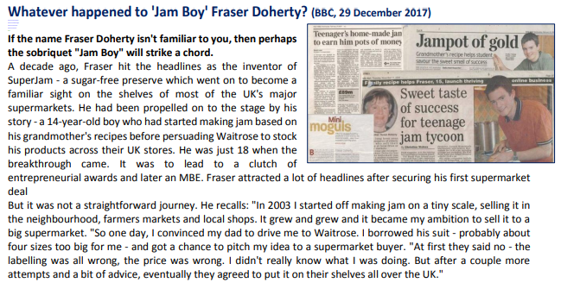

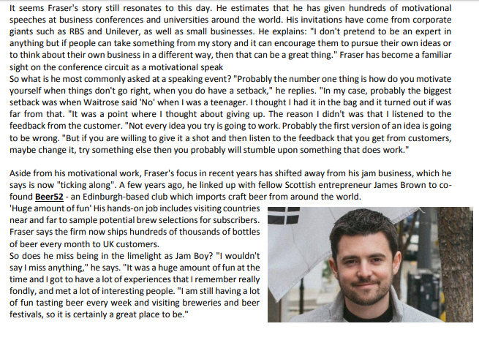
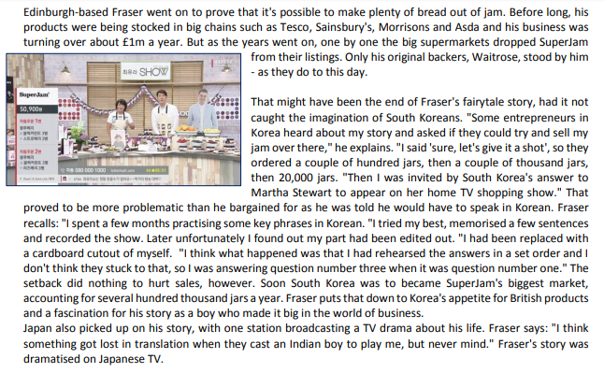

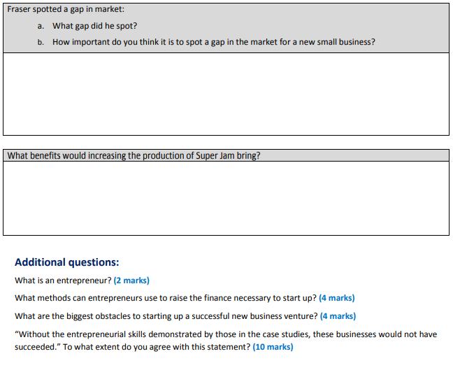
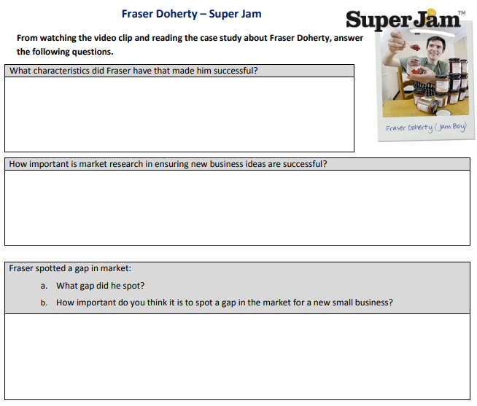

1. | Read the Scenario below.  Business scenario: Huxley Library  Huxley Library is a small public library located in a run-down suburban district. Library users can  borrow books and other materials free of charge. Its current opening hours are Monday to Friday  7am to 3pm. The library is closed on Saturdays and Sundays. Library users can choose to borrow from a good range of general interest books, a small selection of children’s books, a wide range of e-books and an outdated selection of audio books. In addition, Huxley Library’s service provision includes: computer and Internet access, a community room and a reading room. The community room is used for craft activities, primarily targeted at senior citizens. The room is also available for hire at a reasonable rate. The reading room, which contains recent copies of magazines and newspapers, is hardly ever used. Huxley Library is a public sector organisation. It is financed and controlled by Alphashire County Council.  The library is staffed by Malik, the Library Manager, two fully-qualified librarians and  three part-time library assistants. Malik and the two librarians are grateful for the legal, marketing and administrative support provided by Alphashire County Council. They welcome change and pride themselves on being in touch with the needs of library users. Despite wishing that Alphashire County Council would require less paperwork, be more flexible and agree to more of their innovative ideas, they love their jobs. Disappointingly, library assistants never seem to stay at the library for long, frequently leaving to develop their skills elsewhere.  Huxley Library’s primary objective is to meet the information needs of the local community it  serves. With government finance under pressure, this gets harder each year. Huxley Library  has experienced a cut in funding in each of the last four years. Anna, Head of Library Services  at Alphashire County Council, is responsible for monitoring Huxley Library’s performance. Data  relating to Huxley Library’s performance in 2017 is shown in Figs. 1 & 2 below.  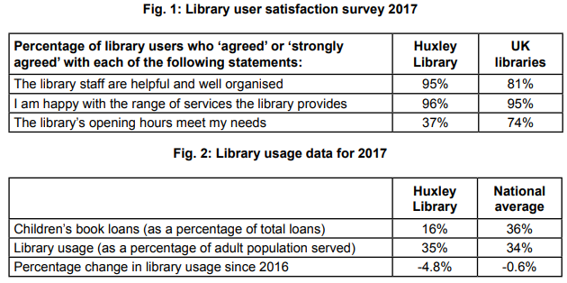  Every three years Alphashire County Council conducts detailed research into changes in the  external environment that may affect its departments. Anna, who makes all major decisions about Huxley Library’s service provision, is waiting for the findings of a study finished in February to be made available. She always feels that study findings are slow to be made available  Please refer to the Scenario Huxley Library to answer this question.  Evaluate the benefits and drawbacks to Huxley Library of being a government-owned organisation.  ----------------------------------------------------------------------------------------------------------------------------------  ----------------------------------------------------------------------------------------------------------------------------------  ----------------------------------------------------------------------------------------------------------------------------------  ----------------------------------------------------------------------------------------------------------------------------------  ----------------------------------------------------------------------------------------------------------------------------------  ----------------------------------------------------------------------------------------------------------------------------------  ----------------------------------------------------------------------------------------------------------------------------------  ----------------------------------------------------------------------------------------------------------------------------------  ----------------------------------------------------------------------------------------------------------------------------------  ----------------------------------------------------------------------------------------------------------------------------------  ----------------------------------------------------------------------------------------------------------------------------------  ----------------------------------------------------------------------------------------------------------------------------------  ----------------------------------------------------------------------------------------------------------------------------------  ----------------------------------------------------------------------------------------------------------------------------------  ----------------------------------------------------------------------------------------------------------------------------------  ----------------------------------------------------------------------------------------------------------------------------------  ----------------------------------------------------------------------------------------------------------------------------------  ----------------------------------------------------------------------------------------------------------------------------------  ----------------------------------------------------------------------------------------------------------------------------------  ----------------------------------------------------------------------------------------------------------------------------------  ----------------------------------------------------------------------------------------------------------------------------------  ----------------------------------------------------------------------------------------------------------------------------------  ----------------------------------------------------------------------------------------------------------------------------------  ----------------------------------------------------------------------------------------------------------------------------------  ----------------------------------------------------------------------------------------------------------------------------------  [12]
Mark Scheme

Level 4 (10 - 12 marks)
Candidate evaluates the benefits and drawbacks to Huxley Library of being a government-owned organisation.

Level 3 (7 - 9 marks)
Candidate analyses benefits/drawbacks of being a government-owned organisation.

Level 2 (4 – 6 marks)
Candidate explains benefits/drawbacks of being a government-owned organisation.

Level 1 (1 – 3 marks)
Candidate identifies benefits/drawbacks of being a government-owned organisation.

Responses include:

Advantages
• government funded/funded from taxation
• not strive for profit/not overburdened by financial motive
• not answerable to shareholders
• can operate for community/society benefit
• legal support services
• marketing support services
• administration support services
• economies of scale (What is this?)
• limited liability
• continuity of provision on change of government

Disadvantages:
• compete for funds with other government departments
• no retained profit
• affected by cuts in government funding
• requirements to make efficiency savings
• difficult to raise additional finance e.g. no shareholders
• can be used for political gain.
• subject to political influences e.g. general election, government policy, government initiatives
• subject to local authority control
• decision makers may be remote/not in touch with needs of service-users
• may not make best use of local employee expertise/knowledge
• slow decision-making/slow to change/respond
• inflexible
• risk averse/lacks innovation
• bureaucratic

Exemplar response:

One benefit to Huxley Library of being owned by the government is that it can operate as a not-for-profit organisation (L1). It does not have to make decisions which maximise profit (L2) rather it can concentrate on the quality of its service provision and the needs of the local community it serves (L3).

On the other hand, government-owned organisations are subject to strict government control (L1). This usually leads to high levels of bureaucracy within the organisation (L2), leading to slow and inflexible decision-making (L3).

Since the library offers its books (CONT) and materials for loan free of charge, it is unlikely that it could ever run as a commercial, profit-making enterprise. Therefore, despite the drawbacks of being government-owned it is advantageous to Huxley Library to operate in the public sector because it is more likely to receive the funding required to enable the organisation to continue to operate (L4).

