Cambridge Technical level 3: Business
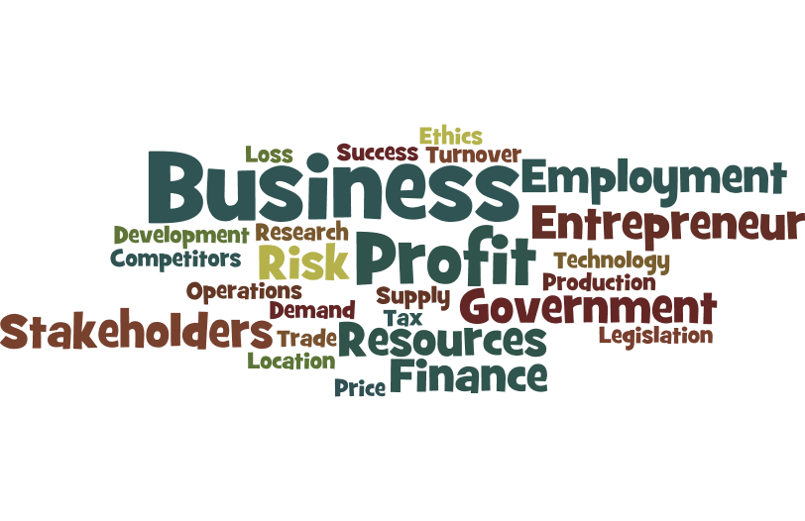

Bridging Course - Week 1



St Mary’s Catholic School
Cambridge Technicals: Business

Entry Requirements for Studying Business?
- Students should be expecting to achieve Grade 4 in GCSE English and Maths.
- Students will need to have good research skills, problem solving skills and must be well organised.
- Students who enjoy the value of money and how Businesses function in the real world will excel.
- Students who love a lively debate and discussion in lessons, and who are willing, and able, to share their ideas.
- Students must be strong communicators and have confidence to present to others.
What to expect from Level 3 Business.
The Cambridge Technicals in Business have been developed to meet the changing needs of the sector, and prepare students for the challenges you will face in Higher Education or employment. Designed in collaboration with experts spanning the breadth of the sector, the Cambridge Technicals in Business focuses on the skills, knowledge and understanding that today’s universities and employers demand.

Students will practically apply skills and knowledge in preparation for further study or the workplace. Students will learn how a business might evolve. From a small start-up business to a large multinational organisation, students will consider a range of different business types and gain an understanding of how the choice of business type might affect the objectives that are set.

Students will also look at the internal workings of businesses, including their internal structure and how different functional areas work together. Plus, by looking at the external constraints under which a business must operate, students will gain an understanding of the legal, financial and ethical factors that have an impact. Students will also explore ways in which businesses respond to changes in their economic, social and technological environment; and gain an appreciation of the influence different stakeholders can have upon a business.

This bridging course will provide you with a mixture of information about level 3 Business, and what to expect from the course, as well as key work to complete. Students who are expecting to study Business, and are likely to meet the entry requirements, must complete the bridging course fully and thoroughly, to the best of their ability. You should complete all work on paper and keep it in a file, in an ordered way.

You will submit it to your teacher in September. All of the work will be reviewed and selected work will be assessed, and you will be given feedback on it. This work will be signalled to you. If you do not have access to the internet, please contact the school and appropriate resources will be sent to you.

If you are thinking about studying Business you should attempt this work to see whether or not you think studying a subject like this is right for you. If you later decide to study Business, you must ensure you complete this work in full. This work should be completed after you have read and completed the Study Skills work that all of Year 12 should complete.

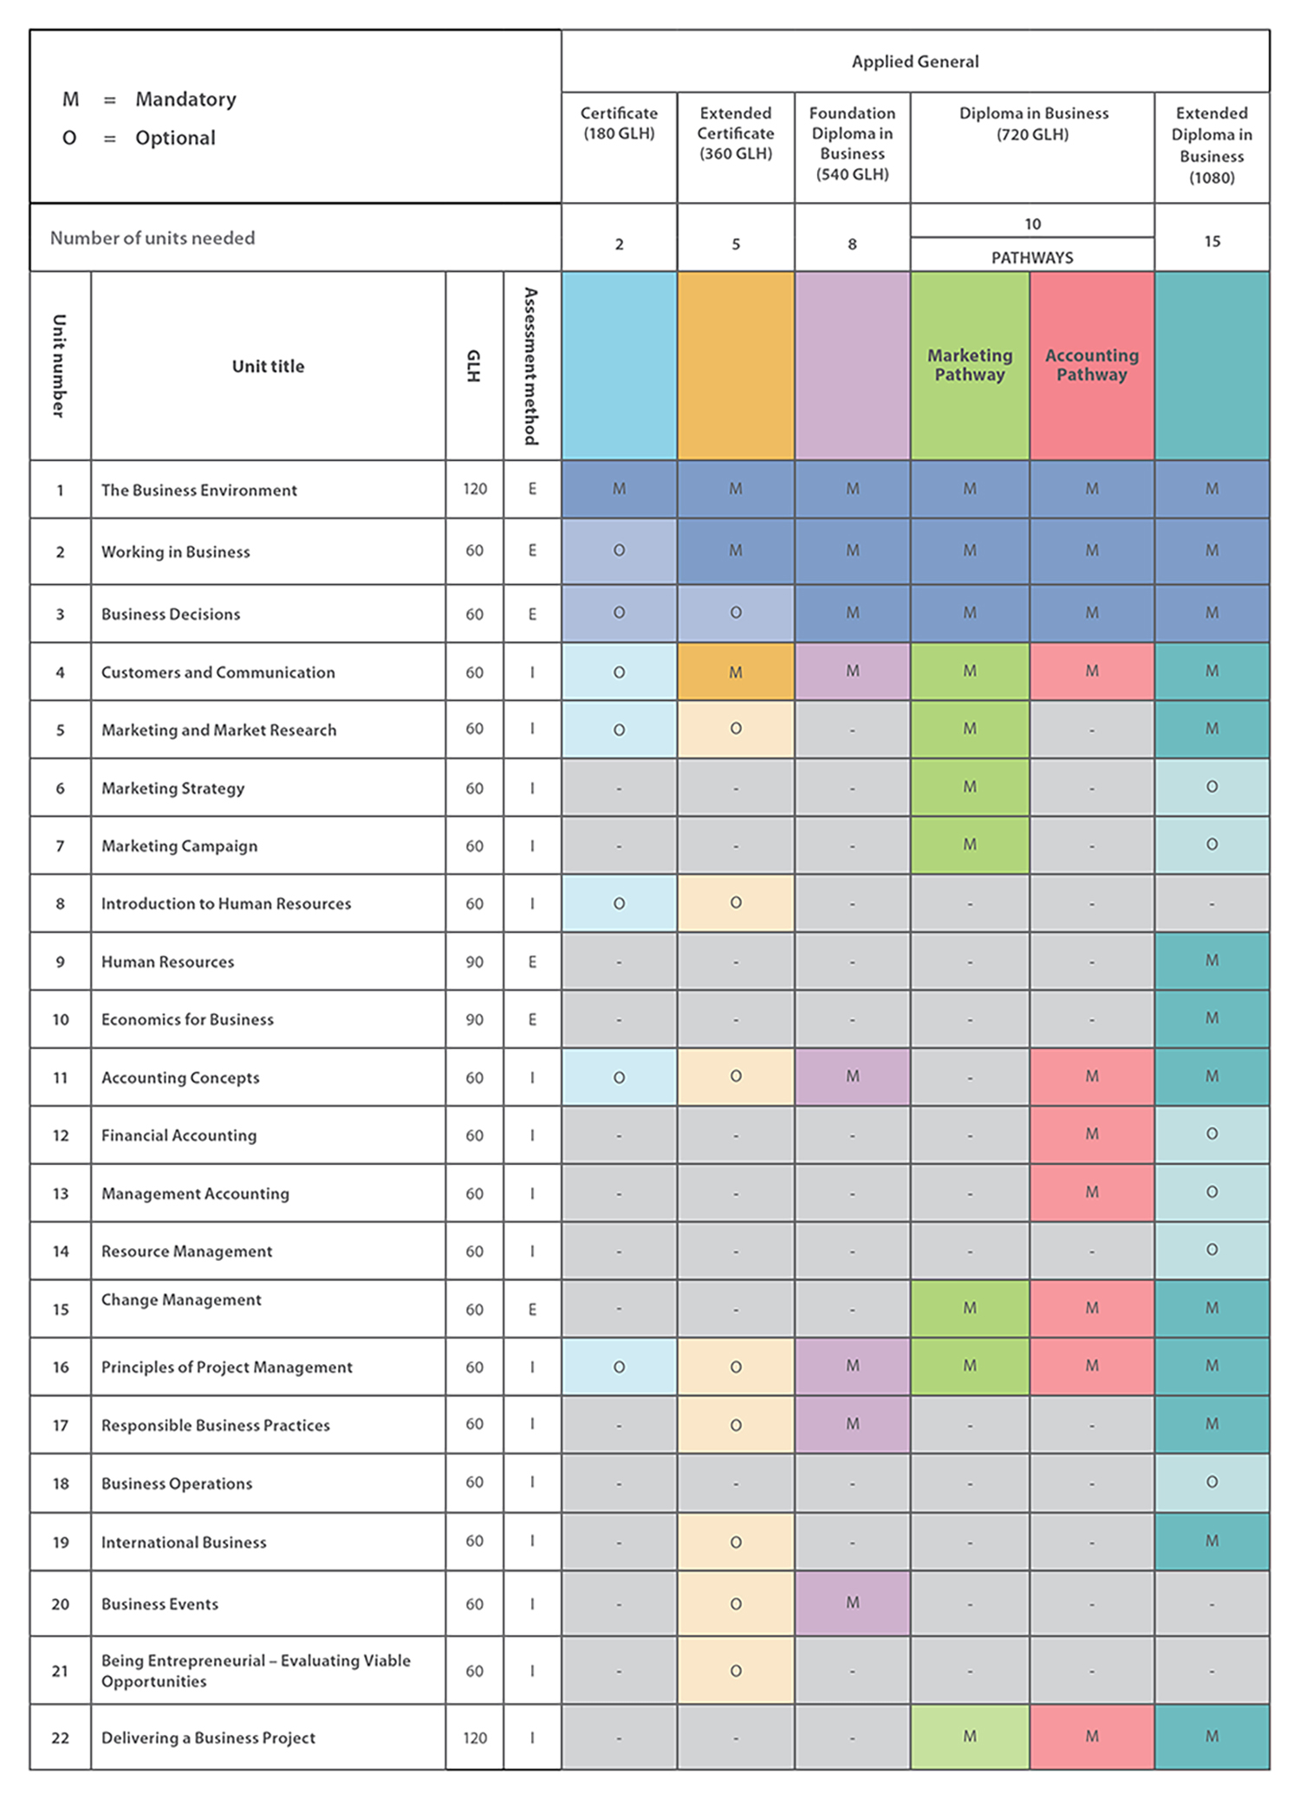
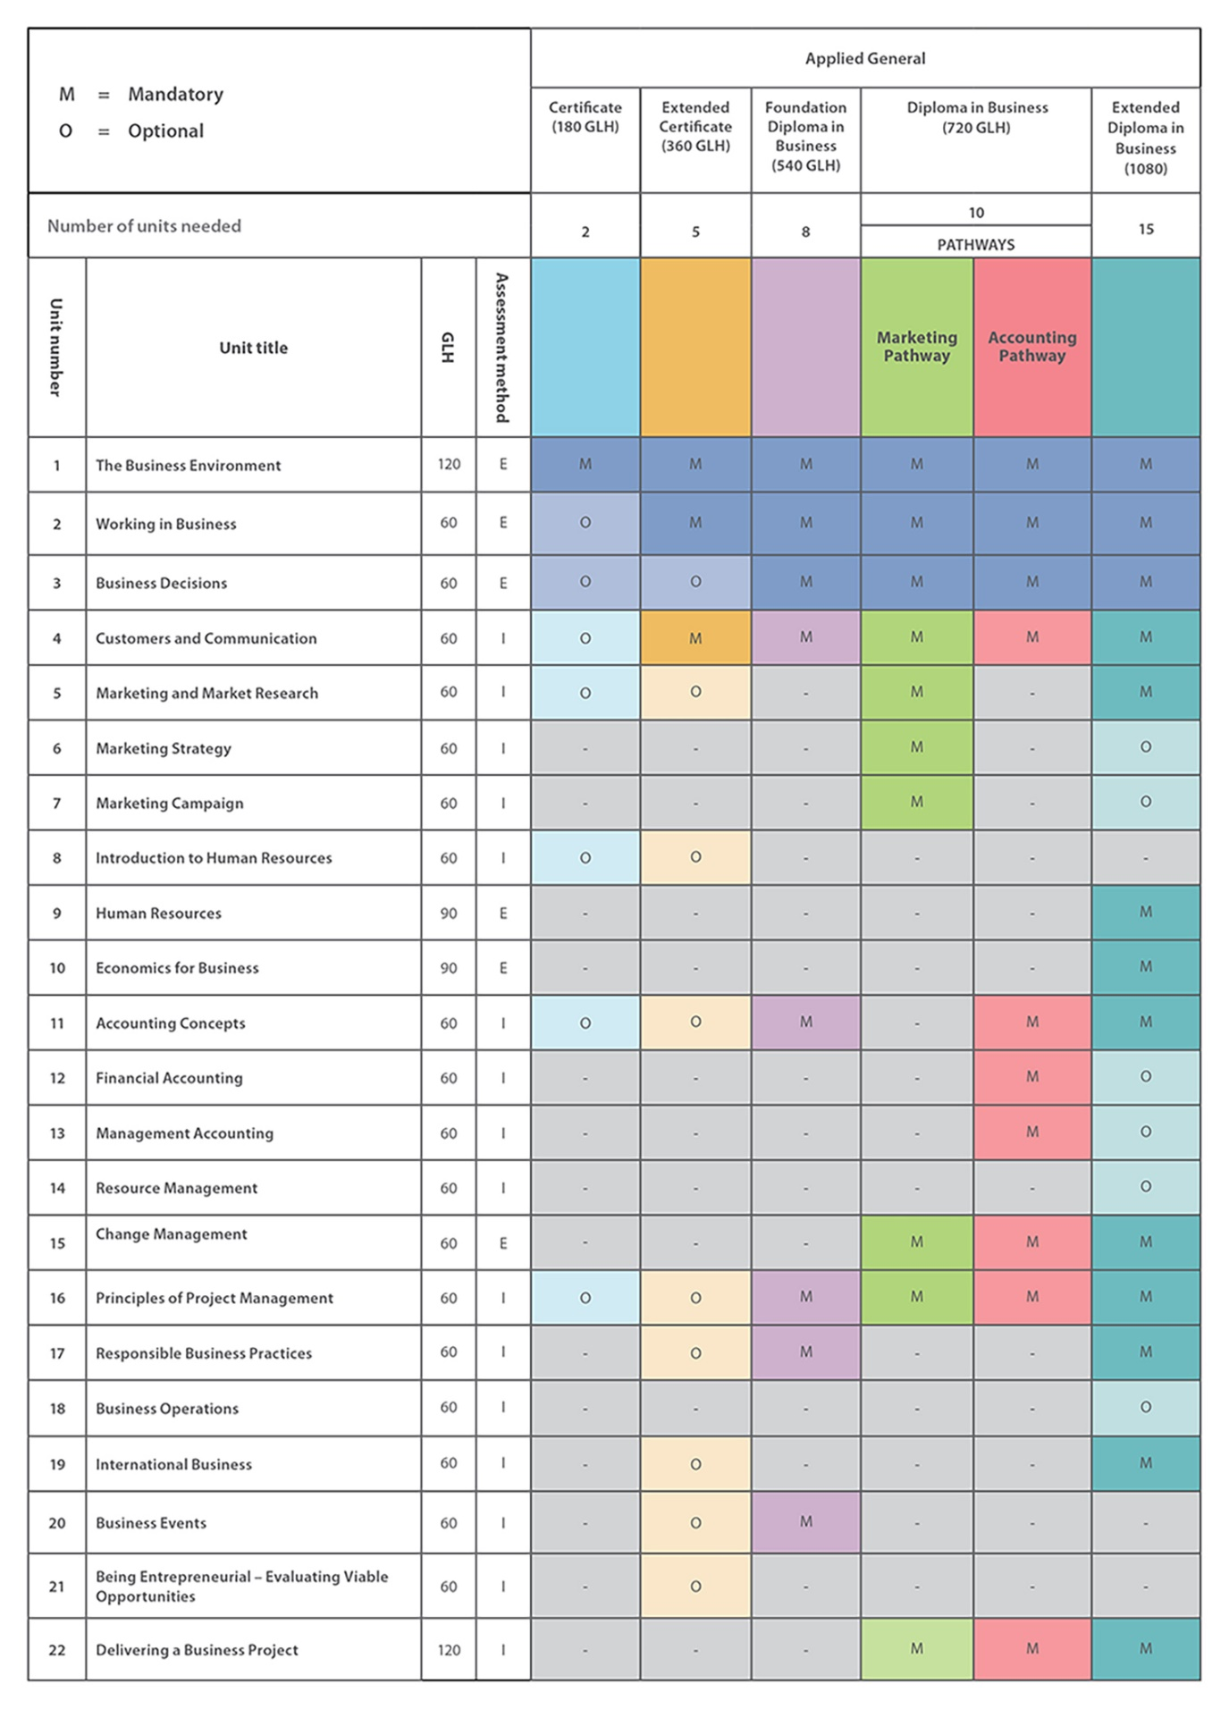
Course outline
Extended Certificate (360 GLH)
- Equivalent to 1 A level (5 hours per week).
- 5 Units
- 2 exams (Unit 1 and 2 – with 3 opportunities January and June)
- 3 pieces of coursework (internally marked and externally moderated).
- Wide variety of topics (Marketing, Finance & accountancy, Enterprise, law, economics)
- Unit 1: Investigates many areas of business theory
- Unit 2: Practical employability skills and tasks
- Unit 8: Human resource's
- Unit 4: Customers and communication
- Unit 17: Business ethics
Diploma
Extended
Certificate
Diploma in Business - Marketing (720 GLH)
- Equivalent to 2 A level (10 hours per week).
- 4 exams (Unit 1,2,3 and 15 – with opportunities to re-sit)
- 6 pieces of coursework (internally marked and externally moderated).
- Marketing specialism (The course still covers many other topics)
- Unit 1: Investigates many areas of business theory
- Unit 2: Practical employability skills and tasks
- Unit 3: Strategic decision making
- Unit 4: Customers and communication
- Unit 5-7: Marketing campaigns from start to finish.
- Unit 15: Change management
- Unit 16 and 22: Managing projects (very useful for university and the world of work)

Preparation for Unit 1- The Business Environment (for both single and double award students)
This unit covers many topics including ownership, marketing, finance human resources and external influences. This task is a simple research task to find definitions of the following terms from unit 1. This will help you clearly understand the information within lessons if you are aware of the basic terms. Try and provide real business examples in the space provided as well as a definition.

Key term | Definition/Example
Sole trader
Partnership
Private limited company
Public limited company
Franchise
Non-Profit organisation
Public Sector
Private sector
Ethical trading
Entrepreneur
Organisational structures
Functional areas
Stakeholders

TASK – Producing a presentation/display about an entrepreneur of your choosing.
(for both single and double award students)
The presentation/display can take any format you feel is appropriate. You can produce it as a newspaper article, presentation, poster etc.
You must include
- Why have you chosen this entrepreneur? (1 paragraph)
- Their background – where did they go to school, what did their parents do etc. (1 paragraph)
- How did they become an entrepreneur? E.g. Did they start a business at university? Did they have a market stall? (1 paragraph)
- Why did they choose to set up their own business? What inspired them? (1 paragraph)
- A brief history of their company / companies / product. E.g. How did they get the money, where did they get the idea, how did they launch it etc. (minimum of 2 pages)
- Were there any problems along the way? (1 paragraph)
- What is their life like now? What keeps them motivated? Do they have any more things they want to do? (2 paragraphs)
- What can you learn from them? This is KEY – what have you learned from their experience & how would this help you if you were to set up your own business?
Log onto:
https://www.businessed.co.uk/index.php/home/theory/as-theory/edexcel-as#1-1-the-characteristics-of-successful-entrepreneurs
– Why are Entrepreneurs important? What skills has your entrepreneur shown? Use examples from you research to back each skill up. (Half a page)

Big Business Quiz (for both single and double award students)
Log onto: https://www.businessed.co.uk/index.php/home/theory/cambtec/cambtec-l3-theory#unit-1-the-business-environment (read through each section)
Try to answer all 10 of the multiple choice questions below:
- Ms Patel has an Indian Restaurant called Javentri LTD. Which type of business is this:

- Sole trader |  | - Partnership
- Private Limited Company |  | - Public Limited Company

- A deed of partnership is unlikely to contain the following details:
- How profits are shared |  | - How responsibilities are shared
- Who exactly is in the partnership |  | - Which football team each partner supports

- John Lewis is a:
- Sole trader |  | - Partnership
- Private Limited Company |  | - Public Limited Company

- Limited liability is…
a. bad for any business |  | b. really good to increase profits
c. good for security and piece of mind |  | d. what all partnerships have

- Sleeping partners are people who…
- Are very lazy in partnerships |  | - Invest money into the business but do little day to day running
- Are fired as they were caught sleeping on the job. |  | - Work hard for the business but have no share of the business

- Mr Holmes and Mrs Shields work in the…

- Primary sector |  | b. secondary sector
c. tertiary sector |  | d. private sector

- A Private Limited Company has…

- Limited liability |  | - Unlimited liability
- Private liability |  | - Public liability

- A social enterprise is a business set up to…
- Make huge profits |  | - Improve the social skills of its stakeholders
- Meet local needs |  | - Help society rather than make a profit

- The following entrepreneur is…

- Steve Jobs |  | - Bill Gates
- James Dyson |  | - Peter Jones

- The following business logo belongs to:


- British Gas |  | b. British Airways
c. Virgin Airlines |  | d.British Petroleum

Tie Breaker Question:

How much does one share in Apple cost?

£_______

Useful resources (No need to purchase – The textbook and revision notes will be accessible in September) :

Textbook: Cambridge Technicals Level 3 Business (Author: Tess Bayley, Karen Tullett, Leanna Oliver, Dianne Wainwright)

Revision notes: Cambridge Technicals Level 3 Business (Author: Dianne Wainwright and Diane Mitchell).

Websites:
https://www.businessed.co.uk/index.php/home/theory/cambtec/cambtec-l3-theory
https://www.tutor2u.net/business

Wide reading:
How I Made It: 40 Successful Entrepreneurs Reveal How They Made Millions - Rachel Bridge. An essential read for anyone that is thinking about starting their own business.

The Tipping Point: How Little Things Can Make a Big Difference - Malcolm Gladwell A very readable and fascinating book, which looks into the reasons products become market leaders.

The Google Story - David A. Vise. An interesting investigation into the culture at Google, includes insights into the four day working week and soft management styles. The questions is; are these the things that made Google the world’s number one search engine?

Billions of Entrepreneurs: How China and India Are Reshaping Their Futures and Yours - Tarun Khanna An investigation into Asia’s two growing economic powers.

Business Stripped Bare: Adventures of a Global Entrepreneur - Sir Richard Branson. The autobiography of Britain’s most famous entrepreneur.

