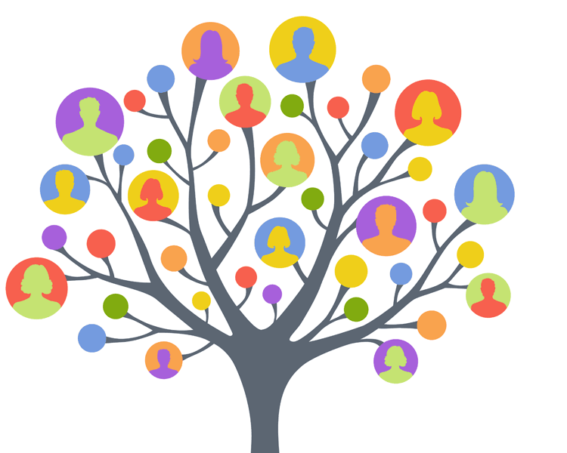
A-level Sociology

Bridging Course – Week 3

St Mary’s Catholic School
A-level Sociology

Week 2 Recap
- Last week you continued to consider the role of education in society from a sociological perspective.
- You explored in further detail the functionalist view of education.

Answer the questions below. The answer is either Durkheim, Parsons, or Davis and Moore.

1) Who believes education “sifts and sorts” so that people end up in the appropriate job equating to their skills and qualifications?
2) Who argued that education was a sort of bridge between the family unit and wider society?
3) Who said education is our first experience of universal values such as achievement, competition and individualism?
4) Who said that education brings social solidarity and shared understanding of cultural values leading to national identity.
5) Who said that education was meritocratic?

This week

- You will be continuing to think about education from a sociological perspective.
- You will interpret some data to help you inform a view of education.
- You will begin to think about ideas relating to gender and feminism.
- You will begin to think about education from a gender and feminist perspective.

Task
- You may still be asking yourself ‘is sociology for me’?
- The purpose of the bridging course is, partly, to help you develop an understanding of the subject, so you can ask yourself whether it is the subject for you.
- Read the following. This will give you some further introductory ideas connected to Sociology as a discipline. Where you see a box with an activity, complete this making relevant notes.
- Then complete the task that follows that is designed to help you develop your understanding of the subject specific terminology.

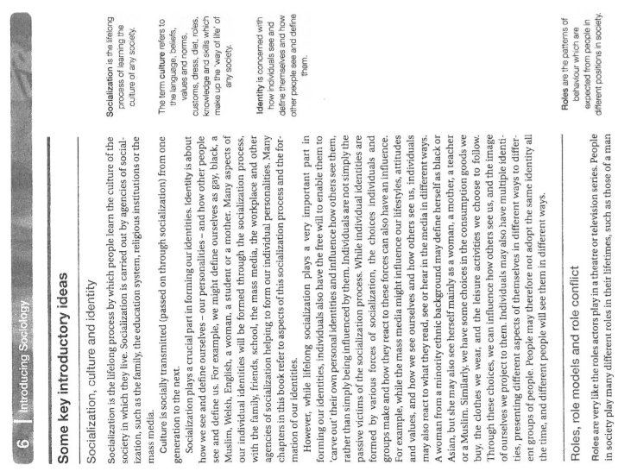

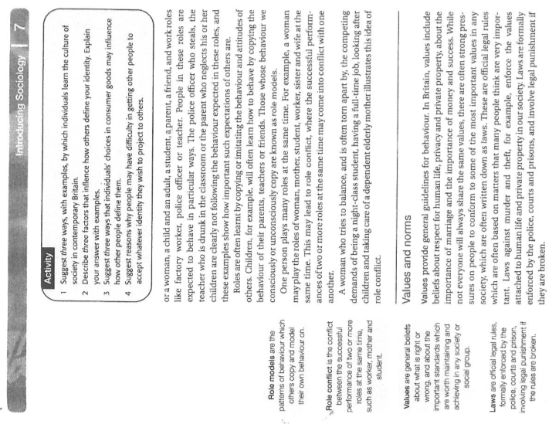

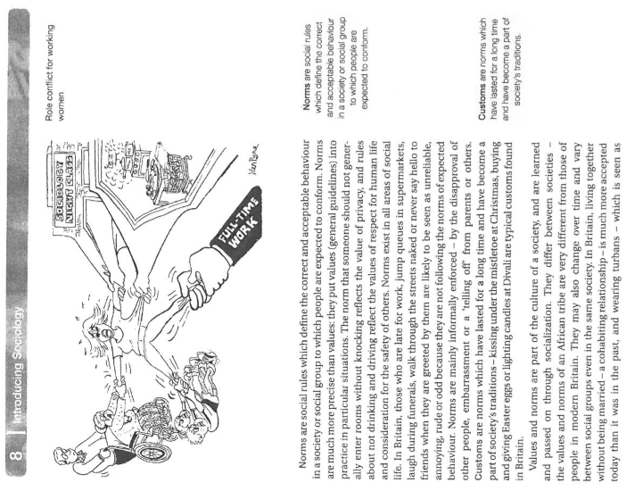

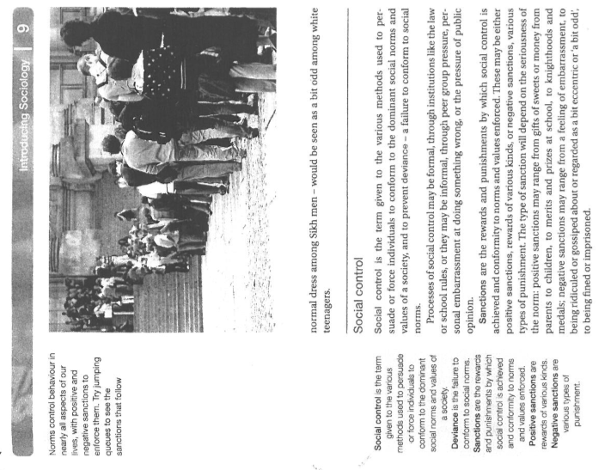

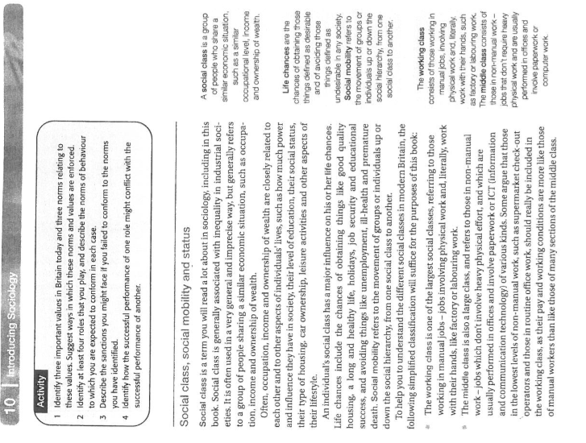

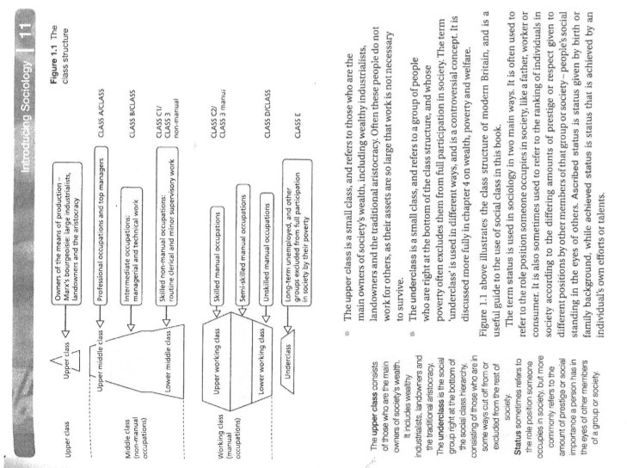

Task: Big Question – What is feminism?

Note down here, before you do any reading or research, what you think feminism is:

This is an image that is often seen in association with the feminist movement. Based on your understanding of feminism, why do you think this image is often associated with feminism? Note your ideas under to the image.

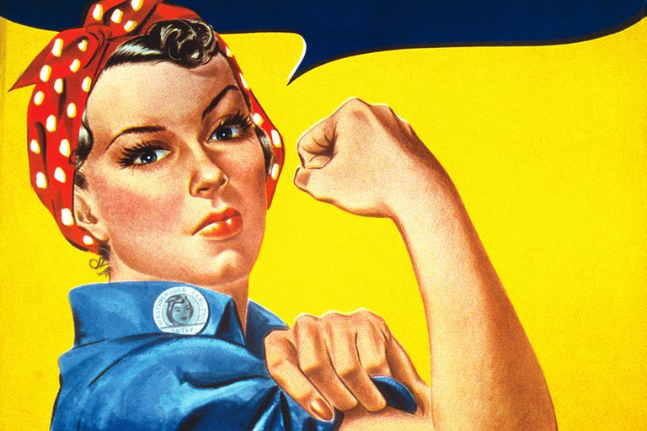

Now to test your definition! You are going to explore in some detail various views and ideas about feminism is, and what feminists are interested in. Then, you will begin to think about what might be some of the concerns and interests of feminist sociologists in relation to education.

Read the following article that summarises a view of what feminism is. Make notes.

The Origin of the Word "Feminism"

While it is common to see the word "feminist" used for figures such as Mary Wollstonecraft (1759–1797), the terms feminist and feminism were not used in the modern sense until a century after her 1792 book "A Vindication of the Rights of Women" was published.
The term first appeared during the 1870s in France as féminisme—although there has been some speculation that it may have been used before then. At the time, the word referred to women's freedom or emancipation.

In 1882, Hubertine Auclert, a leading French feminist and a campaigner for women's suffrage, used the term féministe to describe herself and others working for women's freedom. In 1892, a congress in Paris was described as "feminist." This launched a more widespread adoption of the term in the 1890s, with its use appearing in Great Britain and then America beginning about 1894.

Feminism and Society
Almost all modern societal structures are patriarchal and are constructed in such a way that men are the dominant force in making the majority of political, economic, and cultural decisions. Feminism focuses on the idea that since women comprise one-half of the world population, true social progress can never be achieved without the complete and spontaneous participation of women.
Feminist ideals and beliefs focus on what culture is like for women as compared to what the world is like for men. The feminist assumption is that women are not treated equally to men and as a result, women are disadvantaged in comparison to men.
Feminist ideology considers in which ways culture can and should be different between genders: Do different genders have different goals, ideals, and visions? There's a great deal of value placed on the importance of moving from point A (the status quo) to point B (female equality) through a statement of commitment to behavior and action to produce that change.

Feminism and Sexuality
One arena in which women have long been oppressed is with regard to sexuality, which includes behavior, interactions with men, posture, and exposure of the body. In traditional societies, men are expected to be the commanders, standing tall and allowing their physical presence to represent their role in society, while women are expected to be quieter and more subservient. Under such societal conventions, women are not supposed to take up much space at the table, and most certainly, they should not be seen as a distraction to the men around them.
Feminism seeks to embrace female sexuality and celebrate it, as opposed to so many societal conventions that condemn women who are sexually aware and empowered. The practice of elevating sexually active men while denigrating sexually women creates a double standard between the genders. Women are shunned for having multiple sexual partners, whereas men are celebrated for the same behaviors.
Women have long been subjected to sexual objectification by men. Many cultures still cling to the notion that women must dress so as to not arouse men, and in many societies, women are required to fully cover their bodies.
On the other hand, in some so-called enlightened societies, female sexuality is routinely exploited in the mass media. Scantily clad women in advertising and full nudity in movies and television are commonplace—and yet, many women are shamed for breastfeeding in public. These conflicting views on female sexuality create a confusing landscape of expectations that women and men must navigate on a daily basis.

Feminism in the Workforce

There are many differences within the constellation of feminist ideals, groups, and movements related to workplace unfairness, discrimination, and oppression that result from the real disadvantages women experience. Feminism assumes that sexism, which disadvantages and/or oppresses those identified as women, is not desirable and should be eliminated, however, it continues to be an issue in the workplace.

Unequal salaries are still pervasive in the workforce. Despite the Equal Pay Act of 1963, on average, a woman still earns only 80.5 cents for every dollar a man earns. According to data from the U.S. Census Bureau, women's median annual earnings in 2017 were $14,910 less than that of their male counterparts.

What Feminism Is and What it Isn't
There is a common misconception that feminists are reverse sexists, however, unlike male sexists who oppress women, feminists do not seek to oppress men. Rather, they seek equal compensation, opportunities, and treatment for both genders.
Feminism seeks to achieve equal treatment and opportunity for women and men in order to achieve similar opportunities across different fields of work and culture and equal respect in a variety of roles. Feminists theorists often explore the concepts with regard to which of women's experiences are taken as normative: Do women of different races, classes, age groups, etc. experience inequality in significantly different ways or is the common experience as women more important?
The goal of feminism is to create non-discrimination, which is essential for creating equality to ensure that no one is denied their rights due to factors such as race, gender, language, religion, sexual orientation, gender identity, political or other beliefs, nationality, social origin, class, or wealth status.

Task: From the article above, write down 7 key words that you think help sum up this view of feminism.

1.

2.

3.

4.

5.

6.

7.

It is important that you understand:

The Basics of Feminism. Feminists typically believe that…
- Inequality between men and women is universal and the most significant form of inequality
- Gender norms are socially constructed not determined by biology and can thus be changed.
- Patriarchy is the main cause of gender inequality – women are subordinate because men have more power.
- Feminism is a political movement; it exists to rectify sexual inequalities, although strategies for social change vary enormously.
- There are four types of Feminism that you will explore in your Sociology studies – Radical, Marxist, Liberal, and Difference.

Go back to the image, previously shown in this booklet. Based on your understanding and what you have learnt, why do you think this image is often associated with feminism?

Some suggestions can be found on the next page. Compare your ideas, with the ideas found there.
Compare your ideas with these:

- Challenges the view that women are weak or subordinate – look of fierce determination
- Clenched bicep shows that women are physically powerful too
- Wearing a denim shirt, blurs boundaries of what might be deemed specifically clothes for men.
- The woman is clearly dressed to perform physical work – challenges the view that only men can perform physically demanding work.
- Historically, this poster was created during WWII when women were tasked with jobs that had traditionally been as ‘jobs for men’. Indicates female motivation and ability to do the jobs often seen as being jobs for men.
- With the headscarf – red and white polka dots – celebrates the ‘colour’ and individual nature of every woman, but indicates their practical nature.
- The colours used in the image are bold, energetic positive – all reflecting the positive image behind the image that celebrates female empowerment and ability.
- Some feminists might be critical of the image of the woman – she is slim, wearing make-up, has clearly well groomed hair, plucked and shaped eyebrows – what is this saying about the female image?

Feminist views of education

- In the same way functionalists have a view of education, to too do feminist sociologists.
- Answer the following questions below with your own ideas and views.

1) Can you think of ways in which society enforces gender differences and stereotypes?

2) What role does a school have, in challenging gender stereotypes?

3) Imagine you are a leader in a school, what would you do to ensure that gender stereotypes are challenged? Think about all aspects of school life: the curriculum, employing teachers, clubs, uniform etc.

Feminists says that the education system is patriarchal – it is a system dominated by men.

1) Some feminists argue that that curriculum reinforces gender differences.

2) There are gender differences in subject choice in schools. Gender stereotyping still exists.

3) Girls are academically outperforming boys at school, and yet, in the classroom boys are more demanding of attention from the teacher.

4) Men seem to dominate top positions in schools and universities.

5) Some radical feminists believe that men are a bad influence and want female-centred education for girls.

6) Liberal feminists want equal access to education for both sexes.

Read the following account of Alex’s experience of education. Note down any questions, comments or observations a feminist might make of Alex’s education in the margin.

I loved being in reception – my memory of the early years was playing in the sand, painting and listening to the teacher read. I had Mrs Brown in reception and Year 1, and I remember that Mrs May supported in her classes too, by listening to readers and helping out during lessons like Art and English. We had a school uniform – one for the winter and one for the summer. I wore a grey skirt and blue shirt in winter and then a blue gingham dress in the summer term. By the time I was in Year 3, I have stronger memories of what lessons were like. I remember being sat on a table of 3 other people. There were two boys and another girl. We were often given tasks to do together, working as a group and we were competing with the other tables. I enjoyed this because I enjoyed working with the others on my table, we all got on really well. It wasn’t just lessons I enjoyed. It was the sport I loved too. Girls had a netball team and the boys had a football team. I remember Mr Light who was our head, presenting us with a trophy when we won the county cup.

In secondary school things were a bit different. You got a choice – you could trousers or a skirt as part of the uniform. I loved Year 10 and Year 11 the best because you got to pick the subjects you wanted to study. I chose Health and Social Care and loved it because it was a small group, of 13 girls and 2 boys. I struggled with English. Mrs Ingham was a lovely, and really kind but studying Shakespeare, Dickens, JB Priestley – I just didn’t enjoy reading their books and this made revision more challenging. There was a really good project I took part in which encouraged girls to get involved in computer science and engineering projects. I worked on this in Year 11 and was even awarded a financial scholarship to complete it.

Now think about your own education. What might a feminist say, comment or ask about your education experience? If you can, think back to your time at primary school, secondary school and any other educational setting you might have experienced.

