A-level Sociology

Bridging Course – Week 2

St Mary’s Catholic School
A-level Sociology

Week 1 Recap
- Last week, you spent some time exploring what Sociology is an academic discipline.
- You began to consider the role of education in society from a sociological perspective.
Terminology Recap from Week 1: What do the following terms mean? (If you’re not sure, look them and remind yourself of them. Try to commit them to memory.)
- Meritocratic
- Values
- Culture
- Functionalist / functionalism
You completed some work on the functionalist view of education. As a recap, fill in the blanks below.
Functionalists believe that the education system plays a very ___________role in society. Different functionalists say different things about education. The functionalist Durkheim believes education is positive because it teaches young people about shared ideas and values, that are important in society and lead to a shared consensus. This means that everyone feels part of the same _________ and there is social solidarity and togetherness. Durkheim also believes that education teaches children _______that are necessary for the workplace. Parsons agrees that education teaches children skills needed for the________ . Parsons also says that the education system teaches children the necessary _________ needed for wider society. Parsons says that the education system is fair and_________. This means that a person’s success is down to that person’s talent, effort and_________. Davis and Moore say the outcome of a child’s time in school, how they achieve, allows us to sift, sort and ________ them for specific jobs. The type of job a person gets reflects their hard work and effort – they are ________ with appropriate_________ and money.

Words to select from:
culture … Positive… select … status … skills… workplace …meritocratic… hard work… rewarded… social skills…

How did you do you in the recap task? Compare your answers with the paragraph below.

Functionalists believe that the education system plays a very positive role in society. Different functionalists say different things about education. The functionalist Durkheim believes education is positive because it teaches young people about shared ideas and values, that are important in society and lead to a shared consensus. This means that everyone feels part of the same culture and there is social solidarity and togetherness. Durkheim also believes that education teaches children skills that are necessary for the workplace. Parsons agrees that education teaches children skills needed for the workplace. Parsons also says that the education system teaches children the necessary social skills needed for wider society. Parsons says that the education system is fair and meritocratic. This means that a person’s success is down to that person’s talent, effort and hard work. Davis and Moore say the outcome of a child’s time in school, how they achieve, allows us to sift, sort and select them for specific jobs. The type of job a person gets, reflects their hard work and effort – they are rewarded with appropriate status and money.

Consolidating your understanding:

Task: look up the qualifications you need to begin a career as a junior doctor. What A-levels do you need? At what grade? How long do you study at university for? How does this differ from most other degrees? How much can a doctor expect to earn? How does this compare the national average salary?

Make a note of them here:

Let’s imagine this is a junior doctor called Aliyah. What would a functionalist say about Aliyah’s education, in relation to her career? What assumptions might a functionalist make about how Aliyah was at school? Make notes here:

This week: you are going to consolidate and develop further your understanding of the functionalist view of education, and develop your own response and ideas in relation to this view.

Read the following article on the Functionalist Theory of Education and in the margin, summarise key ideas.

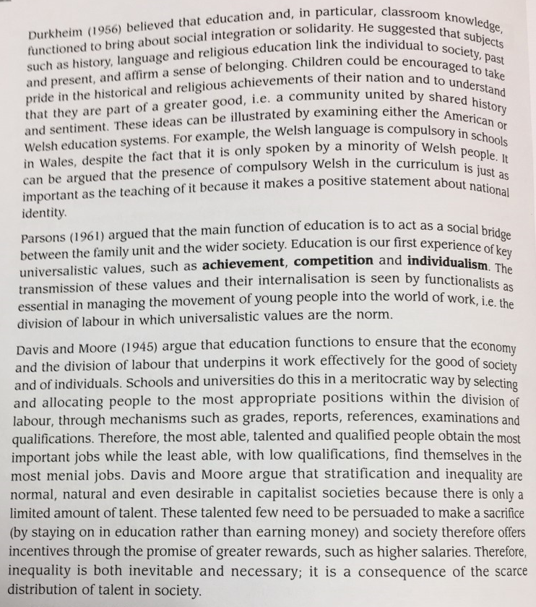

Do not worry if some of the words in this article are unfamiliar to you, or you don’t fully understand them. Any terms that are new, you should look up – either using a dictionary, or online. Your teacher will work with you to secure your understanding of all concepts and ideas, so long as you understand the key principles and theories here.

- With any view or theory you explore in Sociology, you will be required to evaluate it.
- That means, you will need to weigh up the strengths of the view, as well as consider the potential flaws or questions you have about the theory.

Evaluating Functionalism: Think about the following questions, and make some relevant notes on lined paper. You can consider any line of argument you like – you might see things from one perspective or from many, that is absolutely fine. Use ‘evaluating functionalism’ as a subheading.

- In a comprehensive school, like St Mary’s, where so many people come from different backgrounds, traditions, cultures, is there such thing as a “shared consensus”?

- Schools are judged and inspected. They are rated as inadequate / requiring improvement / good or outstanding.
  - Can it really be said that the education system is meritocratic?
  - What does the functionalist view assume about the quality of teaching?

- Look closely at when the three key functionalists were theorising. What questions does this lead you to?

Remember to try to keep an open mind to the different ideas and perspectives. Part of the successful study of Sociology.

Summarising Functionalism – Preparing to discuss it in class

In order to prepare yourself to discuss functionalism in lessons, prepare 3 summary cards. These should include key words that help to summarise the relevant functionalist theory / view and you should bullet points 2 or 3 key points of your own to evaluate the view.

Functionalist View of Education
Durkheim (1956) | Summarise in single, key words | Bullet point your evaluation of this theory – to support or challenge it.
Parsons (1961)

Davis and Moore (1945)

Need a bit more help? Further work on functionalism if you need it.

- If you want, or feel like you need a little bit more help to understand the functionalist view of education, have a look at the following video and resources.

- As you read/ watch, make relevant notes to help you.

https://www.youtube.com/watch?v=hfv8XegXyKY

https://www.slideshare.net/melanietannenbaum/soc-463663-social-psych-of-education-intro-theories (Slides 22-35 only.)

