A-level Economics

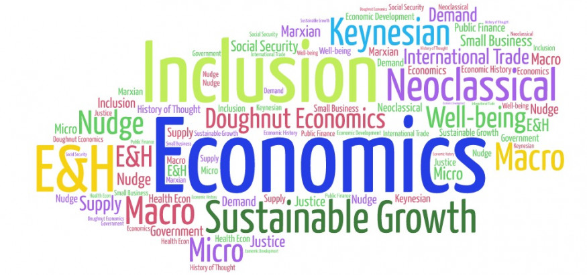

Bridging Course - Week 2



St Mary’s Catholic School
A-level Economics Bridging Course

Entry Requirements for Studying A-level Economics?
- Students are expected to achieve at least a grade 6 in GCSE Maths and English Language.
- Students must have an interest in the news and current affairs
- Students should have an interest in debates and discussion in lessons, and be willing, and able, to share their ideas.
What to expect from A-level Economics
There aren’t many A- level subjects as dynamic as Economics. The news is full of examples of Economics in action. Within the course we study human behaviour, how markets work and how they fail and seek to understand the dynamics of change at a micro level (e.g. within an industry) and at a macro level (e.g. within and between countries).
Whilst studying this course students will develop their analytic and evaluative skills. These will be tested through short explanation questions but a large amount of the course (1/3 of your overall mark) will involve writing longer essay style questions. The course will also use economic models and diagrams to analyse real life events.
It doesn’t matter if you haven’t studied Economics before. You might have an interest in Economics and want to know more about the impact economics has on the world around you. You might want to investigate some of the stories you hear in the news – Why do some economies grow and others don’t? Will the Eurozone survive? Why didn’t economists predict the Global Financial Crisis? This course will help you to understand all this and more.

This bridging course will provide you with a mixture of information about A-level Economics, and what to expect from the course, as well as key work to complete. Students who are expecting to study Economics at A-level, and are likely to meet the entry requirements, must complete the bridging course fully and thoroughly, to the best of their ability.

You should complete all work on paper and keep it in a file, in an ordered way. You will submit it to your teacher in September. All of the work will be reviewed and selected work will be assessed, and you will be given feedback on it. This work will be signalled to you. If you do not have access to the internet, please contact the school and appropriate resources will be sent to you.

If you are thinking about studying Economies at A-level you should attempt this work to see whether or not you think studying a subject like this is right for you. If you later decide to study Economics, you must ensure you complete this work in full. This work should be completed after you have read and completed the Study Skills work that all of Year 12 should complete.

Review of Week 1 Bridging Course

Last week you looked at what Economics is and how it links to the real world. To check your understanding complete the questions below:

- What is Economics the study of?Economics is the study of people .
- What is the difference between Macro and Microeconomics? Macroeconomic looks at economics on a national or global scale. Microeconomics looks at economics on a small scale for businesses and consumers.
- Name one current news story and list the possible effects of this on consumers and businesses. Grocery sales slide as customers retreat from online shopping. Businesses are not making as much money.
- What decisions does the government have to make? They don’t have to make any decisions in this case.
Answers are on the last page of this document

The following work requires a lot of reading, and some of the ideas might be challenging to understand on first reading. Remember to take regular breaks, go back to any of the tasks after some time away, and try your best. Your Economics teacher will go over the following with you in lessons, early in Year 12.

This second week of tasks will focus on the 2008 Financial crisis.

Task one

In order to begin to understand why the crisis happened please watch the below video. The end of this document also includes additional reading if you need further consolidation.

Who was to blame for the financial crisis? - BBC News
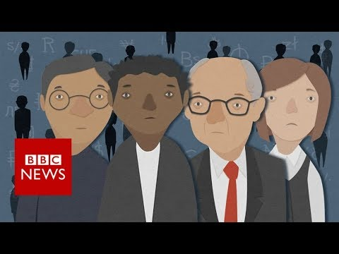

Task two

Complete the match up activity using the below link.

https://www.tutor2u.net/economics/reference/uk-financial-crisis-2008-timeline-match-up-activity

Task three

Using your own knowledge and the links below complete the following research activity. This work will be collected in the first week of Year 12 and assessed. This topic can also be tested in the final Year 13 exams.

The Financial Crisis
In 2008 the world experienced a large economic shock. All major economies around the world suffered a financial crisis and started to go into recession.
You are to write a report on the following (at least 800 words):
- How the 2008 financial crisis started
- The impact this had on the UK and the rest of the world
- What economic measures the UK adopted to help the economy to recover
- How it affected the UK’s 4 main Economic indicators (you will have to research what these are) interest rates Gross domestic product Government regulations and fiscal policy. Existing home sales.
- How the UK is performing now

You could also include the following:
- Your own judgement on whether the measures that the UK used were successful
- How the process of globalisation had an impact on the magnitude of the crisis
- Real life data to support your findings.

Additional resources

List of BBC videos relating to the crisis

https://www.bbc.co.uk/programmes/topics/Financial_crisis_of_2007–2008

Movies

The Big Short (available on Netflix)

Statistics

https://data.worldbank.org/indicator/NY.GDP.MKTP.CD?locations=GB

https://data.oecd.org/united-kingdom.htm

Video resources

https://www.youtube.com/watch?v=YaC4eEQTglw

https://www.youtube.com/watch?v=0yZ5mjbB11I

The real truth about the 2008 financial crisis | Brian S. Wesbury | TEDxCountyLineRoad

https://www.tutor2u.net/economics/reference/economics-of-speculative-bubbles

Answers to review questions

- Economics is a social science. This means that it is a study of people.
- Macroeconomics looks at economics on a national or global scale. Whereas Microeconomics looks at economics on a smaller scale for businesses and consumers.
- This answer will vary depending on your chosen news story.
- How much money to spend, what/ who to spend it on and how to spend it.

