Q1.
When you transfer energy to a shopping trolley, the amount of work done depends on the force used and the distance moved.
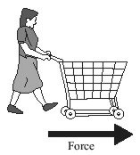
Complete the table by using the correct units from the box.

joule (J) metre (m) newton (N)
The first one has been done for you.

Quantity | Unit
energy (transferred) | joule
force
distance (moved)
work done
(Total 2 marks)
Q2.
The diagram shows the energy transformations produced by a TV.
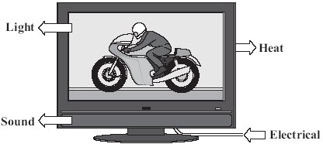
(a) Use words from the diagram to complete the following sentence.
The TV is designed to transform ______________________________ energy into
light and __________________________________ energy.
(2)
(b) Which one of the following statements is false?
Put a tick () in the box next to the false statement.

The energy transformed by the TV makes the surroundings warmer. | 
The energy transformed by the TV becomes spread out.
The energy transformed by the TV will be destroyed.
(1)
(c) Two different makes of television, A and B, transform energy at the same rate.
Television A wastes less energy than television B.
Complete the following sentence by drawing a ring around the correct line in the box.

Television A has | a higher efficiency than  the same efficiency as  a lower efficiency than | television B.
(1)
(Total 4 marks)
Q3.
A student had read about a glacier that had been covered in insulating material. The idea was to slow down the rate at which the glacier melts in the summer.
She investigated this idea using the apparatus shown in the diagram.
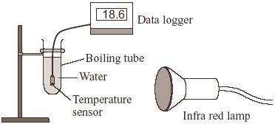
(a) These are the steps taken by the student.
• Measure 30 cm³ of cold water into a boiling tube.
• Place the boiling tube 25 cm from an infra red lamp.
• Record the temperature of the water.
• Switch on the infra red lamp.
• Record the temperature of the water every minute for 5 minutes.
• Repeat with boiling tubes covered in different insulating materials.
(i) Why did she use an infra red lamp?
______________________________________________________________
(1)
(ii) Name one control variable in this investigation.
______________________________________________________________
(1)
(iii) Give one advantage of using a temperature sensor and data logger instead of a glass thermometer to measure temperature.
______________________________________________________________
______________________________________________________________
(1)
(b) The results of the investigation are shown in the graph.
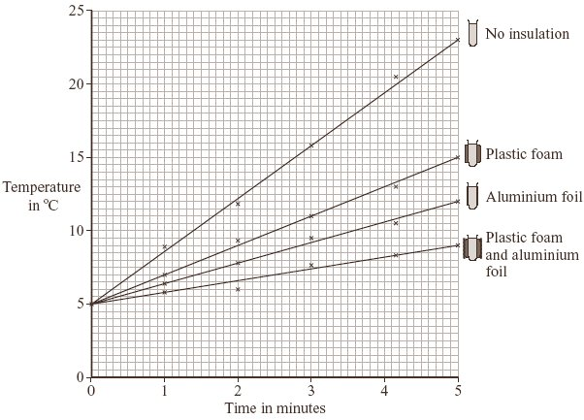
(i) Why did the student use a boiling tube with no insulation?
______________________________________________________________
______________________________________________________________
(1)
(ii) From her results, what should she recommend is used to insulate the glacier?
______________________________________________________________
(1)
(iii) Explain why the insulation recommended by the student will reduce the heat transfer from the Sun to the glacier.
______________________________________________________________
______________________________________________________________
______________________________________________________________
______________________________________________________________
______________________________________________________________
(2)
(c) Explain, in terms of particles, how heat is transferred through the glass wall of a boiling tube.
___________________________________________________________________
___________________________________________________________________
___________________________________________________________________
___________________________________________________________________
(2)
(Total 9 marks)
Q4.
(a) The graph shows the temperature inside a flat between 5 pm and 9 pm. The central heating was on at 5 pm.
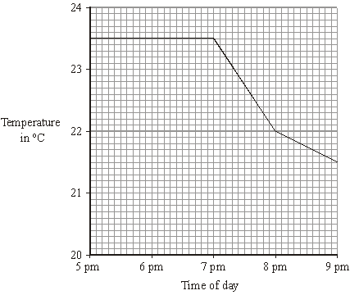
(i) What time did the central heating switch off?
______________________________________________________________
(1)
(ii) Closing the curtains reduces heat loss from the flat.
What time do you think the curtains were closed?
______________________________________________________________
Give a reason for your answer.
______________________________________________________________
(2)
(b) Less heat is lost through double-glazed windows than through single-glazed windows.
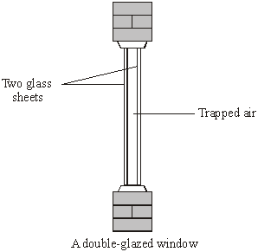
Complete the following sentences by choosing the correct words from the box. Each word may be used once or not at all.

conduction | conductor | convection | evaporation | insulator | radiation
Air is a good ___________________ . When trapped between two sheets of
glass it reduces heat loss by _________________ and ___________________
(3)
(c) The table gives information about three types of house insulation.

Type of insulation | Cost to  install | Money save each  year on heating bills | Payback time
Double glazing | £4000 | £200 | 20 years
Loft insulation | £300 | £100 | 3 years
Cavity wallinsulation | £600 | £150
(i) Use the information in the table to calculate the payback time for cavity wall insulation.
______________________________________________________________
(1)
(ii) Explain why people often install loft insulation before installing double glazing or cavity wall insulation.
______________________________________________________________
______________________________________________________________
______________________________________________________________
______________________________________________________________
(2)
(Total 9 marks)

Mark schemes
Q1.
newton or N
metre or m
joules or J
all three correct 2 marks
two or one correct 1 mark
[2]
Q2.
(a) electrical
1
sound
correct order only
1
(b) the energy transformed by the TV will be destroyed
1
(c) a higher efficiency than
1
[4]
Q3.
(a) (i) as a source of thermal radiation
accept heat for thermal radiation
accept to act as the Sun
do not accept sunlight alone
1
(ii) any one from:
• volume of water
accept amount for volume
• distance between lamp and boiling tube
• initial / starting temperature of water
• same room temperature
do not accept time or same insulation material
1
(iii) any one from:
• greater sensitivity / precision
do not accept more reliable (negates mark)
• could link to a computer for (automatic) data analysis
• could take more frequent readings
• reduces instrument reading error
accept more accurate
do not accept easier to use on its own
1
(b) (i) acts as a control
accept to be able to make a comparison
accept to see the difference
do not accept ‘to make it a fair test’ OWTTE on its own
1
(ii) (plastic) foam and aluminium foil
1
(iii) (aluminium) foil is a poor absorber of thermal radiation
accept heat / infra red for thermal radiation
1
or (aluminium) foil is a (good) reflector of thermal radiation
do not accept ‘reflects sunlight’ on its own
(plastic) foam traps air which is a (good) insulator
accept (plastic) foam is a poor conductor / (good) insulator
do not accept ‘the material’ is a good insulator / poor conductor
1
(c) particles vibrate with a bigger / stronger amplitude / faster / with more
(kinetic) energy
accept particles vibrate more
do not accept start to vibrate only
1
energy transferred by collisions with other particles
do not accept answers in terms of
free/mobile electrons
1
[9]
Q4.
(a) (i) 7pm
accept 19.00 / 1900
1
(ii) 8pm
accept 20.00 / 2000
1
temperature drops more slowly
accept heat for temperature accept line is less steep
1
(b) insulator
1
conduction *
1
convection *
* answers can be either way around
1
(c) (i) 4 (years)
1
(ii) it is the cheapest / cheaper / cheap
do not accept answers in terms of heat rising or DIY
1
has the shortest / shorter payback time
do not accept short payback time
1
[9]

