Q1.
This question is about the structure of atoms.
(a) Choose words from the list to complete the sentences below.
electrons ions neutrons protons
In an atom, the particles with a negative charge are called ___________________
Particles in the nucleus with no charge are called ___________________________
An atom has no overall charge because is has the same number of electrons and
___________________________________________________________________
(3)
(b) Two isotopes of the element carbon are:
12 14
C and C
6 6
Complete the table of information for these two isotopes.

 | ATOMIC NUMBER | MASS  NUMBER | NUMBER OF PROTONS | NUMBER OF NEUTRONS
12  Isotope C  6 | 6 | 12 | 6 | 6
12  Isotope C  6 | 6 |  | 6
(2)
(Total 5 marks)
Q2.
The diagram shows the structure of a lithium atom.
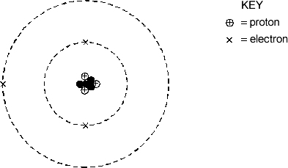
(a) (i) What is represented by ________________________________________
(ii) What is represented by  ______________________________________
(2)
(b) What is the symbol for lithium? ________________________________________
(1)
(Total 3 marks)
Q3.
The diagram shows an atom.
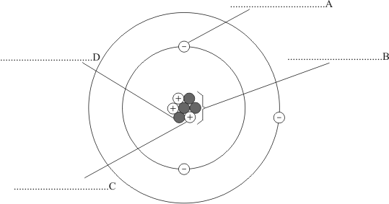
(a) On the diagram, write the names of structures A, B, C and D.
(4)
(b) To which Group of the periodic table does this atom belong?
___________________________________________________________________
Give one reason for your answer.
___________________________________________________________________
___________________________________________________________________
(2)
(c) Name the element which is made up of this type of atom.
___________________________________________________________________
(1)
(Total 7 marks)
Q4.
This question is about mixtures.
(a) Substances are separated from a mixture using different methods.
Draw one line from each substance and mixture to the best method of separation.

Substance and mixture |  | Method of separation
 |  | Chromatography
Ethanol from ethanol and water |  | Crystallisation
Salt from sea water |  | Electrolysis
The different colours in black ink |  | Filtration
 |  | Fractional distillation
(3)
(b) A student filters a mixture.
Figure 1 shows the apparatus.
Figure 1
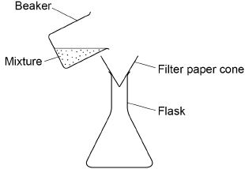
Suggest one improvement to the apparatus.
___________________________________________________________________
___________________________________________________________________
(1)
(c) Complete the sentences.
Choose answers from the box.

condense | evaporate | freeze | melt | solidify
In simple distillation, the mixture is heated to make the liquid _________________ .
The vapour is then cooled to make it _________________ .
(2)
Figure 2 shows the arrangement of atoms in a pure metal and in a mixture of metals.
Figure 2
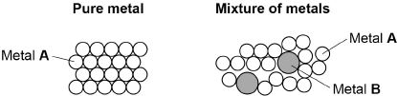
(d) Calculate the percentage of metal B atoms in the mixture of metals shown in Figure 2.
___________________________________________________________________
___________________________________________________________________
___________________________________________________________________
Percentage of metal B atoms = __________________ %
(2)
(e) What is a mixture of metals called?
Tick one box.

An alloy | 
A compound
A molecule
A polymer
(1)
(f) Why is the mixture of metals in Figure 2 harder than the pure metal?
Tick one box.

The atoms in the mixture are different shapes.
The layers in the mixture are distorted.
The layers in the mixture slide more easily.
The mixture has a giant structure.
(1)
(g) A nanoparticle of pure metal A is a cube.
Each side of the cube has a length of 20 nm.
Figure 3 shows the cube.
Figure 3
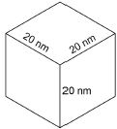
What is the volume of the nanoparticle?
Tick one box.

20 nm³
60 nm³
400 nm³
8000 nm³
(1)
(Total 11 marks)
Q5.
This question is about elements, compounds and mixtures.
Figure 1 shows five different substances, A, B, C, D and E.
represent atoms of different elements.
Figure 1
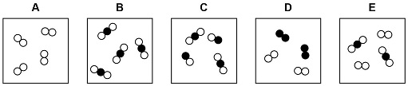
Use Figure 1 to answer parts (a) to (c)
(a) Which substance is only one compound?
Tick (✓) one box.

A |  | B |  | C |  | D |  | E
(1)
(b) Which substance is a mixture of elements?
Tick (✓) one box.

A |  | B |  | C |  | D |  | E
(1)
(c) Which substance is a mixture of an element and a compound?
Tick (✓) one box.

A |  | B |  | C |  | D |  | E
(1)
Substances are separated from a mixture using different methods.
(d) Draw one line from each method of separation to the substance and mixture it would separate.
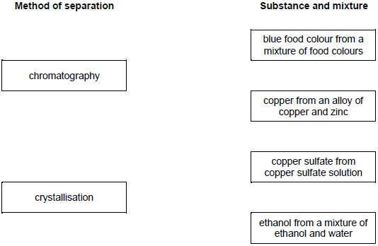
(2)
(e) Sand does not dissolve in water. A student separates a mixture of sand and water by filtration.
Draw a diagram of the apparatus the student could use.
You should label:
• where the sand is collected
• where the water is collected.
Diagram
(3)
(f) A student distils a sample of salt solution to produce pure water.
Figure 2 shows the apparatus.
Figure 2
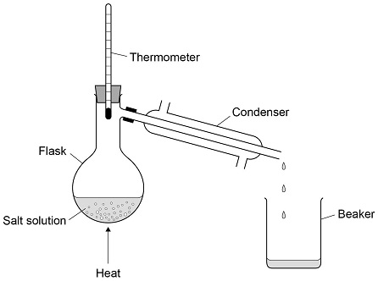
What temperature would you expect the thermometer to show?
Tick (✓) one box.

0 °C
10 °C
50 °C
100 °C
(1)
(g) Describe how the process of distillation shown in Figure 2 produces pure water from salt solution.
___________________________________________________________________
___________________________________________________________________
___________________________________________________________________
___________________________________________________________________
___________________________________________________________________
___________________________________________________________________
___________________________________________________________________
___________________________________________________________________
(4)
(Total 13 marks)

Mark schemes
Q1.
(a) electrons
neutrons
protons
for 1 mark each
3
(b) mass number no. of neutrons
14 8
for 1 mark each
2
[5]
Q2.
(a) (i) neutron (name only)
2
(ii) nucleus / protons and neutrons
each for 1 mark
(do not allow mass number)
(b) Li (correct cases of letters required)
for 1 mark
1
[3]
Q3.
(a) A – electron
1
B – nucleus
1
C – proton
1
D – neutron
1
(b) Group 1 / alkali metals
1
has one electron in outer shell
accept 3 protons / 3 electrons / atomic number 3
therefore lithium (so Group 1 / alkali metals)
1
(c) lithium
accept Li
1
[7]
Q4.
(a)
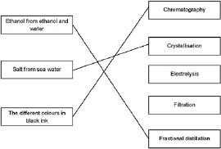
1
1
1
(b) include a (filter) funnel
allow funnel drawn on the diagram
ignore clamp stand
1
(c) evaporate
1
condense
1
must be this order
(d) 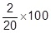
1
= 10 (%)
1
an answer of 10 (%) scores 2 marks
an answer of 11.1(%) or 90 (%) scores 1 mark
(e) an alloy
1
(f) the layers in the mixture are distorted
1
(g) 8000 nm³
1
[11]
Q5.
(a) B
1
(b) D
1
(c) E
1
(d)
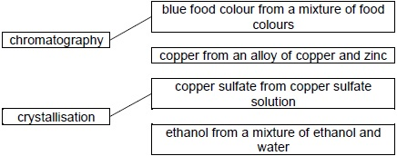
additional line from a box negates the mark for that box
2
(e) (filter) funnel containing filter paper
1
suitable vessel for collecting filtrate
1
sand and water labelled in correct place
1
(f) 100 °C
1
(g) any four from:
• solution is heated
• water evaporates
allow water boils / vaporises
• the vapour cools in the condenser
• the vapour condenses
or
the vapour turns to a liquid
• (pure) water collects in the beaker
4
[13]

