Health Promotion
What is health promotion?
Health promotion is the process of enabling people to increase control over, and to improve, their health. It moves beyond a focus on individual behaviour towards the public.
Health promotion supports governments, communities and individuals to cope with and address health challenges. They will do this by creating healthy public policies, supportive environments, and advertising this through public health promotion campaigns.
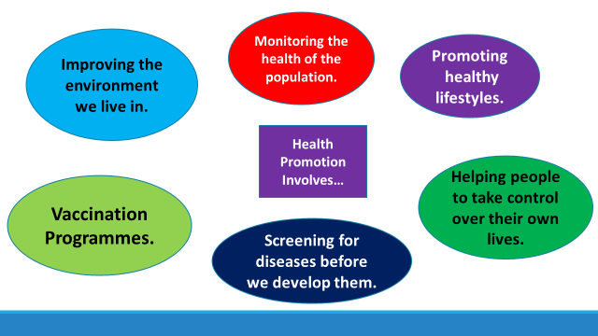
Examples of Health Promotion Campaigns (useful websites)
https://www.nhs.uk/healthier-families/
https://www.blf.org.uk/take-action/campaign-with-us/stoptober
https://www.drinkaware.co.uk/
https://www.thisgirlcan.co.uk/

