Video: Parents - invite another parent/guardian to join your appointments

Inviting another parent/guardian to join your appointments
You can give ONE other parent/guardian access to join your video appointments in respect of each student linked to you that is involved in the evening. You can grant this access at the time of booking, or later if required.
1. Once you have made your bookings (or when you later log in and go to My Bookings) click on the Invite Parent/Guardian link at the top of the list of your bookings. If you have already sent an invitation this link will show as Manage Invites instead.
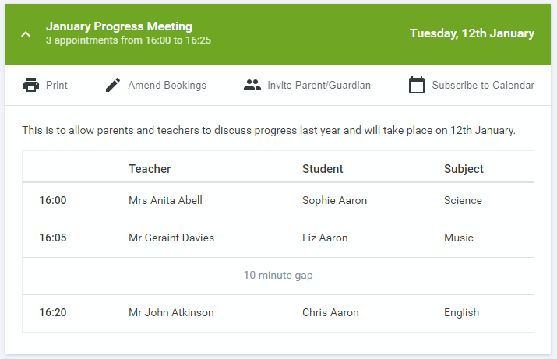
2. You will then be presented with a box asking for the details of the parent/guardian to be given access.
If there is more than one student linked to you and involved in the evening they will all be shown.
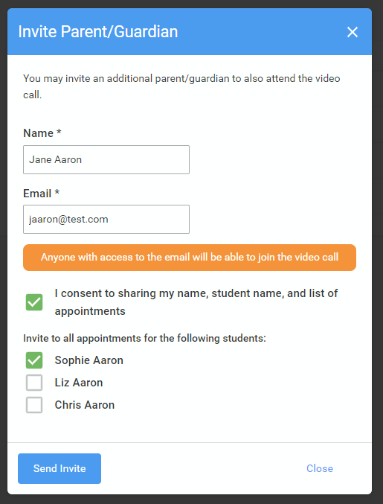
You must enter a Name, and an Email address, as well as tick the box to consent to that person being given access to the information used to make the appointments.
If there is more than one student linked to you, choose the student(s) in respect of whose appointments the access to this person will be granted.
When you click the blue Send Invite button an email is sent to the address entered, giving them a link and details on how to join the call.
Please note that ONLY the invited guest should use this link. Anyone else using it (including the parent that sent the invite, who should log in via their own confirmation email) will knock the guest out of appointments.
Here is an example of what the invite email looks like:
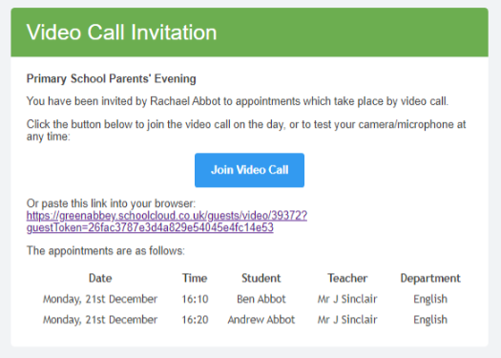
3. You will then see a Manage invites box that shows your sent invitation(s), allows you to add another invite if you have any more available (you can have one invite per student, if wished), and also allows you to Resend invites or Remove them. If you have no more invitations available the green button will be replaced with a message that says Unable to invite another parent/guardian. Only one invite can be sent per student.
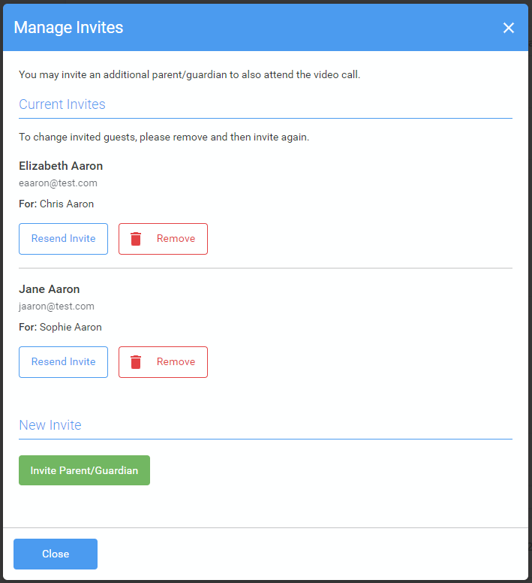
If you click Remove the link in the previously sent invitation will no longer work and that person can no longer join the video call.
Note that a call can have a maximum of 4 people in it at any one time. A school can assign 3 teachers to take joint appointments for a class, if they do this the parent can still invite their ONE guest, however once the number of active participants in the call reaches 4 no further people can join it (unless one of the existing participants leaves the call).

