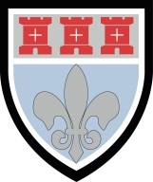
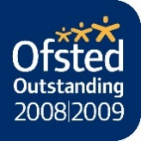

St Mary’s Catholic School

Benton Park Road, Newcastle upon Tyne. NE7 7PE

where everyone can succeed

Tel: 0191 2153260 Fax: 0191 2153279 admin@st-marys.newcastle.sch.uk www.stmarysnewcastle.co.uk

Student Medical Information
September 2021

Name:

Current Primary school:

Does your child have any medical needs? Yes No

If so, please give details of any medical needs your child has.

Please give details of any medication they currently take, the dosage, when it is administered and by whom.

Please give details of any symptoms that may require immediate action.

Any additional medical information

Form completed by: Date:

Signature:

