A-Level History
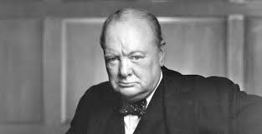
Britain 1906-57
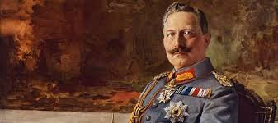
Germany 1871-1991

Bridging course – Week 1
St Mary’s Catholic School
A-level History Bridging Course

Entry Requirements for Studying A-level History?
- Students who are expected to achieve at least a 6 in History and a 6 in either English Lang or English Lit.
- Students who have enjoyed their GCSE History course.
- Students who love a lively debate and discussion in lessons, and who are willing, and able, to share their ideas.
- Students who enjoy writing essays and analysing source material.

Expectations for students studying A-level History?
Studying A-level History will challenge you. There’s a lot do and a lot to learn. You will be supported fully, but there are a few important expectations that you need to be aware. Adhering to these will help to ensure that you maximise your chances for success at A-level.
- Ensure excellent standards of attendance and punctuality
- Students need to be well prepared for lessons- having always completed the homework/preparatory work required
- Students need to be well-equipped with all relevant resources, so that you can fully access the lesson
- All homework and classwork really needs to be completed to a high quality – and always to the best of your ability
- All homework and classwork must be well-presented to support your future learning and revision for examinations
- Homework matches class work-10 hours of History lessons per fortnight therefore 10 hours of homework per fortnight will be set. Keep organised so that you keep can keep on top of this minimum expectation.
- You will need to study wisely to stay on top of the content of the course. Therefore, use your study periods wisely!
What to expect from studying A-level History
This A-Level course will help you develop your knowledge about key political, social and economic features within Britain during the Twentieth century as well as developing key understanding of the development of Germany over 120 years. Both of these units will develop your key historical knowledge covering key events of the twentieth century. The third coursework based unit on Tsarist Russia offers a look at an earlier period of History and to develop your understanding of Russia’s development under Tsarist rule.
A-Level History is an interesting and demanding course. History is heavily focused on essay writing and dealing with complex historical sources and interpretations. Students will be required to complete key readings both in and outside the classroom in order to fully understand the debate surrounding each of the topics. This understanding of debate will be key as many of the essay questions will be asking how far you agree with certain views or interpretations of events. These skills will already have been developed at GCSE History but will need to be improved upon further through developing a deeper understanding of topics through extended reading and through contributions to class discussion and debate. Studying A-Level History not only helps improve your knowledge of the past, but it also helps you gain transferable skills that are invaluable in many jobs. Some of these skills include analysing, researching, communication and problem-solving. You will also gain the ability to prioritise information and learn how to make vital decisions. This helps you to build an important skill-set for progression into university.
Course outline
Unit 1L - The quest for political stability: Germany 1871-1991
Unit focuses on the issues of change, continuity, cause and consequence of this unstable period.
- The German Empire in 1871
- Social developments: class hierarchy, elitism, the culture of militarism and the conditions of the working class
- The impact of the First World War
- 1918 revolution
- The impact of the Ruhr invasion
- The leadership of Stresemann
- Economic developments: Dawes and Young plan
- Collapse of Weimar Germany
- Nazi rule
- Division of Germany
- Berlin Wall
- Reunification of Germany 1991

40% Exam – 2hr 30mins
Unit 2M - War and welfare 1906 – 1957
Unit focuses on the rapid and significant changes affecting British politics, society and the economy in first half of the twentieth century.
- Pre-WWI Liberal governments and reform
- Social changes as a consequence of war e.g. position of women
- Domestic polices and problems in 1920’s
- First Labour government and crises of 1930’s coalitions governments- Depression
- Wartime policies and impact of total war upon society
- Post WWII government and birth of Welfare State e.g. NHS etc

40% Exam – 2hr 30mins
Unit 3 – NEA – Tsarist rule: reform and reaction, Russia 1762-1881
Unit focuses on reform and reaction in Russia
- Catherine the Great
- Paul I
- Alexander I
- Nicholas I
- Alexander II - the Tsar Liberator/Emancipation of the Serfs 1861

20% - written essay

This bridging course will provide you with a mixture of information about A-level History, and what to expect from the course, as well as key work to complete. Students who are expecting to study History at A-level, and are likely to meet the entry requirements, must complete the bridging course fully and thoroughly, to the best of their ability. You should complete all work on paper and keep it in a file, in an ordered way. You will submit it to your teacher in September. All of the work will be reviewed and selected work will be assessed, and you will be given feedback on it. This work will be signalled to you. If you do not have access to the internet, please contact the school and appropriate resources will be sent to you. If you are thinking about studying History at A-level you should attempt this work to see whether or not you think studying a subject like this is right for you. If you later decide to study History, you must ensure you complete this work in full. This work should be completed after you have read and completed the Study Skills work that all of Year 12 should complete.

Task One
Using the sources below describe in one paragraph what you think life was like in the 1900s.
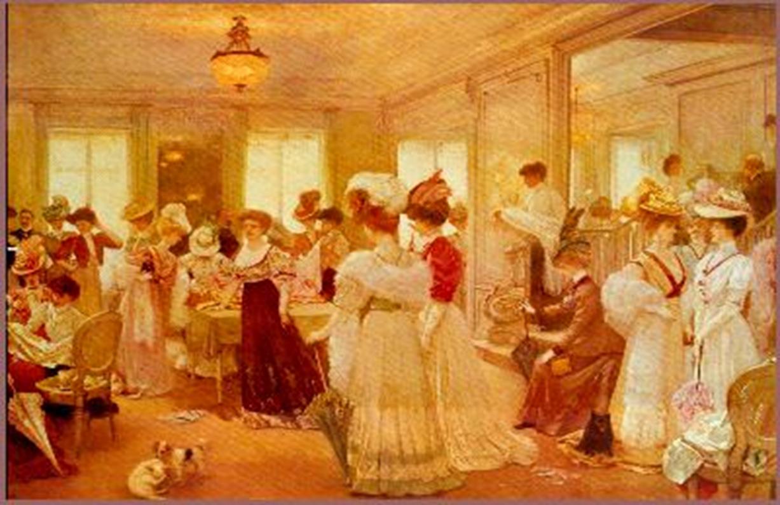

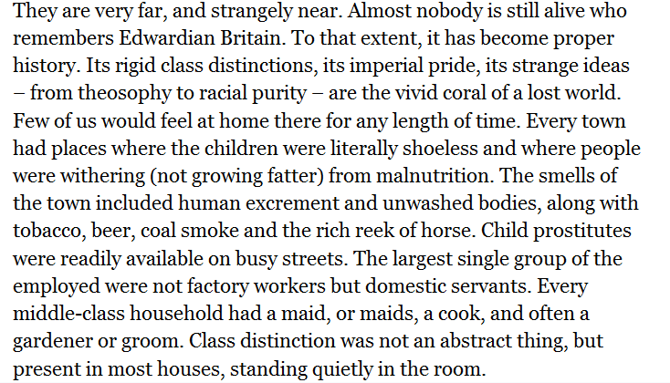

What was it like in the 1900s?

Task Two - Watch the following Andrew Marr video
www.youtube.com/watch?v=Vx3-uVwAVo4

Make notes on Britain in early 1900s using the information in the video.
Focusing on the following areas:
- The impact of the Boer war

- The impact of Emily Hobhouse

- Eugenics

- Key political parties

- Living conditions

- Poverty

- Rowntree’s study

- British culture in the early 1900s

- Class differences

- Development of trade unions – Taff Vale case

- Tariff reform

- Development of the Daily Mail, the Mirror and the Times

- Development of technology

- Women’s rights

Task three – Create a summary sheet on each of the four political parties in Britain in the 1900s, use your own research and the information from the video to help with this task.
Conservative Party | Liberal Party
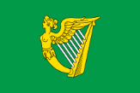  Irish Nationalist Party | 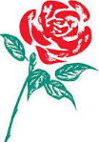  Labour Party

Task Four – You will now produce a short written piece of work (2 sides of A4) summarising what Britain was like in the early 1900s using the information you have gathered from the video, sources and from your own research. This will then be handed in to be marked in September.

