A-Level History
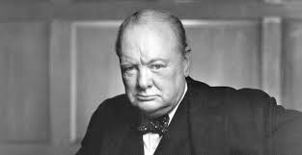
Britain 1906-57
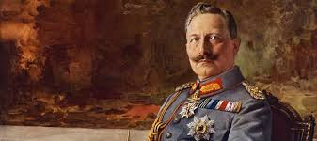
Germany 1871-1991

Bridging course – Week 3

Wars and Welfare: Britain in Transition, 1906–1957
Recap task – (use your knowledge from week 1 and 2 tasks)

- What key political parties were dominant during the period 1906-57 in Britain?

- How did the influence of political parties change during this period?

- Which Prime Ministers did you want to know more about and why when completing your overview?

This week you are going to begin to explore the other A-Level exam unit – Germany 1871-1991

German Unification
Before 1871 there had been no single state of Germany
  - It had been made up over 300 different German states loosely grouped together in the First Reich since the nineth century
  - This was destroyed in 1806 by Napoleon
  - After his defeat in 1815, 39 new states had been established by the Congress of Vienna to create greater stability
Prussia had played a key role in the defeat of France and were given new territory in the Rhineland for this
However, Prussia and Austria continued to compete against each other for influence
  - In 1862 Kaiser Wilhelm I and Bismarck went to war with Austria and forged a new ‘North German Confederation’ in 1867
  - In 1871, after another war with France, this Confederation now included the southern states of Germany
This was the beginning of the Kaiserreich – Wilhelm I was proclaimed as German Kaiser in Versailles.
With this, Wilhelm I presided over 26 separate states
  - Largest - Prussia comprised over 60 percent of the Reich in land and population
  - French-speaking provinces of Alsace-Lorraine in the west
  - Danish-speaking North Schleswig
  - Polish-speaking areas in East Prussia
As this was a voluntary agreement, these states would retain their right to self-govern, making Germany a federal state
  - 22 of these states retained their own monarchies
  - Bavaria was even allowed to retain their own army in peacetime
  - Grand-dukes ruled in Baden, Mecklenburg and Hesse
  - Hamburg, Lubeck and Bremen were self-governing
Because of this, a new constitution was certainly necessary in order to establish the powers of the Reich
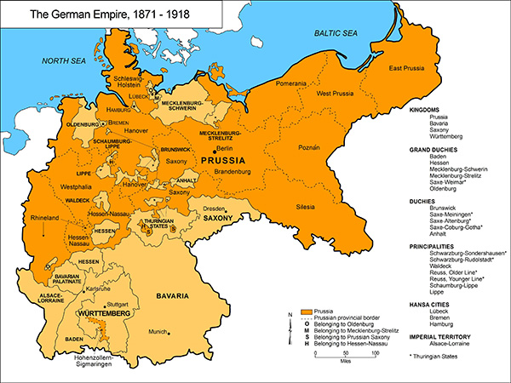
Since the early nineteenth century, German liberals, had been pushing for a ‘democratic constitution’
  - They wanted a system where the power of the ruler and his ministers was limited, giving the people more control over its government
  - They wanted an elected parliament, chosen by ‘the people’
  - This would guard the people’s freedom as an elected parliament would represent the people’s views, question ministers’ policies, and ensure that taxes were properly spent
  - They supported the unification believing that a constitution like this would be created
However, Bismarck was conservative and believed in an authoritarian system
  - He was suspicious of ‘people power’
His idea of a constitution was very different.

Task One – Complete the questions below using the information above.
- Which leader destroyed the First Reich?
- Create a timeline of events up until 1871
- What issues could arise from controlling 26 separate states?
- Why was a constitution essential?
- What did the German liberals want?
- Why was Bismarck not going to provide the constitution that the liberals were after?

Task two – You will need to draw a timeline from 1871-1991 (like the one below but bigger)

1871 1991

On your timeline I want you to plot
1 – Any world events you know about that you think may have impacted Germany during this time period
2- Any events or people you know about in German History that may have impacted this period
3- Any key events that you have read about in task one

Then I want you to think about how much may have changed for Germany during this 120 year period?

What questions do you have about this period in Germany?

Which period do you think you are most looking forward to studying and why?

Task Three – Research the key parties in the early period of the Germany course and complete the table below
Party | Key features
National liberals

Zentrum

Social Democratic Party

German Conservative Party

Free conservatives or Reichspartei

Progressives or Fortschrittspartei

How do you think the parties may change over time?

Think about your GCSE History knowledge?

Task Four – Create a mini profile on the two key early figures in this unit – Bismarck and Wilhelm I

Task Five –
What key events do you think are important during this period of Germany History? Thinking back to your timeline.

Now, I want you to look at the key events below, I would like you to research any you are unsure of and I would like you to think carefully about the impact they have on Germany during this time.

Then I would like you to place them on your timeline if you haven’t got them already.

Then I would like you to rank them from most important to least important and explain why you have chosen that order.
- Unification of Germany 1871
- Outbreak of WWI
- Treaty of Versailles
- Hitler becoming Chancellor
- WWII
- Outbreak of the Cold War
- Berlin blockade
- Collapse of the Soviet Union

Most Important impact on German History

Least Important impact on German History
Explain your order with key explanation of your most and least important events. (There is no right or wrong answer as long as you can explain your decision)

Researching and outlining these key events you should be able to now see what a turbulent and challenging 120 years this topic covers in German History.

Which part of the time period are you now most interested in studying?

Are there any key questions you have now about this topic?

