A-Level History
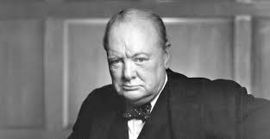
Britain 1906-57
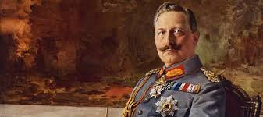
Germany 1871-1991

Bridging course – Week 4

Recap task – (use your knowledge from week 3 tasks)

- What is German unification? How did it impact Germany?

- What are the key political parties in Germany during this period?

- What key major historical events will change and develop Germany over this 120 year period of study?

- Which of the key events do you think will have the biggest impact on Germany?

The beginnings of the Cold War
The invasion of Russia by Nazi Germany in 1941 shattered their former Nazi-Soviet pact and sent the USSR into the arms of the West. For the remainder of the Second World War, the USSR fought on the same side as Britain, the USA and their allies.
- The Second World War ended in 1945 with the surrender of Germany in May and the dropping of the atom bomb in August forcing Japan to surrender.
- At the end of 1944 Hitler had launched one last offensive in the west but Germany could not compete against the extra resources of the Allies and the Allied advance continued.
- In the east, Soviet troops entered Berlin, which the Germans defended to the last, but in the end Hitler committed suicide and the Germans were forced to surrender.
- Europe had been left devastated by war.

Capitalism – USA, Britain | Communism - USSR
Several political parties representing different sectors of society | One-party state
Governments are chosen by democratic elections | No democratic elections and no opportunity to change the government by election
People are free to set up private businesses and make money for themselves | All businesses and factories are owned by the state
Individual rights and freedoms are important | Individual rights and freedoms are less important than obedience to the state
Freedom of speech and freedom of the press | Censorship and state controlled media

In February 1945, the Big Three – Churchill, Roosevelt and Stalin - met at Yalta.
With an Allied victory looking likely, the aim of the Yalta Conference was to decide what to do with Germany once it had been defeated. In many ways the Yalta Conference set the scene for the rest of the Cold War in Europe.
Outcomes:
- Germany would be divided into four zones of occupation with the USSR, Britain, France and the USA each controlling a zone. France had been liberated from Nazi Germany and was included at the conference partly due to pressure from the French leader, General de Gaulle, but also because Britain wanted a European ally with whom it could share the cost of the post-war reconstruction of Germany.
- The German capital, Berlin, was about 100 miles inside the Soviet zone and it, too, was to be divided into four zones, each controlled by one of the Allied powers. Berlin would become a continuing source of tension once the Cold War began in earnest.
- All countries freed from Nazi control were to be guaranteed the right to hold free, democratic elections to choose their own governments. This commitment was released as an official joint statement, the Declaration on Liberated Europe. However, Stalin was offered a sphere of influence in Eastern Europe where communist ideals would dominate.
- Again, Stalin committed to joining the war against Japan, once Germany had been defeated. This was important to the Americans who were suffering heavy losses in the Pacific, despite the fact they were gradually pushing back the Japanese.
- All the leaders made a commitment to pursue, and put on trial, suspected Nazi war criminals.
- The Allies agreed to the setting up of the United Nations, an organisation dedicated to international cooperation and the prevention of war.
The next meeting of the Big Three took place in July 1945 at Potsdam, just outside Berlin.
Objectives:
The main objective of the Potsdam Conference was to finalise a post-war settlement and put into action all the things agreed at Yalta. While the meeting at Yalta had been reasonably friendly, the Potsdam Conference was fraught with disagreements, which were the result of some significant changes that had taken place since the Yalta Conference.
1. A new US President:
The US President, Franklin D Roosevelt, had died and been replaced by his Vice-President, Harry S Truman. While Roosevelt had been willing to work with Stalin, largely because he needed the USSR to join the war against Japan, Truman made little secret of his dislike for communism and for Stalin personally. Truman remarked that he was tired of babying the Soviets and that the only language Stalin understood was how many army divisions do you have?
2. Nuclear threat:
Just before the Conference began, on 16 July 1945, the USA had successfully exploded an atomic bomb at their test site in the New Mexico desert. When first told about the success of the experiment, Truman is said to have remarked: if it works... I’ll sure have a hammer on those boys. At Potsdam, Truman chose to inform Stalin that the US possessed a new weapon of unusual destructive force. Although Stalin already knew details about the Manhattan Project through his spy networks, he was able to complain at this treatment and the fact that there were secrets between supposed Allies.
3. Expansion of communism:
Despite agreeing at Yalta that free elections would be held in Eastern Europe after the defeat of Nazi Germany, there was little evidence at Potsdam that Stalin intended to allow them. In fact the Red Army was in control of Poland and the USSR was in the process of setting up a communist government
Little real progress was made at Potsdam beyond an agreement to put into action the commitments made at Yalta.
The main points of the Conferences are summarised in the table below:
 | Yalta | Potsdam
People and participants | Churchill, Roosevelt and Stalin | Churchill (replaced midway by Attlee), Truman and Stalin
Elections | Stalin to have a ‘sphere of influence’ over Eastern Europe but all countries freed from Nazi occupation would be allowed free elections to choose their own governments | There was no sign of Stalin allowing free elections in Eastern Europe and a communist government was being set up in Poland
Europe | Germany to be divided into four zones of occupation - Berlin to also be divided | Arguments over where the boundaries between the zones would be drawn
Repayment | The USSR would be allowed to take reparations from defeated Germany | Arguments about how much the USSR should be allowed to take in reparations. It was agreed that the Soviets could take whatever they wanted from the Soviet controlled zone and 10 per cent from the Western zones. This remained a source of disagreement, with the Western Allies worried that they were repeating the mistakes of the Treaty of Versailles after World War One

Japan and the Atomic Bomb
On 6 August 1945, the USA dropped an atomic bomb on the Japanese city of Hiroshima. The blast devastated an area of five square miles, destroying more than 60 per cent of the city’s buildings and killing around 140,000 people. Three days later the USA dropped a second atomic bomb on the Japanese city of Nagasaki, killing around 74,000 people.

Why were the bombs dropped?

The damage caused by the atom bomb attack on Hiroshima on 6th August 1945
The official US justification for the dropping of the two atomic bombs was to force the Japanese government to surrender, which it did on 14 August 1945. Some historians have speculated that the bombs might also have had another purpose - to send a warning to the Soviet Union about the strength of the American arsenal.
Whatever the intention, the USA had changed the nature of warfare, and for the remainder of the Cold War the threat of atomic weapons and nuclear war would be a constant theme. Stalin himself remarked that future wars were inevitable and the Soviet Union now stepped up its own programme of atomic research. American 'nuclear hegemony' would not last long.
The Soviet expansion
Despite the promises made by Stalin at the Yalta Conference to allow free elections, he had in fact started turning Eastern Europe into a buffer zone between the Soviet Union and Western Europe. Stalin feared that Eastern Europe could be the doorway for an attack on the Soviet Union by the West.

Timeline of Soviet takeover of Eastern Europe

Country | Year | Methods used
Albania | 1945 | A communist government took power at the end of World War Two.
Bulgaria | 1946 | In 1946 the Bulgarian monarchy was abolished and later that year a communist government was elected and gradually eradicated its opponents.
East Germany | 1945 | East Germany was part of the Soviet zone of occupation agreed at the Yalta Conference and in 1945 the Soviets set up a communist regime.
Romania | 1945 | In the 1945 elections, a communist-led coalition government was elected. The communists gradually removed their coalition partners and abolished the Romanian monarchy.
Poland | 1947 | Fearing that a non-communist government would be elected in 1947, Stalin invited 16 non-communist politicians to Moscow, where they were arrested. With their political opponents removed, the Polish communists won the election.
Hungary | 1948 | Although non-communists won the 1945 election, a communist politician, Rakosi, took control of the secret police and used it to arrest and execute his political opponents. By 1948 the Communist Party was in complete control of the country.
Czechoslovakia | 1948 | Czechoslovakia was the last country in Eastern Europe to fully fall to communism in 1948. At elections that year only Communists were allowed to stand and a communist government was duly elected.
Task One
Read through the key information on the Cold War and answer the questions below.
- Who was Russia allied with during the Second World War? Why did this change?

- What is Capitalism?

- What is Communism?

- Why might countries having different ideologies cause conflict?

- Who were the big three?

- What was the outcome at the Yalta conference?

- How does the Yalta conference impact Germany?

- What changed at the Potsdam conference?

- What increased tensions at Potsdam?

- What was agreed or discussed at Potsdam?

- Why were the nuclear bombs dropped?

- What is the impact of the dropping of nuclear bombs at the end of WWII?

- How did Stalin break his promises at the Yalta conference?

- What do you think the impact of Communist expansion will be?

- How do you think the USA will react to Communist expansion?

Task Two
Define the term
Cold War –

Task Three
How did the Cold war begin?

Who is to blame?

Read the different historical interpretations below
Orthodox view –
The Cold War was caused by the military expansionism of Stalin and his successors. The American response… was basically a defensive reaction. As long as Soviet leaders clung to their dream of imposing Communism on the world, the West had no way (other than surrender) of ending the conflict. When a Soviet leader appeared who was willing to abandon that goal, the seemingly interminable Cold War soon melted away.
Summary of Michael Hart’s argument justifying placing Mikhail Gorbachev in his top 100 most influential persons in history.
Michael H Hart worked for NASA and is currently a professor of astronomy and physics at a US college. He holds degrees in physics, astronomy, and law and is author of: The 100: A Ranking of the Most Influential Persons in History (1986)

Revisionist view
The atomic bomb did help seed the Cold War. Let's face it, the bomb was not just meant to buckle Japan into surrender, it was also a political statement towards the Soviet Union. A statement of power towards a nation who practiced a political ideology different from America which was unacceptable to the "free democratic" United States…
Michael Hughes

Post-Revisionist view
The Cold War was caused by the conflicting interests of the United States and the U.S.S.R., compounded by miscommunication and poor diplomacy. The differences in the cultures of the American political leaders and their moral and righteous justifications for diplomacy from Soviet leaders' communist expansionist policies led to the unravelling of the new international order nearly established in Roosevelt's wartime conferences with Churchill and Stalin.
Analysis of President Truman’s ideas at a site called Innocents Abroad: Presidents and Foreign Policy
Post-1991
The 'realist' interpretation views the Cold War as a great power conflict between the two geopolitically dominant powers which emerged from the Second World War. Wolhforth captures this approach: ‘the Cold War was caused by the rise of Soviet power and the fear this caused in the West’.

Similarly, the 'liberal' interpretation sees the Cold War as a military conflict, which, rather than being the result of power vacuums, was the product of poor policy decisions, misperceptions and missed opportunities; given this, many argue, the Cold War could have been avoided. For 'radicals', the Cold War was not really a conflict of values, ideas or interests, but a military conflict coloured with the patina of ideological rhetoric that was used by both sides to establish and further the domination of their own spheres of influence.

The liberal, realist and radical approaches are not satisfactory… In short, seeing the Cold War as an acute phase of the conflict between capitalism and Soviet communism avoids the determinism of the radicals and the simplification of the realists and liberals.
Unknown

Reading the different historical interpretations – Who do you think is to blame for the Cold War?

How do we think the Cold War impacts Germany as a defeated nation at the end of WWII?

Task Four - Germany during the Cold War
After WWII, Germany was occupied and divided into four military zones, each controlled by one of the four allied powers: USSR, USA, Britain and France. Its capital Berlin was similarly divided amongst the occupiers. (see map below)
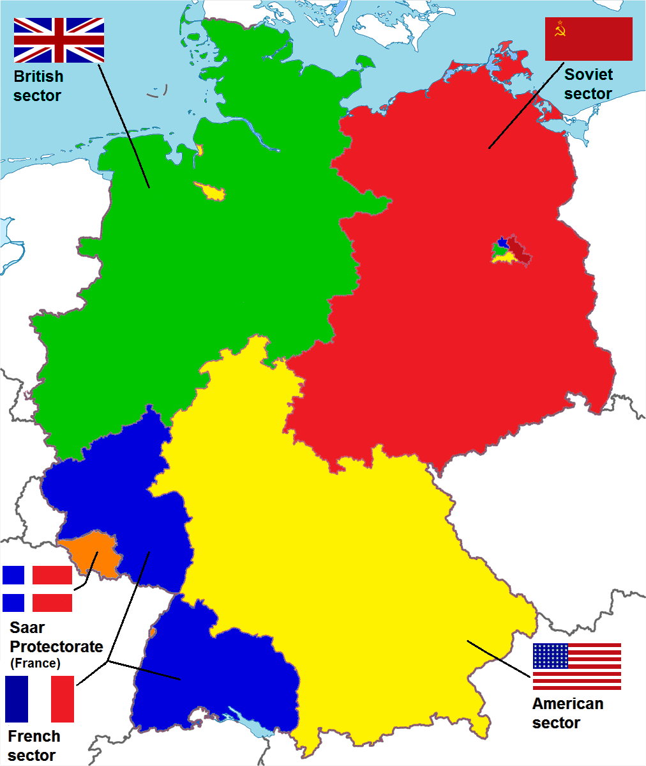

Eventually Britain, USA and France joined their zones together to unite as West Germany and to try and rebuild Germany as a new democracy. However USSR wanted to remain separate and this became known as East Germany and was run as one of its communist states.

What do you think the impact of this split between East and West would have on Germany?

What problems might this cause with Berlin?

Can you see how Germany is going to be impacted by the Cold War?

What problems can you predict?

Task Five
Research the key cold war event of the ‘Berlin crisis’ or the ‘Berlin Blockade and Airlift’

Summarise below the key events – What happened? Why there was conflict? Who were the victors?
Berlin Blockade and Airlift Key events

Thinking point –
Thinking about what you have found out about the Berlin Blockade and Airlift – How great an impact is this event going to have on Germany?

Is it really Germany’s issue?

Does it show the clear influence and impact of the Cold War on Germany?

Although we do not go into the detail of the Cold War in the course it is important for you to understand the background and tensions between USA and the USSR during this period as it has a huge impact on the development of Germany and the lives of German people from 1945 until the end of the course due to the continuing division of West and East Germany and the continuing influence of the USSR on East Germany and Berlin.

