St Mary’s Catholic School
Year 11 into Year 12 Bridging Work

Recommended Reading List for Year 12
Geography
To prepare you for your Sixth Form studies, the reading list below includes a variety of books, articles and other material to read and use, to broaden your knowledge, and to enrich your understanding of Geography.Take some time over the summer to complete the reading below, using the tasks to help structure your reading.

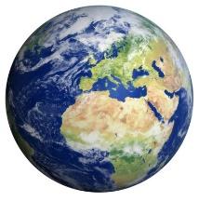
Credit to Amazon and Waterstones for the synopsis

Want to really understand Geography? If you have only got a few hours or minutes, why not check out some of the resources below?
Book | What is it about? | Theme
Empire Antarctica: Ice, Silence & Emperor Penguins (Gavin Francis) | Following the penguins throughout the year -- from a summer of perpetual sunshine to months of winter darkness -- Gavin Francis explores a world of great beauty conjured from the simplest elements, the hardship of living at 50°C below zero and the unexpected comfort that the penguin community bring. | Biodiveristy  Frontiers  Climate
Chinese Cinderella (Adeline Yen Mah) | An autobiography following the life of a Chinese child growing up in hardship. Great reviews! | China  Development
The Carbon Diaries 2015 (Saci Lloyd) | It's January 1st, 2015, and the UK is the first nation to introduce carbon dioxide rationing, in a drastic bid to combat climate change. As her family spirals out of control, Laura Brown chronicles the first year of rationing with scathing abandon. Will her mother become one with her inner wolf? Will her sister give up her weekends in Ibiza? Does her father love the pig more than her? Can her band the dirty angels make it big? And will Ravi Datta ever notice her? | Climate Change
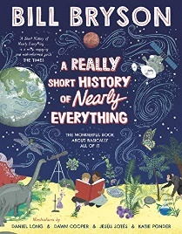  A Short History of Nearly Everything and Notes from a small island (Bill Bryson) | Ever wondered how we got from nothing to something? Or thought about how we can weigh the earth? Or wanted to reach the edge of the universe? Uncover the mysteries of time, space and life on earth in this extraordinary book - a journey from the centre of the planet to the dawn of the dinosaurs, and everything in between. | Tectonics  Hazards  Biodiversity  Ecosystems
Trash (Andy Muligab) | Raphael lives on a dumpsite, eking out a living sifting through rubbish. One unlucky-lucky day, he makes an extraordinary and deadly discovery. Now he and his two friends, Gardo and Rat, are wanted by the corrupt forces that run the city and will stop at nothing to get back what they've lost. From the slums to the mansions of the elite, it's going to take all of their quick-thinking and fast-talking to stay ahead. And to stay alive. | Urbanisation  Development
How Population will transform our World (Sarah Harper) | Predicting the shape of our future populations is vital for installing the infrastructure, welfare, and provisions necessary for society to survive. There are many opportunities and challenges that will come with the changes in our populations over the 21st century | Population  Health  Development
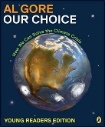  Our Choice (Al Gore) | Follows on from An Inconvenient Truth. Al Gore thinks about how to solve the issue of global climate change | Natural Hazards  Climate change
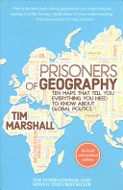  Prisoners of Geography: Ten Maps That Tell You Everything You Need To Know About Global Politics (Tim Marshall) | Splitting the world into 10 distinct region this book Looks at the past, present and future to offer an essential insight into one of the major factors that determines world history. A great book about geopolitics | Changing Economic World  Development.
How Bad Are Bananas?: The carbon footprint of everything. (Mike Berners-Lee) | By talking through a hundred or so items, Mike Berners-Lee looks at our carbon instinct for the footprint of literally anything we do, buy and think about. The book ranges from the everyday (foods, books, plastic bags, bikes, flights, baths...) and the global (deforestation, data centres, rice production, the World Cup, volcanoes, ...) Be warned, some of the things you thought you knew about green living may be about to change. | Sustainability  Climate change  Resource Management
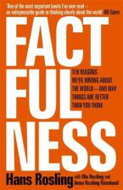  Factfulness (Hans Rosling) | A radical new explanation of our world. Hans Rosling explains why the world isn’t in quite such a bad shape as we thought and why we so often get our facts wrong. | Changing Economic World  Development.
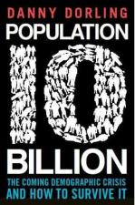  10 Billion (Danny Dorling) | Explores how we got to 10 billion and the key issues that we face in the coming decades including how to deal with scarcity of resources and how our cities will grow and how we should prepare for population decline. | Urbanisation  Economic World
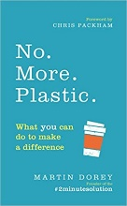  No. More. Plastic.: What you can do to make a difference – the #2minutesolution (Martin Dorey) | Open this book with your children, give it to your friends. Share your #2minutesolution on twitter and instagram and inspire others. Martin Dorey, anti-plastics expert, has been The book has proven that collective small actions can add up to a big difference. Together we can fix this. | Resource Management
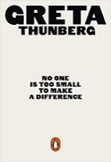  No One Is Too Small to Make a Difference (Greta Thunberg) | In August 2018 a fifteen-year-old Swedish girl, Greta Thunberg, decided not to go to school one day. Her actions ended up sparking a global movement for action against the climate crisis, inspiring millions of pupils to go on strike for our planet, forcing governments to listen, and earning her a Nobel Peace Prize nomination. | Climate change
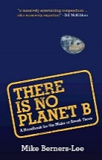  There Is No Planet B: A Handbook for the Make or Break (Mike Berners-Lee) | What are the impacts of our actions? What are the key environmental and economic challenges we face? | Sustainability  Climate change
When the Rivers Run Dry: The Global Water Crisis and How to Solve It (Fred Pearce) | This examines the worlds water crisis. But with 7.5 billion people competing for this single unevenly-distributed resource, the planet is drying up. In When the Rivers Run Dry, Fred Pearce explores the growing world water crisis | Rivers  Resource Management  Water Security  Climate Change
Climate Wars: The Fight for Survival as The World Overheats (Gwynne Dyer) | Bringing together extensive interviews and latest research, this book reveals the realities of a planet facing scarce food, water and land. Can out technology save us, or is it too late? | Natural Hazards  Climate change  Resource Management Food and water resources.
Our Final Warning: Six Degrees of Climate Emergency (Mark Lynas) | A look at the future if current rates of warming increase. The book talks through the different scenarios of a 1 to 6*C of warming. | Climate Change
The Future of Energy: 2020 (John Michael Armstrong) | The author takes you on a. journey through a range of environmental scenarios (home heating, air travel, industrial consumption) where energy is the problem but also, potentially, brings a range of solutions. | Sustainability  Climate change  Resource Management Energy Security
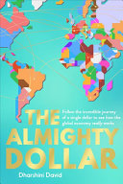  The Almighty Dollar (Dharshini David) | Follows $1 from a shopping trip in Texas, via China’s central bank, Nigerian railroads, the oilfields of Iraq and beyond to reveal the complex relationships of our new globalised world . Ties into economic world, trade, development and also has a chapter on China investing in Nigeria | Changing Economic World  Development  Globalisation
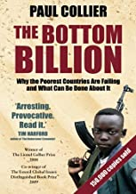  The Bottom Billion (Paul Collier) | Looks at the growth of the development gap - why countries are poor. Also globalisation and the way it can help countries develop. | Changing Economic World  Development, Globalisation
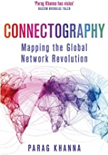  Connectography (Parag Khanna) | Looks at megacities and how globalisation is eroding borders. | Changing Economic World  Development Globalisation
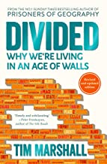  Divided (Tim Marshall) | From the same author as Prisoners of Geography Which side of the fence are you on?  The book looks at how money, race, religion, politics are the things that divide us. An essential book looking at what is going on today | Changing Economic World  Development Globalisation
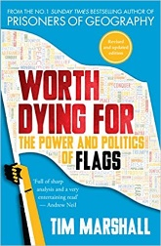  Worth Dying For (Tim Marshall ) | Nine chapters (covering the USA, UK, Europe, Middle East, Asia, Africa, Latin America, international flags and flags of terror), Tim Marshall draws on more than twenty-five years of global reporting experience to reveal the histories, the power and the politics of the symbols that unite us – and divide us. | Changing Economic World  Development Globalisation
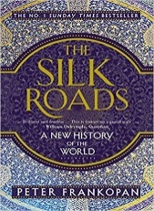  The Silk Roads (Peter Frankopan) | A look at the interconnections between the silk roads travelling eastwards from Europe to China Via The Middle East and Russia. | SuperPowers
Poverty Safari understanding the Anger of Britain's Underclass (Darren McGarvey) | The author has experienced poverty and its devastating effects first-hand. He knows why people from deprived communities all around Britain feel angry and unheard | Regenerating place  changing places
Extreme Cities: The Peril and Promise of Urban Life in the Age of Climate Change (Ashley Dawson) | How will climate change affect our lives? Where will its impacts be most deeply felt? Are we doing enough to protect ourselves? Today, the majority of the worlds megacities are located in coastal zones, yet few of them are adequately prepared for the floods that will menace their shores. | Climate Change  Natural Hazards  Coasts
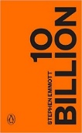  Ten Billion (Stephen Emmott) | Ten Billion is a book about every one of us. It's about our failure: failure as individuals, the failure of business, and the failure of our politicians. It is about an unprecedented planetary emergency. It's about the future of us. | Climate Change  Resource Management
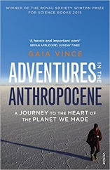  Adventures in the Anthropocene (Gaia Vince) | The changes we humans have made in recent decades have altered our world beyond anything it has experienced in its 4.6 billion-year history. As a result, our planet is said to be crossing into the Anthropocene – the Age of Humans. This book examines these changes and looks as what life is really like for the people on the frontline of the planet we’ve made. | Sustainability  Climate change  Resource Management
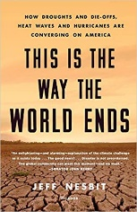  This is the way the World ends (Jeff Nesbitt) | Our world is in trouble - right now. This book tells the real stories of the substantial impacts to Earth’s systems unfolding across each continent from longer droughts in the Middle East to the monsoon season shrinking in India. A blueprint for real-time, workable solutions we can tackle together. | Middle East  Sustainability  Climate change  Resource Management

Can we eat our way out of climate change? | https://www.bbc.co.uk/programmes/w3cswqtg
Why is cape town running out of water? | https://www.bbc.co.uk/programmes/w3csvsyq
Could we ban the sale of petrol and diesel cars now? | https://www.bbc.co.uk/programmes/w3csv1c0
How do we stop people dying in floods | https://www.bbc.co.uk/programmes/w3csv1by
Can we earthquake proof a city? | https://www.bbc.co.uk/programmes/p03mqhzy
Disasters | https://www.bbc.co.uk/programmes/m000b0c7
Antarctica | https://www.bbc.co.uk/programmes/b00ss2th
Vulconology | https://www.bbc.co.uk/programmes/p005490h
50 things – The i phone | https://www.bbc.co.uk/programmes/p04hyzm5
Building a city for an aging population | https://www.bbc.co.uk/programmes/p06rjnl5
https://earth.nullschool.net/ - An AMAZING website which shows live and past weather patterns
https://timeforgeography.co.uk/ - a wide range of Geography videos
https://earthobservatory.nasa.gov/ - satellite images and maps of global events
http://www.worldometers.info/ - live demographic data. Watch the world’s population change in front of your eyes.
https://www.nationalgeographic.com/ - geographical articles, photos and more
https://www.atlasobscura.com/destinations - the interesting, the wonderful and the just plain weird as aspects of places around the world
https://www.worldatlas.com/aatlas/world.htm - maps and information about the world’s countries
https://www.gapminder.org/ - full of facts, videos and insight into the realities of development

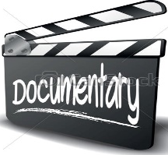
TV
DON'T PANIC | Hans Rosling showing the truth behind population growth | Changing Economic World –Demographic transition Development
Welcome to Rio | Series of 3 documentaries charting life in the favelas of Rio, prior to the World Cup and Olympics | Urban Issues and Challenge Social and environmental challenges in a city in a NIC
10 things you didn’t know about earthquakes/10 things you didn’t know about earthquakes | Professor Iain Stewart looks at some of the more unusual aspects of this destructive force of nature. | Challenge of Natural Hazards - Tectonics – causes and effects.
Food, Inc | Investigative look into the realities of the industrial food system | The Challenge of Resource Management – one solution to global inequalities in food supply
Megacities with Andrew Marr  www.youtube.com/watch?v=uwCABmP3uQ4 | Documentaries in which Andrew Marr finds out how some of the world's biggest cities feed, protect and move their citizens. | Urban Issues and Challenges : urbanisation and the rise of the megacity
Supersized Earth – episode 3 – Food, Fire and Water | Documentary exploring how we have transformed our world. Dallas Campbell examines what it takes to keep seven billion humans alive with food, energy and water. | The challenges of resource management
Before the Flood | The causes and impacts of climate change | Climate Change Natural Hazards
Climate Change – the Facts | David Attenborough outlines the impacts and some solutions to the threat of climate change. | Climate Change Natural Hazards
Blue Planet II, http://www.bbc.co.uk/programmes/p05jqnq4  Planet Earth / Planet Earth 2  Our Planet / Frozen Planet | Series of radio and TV programmes exploring different environments and issues | Biodiversity Ecosystems
Explained (15) | Looks at a range of issues from pirates, diamonds, billionaires, the water crisis, the racial wealth gap and can we live forever). | Various
Into The Inferno | Filmmaker Werner Herzog takes a look at active volcanoes around the globe in this documentary. Learne about the science behind volcanic eruptions, and remarks on how volcanoes are frequently connected to the local mythology of their surrounding area. | Natural Hazards
Decoding the weather machine | Join scientists on a quest to better comprehend the workings of the weather and climate change. | Weather  Climate Change
The future of water | Overview of the competition for water, good for A Level | Water Security
72 Dangerous Places to Live | From poisonous water to poisonous dunes, polluted air, flooding, earthquakes and rising sea levels, 72 Most Dangerous Places to Live provides a depiction of life on Earth, and some of the locals who live there. It is an ecologial, and cultural, walk through life and the resilience of man. | Biodiversity  Water Security  Plate tectonics
Mission Blue | Oceanographer Dr. Sylvia Earle is on a mission to save our oceans. | Biodiversity  Water Security
Dark Tourism | From a nuclear lake to a haunted forest, New Zealand filmmaker and journalist David Farrier visits unusual tourism spots around the world. | Tourism  Economic Development

KS5 specific recommendations
- Crude Impact (Geopolitics of the oil industry/oil consumption)
- Cowspiracy (Global warming and meat production)
- Great Barrier Reef by Richard Fitzpatrick
- The True Cost – The garment industry
- Under the Sun – North Korea from the inside out.

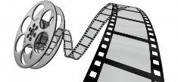

Films:
The Constant Gardener | A drug company exploits the Kenyan population to allow them to test a new drug, despite the fact they know it has harmful side effects. Good for economic world and the impact of TNCs on LICs
The Full Monty | A group of unemployed men from Sheffield go to desperate measures to make some money. Good for economic world and the N/S DIvide
City of God (ask at home – it’s an 18 certificate for a reason) | Growing up in a Rio de Janeiro slum, Rocket is able to avoid being drawn into a life of drugs and crime by having a passion for photography.
The Age of Stupid | A survivor beams back his views of our lack action on climate change from a ruined future planet earth. About climate change, energy consumption and production via some interesting case studies.
Slumdog Millionaire | Life in within the shanty towns of Mumbai. Good film to see what life is like in a shanty town/ squatter settlement. Good for KS3 and KS4 geographers.
Brassed Off – | Similar in era to the Full Monty this film shows industrial decline in the UK. Good for looking at the N/S Divide.
Under the Dome | Documentary film about the frightening level of pollution in China and the challenges of urban living
An Inconvenient Truth | Al Gore’s ground-breaking climate change movie. A must for anyone interested in climate change.
The Day After Tomorrow | Climate change has never been this traumatic! Be careful as a lot of this is fiction!
Dante’s Peak – | Shows most of the features of a volcano.
Twister | The formation and impact of a twister
The Impossible (be aware it is based on real life so has upsetting scenes) | Based on the events of the Boxing Day 2004 tsunami which occurred in the Indian Ocean where an earthquake measured 9.1 killing over 200,000. A gripping film!
Before the flood | Leonardo DiCaprio presents the dangers of climate change and solutions through meeting scientists, activities and world leaders.
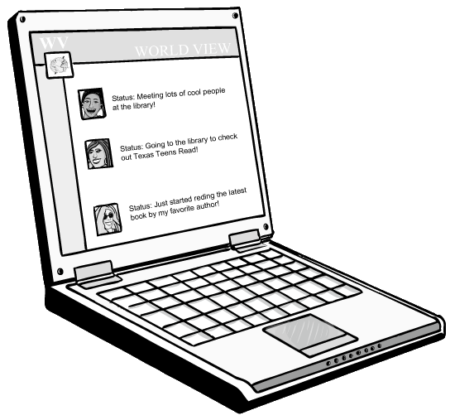
KS5 Films and docufilms
Bridge of Spies: (Cold War Superpowers)
Gas Land (carbon)
Fahrenheit 911 (9/11, Iraq & terror from view point of Michael Moore)
Capitalism, a love story. (Views of Michael Moore on capitalism)
Yellow Earth (a film about China’s history…Subtitles!)
Gandhi – (Superpowers – The British Empire in India)
Zulu (The British Empire in Africa Superpowers)
Hotel Rwanda – Rwandan Genocide
Question what you see. Some present very one sided views. Try to form your own opinions on issues.

