BTEC HEALTH AND SOCIAL CARE

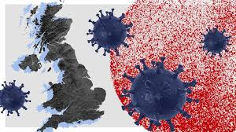

Bridging Course - Week 4
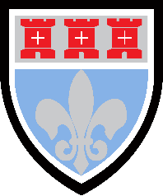

St Mary’s Catholic School
BTEC HEALTH AND SOCIAL CARE Bridging Course
This bridging course will provide you with a mixture of information about BTEC Health and Social Care, and what to expect from the course, as well as key work to complete. Students who are expecting to study Health and Social Care, and are likely to meet the entry requirements, must complete the bridging course fully and thoroughly, to the best of their ability. You should complete all work on paper or and keep it in a file, in an ordered way. You will submit it to your teacher in September. All of the work will be reviewed and selected work will be assessed, and you will be given feedback on it. This work will be signalled to you. If you do not have access to the internet, please contact the school and appropriate resources will be sent to you. If you are thinking about studying BTEC Health and Social Care you should attempt this work to see whether or not you think studying a subject like this is right for you. If you later decide to study Health and Social Care, you must ensure you complete this work in full. This work should be completed after you have read and completed the Study Skills work that all of Year 12 should complete.
Entry Requirements for Studying BTEC Health and Social Care?
- Students who are expected to achieve at least a grade 4 in GCSE English and Maths.
- Students who are prepared to undertake work experience in a health or social care setting.
- Students who enjoy learning about a wide range of contemporary issues pertaining to the health and social care sector.
- Students who are willing to take part in class discussions and presentations on their research findings.
- Students who enjoy independent research tasks and preparing written assignments.
What to expect from BTEC Health and Social Care. BTEC courses do work differently to other subjects and you will be expected to work hard both in and out of your lesson to meet coursework deadlines. You will also be presented with many different opportunities to broaden your vocational learning, as this qualification contains a wide range of contemporary topics pertaining to health and social care. A variety of assessment methods are also used, ranging from external exams to course work. Additionally, this BTEC qualification has been designed with employers and representatives from higher education and professional bodies. In this way, the qualification is up to date and covers all of the knowledge, skills and attributes that are required in the health and social care sector. Students will also undertake work experience in a health or social care setting, this provides an excellent opportunity for you to experience working with other professionals in the sector.

Course outline
External Assessed Units | Coursework Unit
- You will undertake 3 external exams.  - Human Lifespan Development 1.5 hours – You will be presented with an individual who has specific health and wellbeing needs. You will be required to consider their circumstances from a health and social care perspective and answer a mixture of short and long answered questions.  - Working in the Health Sector 1.5 hours – You will be presented with 4 case studies about individuals who are currently accessing a health or social care service. You will be required to respond to several short and long answer questions.  - Research Enquiries 3 hours – Four weeks before this exam you will be presented with a research article. You will be able to prepare notes to take into your exam. In the exam you will be presented with 4 questions about the reliability and validity of the research that require an essay style response. | - You will undertake 5 coursework units.  - Supporting Individual Needs - This unit will focus on the care and support that individual’s need.  - Promoting Public Health - You will explore the aims of public health policy and the current approaches to promoting and protecting public health in the UK.  - Principle of Safe Practice - This unit explores the importance of safe working practices, safeguarding procedures and responding to emergency situations.  - Physiological Disorders - This unit explores the physiological disorders of two individuals, including how they are diagnosed and treated. You will also investigate the impact the disorder has on their long term health and wellbeing.  - Supporting Individual with additional needs - This unit will explore working with a full range of individuals who have additional needs.

The following work requires a lot of independent research, and some of the ideas might be challenging to understand on first reading. Remember to take regular breaks, go back to any of the tasks after some time away, and try your best. Your Health and Social Care teacher will go over the following with you in lessons, early in Year 12.

Public Health

- This week we will focus on the aims of public health in the UK and globally. We will have a specific focus on Covid-19 and how Public Health UK has attempted to monitor and prevent the spread of the disease. In year 12 you will produced two written reports on public health in the UK, therefore this work will help to develop a good foundation for you to build upon.

Please read and make notes on the following information.

Public health is about helping people to stay healthy and protecting them from threats to their health. Sometimes public health activities involve helping individuals, at other times they involve dealing with wider factors that have an impact on the health of many people (for example an age-group, an ethnic group, a locality, or a country). While medicine and nursing are vital for helping and supporting people when they fall ill, work in public health contributes to reducing the causes of ill-health and improving people's health and wellbeing. It does this through its work in three main 'domains':

Health protection - protecting people's health (for example from environmental or biological threats, such as food poisoning or radiation)

Health improvement - improving people's health (for example by helping people quit smoking or improving their living conditions)
Healthcare public health - ensuring that our health services are the most effective, most efficient and equally accessible

​History of Public Health

In simple terms, efforts to improve public health in the UK can be seen as having had four ‘waves’ of activity:

• The first wave, in the nineteenth century, was concerned with improving environmental conditions, for example by providing clean drinking water, safe sewage disposal, and safer working conditions. It is illustrated by the achievements of people like John Snow. During an outbreak of cholera in London’s Soho district in 1854, Snow plotted cases of the disease on a map and identified a water-pump in Broad Street as the source. Snow argued that Cholera was a water-borne disease, and the handle was removed from the pump on his instruction. Snow is considered a founder of epidemiology, the study of the distribution and causes of health-related events, including disease.
• The second wave (dated to around 1890-1950) concentrated on preventing and treating disease using vaccines and antibiotics.
• The third wave (dating roughly from 1940 to 1980) saw improvements in our understanding of the link between lifestyle and disease, such as the identification of smoking, high blood-pressure, and high cholesterol as the leading risk-factors for heart disease. This knowledge led to efforts to target people at high risk with information about lifestyle improvement.
• From the 1960s, a fourth wave focused on working out the economic and social factors that affect people’s health. For example, in 2010 the Marmot review, Fair Society, Healthy Lives, proposed six ways of reducing inequalities that exist in health and wellbeing around the UK.
This is a helpful way to think about the history of public health, but it is over-simplified. In reality, these waves of activity did not happen one after the other, but overlapped, and they all continue to be important today. For example, the impact of the environment on the health of the public is still a highly relevant topic, as is shown by the current debate about the effects that human activities are having on the climate. In addition, there is now grave concern about the increasing resistance of bacteria to the antibiotics that we have relied upon since the 1940s, and the search is on for new treatments. Therefore, it is better to imagine the waves of public health activity not as happening successively, but as building one upon the other and working together to strengthen our efforts to protect and improve health.

*There has recently been a call for a fifth wave in public health, which requires everyone to take a shared responsibility for healthier behaviour. This involves encouraging people to value their health more highly, helping them to make healthy choices more easily, reducing the ways in which unhealthy lifestyles are promoted, and recognising that we all have a role in supporting others to adopt a healthy lifestyle. Again, this should not be seen as representing a complete change in our approach to public health, but rather an additional approach that is a further boost towards achieving better public health outcomes. Today we can see that this fifth wave approach is being adopted when we consider the nation approach to covid-19 when the government has issued ‘stay home, protect the NHS and save lives’.

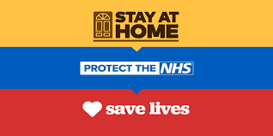

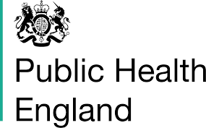
Achievements

- things that have been achieved in public health in recent decades:

- increases in life expectancy since 1981, life expectancy for men in England has increased from 70.9 years to 79.4 years and life expectancy for women has increased from 76.9 years to 83.3 years
- reported use of drugs, smoking and alcohol in 11-15 year-olds, this has roughly halved between 2003 and 2013
- reduction in numbers of people smoking, e.g. the ban on smoking in public places is estimated to save the NHS over £380 million a year
- putting fluoride into drinking water, e.g. the fluoridation of drinking water has resulted in reduced tooth decay and tooth loss
- safer working conditions, e.g. wearing of protective equipment and development of policies and methods has promoted safer working practices and reduced workplace accidents
- safe food, e.g. setting temperature standards for keeping food safe in supermarkets and food outlets
- reduced salt targets in food, e.g. in bread, cakes, biscuits, breakfast cereals, snacks, pastries, pasta, rice among others
- ​fewer infectious diseases, e.g. typhoid, cholera and tuberculosis (TB)
- increased access to family planning services so reducing unwanted pregnancies and transmission of sexually transmitted diseases
- increased physical activity, e.g. after the 2012 London Olympics, there were a record 15.5 million aged 16 or over playing sport at least once a week - that's 750,000 more than the year before and 1.57 million more than when London won the Olympic bid in 2005!
Activity 1: What is Public Health?
Watch this video and make notes: https://youtu.be/oy1CAMObRzc Create a detailed mind map about the aims and achievements of public health based on your notes so far.

Activity 2 - Quiz Time.

Please complete the blanks: (answers on the last page!)

- _______in 10 are harmful smokers in the UK.
- Smoking costs the NHS £_______________________ every year.
- ________ in 10 men and ________in 10 women are overweight or obese.
- Obesity costs the NHS £________________ per year.
- 1 in _______ people have harmful drinking patterns.
- Harmful drinking costs the NHS £____________ every year.
- It is estimated that vaccinations prevent _______________ deaths worldwide per year.

Any surprises? Our lifestyle is now the major risk factor for ill health in the UK!

Activity 3

Read the following article from the Royal College of Nursing (2020)’Smoking Cessation’ (*this means stopping smoking).

Also conduct your own research and prepare notes for a class discussion based on the statement:

‘Why is smoking cessation important for the health of the UK population’

Useful websites:
NHS.UK https://www.nhs.uk/live-well/quit-smoking/
GOV.UK https://www.gov.uk/government/publications/health-matters-smoking-and-quitting-in-england/smoking-and-quitting-in-england

The side effects of smoking tobacco only became noticeable in the 1920s. Many of these adverse effects and life-limiting illnesses are caused by the 4000+ chemicals involved. The widespread effects of tobacco smoking affect the whole body as well as common smoking-related conditions such as chronic obstructive pulmonary disease (COPD) and lung cancer. Second-hand exposure to other people’s tobacco smoke is also a cause of ill health. Smoking in pregnancy can also cause harm as well as risks to children’s future health.
Third hand exposure comes from contamination of surfaces with smoke particles. One example of third hand exposure is when smoking close to a furry pet such as a dog, the particles collect in the fur and then can be inhaled/ digested when petting e.g. a child cuddling them. The pet themselves can also be exposed when grooming themselves and are also very susceptible to second hand smoking damage due to smaller lungs (similar to babies and children).
Smoking cessation should be seen as a treatment and in a current smoker it is one of the most cost-effective options in chronic disease management. This is especially important in COPD as it is the only intervention that will slow disease progression.
The body starts to recover in as little as 20 minutes when a person quits smoking.
- after 20 minutes blood pressure and pulse start returning to normal
- after 24 hours carbon monoxide is eliminated from the body and the lungs start to clear out smoking debris
- after 48 hours ability to taste and smell improves
- after 3–9 months lung function improves up to 10%
- after 5 years the risk of heart attack falls to about half that of a smoker
- after 10 years the risk of lung cancer is halved and the risk of heart ischaemia falls to that of someone who has never smoked.
Smoking rates have in recent years continued to decline, see: Adult smoking habits in the UK: 2017. However the harm remains high as tobacco smoking kills over half of its users as well as causing significant long term damage and distress due to poor quality of life.
Smoking is a relapsing addiction and many people have 6–7 attempts before quitting long term. Receiving behavioural support, for example from a NHS Stop Smoking Service, will quadruple chance of success (NICE, 2018). It is also recommended that behavioural support is combined with nicotine replacement therapy and/or medication.

Activity 4: Please find a definition for each key term.

Key Term | - Definition
Wellbeing

Vaccination

Health Screening

Notifiable Disease

Morbidity

Health Inequalities

Epidemiology

,

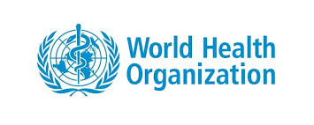

On 7TH April 1948, the World Health Organization (WHO) was founded on the principle that health is a human right and all people should enjoy the highest standard of health. This aspiration towards better health for everyone, everywhere has guided the Organization’s work ever since. In partnership with all countries throughout the world, WHO has made impressive progress in many areas that promote our health and well-being. Public Health England works very closely with the World Health Organisation (WHO) which is a global organisation, to make sure that we are aware and prepared for any health issues that might arise. An example of how this is the current Covid-19 pandemic! This is classed as a communicable disease as it is can be spread through human contact and hence why the WHO has been central to sharing information on the disease and giving advice on how to prevent further transmission (spread of the disease). Coronaviruses (CoV) are a large family of viruses that cause illness ranging from the common cold to more severe diseases. A novel coronavirus (nCoV) is a new strain that has not been previously identified in humans. On 30 January 2020, the WHO Director-General declared the novel coronavirus (2019-nCoV) outbreak a public health emergency of international concern.

Activity 5

Although you will have probably been watching the news closely, the focus of this activity is to concentrate on the specific role of the WHO has had during this time.

https://youtu.be/qHksVwOrpbE How has WHO prepared the world for COVID-19?

https://youtu.be/mOV1aBVYKGA What is corona virus and what are the symptoms? How does the WHO recommend preventing transmission and spread of the virus?

Review the data dashboard from the WHO website (taken on 15.5.20).

Why do you think it is important that the WHO collects and shares data about COVID-19 statistics with each country?

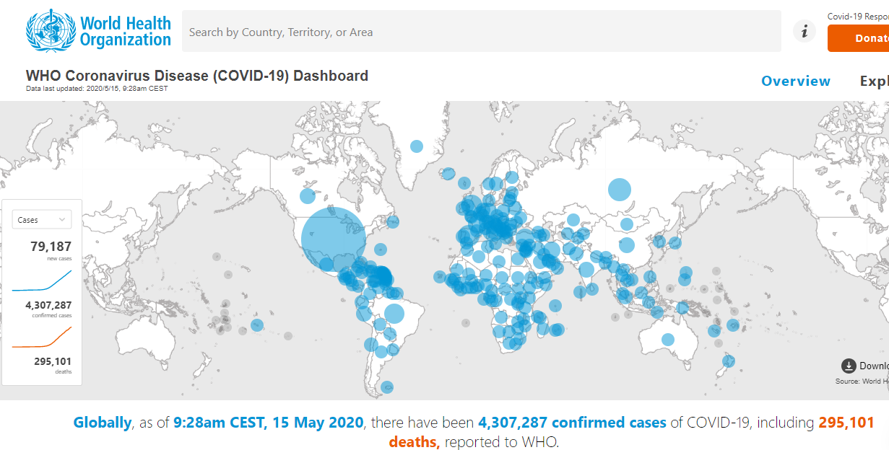

- Now, it is time to consolidate your learning on public health.

Task
Prepare a PPT presentation (or something similar) for a small group of students in Y12, it should be titled:

‘The public health response to Covid-19 in the UK.’

Your presentation should include:
- A description of what Covid-19 is and how it can be transmitted.
- A list of key statistics about the disease in the UK and globally.
- A description of the role of World Health Organisation in trying to combat the spread.
- An outline of the measures taken by Public Health England and the government to reduce its transmission (e.g. social distance rules etc.)
- An evaluation of the impact it has had so far on the health and wellbeing of the UK population (don’t forget to consider the impact it has had on people’s mental health).

*You can use photos taken in your home or local area that reflect the impact public health measures have had on your family and local community. Don’t forget to ask for permission first!

Answers to quiz!
1. 2 in 10 are harmful smokers in the UK.
2. Smoking costs the NHS £ 5.2 billion every year.
3. 7 in 10 men and 6 in 10 women are overweight or obese.
4. Obesity costs the NHS £4.2 billion per year.
5. 1 in 3 people have harmful drinking patterns.
6. Harmful drinking costs the NHS £3.5 billion every year.
7. It is estimated that vaccinations prevent 300-500,000 deaths worldwide per year.

