BTEC HEALTH AND SOCIAL CARE

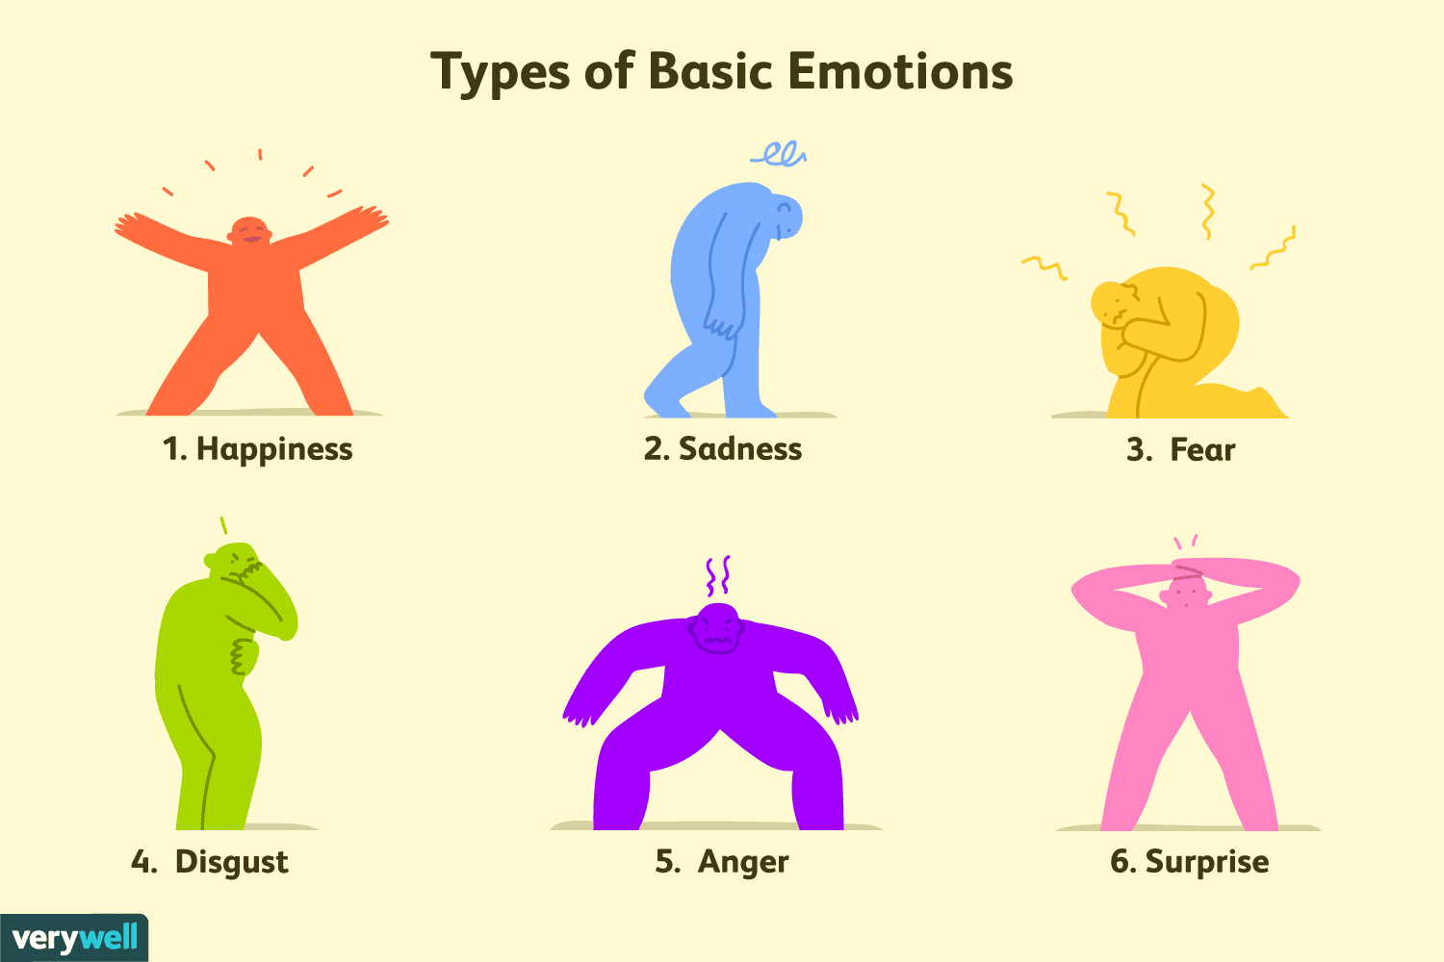

Bridging Course - Week 2

St Mary’s Catholic School
BTEC HEALTH AND SOCIAL CARE Bridging Course
Entry Requirements for Studying BTEC Health and Social Care?
- Students who are expected to achieve at least a grade 4 in GCSE English and Maths.
- Students who are prepared to undertake work experience in a health or social care setting.
- Students who enjoy learning about a wide range of contemporary issues pertaining to the health and social care sector.
- Students who are willing to take part in class discussions and presentations on their research findings.
- Students who enjoy independent research tasks and preparing written assignments.
What to expect from BTEC Health and Social Care.
BTEC courses do work differently to other subjects and you will be expected to work hard both in and out of your lesson to meet coursework deadlines. You will also be presented with many different opportunities to broaden your vocational learning, as this qualification contains a wide range of contemporary topics pertaining to health and social care. A variety of assessment methods are also used, ranging from external exams to course work. Additionally, this BTEC qualification has been designed with employers and representatives from higher education and professional bodies. In this way, the qualification is up to date and covers all of the knowledge, skills and attributes that are required in the health and social care sector. Students will also undertake work experience in a health or social care setting, this provides an excellent opportunity for you to experience working with other professionals in the sector.

This bridging course will provide you with a mixture of information about BTEC Health and Social Care, and what to expect from the course, as well as key work to complete. Students who are expecting to study Health and Social Care, and are likely to meet the entry requirements, must complete the bridging course fully and thoroughly, to the best of their ability. You should complete all work on paper or and keep it in a file, in an ordered way. You will submit it to your teacher in September. All of the work will be reviewed and selected work will be assessed, and you will be given feedback on it. This work will be signalled to you. If you do not have access to the internet, please contact the school and appropriate resources will be sent to you. If you are thinking about studying BTEC Health and Social Care you should attempt this work to see whether or not you think studying a subject like this is right for you. If you later decide to study Health and Social Care, you must ensure you complete this work in full. This work should be completed after you have read and completed the Study Skills work that all of Year 12 should complete.
Course outline
External Assessed Units | Coursework Unit
- You will undertake 3 external exams.  - Human Lifespan Development 1.5 hours – You will be presented with an individual who has specific health and wellbeing needs. You will be required to consider their circumstances from a health and social care perspective and answer a mixture of short and long answered questions.  - Working in the Health Sector 1.5 hours – You will be presented with 4 case studies about individuals who are currently accessing a health or social care service. You will be required to respond to several short and long answer questions.  - Research Enquiries 3 hours – Four weeks before this exam you will be presented with a research article. You will be able to prepare notes to take into your exam. In the exam you will be presented with 4 questions about the reliability and validity of the research that require an essay style response. | - You will undertake 5 coursework units.  - Supporting Individual Needs - This unit will focus on the care and support that individual’s need.  - Promoting Public Health - You will explore the aims of public health policy and the current approaches to promoting and protecting public health in the UK.  - Principle of Safe Practice - This unit explores the importance of safe working practices, safeguarding procedures and responding to emergency situations.  - Physiological Disorders - This unit explores the physiological disorders of two individuals, including how they are diagnosed and treated. You will also investigate the impact the disorder has on their long term health and wellbeing.  - Supporting Individual with additional needs - This unit will explore working with a full range of individuals who have additional needs.

The following work requires a lot of independent research, and some of the ideas might be challenging to understand on first reading. Remember to take regular breaks, go back to any of the tasks after some time away, and try your best. Your Health and Social Care teacher will go over the following with you in lessons, early in Year 12.

This week we will focus on the emotional development of an individual. This is a critical aspect of Unit 1 Human Lifespan Development and will contribute to a significant amount of the marks in the exam.
Attachment and bonding are felt to be important developmental processes. The social-emotional development begins with parental bonding to the child. This bonding allows the mother/ main carer to respond to the child’s needs timely and soothe their new-born. The consistent availability of the caregiver results in the development of "basic trust" and confidence in the infant for the caregiver during the first year of life. Basic trust is the first psychosocial stage and allows the infant to seek for parents or the caregiver during times of stress, known as the attachment.

Even before acquiring language, babies learn to communicate through emotions. One may argue that learning emotional regulation and impulse control may determine later success in life more than IQ. There is a rapid growth in social and emotional areas of the brain during the first 18 months of life.
In healthy children, social-emotional stages develop on an expected trajectory and monitoring these milestones is an imperative part of preventative health supervision visits. The caregiver’s sensitive and available supportive role is imperative to establish attachment and the skill set that follows.

Three distinct emotions are present from birth; anger, joy, and fear, revealed by universal facial expressions. During the brief periods of alertness in the new-born period, the new-born may return a mother’s / care-givers gaze. The first measurable social milestone is around one-two months of age, and it is the infant’s social smile in response to parental high pitched vocalizations or smile. Infants can use a distinct facial expression to express emotions in an appropriate context after 2 months of age. In the first 2 to 3 months infant learns to regulate physiologically and need smooth routines. She progressively learns to calm herself, gives a responsive smile and responds to gentle calming. Sensitive cooperative interaction with the caregiver helps the infant to learn how to manage tension. Around 4 months the infant learns to manipulate his environment. She lets her caregiver know taking away his toy upsets him or she is happy when held.

Let us now focus on the first few months when babies bond and form attachments with their main care-givers. Bonding and forming attachments are the main factors for developing long-term good emotional mental health and resilience of children.

Read the information below and conduct further internet research:
Write a detailed response to the following questions…
- What are the key messages a health visitor should give to first time parents about how to form a bond with their baby?
- Describe at least 5 signs that a health visitor will observe to see if a mum is bonding with her baby?

Extension:
- Research the impact of post-natal depression on a baby bonding with its mother.

Babies bond in many different ways, mainly through touch and smell. Bonding is the sense of connection between parents/main carer and the infant. Bonding is the basic link of trust between an infant and its main carer, which is usually the mother. Successful bonding results in an infant developing basic trust in others. While bonding is about trust, attachment is about affection. The quality of an infant’s initial attachment is really important because it influences some of the important parts of development. Attachment and bonding play a vital role in all of the following:

- Maintaining the bonds of trust.
- Attaining full physical, intellectual, emotional and social potential.
- Acquiring a conscience.
- Developing relationships with others identity and self-esteem.
- Learning about feelings.
- Language development.
- To help a child’s development through attachment and bonding you could do things such as holding, talking, singing, rocking and cuddling as well as numerous other nurturing interactions.

Parents should provide an infant with plenty of face-to-face interaction. Using different facial expressions will help to improve an infant’s emotional development. Gentle kissing or stroking of an infant’s cheeks, shoulders, hands and fingers will help to improve an infant’s emotional development and improve their sensory awareness. Talking and singing to an infant will help to strengthen the bond between the infant and the main carer whilst the infant’s language is improving. Playing with an infant with toys will help an infant to develop more advanced social skills. Without bonding and attachment an infant may have delayed development or could be diagnosed with an attachment disorder.

In the first month of life infants experience themselves as one with the surrounding environment. The basic development task is for an infant to achieve a physiological balance and rhythm. This balance prepares the infant for further attachment and bonding. From 2 to 6 months an infant’s experience shifts from feeling merged with her environment to feeling one with the parent. There now appear a number of signs of an infant developing attachment with its main carer. The infant will smile; make eye contact with the main carers face. At 6 months an attaching infant will show a full range of emotions and will be responsive to parental wooing. By 6 or 7 months an infant will usually have begun to experience stranger anxiety. Stranger anxiety testifies to the strength of an infant’s attachment to their main carer. It is this attachment that defines everyone else as strangers. Without an attachment there are no strangers, everyone is of equal emotional importance or unimportance. When there are strangers around an infant checks in with the main carer for reassurance. Over the next 2 or 3 months stranger anxiety intensifies before fading into separation anxiety. Separation anxiety usually begins at 9 to 10 months and peaks between 12 and 15 months. Separation anxiety can last until somewhere between 24 and 36 months. Separation anxiety emerges from an infant’s growing awareness of being apart from their main carer. Infants react differently to separation. Some infants cry in protest and cling to the main carer, while others withdraw from the world until the main carer returns, some infants also protest by becoming angry and aggressive. These reactions prove that attachment has taken place.

Emotional development is the way an individual begins to feel about themselves and other people. This forms the basis of emotional literacy and empathy. As previously mentioned, emotional development begins with attachments which an infant forms with their main caregiver. If a child forms a strong attachment to their main caregiver, research has proven it can help to ensure a positive self-image and good self-esteem.

Read the information below:

The three related ideas of self-concept, self-image and self-esteem and how emotional development changes through the life stages.

Self-Concept is how someone sees themselves and the perception that they hold about their abilities. There are various factors that can affect self-concept, these include: age, sexual orientation, gender and religion. The self-concept is also made up of a combination of self-esteem and self-image.

Self-esteem refers to a person’s feelings of self-worth or the value that they place on themselves. There are a number of characteristics of high and low self-esteem. Characteristics of high self-esteem:

  - Willing to try new things in their life
  - Can cope well under pressure
  - Emotionally stable and confident
  - Happy to share their ideas and experiences
Characteristics of low self-esteem:
  - Feels worthless
  - Reluctant to try new things
  - Struggles in new or challenging circumstances
  - Do not value their own opinions and sensitive to the opinions of others
Factors affecting self-esteem:
  - Parents/carers teaching problem solving skills from a young age (so that a child feels a sense of achievement) can lead to a positive self-esteem.
  - Learning difficulties at school can lead to a child struggling to complete work or maintain friendships, which can lead to negative self-esteem.

Self-Image refers to the way an individual sees themselves, both physically and mentally. An individual’s self-image is developed over time and influenced by the experiences they have encountered. There are a number of characteristics of a positive and negative self-image. Characteristics of a positive self-image:
  - Feels confident
  - Compares themselves positively with peers
  - Content with how they look and has belief in their own ability
  - Positive feedback received from friends and family on looks and abilities
Characteristics of a negative self-image:
  - Doubts own ability
  - Compares themselves negatively with peers and images on social media/TV/magazines
  - Received negative comments from friends and family on physical appearance or mental ability
Factors affecting self-image
- Early childhood experiences and social interactions eg parents who pass positive comments to a child can help contribute to a positive self-image.
  - Life events or roles eg a child who is captain of the rugby team is more likely to have a positive self-image that a child who is bullied at school

During the infancy life stage, infants develop a sense of self and positive self-esteem through secure attachments with their caregivers. This starts with their basic needs being met as a baby. By the age of four, the child’s self-esteem develops further through the support they receive outside of the family. Being able to solve problems through puzzles will enhance self-esteem, as will involving the children in scenarios where their opinion is sought. Children who do not receive these experiences may develop low self-esteem. However, several factors affect self-esteem during adolescence. These can include stress within the home, or at school, or a combination of the two. Coupled with the changes that occur during puberty, these can all have an impact on self-image too. Being bullied or not being accepted by your peers can have detrimental effects on a young person’s self-esteem and can feed into way they feel about themselves. This can lead to anxiety and depression and a sense of not belonging, all characteristics of having low self-worth. This can be intensified by peer pressure, the use of images in the media, social media and the increase in cyberbullying.

Self-esteem continues to develop through adulthood and an individual’s self-esteem may increase through the achievements they have made which, in turn, increases self-worth. During adulthood a person develops a real understanding of who they are and how to deal with situations more effectively and with more confidence.

Activity:

Prepare a PPT presentation for a small group of youth and community workers to explain:

- What is the meaning of the terms self-esteem, self-image and self-concept.
- What are the signs that an individual may have low self-esteem or poor self-image
- Advice you would offer an individual to improve their self-esteem.
- An explanation of services that are available to support individuals with low self-esteem.

The following NHS. UK website is an excellent resource to help you prepare your presentation: https://www.nhs.uk/conditions/stress-anxiety-depression/raising-low-self-esteem/

Emotional development has been the focus of many researchers over the decades. They have conducted many studies on a child’s attachment to their caregivers. Two main researcher’s in the 1950s were John Bowlby, a child psychiatrist, and Mary Ainsworth, a psychologist, who both became interested in young children's responses to experiencing loss. They began studying the realms of attachment and bonding. Their theory was developed and integrated over the following 60 years by researchers around the world. Attachment theory is based on the idea that the bond between an infant and his or her primary caregiver is the crucial and primary influence in infant development and as such forms the basis of coping, the development of relationships, and the formation of personality. If the mother is absent or not available, a primary caregiver serves the role usually assumed by the mother. Attachment refers to a relationship that emerges over time from a history of caregiver-infant interactions. As adults nurture and interact with infants during the first year of life, infants organise their behaviour around these caregivers. Attachment is a phenomenon involving physiological, emotional, cognitive, and social processes. The baby displays instinctual attachment behaviours that are activated by cues or signals from the caregiver. Therefore, the process of attachment is defined as a mutual regulatory system, in which the baby and the caregiver have an influence on one another over time. The caregiver's presence provides a feeling of safety and security for the infant. Once this relationship is established, the preference tends to remain stable, and a shift of attachment behaviour to a new or strange person becomes more difficult.
Some theorists believe that the attachment system evolved to ensure that infants and caregivers remain physically close, and that the infant is protected. Thus, in order to survive, an infant must become attached to the primary caregiver, who is stronger and wiser regarding the dangers of the world. The caregiver is a safe refuge, a source of comfort and protection, and serves as a secure base from which the infant can explore. Research has also shown that babies and caregivers demonstrate an instinct to attach. Babies instinctively reach out for the safety and security of the safe haven they have with their primary caregiver, while parents usually instinctively protect and nurture their children. Children who start their lives with the essential basis of secure attachment fare better in all aspects of functioning as their development progresses.
From 12 to 18 months, as they start to walk and crawl, children use their attachment figure as a secure base from which to go out and discover the world and as a safe haven to which to return when frightened or alarmed. Children with secure histories have been shown to be more determined, enthusiastic, and competent in problem-solving as toddlers. During preschool years, the attachment relationship is characterized by an increased tolerance for separation and an ability to cooperate with others. The child is learning to balance his or her need for independence, self-discipline, and exploration and the need for love and protection from the primary caregiver. However, as pre-school approaches, children are still susceptible to a variety of dangers. Therefore, attachment behaviours, such as wanting to stay close to the primary caregiver and displaying occasional separation anxiety are adaptive processes, not regressive ones. Western culture has often portrayed this type of behaviour as controlling or attention-seeking. Attachment theorists believe this is inaccurate, as these behaviours help serve to ensure the child's survival and socialisation. At school-age children with a history of secured attachment histories demonstrate an ability to be more goal-oriented and often display positive leadership skills. Numerous long-term studies have shown that in the following areas securely attached children do better as they grow older:
- self-esteem
- autonomy
- ability to manage impulses and feelings
- long-term friendships
- positive relationships with parents, caregivers, and other authority figures
- effective coping skills
- trust, intimacy, and affection
- positive and hopeful belief systems
- academic success in school
Activity:

The three stages of emotional child development. https://youtu.be/UtGqRVIKg4U
- What are the key factors of emotional development through childhood?

Still face experiment https://youtu.be/apzXGEbZht0
- What did you learn from this experiment?

How babies form attachment Schaffer and Emmerson https://youtu.be/WRQiCcH351E

- What Schaffer and Emmerson consider as the 4 stages of attachment?

Activity:
Read through the work of John Bowlby and create a mind map on his research and its findings.

John Bowlby (1907 - 1990) was a psychoanalyst and believed that mental health and behavioural problems could be attributed to early childhood. Bowlby’s evolutionary theory of attachment suggests that children come into the world biologically pre-programmed to form attachments with others, because this will help them to survive. Bowlby was very much influenced by ethological theory in general, but especially by Lorenz’s (1935) study of imprinting. Lorenz showed that attachment was innate (in young ducklings) and therefore has a survival value. Bowlby believed that attachment behaviours are instinctive and will be activated by any conditions that seem to threaten the achievement of proximity, such as separation, insecurity, and fear.

Bowlby (1969, 1988) also postulated that the fear of strangers represents an important survival mechanism, built in by nature. Babies are born with the tendency to display certain innate behaviours (called social releasers) which help ensure proximity and contact with the mother or attachment figure (e.g., crying, smiling, crawling, etc.) – these are species-specific behaviours. During the evolution of the human species, it would have been the babies who stayed close to their mothers that would have survived to have children of their own. Bowlby hypothesized that both infants and mothers have evolved a biological need to stay in contact with each other. These attachment behaviours initially function like fixed action patterns and all share the same function. The infant produces innate ‘social releaser’ behaviours such as crying and smiling that stimulate caregiving from adults.

The determinant of attachment is not food but care and responsiveness. Bowlby suggested that a child would initially form only one attachment and that the attachment figure acted as a secure base for exploring the world. The attachment relationship acts as a prototype for all future social relationships so disrupting it can have severe consequences. A child has an innate (i.e., inborn) need to attach to one main attachment figure (i.e., monotropy). Although Bowlby did not rule out the possibility of other attachment figures for a child, he did believe that there should be a primary bond which was much more important than any other (usually the mother). Bowlby believes that this attachment is qualitatively different from any subsequent attachments.

Bowlby argues that the relationship with the mother is somehow different altogether from other relationships. Essentially, Bowlby (1988) suggested that the nature of monotropy (attachment conceptualized as being a vital and close bond with just one attachment figure) meant that a failure to initiate, or a breakdown of, the maternal attachment would lead to serious negative consequences, possibly including affectionless psychopathy. Bowlby’s theory of monotropy led to the formulation of his maternal deprivation hypothesis. The child behaves in ways that elicits contact or proximity to the caregiver. When a child experiences heightened arousal, he/she signals their caregiver. Crying, smiling, and, locomotion, are examples of these signalling behaviours. Instinctively, caregivers respond to their children’s behaviour creating a reciprocal pattern of interaction.

A child should receive the continuous care of this single most important attachment figure for approximately the first two years of life. Bowlby (1951) claimed that mothering is almost useless if delayed until after two and a half to three years and, for most children, if delayed till after 12 months, i.e., there is a critical period. If the attachment figure is broken or disrupted during the critical two year period, the child will suffer irreversible long-term consequences of this maternal deprivation. This risk continues until the age of five. Bowlby used the term maternal deprivation to refer to the separation or loss of the mother as well as failure to develop an attachment. The underlying assumption of Bowlby’s Maternal Deprivation Hypothesis is that continual disruption of the attachment between infant and primary caregiver (i.e., mother) could result in long-term cognitive, social, and emotional difficulties for that infant.

The implications of this are vast – if this is true, should the primary caregiver leave their child in day care, while they continue to work? The long-term consequences of maternal deprivation might include the following: delinquency, reduced intelligence, increased aggression, depression, affectionless psychopathy Affectionless psychopathy is an inability to show affection or concern for others. Such individuals act on impulse with little regard for the consequences of their actions. For example, showing no guilt for antisocial behaviour. The child’s attachment relationship with their primary caregiver leads to the development of an internal working model (Bowlby, 1969). This internal working model is a cognitive framework comprising mental representations for understanding the world, self, and others.

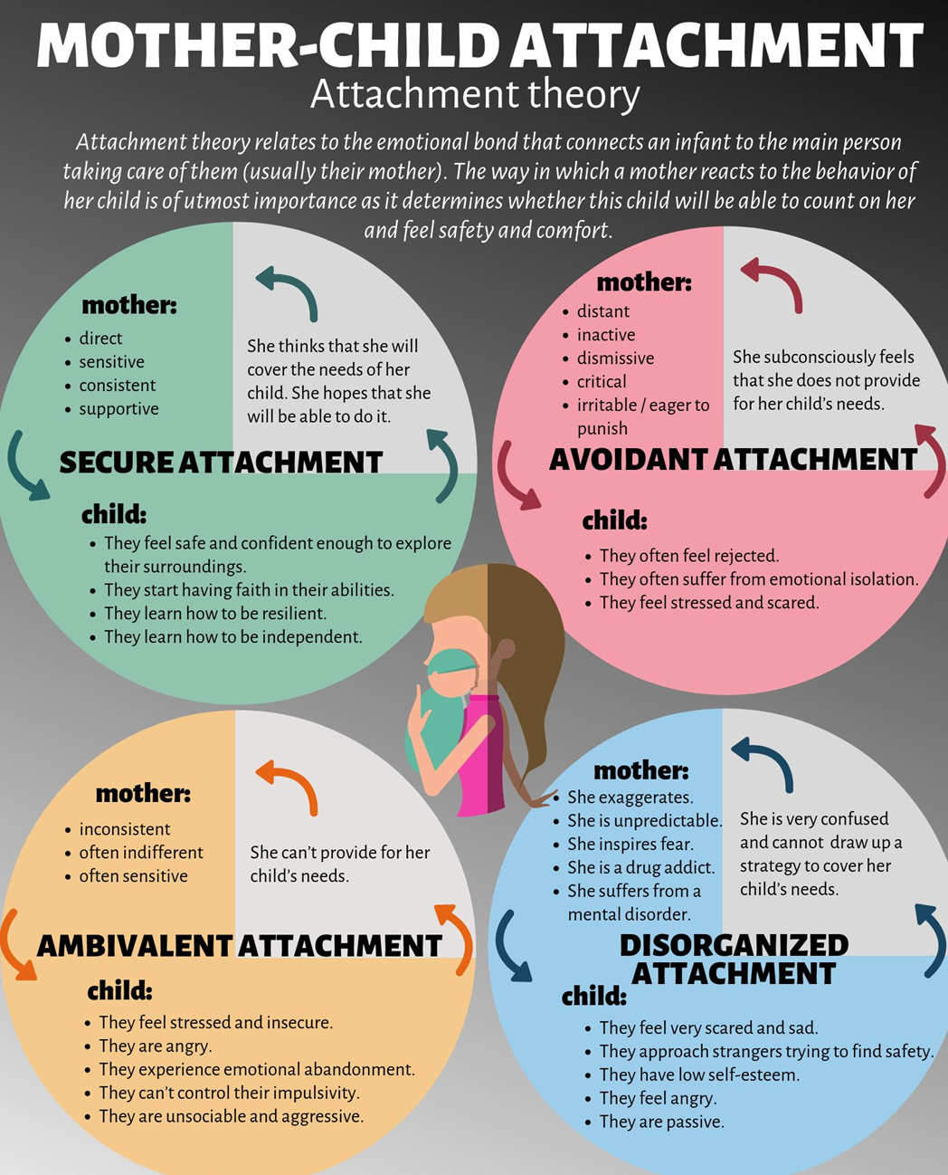

- Now consider emotional development through all of the life stages. What key features would you expect? Key words have been provided to help you to consider emotional development in that life stage.

 | Aspects of Emotional Development during this life stage
Infancy 0-2 years | Bonding and Attachment…
Early Childhood 3-8 years | Understanding self and others…
Adolescence 9-18 years | Identity…
Early and Middle Adulthood 19-65 years | Intimacy…
Later Adulthood 65+ years | Making sense of your life…

Activity
When you embark on studying health and social care it is very important to become familiar and use key technical terms. To develop this knowledge of vocabulary please find a definition for the key terms detailed below.
Technical Term | Meaning
Emotional Literacy

Empathy

Attachment

Self-image

Self-esteem

Self-concept

Stranger anxiety

Deprivation

- Now, it is time to consolidate your learning on emotional development.
Read the following case study about Ibrahim.

Ibrahim was born two months prematurely. Following the birth, his mother Ayesha had experienced severe post-natal depression. Ayesha’s husband Farid worked long hours as a pharmacist. Ibrahim has an older sibling, a brother named Tariq who is 15 years old. Tariq was very close to his mum and helped her with his new baby brother following the birth. Tariq was extremely good a playing, feeding and talking to Ibrahim. Soon Ibrahim became upset if Tariq was not with him and would refuse to take his feed and become very distressed.

  - Describe in detail what is meant by the term ‘attachment’ and explain its importance in child development.

  - Explain in detail three factors that have affected Ibrahim’s attachment to his mother.

  - In a detailed essay, Justify Ibrahim’s reaction to being separated from his brother using John Bowlby’s and Schaffer and Emmerson’s theory.

