BTEC Children’s Play, Learning and Development

Bridging Course - Week 3
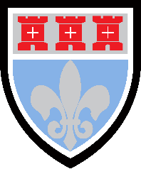

St Mary’s Catholic School
BTEC Children’s Play, Learning and Development Bridging Course
Entry Requirements for Studying BTEC Children’s Play, Learning and Development?
- Students who are expected to achieve at least a grade 4 in GCSE English and Maths.
- Students who are prepared to undertake 50 hours of mandatory work experience in an early years setting and undertake practical activities with children in their care.
- Students who enjoy learning about child development and the different theories about learning and development.
- Students who are willing to take part in class discussions and presentations on their research findings.
- Students who enjoy independent research tasks and preparing written assignments.
What to expect from BTEC Children’s Play, Learning and Development.
BTEC courses do work differently to other subjects and you will be expected to work hard both in and out of your lesson to meet coursework deadlines. You will also be presented with many different opportunities to broaden your vocational learning as you will be expected to work 50 hours in an early years setting. During this time you will work closely with your mentor and be expected to undertake activities with the children. A variety of other assessment methods are also used, ranging from external exams to course work. Additionally, this BTEC qualification has been designed with employers and representatives from higher education and professional bodies. In this way, the qualification is up to date and covers all of the knowledge, skills and attributes that are required in the early year’s sector.

This bridging course will provide you with a mixture of information about BTEC Children’s Play, Learning and Development, and what to expect from the course, as well as key work to complete. Students who are expecting to study Children’s Play, Learning and Development, and are likely to meet the entry requirements, must complete the bridging course fully and thoroughly, to the best of their ability. You should complete all work on paper or and keep it in a file, in an ordered way. You will submit it to your teacher in September. All of the work will be reviewed and selected work will be assessed, and you will be given feedback on it. This work will be signalled to you. If you do not have access to the internet, please contact the school and appropriate resources will be sent to you. If you are thinking about studying BTEC Children’s Play, Learning and Development you should attempt this work to see whether or not you think studying a subject like this is right for you. If you later decide to study Children’s Play, Learning and Development, you must ensure you complete this work in full. This work should be completed after you have read and completed the Study Skills work that all of Year 12 should complete.
Course outline
External Assessed Units | Coursework Unit
- You will undertake 2 external exams.  - Unit 1 Child Development 1hr 45 min exam. In this unit, you will learn about theories and models of development that explain how and why children develop and how this relates to the Early Years Foundation Stage (EYFS). You will develop an understanding of a range of factors that may influence children’s development.  - Unit 2 Development of Children’s Literacy, Numeracy and Communication skills – 3 hr exam. In this unit, you will learn the sequence of children’s speech, communication, language, literacy and numeracy skills development. You will have 48 hours before the exam to plan stage appropriate activities that encourage children’s development and understanding by stimulating their enthusiasm. | - You will undertake 2 coursework units. That will require you to complete referenced reports and provide evidence of witness testimonies from your work placement experiences.  - Unit 3 Play and Learning. In this unit, you will produce two written assignments that link to your placement experience. You will report on the types of play and the opportunities that should be made available to children at different ages and the theoretical perspectives, philosophies and curriculum approaches to play.  - Unit 6 Keeping Children Safe. In this unit, you will look at the legislation, regulations and guidance relevant to health, safety and safeguarding. You will investigate approaches to creating safe and secure environments and policies and procedures to control and prevent the spread of infection.

In week 3 we will focus on the role of speech, communication and language in child development. Additionally we will consider the opportunities and activities that Early Years settings provide to encourage children to develop their language skills. Additionally, you will review the work of Noah Chomsky on the principles of language development and his work on ‘language acquisition device’. This work will be relevant to both exam units that you will undertake in Y12 where a substantial amount of marks can be gained through in-depth understanding of language development.

Speech, language and communication skills are crucial to young children’s overall development. Being able to speak clearly and process speech sounds, to understand others, to express ideas and interact with others are fundamental building blocks for a child’s development. Research suggests that good communication, language and literacy at a young age have the highest correlation with outcomes at school.

Speech and language skills underpin many other areas of children’s development by:
- providing a strong foundation for other areas of learning, such as reading and writing and enabling access to the whole curriculum
- supporting communication skills
- promoting social skills and forming friendships
- building confidence and self-esteem
- supporting emotional and behavioural development
- helping children to make sense of the world around them.

Whilst studying Children’s Play, Learning and Development you will see that communication and language are one of the three prime areas in the Early Years Foundation Stage (EYFS) and involves giving children opportunities to:
- experience a rich language environment
- develop their confidence and skills in expressing themselves
- speak and listen in a range of situations

Each prime area is divided into early learning goals and for communication and language these are as follows.

Listening and attention: children listen attentively in a range of situations. They listen to stories, accurately anticipating key events and respond to what they hear with relevant comments, questions or actions.

Understanding: children follow instructions involving several ideas or actions. They answer “how” and “why” questions about their experiences and in response to stories or events.

Speaking: children express themselves effectively, showing awareness of listeners’ needs. They use past, present and future forms accurately when talking about things that have happened or are to happen in the future. They develop their own narratives and explanations by connecting ideas or events.
Children are expected to achieve these early learning goals by the end of reception when they have turned five years old. Early years providers and schools must ensure they have been offered the opportunities and support to do so.

  - Language Development
In order to consider language development we need to begin with the ‘stages of language acquisition’. This refers to the stages that children pass through in order to become competent language uses. There are two stages:

Pre-linguistic phase: begins from birth and children can use their first words. This is when babies are listening to the sounds of language that they are hearing and working out the meaning of specific words.

Linguistic phase: they now begin to use words that have meaning, initially single words that will be gradually replaced with two word utterances and then to simple sentences. Most children are fluent language users by the age of 4 years old and be able to hold conversations easily.

Activity 1– Review the picture and conduct your own research to find out the average age children are able to meet the following language milestones:
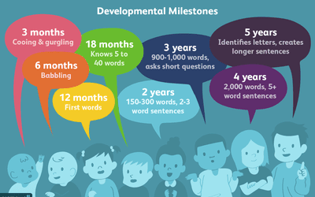

Stage | Typical Age
Babbling
One word stage
Two word stage
Multi-word stage
e.g use of ‘I’ and ‘the’ such as ‘I want the book’
Use of third person (he /she)
e.g. ‘he has my hat on’

There are several components of speech that children need to acquire. Once they have mastered these components, they will, in theory be able to use language to think, predict and explain. These are known as higher order language skills.

Phonology : This is the study of speech sounds used in language, and are often known as phonemes. These are the smallest units of sound in a language that help to distinguish one word from another. English language has around 44 phonemes. The poster below demonstrates the phonemes.

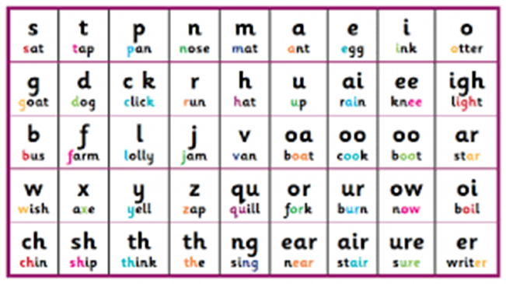

Activity 2: Watch this video clip and make notes: https://youtu.be/UCI2mu7URBc
Create bunting or a poster for children in a nursery setting to help them learn some of the phonemes. Give examples with words or pictures linked to the phoneme.

  - Noah Chomsky
You are now being introduced to one key theorist, Noah Chomsky, who you will learn about in much greater depth in Y12. There are some theorists who believe language is learned and others who believe that language is innate. Noam Chomsky is a credible linguist and expert in language development. He started his research into language in the 1960s. He suggests that children are born with an innate ability to learn language (e.g. we are born with it). The Language Acquisition Device (LAD) is a hypothetical tool in the human brain that lets children learn and understand language quickly. A theory developed by Noam Chomsky who believed that every child has a Language Acquisition Device. The LAD is a structure in the brain that infants are born with, allowing them to quickly learn and understand language as they mature. This is not an actual physical part of the brain, but a structure that allows babies to learn and absorb the rules of language that it has been exposed to.

His theory explains why all babies can learn any language they are exposed to and why all babies follow the same pattern of development even though their abilities may be very different.

The Key Principles of Chomsky’s Model of Language Acquisition Device (LAD):

- Everyone is born with the capacity to develop and learn any language.
- Language development is instinctive.
- Every child has a “Language Acquisition Device”, or LAD for short.
- The LAD is a tool that is found in the brain; it enables the child to rapidly develop the rules of language.
- The role of the LAD is to encode the major skills involved in language learning, but with a focus on the encoding of grammar.
- Grammar is a vital skill needed for children to learn language.
- Chomsky disregarded the role of imitation alone - especially if the adult is using a structure that the child themselves has not started to use yet.

Children are often heard making grammatical errors such as “I sawed,” and “sheeps” which they would not have learned from hearing adults communicate. This shows the child using the LAD to get to grips with the rules of language. Once the child has mastered this skill, they are only in need of learning new words as they can then apply the rules of grammar from the LAD to form sentences. Chomsky proposed that native-speaking children would become fluent by the age of ten. He also argued that if children learn two languages from birth, they are more likely to be fluent in both.

Criticisms of Chomsky’s Model:

- There is a lack of evidence to support the theory.
- The theory offers a hypothetical explanation and we do not know where the LAD is located.
- The model ignores the importance of social interaction.
- The model cannot explain why individuals with certain learning disabilities such as Down’s Syndrome have delayed language.
- Watch this video clip about Chomsky’s theory: https://youtu.be/MLNFGWJOXjA

- Using information you have read and from an internet research create a detailed mind map about Chomsky’s theory.

- Do you agree with the statement

‘Babies have are born with an ability to learn language’?

- Write down reasons to support your opinion.

  - How to support language development
It is never too early to begin encouraging language development. Parents and early year’s practitioners should offer children speaking and listening opportunities through everyday conversation and practical activities. Children often learn best by observing and copying adult behaviour so early years staff should model good speech and language skills whenever possible. Good practice includes:

- getting a child’s attention and making eye contact (get down to the child’s level if necessary)
- speaking clearly and calmly
- using age-appropriate, simple language
- repeating or modelling what the child has said
- repeating sentences back to children, extending what they have said
- describing and commenting on what is happening and what children are doing
- listening carefully when children are talking and being patient so they have plenty of time to respond and find their words
- using all the senses
- using gesture, tone of voice and facial expressions
- using effective questioning but being careful not to over question children or use closed questions.

Early years providers need to offer experiences and opportunities for young children to develop their speech and language skills. Stimulating activities include:
- reading books every day and talking with children about stories, characters and illustrations — books with rhythm and rhyme are particularly effective with very young children
- show and tell when children can bring in toys or other objects from home and talk about them
- circle time which offers children a good opportunity to practise their speaking and listening skills
- singing songs, nursery rhymes and lullabies
- describing and guessing games
- role-play games
- using puppets
- using technology such as microphones, walkie talkies and video recorders
- offering real life experiences both inside and outside the nursery.
Circle Time

In early childhood development, language, and communication are crucial skills for children to build. Talking, understanding language and expressing thoughts and feelings are essential to children’s development. Good communication, language, and literacy skills which are developed at a young age directly correlate with positive outcomes later on in education. These language skills are fundamental in allowing a child to access the rest of the curriculum. They promote social skills and help children build relationships as well as improving their confidence and self-esteem.

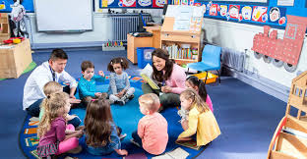

Activity 4:
Circle time is a central part to most days in an early years setting.
Watch the following video about circle time
https://teachpreschool.org/2013/03/25/ten-tips-for-circletime/
Conduct research into what activities can take place during circle time to help a child to develop their phonics or language skills.
Complete the following activity plan below.

Activity Plan for Language Development during Circle Time

Name of Activity
What does the activity aim to do?
What resources do you require?
What will be the role of the adult (early year’s worker) during the activity?
Are there any health and safety concerns?

Activity 5:
Complete the table of key technical terms to help you to become familiar with this topic.
Linguistic Phase
Phonemes
Pre-Linguistic Phase
Innate
Vocalisations
Expressive Language

- To consolidate your learning for week 3 you need to write a short report on how children acquire speech, communication and language skills.

The information on the report will be used by the Early Years co-ordinator in the setting to trainee teaching assistants about language development in children.

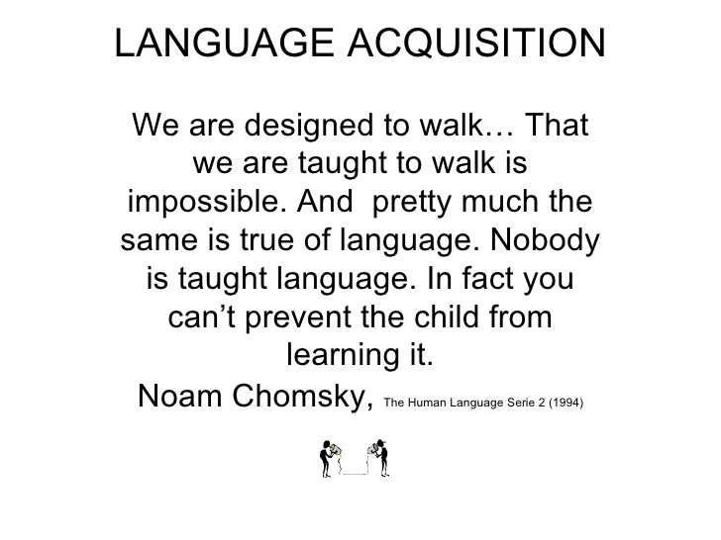
You must include:
- A description of how language develops.
- An explanation of the pre-linguistic and linguistic phase.
- Explain the importance of teaching phonics in the setting.
- A brief outline of Noah Chomsky’s theory on the language acquisition device.

