Cambridge Technical level 3: Business
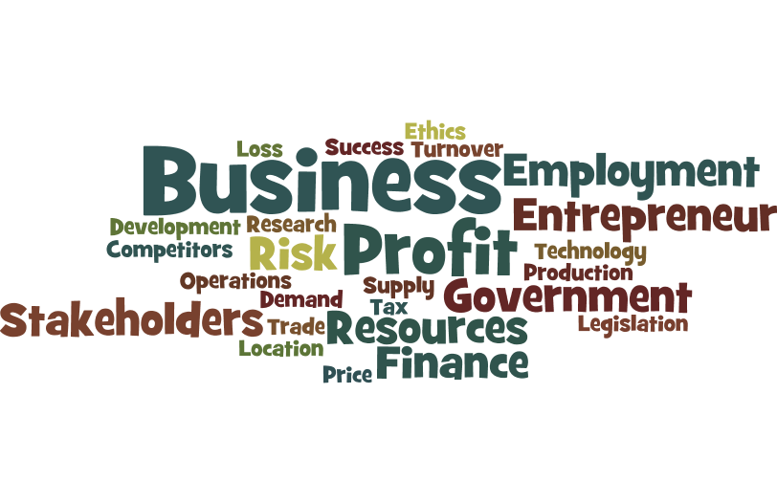

Bridging Course - Week 3
(For Single and Double award students)

St Mary’s Catholic School
Cambridge Technicals: Business
Week 2 Re-cap
1. | Put a tick (✓) in the box next to the one correct answer.  Which of the following is a key feature of a public sector organisation?  (a) It does not have financial objectives  (b) It is funded by taxation  (c) It must share profits between the owners  (d) It operates as a charity  [1]

2. | The liability of a sole trader is:  (a) centralised  (b) decentralised  (c) limited  (d) unlimited  [1]

3. | A private limited company:  (a) cannot use crowd-funding  (b) does not pay tax  (c) is owned by shareholders  (d) sells its shares on the stock exchange  [1]

4. | The legal form of ownership of a business trading as ‘Tritian plc’ is:  (a) a not-for-profit organisation  (b) a partnership  (c) a private limited company  (d) a public limited company  [1]

5. | Which of the following sources of finance is not available to a partnership?  (a) Bank loan  (b) Credit card  (c) Share issue  (d) Trade credit  [1]

6. | Which of the following is an example of a tertiary sector business?  (a) A car manufacturer  (b) A dairy farm  (c) A fishing fleet  (d) A pet shop  [1]

7. | Which one of the following would be carried out by the personnel function in a large business?  (a) Applying for a bank loan  (b) Liaising with customers  (c) Recruitment planning  (d) Research and development  [1]

Answers:

1 | Indicative content: B
2 | Indicative content: D
3 | Indicative content: C
4 | Indicative content: D
5 | Indicative content: C
6 | Indicative content: D
7 | Indicative content: C

Unit 1 – LO2

As you now know unit 1 is the most valuable unit (worth double points). It covers many aspects of business theory. There are 8 Learning objectives to cover (LOB’s). Last week you concentrated on LO1:

  - Different types of business activity.
  - Different sectors of operation.
  - Different forms of legal business ownership.
  - Factors which inform business ownership.
  - Differing business aims and objectives.

This week we will be looking at the internal functions of an organisation (LO2). You must research the key functional areas below (make notes/Mind maps on each area):

- Finance
- Marketing
- Sales
- human resources (HR)
- operations management
- customer services
- business support services
- research and development
- purchasing/procurement

To help you get started log onto: https://www.businessed.co.uk/index.php/home/theory/cambtec/cambtec-l3-theory#unit-1-the-business-environment.

You will need to conduct some wider research. What other functions could you include for each department? Can you provide real examples of these departments in action (news articles, your own experiences for example).

Activity 2:

Read the article below. E-commerce: Impact of E-commerce on Businesses and their Functional Areas (www.tutor2u.co.uk):

Introduction

E-commerce is about much more than marketing or selling. It impacts significantly on all the functional areas of a business. The largest and most-successful e-commerce businesses have invested hugely over many years to develop their IT systems, business processes and capabilities. E-commerce is at the heart of their businesses. This is particularly the case for multi or omnichannel businesses. A key strategic challenge is for firms to integrate e-commerce across all the functional areas. In particular it is essential that operations (logistics and stock management) are closely aligned with marketing activities.

Key Terms / Concepts / Models

Omnichannel retailing - A multichannel approach to distribution that aims to provide customers with a seamless experience which ever distribution channel they use to connect with the business.

Seasonal demand - A predictable, regular peak in demand. In many consumer markets, e-commerce demand is highly seasonal (particularly in the run-up to Christmas) which puts a premium on having strong operations (e.g. inventory control & delivery logistics).

Mass customisation - Offering a wide range of choice to customers in terms of how a product is configured and delivered. E-commerce technology is increasingly making this possible across a wide range of products and services.

Supply chain - The chain of suppliers, systems and processes (including IT) that bring a product or service to the customer. Greater use of e-commerce is making the need for supply chains to be digitised and integrated even more important than ever.

Localisation - Adapting the marketing mix to suit the tastes & preferences of a specific market (e.g. country). E-commerce makes is easier for firms to expand into international markets, but only if the marketing mix is appropriate.

Dynamic pricing - Where firms set flexible prices for products or services based on current market demands. Increasingly sophisticated e-commerce systems make much wider use of dynamic pricing, even if customers are unaware of this!

Long-tail - Refers to the large number of products that sell in small quantities, particularly online. Omnichannel retailers in particularly are able to make a much wider product range available now, potentially increasing both their physical store and digital channel sales.

Key Impacts of E-commerce on Marketing

- Marketing strategy of differentiation increasingly effective (easier to reach niche markets online)
- Product life cycles are shortened (note the link with technological disruption)
- Greater use of digital promotion (much easier now to track effectiveness of promotion)
- Brands and retailers increasingly using multiple distribution channels
- Greater use of dynamic pricing (easier to maximise revenues, but is it fair for customers?)

- Increased need for localisation (but on its own, not enough)
- Ability to sell a much wider product range (the “long tail”)

Key Impacts of E-commerce on Human Resource Management
- Need for employees to have a broader range of digital skills (e.g. store staff trained to sell via other digital options)
- Workforce planning – to support highly seasonal demand (e.g. Amazon hire 000's of extra staff during peak periods)
- Concerns over the working conditions of staff working in e-commerce warehouses
- Increased use of automation in e-commerce (e.g. John Lewis £500m investment) changes the workforce needs

Key Impacts of E-commerce on Operations
- Logistics behind large-scale e-commerce platforms are complex
- Places greater emphasis on close relationships with key suppliers
- Economies of scale are becoming increasingly important
- It is now relatively easy for smaller firms to sell online; sophisticated e-commerce software (integrated with financial, marketing and other systems) is widely available

Key Impacts of E-commerce on Finance

- Significant investment required to set-up e-commerce platforms and to integrate them with other systems.
- E-commerce likely to involve greater use of multi-currency transactions
- Impact of exchange rate changes more likely to be significant for businesses selling online (if they are using e-commerce to build international sales)

Evaluation Points

Developments in e-commerce systems have made it relatively straightforward for all businesses to sell digitally. Off-the shelf software or cloud-based services, as well as trading platforms like Amazon & Tmall make it easy. However, to compete at any scale or complexity, there needs to be substantial and sustained investment in integrated e-commerce systems. Does this give larger firms an advantage?

A key evaluation issue is ensuring a business has the right skills and expertise (either within the workforce or via suppliers). E-commerce technology is becoming more complex and is fast-changing. This places a premium on the need to recruit and retain specialist technical expertise, as well grow the overall digital skills of the workforce.

From a financial point of view, investing in e-commerce still involves risk. There is no guarantee of success. Most investments in e-commerce are long-term in nature. They are intended to be transformational in that they are made to improve competitiveness.

Task

Using the key terms and the evidence above prepare a letter to Mr Holmes (using the school address) discussing the value of e-commerce within an organisation.

Include a section on how you can see e-commerce working in the public sector/schools. Make sure you acknowledge positive and negative impacts (short and long term). End the letter with a judgement (is e-commerce beneficial or not – why?)
LO2 past paper question
Describe two tasks performed by the finance function in a business that you have researched.
Name of business

Activity of business

1
2

[4]
Mark scheme:

responses include:  - financial control  - financial record keeping  - financial planning  - allocating funds/authorising spending  - agree departmental spend  - controlling cost  - looks after the money  - handles cash and float for the till  - monitoring cash flow/statement/forecast  - monitoring transactions  - handling payments and receipts  - producing accounts  - calculating break-even  - calculate costs/revenues  - calculating profit/loss  - producing accounts/final accounts/income statements/ statements of financial position  - sourcing finance/raising funds  - investing in new ventures  - making payments/paying the bills  - paying the wages  - budgeting  - reimbursing expenses  - debt-management. | Exemplar responses:  Name of business: DL Motors  Activity of business: Car sales  The finance function produces cash flow forecasts (1), using a spreadsheet (+1).  Name of business: ABPT plc  Activity of business: Oil refinery  The finance function calculates profit (1) by deducting costs from revenue (+1).

