Cambridge Technical level 3: Business
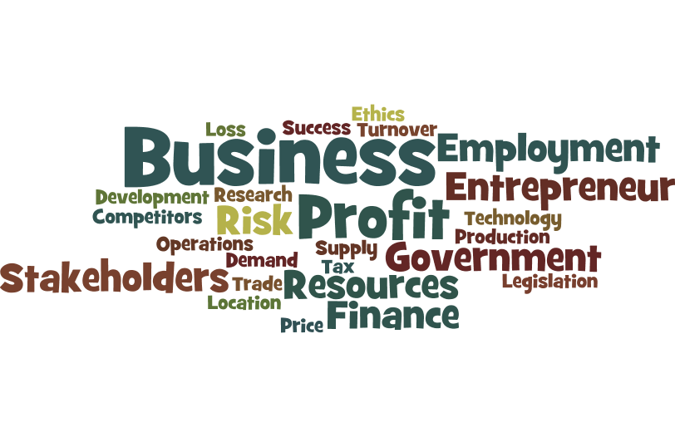

Bridging Course - Week 4
(For Single and Double award students)

St Mary’s Catholic School
Cambridge Technicals: Business
1. | Week 3 Re-cap  Put a tick (✓) in the box next to the one correct answer.  A customer service assistant who works for a theme park is most likely to:  (a) deal with visitor enquiries  (b) make staff redundant at the end of the season  (c) order stock for the gift shop  (d) update the technology which controls the rides  [1]

2. | In a large company the research and development function is most likely to work with the operations management function to:  (a) develop new manufacturing processes  (b) provide administrative support  (c) recruit production operatives  (d) source cheaper raw materials  [1]

3. | Which of the following is the most likely consequence to a manufacturer of a poor relationship between its purchasing function and its operations management function?  (a) Incorrect prices  (b) Insufficient stocks of raw materials  (c) Late payment of employee wages  (d) Too few staff  [1]

4. | Which of the following is a correct definition of the term ‘remuneration’?  (a) An unnecessary risk  (b) Financial reward  (c) Non-monetary payment  (d) Shortlisting applicants  [1]

Answers:

1 | Indicative content: A
2 | Indicative content: A
3 | Indicative content: B
4 | Indicative content: B

Unit 1 – LO2

As you now know unit 1 is the most valuable unit (worth double points). It covers many aspects of business theory. There are 8 Learning objectives to cover (LOB’s). Last week you concentrated on LO2:
- Finance
- Marketing
- Sales
- human resources (HR)
- operations management
- customer services
- business support services
- research and development
- purchasing/procurement

This week we will be looking at organisation structures (LO3). You must research the key areas below (make notes/Mind maps on each area):
- Different organisational structures.
- Elements of organisational structures.
- How the elements of the organisational structures impact on businesses operations.
- The use of organisation charts.

To help you get started log onto: https://www.businessed.co.uk/index.php/home/theory/cambtec/cambtec-l3-theory#lo3

You will need to conduct some wider research. Can you provide real examples of these structures (news articles, your own experiences for example).

Activity 2: - Organisational Structure - Basics

1. Define the term "organisational structure"

2. List three features of a tall organisational structure (one mark for each valid feature)
A.
B.
C.
D.
E.
F.

3. Briefly explain what is meant by the organisational hierarchy?

Define "delayering" and outline a key objective of delayering

5. Describe two potential benefits that a business would enjoy if it successfully delayered its organisational structure (two marks for each valid benefit)
A.
B.
C.
D.

6. What is meant by the "span of control" in an organisational structure?

7. Outline up to three factors that influence the span of control in a business (one mark awarded for each valid factor)

8. Define "delegation"

9. List two advantages for a business that encourages delegation (one mark for each valid point)
A.
B.
C.
D.
E.

10. List two potential disadvantages for a business that uses delegation significantly (one mark for each valid point)
A.
B.
C.
D.

Answers - Total Possible Marks: 22

1. Define the term "organisational structure"
The way in which the roles and responsibilities of management and employees are
organised in a business.
How a business decides to organise itself in order to operate the business activities

2. List three features of a tall organisational structure (one mark for each valid feature)
A. Many layers
B. Often associated with narrow spans of control
C. More opportunities for staff promotion
D. Sometimes called a traditional or mechanistic structure
E. Takes longer for communication to pass through the layers
F. More layers = more staff = higher costs

3. Briefly explain what is meant by the organisational hierarchy?
The levels of hierarchy refer to the number of layers within an organisation
Each layer involves a management or supervisory relationship
The hierarchy influences how decisions are taken in an organisation and also
influences how good communication is

4. Define "delayering" and outline a key objective of delayering
Delayering involves removing one or more levels of hierarchy from the
organisational structure.
Delayering is associated with creating flatter organisational structures
The main aim of delayering is to reduce costs, improve communication and
encourage better and quicker decision-making

5. Describe two potential benefits that a business would enjoy if it successfully
delayered its organisational structure (two marks for each valid benefit)
A. Offers opportunities for delegation, empowerment and motivation as the
number of managers is reduced and more authority is given to shop-floor
workers.
B. Can improve communication within the organisation as messages have to pass
through fewer levels of hierarchy.
C. Can remove departmental rivalry if department heads are removed as the
workforce is organised in teams.
D. Can reduce costs as fewer employees are required and employing middle
managers can be expensive.
6. What is meant by the "span of control" in an organisational structure?
The span of control is the number of subordinates for whom a manager is directly
responsible.

7. Outline up to three factors that influence the span of control in a business (one mark
awarded for each valid factor)
•The experience and personality of the manager
•The nature of the business. If being a line manager requires a great deal of close
supervision, then a narrower span might be appropriate
•The skills and attitudes of the employees. Highly skilled, professional employees
might flourish in a business adopting wide spans of control
•The tradition and culture of the organisation. A business with a tradition of
democratic management and empowered workers may operate wider spans of
control

8. Define "delegation"
Delegation involves the assignment to others of the authority for particular functions,
tasks, and decisions.

9. List two advantages for a business that encourages delegation (one mark for each
valid point)
A. Reduces management stress and workload
B. Allows senior management to focus on key tasks
C. Subordinates are empowered and motivated
D. Better decisions or use of resources (potentially)
E. Good method of on-the-job training

10. List two potential disadvantages for a business that uses delegation significantly (one
mark for each valid point)
A. Cannot / should not delegate responsibility
B. Depends on quality / experience of subordinates
C. Harder to do in a smaller firm
D. May increase workload and stress of subordinates

LO3 past paper question
Analyse one advantage and one disadvantage to a business that you have researched of being
organised by function.
Name of business
Activity of business

Advantage

Disadvantage
[6]

Mark Scheme
Mark scheme
Question |  |  | Answer/Indicative content | Guidance
1 |  |  | Organisation by function refers to splitting a business into departments that each specialise in a specific business functional area e.g. finance, marketing, sales, HR, operations management, customer service, business support services, R&D and purchasing/procurement.  Responses include:  - advantage e.g. specific roles, specialisation, division of labour/share workload/allows focus, avoidance of duplication of effort and activities, avoidance of duplication of resources, economies of scale, consistency across the organisation, productivity, share expertise, line managers gain experience in specific function, retention of expertise due to promotional opportunities.  - disadvantage e.g. lacks detailed knowledge of specific products, lacks local knowledge, lacks companywide co-ordination, functional objectives may take priority over corporate objectives, difficult to control, poor/slow decision making, slow problem solving, lack of support for other functional areas, poor communication, inflexible workforce. | One mark for an advantage  and one mark for an explanation  plus a further one mark for analysis.  AND  One mark for a disadvantage  and one mark for an explanation  plus a further one mark for analysis.  NB Each response i.e. advantage and disadvantage needs to show understanding of what a business function is (or give an example) to award more than one mark.  Exemplar response:  Name of business: Superior Accountancy  Activity of business: Accounting Firm  One advantage to Superior Accountancy of being organised by function is that the workforce can specialise (1) in a particular functional area, for example customer service (+1 Explanation). This should lead to better customer satisfaction (+1 Analysis).  One disadvantage to Superior Accountancy of being organised by function is that the business may be difficult to control (1) because each functional area may pursue its own goals rather than those of the business as a whole (+1 Explanation), leading to lower profits (+1 Analysis).
 |  |  | Total

