A-level Psychology
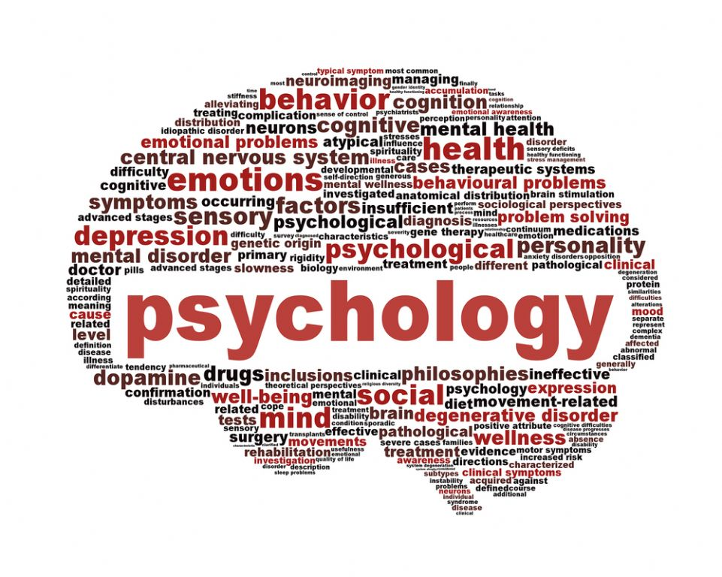
Bridging Course - Week 2

St Mary’s Catholic School
A-level Psychology Bridging Course

The following work requires you to explore the approaches which you were introduced to last week in more detail by considering their key assumptions, methods of testing, ways of explaining and treating abnormal behaviour, as well as the positive and negatives of each approach. You will then begin the process of learning to apply the approaches to scenarios, before checking your understanding with a series of multiple choice questions. Remember to take regular breaks, go back to the tasks after some time away, and try your best. Your Psychology teacher will go over the concepts with you in lessons, early in Year 12 to check your understanding.

Task 1: Recap

Last week you researched some key researchers from the various approaches in psychology and you were introduced to some key concepts and terminology. Before we move on to explore each approach more thoroughly, complete the questions below to see what you can remember. You do not need to write the questions out. Write your answers on paper under the title ‘Task 1: Recap Questions Week 2.’

- Who proposed a) classical conditioning b) operant conditioning c) social learning theory?
- What approach do these three theories come under?
- Where do psychologists conduct controlled research?
- When does a person achieve self-actualisation?
- Why do psychologists carry out pilot studies?
- Which approach looks at conscious thought processes?
- How does the psychodynamic approach suggest we access the unconscious?

If you are unsure of the answers to any of these questions, look over your notes from last week to refresh your memory

Extension:

For each approach (biological/behavioural/cognitive/psychodynamic/humanistic) create a brainstorm of everything you can remember from last week. File these with your answers to the questions above. Entitle each brainstorm “Extension Task 1, Week 2 (insert approach).

Task 2: The Approaches in Detail

We touched upon each of the main psychological approaches last week before focusing our attention on some key researchers. We will now investigate each approach in detail to ensure you can:

- Outline the key assumptions of each approach
- Describe the methods of testing used within each approach
- Describe how each approach attempts to explain and treat behaviours

You are going to create an overview of each approach (five in total), which should be a minimum of one side of A4 and a maximum of two sides of A4 for each approach. These overviews can be created electronically or be handwritten but should present the information in a way which is useful to your style of learning. Some of the information you include may crossover from your factsheets as the key researchers have helped make the approaches what they are today; that is perfectly acceptable and reorganising/rewording information will simply help you to process and retain it better.

Entitle each overview “Overview of (insert approach): Task 2, Week 2.” You should then file them with your answers to Task 1 and last week’s work. As with last week’s factsheets, be creative and include images if you wish. What needs to be included in each overview is outlined below, along with some links to websites and webinars for you to use to research each approach before you get started:

For each overview include:

The approach’s key assumptions (these are sometimes called beliefs, core beliefs, principles, ideas or arguments) and any key researchers (the researchers you looked at last week should be included on the relevant overview they link to)

How the approach believes we should investigate behaviour (for this you should reference some of the research methods from your glossary you made last week)

How the approach believes we should explain behaviour; some approaches will offer more than one explanation, you should include at least one explanation but consider doing up to three per approach.

How the approach believes we should treat/change behaviour; some approaches will offer more than one treatment option, you should include at least one option but consider doing up to three per approach.

Where the approach has been applied in the real world (Hint: has it been used to treat/explain a particular behaviour?)

When this approach was made popular (Hint: during which time period and why?)

Links:

Overview of the approaches:
https://pmt.physicsandmathstutor.com/download/Psychology/A-level/Notes/AQA/5-Approaches-in-Psychology-AS/Approaches%20Notes%20-%20AQA%20Psychology%20A-level.pdf

Biological approach
https://www.simplypsychology.org/a-level-approaches.html#bio
https://www.youtube.com/watch?v=WFzDt-KkFMY

Behavioural approach
https://www.simplypsychology.org/a-level-approaches.html#behave
https://www.simplypsychology.org/a-level-approaches.html#slt
https://www.youtube.com/watch?v=Q4Y5MXomJ6E

Cognitive approach
https://www.simplypsychology.org/a-level-approaches.html#cog
https://www.youtube.com/watch?v=Y4OG-ZO75Uk

Humanistic approach
https://www.simplypsychology.org/a-level-approaches.html#human
https://www.youtube.com/watch?v=dtiQV_mg2bg

Psychodynamic approach
https://www.simplypsychology.org/a-level-approaches.html#psych
https://www.youtube.com/watch?v=AlYn8o8k1QE

Extension:

Click on the link below and make notes, or an overview like ones you have already done, about the interactionist approach. This is an alternative approach which is gaining more and more support, especially when trying to understand and treat mental health disorders. Add these notes to your work from Task 2 under the heading “Extension for Task 2, Week 2.”

https://www.simplypsychology.org/a-level-Schizophrenia.html#6

Task 3: Evaluating the Approaches

We will now look at the key approaches in terms of their positives and negatives. We must consider practical and ethical issues when evaluating the approaches so that in essay questions next year you are able to evaluate them in detail and make informed decisions about which approach is most appropriate for a given situation or behaviour. It is important that evaluations are balanced and this means even if an approach seems outdated or irrelevant, we must consider its merits. We must consider each approach in terms of how well it can explain human behaviour and if there is one approach which seems to be the most appropriate. We do this because as yet psychology does not have a firm set of assumptions; it is a young science which is still developing and considering a range of approaches.

You will have already come across some positives and negatives when completing your background reading and watching for Task 2. Use this information and the information/links provided below to complete an evaluation table for each approach (five in total). A template of how to set this out has been provided below. Each evaluation table should be entitled “Evaluating the (insert approach): Task 3, Week 2” and should be filed alongside your Task 2 work. For each approach you must include at least three strengths and at least three weaknesses. You then need to decide if the evaluative point links to ethics or practical issues. Completing the reading below the template will help you with this.

Template:

Evaluating the Biological Approach: Task 3, Week 2
Strengths/Positives | Weaknesses/Negatives | Is this an ethical issue? | Is this a practical issue?
This approach does not place the blame with individuals who are mentally ill as it focuses on genetics rather than choices |  | Yes – this minimises distress caused to those who are mentally ill, although parents may suffer with guilt
 | A lot of the research investigating genetic assumptions uses twins and so it is difficult to see if the shared behaviour is genetic or if it is learnt from a shared environment |  | Yes – it is difficult to establish cause and effect and therefore decide whether to address the behaviour with drugs to counteract the biological problem or address the issue with therapy to change the environment

Reading:

We will look at ethical issues involved in the planning of research next year. However, with regards to evaluating the approaches we need to consider how ethical they are. To do this we need to think about whether the assumptions, explanations, treatments and methods they use are ethically acceptable. If an approach suggests something which could be distressing to hear, place blame with an individual or their family or encourage discrimination then this could be unethical. Similarly, if the treatment suggested has potential side effects then the ethical issue of harm comes into question. If the research involves causing distress or harm in order to test the approach this is also in breach of ethical codes which psychologists are expected to follow.

We also need to think about the practical issues of the approaches. This means we need to consider whether the treatment options they offer are practical in terms of cost and time to both the individual and the NHS. For example, if an approach supports the use of therapy this can be impractical due to the long process involved, which is not only expensive, but requires a lot of time in comparison to drug treatments which can be self-administered at home. We need to think about how practical each approach’s assumptions are to test and how useful the research done by key researchers is. For example, if animals have been used to make a theory within an approach, it could be suggested this is not practical or useful as the results cannot be generalised to humans.

When completing your strengths and weaknesses you need to consider whether each point links to ethical issues or practical issues. This is a higher level skill so have a go but do not worry if you are unsure. All of these evaluations will be discussed and can be reflected upon when you start the Psychology course in September.

Links:

Biological psychology
https://www.psychologistworld.com/biological/can-it-explain
https://getrevising.co.uk/grids/learning-approaches-evaluation

Behavioural psychology
https://www.psychologistworld.com/issues/behavioral-approach
https://getrevising.co.uk/grids/evaluation-behaviourism

Cognitive psychology
https://www.psychologistworld.com/cognitive/approach
https://getrevising.co.uk/grids/evaluation_of_cognitive_approach

Humanistic psychology
https://www.psychologistworld.com/issues/humanistic-approach
https://getrevising.co.uk/grids/humanistic-approach-2

Psychodynamic psychology
https://www.psychologistworld.com/freud/evaluation
https://getrevising.co.uk/grids/evaluation_of_psychodynamic_approach

Extension: Make an evaluation table for the interactionist approach using the template and guide of what to include above. Entitle it “Extension for Task 3, Week 2.” The link below will provide you with further reading to assist you.

https://getrevising.co.uk/diagrams/evaluation-of-the-interactionist-approach-to

Task 4: Applying the Approaches

Now you need to complete the questions below to see if you can apply your knowledge successfully. You should write in full sentences for the first three questions, but the rest you can simply put the correct letter(s). Try to complete these questions without your notes from this week, or last, in front of you (review them before you start the questions). Doing them without the notes in front of you will give you an opportunity to see how much information you have retained and understood. These questions will be marked by your teacher. You do not need to write the questions out. Write your answers on paper under the title ‘Task 4: Comprehension Questions, Week 2.’ File them with your work from this week’s Task 3.

Questions

- Dominic is unhappy and lacks confidence. He also thinks he is not very good-looking and not very clever. He goes to a counselling therapist for help. The therapist suggests that Dominic lacks congruence. Outline what is meant by ‘congruence’.

Explain one way in which Dominic might achieve ‘congruence’.

- Bradley has just started to play snooker and is keen to play well. He watches carefully when his partner takes a difficult shot then tries to copy the same shot. He thinks about how his partner was holding the snooker cue and whether he can do the same. Social learning theorists refer to the role of mediational processes in learning.

Referring to Bradley’s experiences, explain the role of mediational processes in learning

- A Sarah is terrified of lifts because she was trapped in one for 5 hours. She cannot go in a lift now. B Jerry watches as his brother James is given sweets for cleaning their pet hamster’s cage. The next day, Jerry’s mum finds Jerry cleaning out the hamster cage.

How can the behaviours described in A and B above be explained by the behaviourist approach?

4) Which one of the following statements is FALSE?

A Repression can lead to unpleasant memories causing distress
B Repression causes people to have difficulty accessing unpleasant memories
C Repression involves people choosing to forget unpleasant memories
D Repression involves unpleasant memories being kept from conscious awareness

5) Which one of the following statements is FALSE?

A The Id is responsible for pleasure-seeking behaviour
B The Id is responsible for unreasonable behaviour
C The Superego is responsible for bad behaviour
D The Superego is responsible for guilty feelings

6) A phenotype is the result of the combined effect of ….

A neurotransmitters and environment.
B inheritance and environment.
C genetic makeup and neurotransmitters.
D genotype and evolution.

7) Which one of the following statements about evolution is FALSE?

A Evolution involves adapting to the environment.
B Evolution involves breeding of those best able to survive.
C Evolution involves common genetic material between species.
D Evolution involves changes in behaviour from one generation to the next.

8) Which of the following statements about the cognitive approach is FALSE?

A Inferences about internal mental processes are made on the basis of behaviour.
B Internal mental processes are studied scientifically.
C Mental processes are studied directly by making inferences.
D Theoretical and computer models are used to help explain mental processes.

9) Which of the following best describes identification as a feature of social learning?

A wanting to be like another person
B watching another person
C copying another person
D liking another person

10) Which of the following is NOT a feature of the cognitive approach in psychology? Internal mental processes are studied:

A using computer models.
B using direct observation.
C using inference.
D using theoretical models.

11) According to operant conditioning, which of the following statements is TRUE?

A Negative reinforcement and positive reinforcement decrease the likelihood that a behaviour will be repeated.
B Negative reinforcement and positive reinforcement increase the likelihood that a behaviour will be repeated.
C Negative reinforcement and punishment decrease the likelihood that a behaviour will be repeated. D Negative reinforcement and punishment increase the likelihood that a behaviour will be repeated.

12) According to the biological approach, which of the following statements is TRUE?

A Environment may influence the expression of the genotype.
B Genotype is just the expression of the environment.
C Outside influences cannot affect the expression of the genotype.
D Phenotype is only the expression of the genotype.

13) Which one of these researchers is NOT considered to be behaviourist?

A Pavlov
B Maslow
C Skinner
D Bandura

14) Which one of these key terms is NOT related to the humanistic approach?

A Self-actualisation
B Congruence
C Unconditional positive regard
D Displacement

15) Which TWO approaches support the use of animal research to investigate behaviour and generalise findings to humans?

A Biological
B Humanistic
C Psychodynamic
D Behavioural

