4/23/2020

Rob Gamesby

St Marys Catholic School

Water and Carbon Cycles Lesson Preparation Sheets

All topics are covered extensively at http://coolgeography.co.uk/advanced/water_carbon_cycles.php

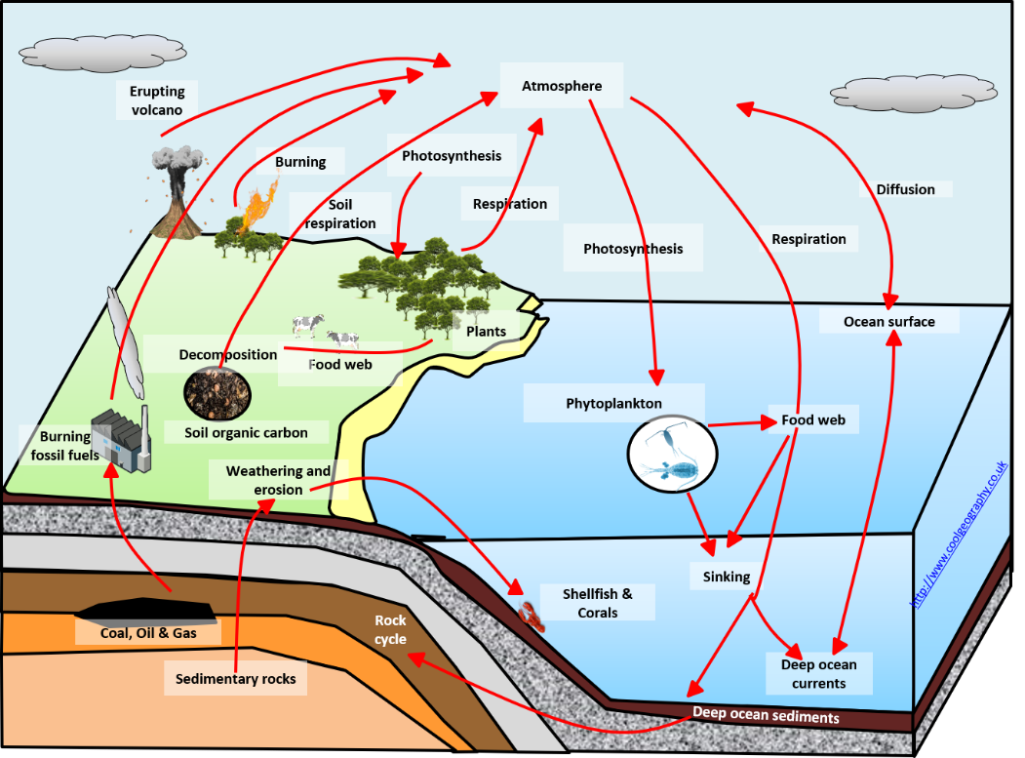

**Lesson Preparation Sheet – Water and the Carbon Cycle**

|  |  |
| --- | --- |
| Topic: SYSTEMS THEORY | **Water and Carbon Cycle** |
| Reading:  <http://coolgeography.co.uk/advanced/Systems_water_carbon_cycles.php> | |
| Glossary:  Hydrospheric system -  Flow/transfer –  Input –  Store/component –  System –  System boundary –  Isolated systems –  Open systems –  Closed systems –  Dynamic equilibrium –  Positive feedback –  Negative feedback –  Cascading system – | |
| Notes | |
| Key learning points: | Diagrams or maps: (2 diagrams, positive and negative feedbacks) |
| Questions EITHER to ask at the start of next lesson OR that you could be asked by an examiner   * Low level (Name, List, define, Recall, relate, Describe) * Medium Level (Explain, Compare, Classify, Justify, Apply) * Hard level (Speculate, Interpret, Analyse, Sequence, Summarize, Develop, Synthesise, Adapt, Judge, Rank, Evaluate, Prove) | |
| Case studies or examples (explain an example system - such as a river system) | |
| Teachers Initials |  |

|  |  |
| --- | --- |
| Topic: Water Cycle – Stores in the water cycle. | **Water and Carbon Cycle** |
| Reading:  <http://coolgeography.co.uk/advanced/Major_Stores_Water.php> | |
| Glossary:  Atmospheric water –  Cryospheric water –  Hydrosphere –  Oceanic water –  Terrestrial water –  Sea ice –  Ice shelves –  Ice sheets –  Ice caps –  Alpine glaciers –  Permafrost –  Surface water –  Wetlands –  Groundwater –  Soil water –  Biological water – | |
| Notes | |
| Key learning points: | Diagrams or maps: (Distribution of the world’s water Pie chart) |
| Questions EITHER to ask at the start of next lesson OR that you could be asked by an examiner   * Low level (Name, List, define, Recall, relate, Describe) * Medium Level (Explain, Compare, Classify, Justify, Apply) * Hard level (Speculate, Interpret, Analyse, Sequence, Summarize, Develop, Synthesise, Adapt, Judge, Rank, Evaluate, Prove) | |
| Case studies or examples (any examples of each store) | |
| Teachers Initials |  |

**Lesson Preparation Sheet – Water and the Carbon Cycle**

|  |  |
| --- | --- |
| Topic: Water Cycle – Processes | **Water and Carbon Cycle** |
| Reading:  <http://coolgeography.co.uk/advanced/Water_Cycle_Processes.php> OR  “AQA A-level Geography” Skinner et al. P9 to 13 | |
| Glossary:  Evaporation, Condensation, Cloud formation, Causes of precipitation and Cryospheric processes  Evapotranspiration –  Residence Time  Melting  Freezing  Vaporisation  Sublimation  Deposition  Humidity  Relative humidity | |
| Notes | |
| Key learning points: | Diagrams or maps: A sketch of the Water Cycle; |
| Questions EITHER to ask at the start of next lesson OR that you could be asked by an examiner   * Low level (Name, List, define, Recall, relate, Describe) * Medium Level (Explain, Compare, Classify, Justify, Apply) * Hard level (Speculate, Interpret, Analyse, Sequence, Summarize, Develop, Synthesise, Adapt, Judge, Rank, Evaluate, Prove) | |
| Teachers Initials |  |

|  |  |
| --- | --- |
| Topic: Water Cycle – The Drainage Basin | **Water and Carbon Cycle** |
| Reading:  <http://coolgeography.co.uk/advanced/Drainage_Basins.php> | |
| Glossary:  Drainage basin –  Evaporation –  Groundwater flow –  Infiltration –  Infiltration rate –  Interception storage –  Overland flow –  Percolation –  Run-off –  Saturated –  Stemflow –  Storm and rainfall event –  Throughfall –  Throughflow –  Transpiration –  Soil storage –  Vegetation storage –  Channel flow – | |
| Notes | |
| Key learning points: | Diagrams or maps: (Sketch a diagram of how water moves through the drainage basin system) |
| Questions EITHER to ask at the start of next lesson OR that you could be asked by an examiner   * Low level (Name, List, define, Recall, relate, Describe) * Medium Level (Explain, Compare, Classify, Justify, Apply) * Hard level (Speculate, Interpret, Analyse, Sequence, Summarize, Develop, Synthesise, Adapt, Judge, Rank, Evaluate, Prove) | |
| Case studies or examples (any examples of a drainage basin system with some background factual evidence – such as the Tyne Basin, or the Amazon) | |
| Teachers Initials |  |

**THE SHEETS FROM THIS POINT ON WILL BE USED ONCE YOU START THE COURSE, THERE IS NO NEED TO FILL THEM OUT**

**Lesson Preparation Sheet – Water and the Carbon Cycle**

|  |  |
| --- | --- |
| Topic:Water Cycle - The water balance and soil moisture budgets. | **Water and Carbon Cycle** |
| **Reading:**  “AQA A-level Geography” Skinner et al. P13 to 14  “Geography in Focus” Cook et al, page 380 | |
| **Glossary:**  Water Balance/budget –  River regime –  Soil moisture budget –  Storage –  Transfers –  Discharge –  Potential evapotranspiration –  Soil moisture surplus –  Soil moisture utilization –  Soil moisture recharge –  Soil moisture surplus – | |
| **Notes** | |
| **Key learning points:** | **Diagrams or maps:** (Figure 1.18 Soil water budget graph) |
| Questions EITHER to ask at the start of next lesson OR that you could be asked by an examiner   * Low level (Name, List, define, Recall, relate, Describe) * Medium Level (Explain, Compare, Classify, Justify, Apply) * Hard level (Speculate, Interpret, Analyse, Sequence, Summarize, Develop, Synthesise, Adapt, Judge, Rank, Evaluate, Prove) | |
| **Case studies or examples** (Younde and Navrongo) | |
| Teachers Initials |  |

**Lesson Preparation Sheet – Water and the Carbon Cycle**

|  |  |
| --- | --- |
| Topic: Water Cycles - River regime and storm hydrographs | **Water and Carbon Cycle** |
| **Reading:**  “AQA A-level Geography” Skinner et al. P14 to 19  [**http://coolgeography.co.uk/advanced/Hydrographs_Regimes.php**](http://coolgeography.co.uk/advanced/Hydrographs_Regimes.php) | |
| Glossary:  Discharge –  Base flow –  Storm hydrograph –  River regime -  Bankfull discharge -  Rising limb -  Falling limb –  Antecedent flow rate –  Lag time –  Storm Flow –  Drainage density –  Geology – | |
| **Notes** | |
| **Key learning points:** (focus on hydrographs and what affects them) | **Diagrams or maps:** (Figure 1.26 A storm hydrograph) |
| Questions EITHER to ask at the start of next lesson OR that you could be asked by an examiner   * Low level (Name, List, define, Recall, relate, Describe) * Medium Level (Explain, Compare, Classify, Justify, Apply) * Hard level (Speculate, Interpret, Analyse, Sequence, Summarize, Develop, Synthesise, Adapt, Judge, Rank, Evaluate, Prove) | |
| **Case studies or examples** (make notes on river regimes and these examples) | |
| Teachers Initials |  |

**Lesson Preparation Sheet – Water and the Carbon Cycle**

|  |  |
| --- | --- |
| Topic: Water Cycles – Changes in water cycle over time-human impact | **Water and Carbon Cycle** |
| **Reading:**  “AQA A-level Geography” Skinner et al. P19 to 24  <http://coolgeography.co.uk/advanced/Human_Influences_Water_Cycle.php> | |
| Glossary: (you will have to do research on the internet for most of these definitions)  Deforestation –  Forest degradation –  Biodiversity –  Soil drainage –  ‘Tiles’ (to do with soil drainage) –  Aeration of soil –  Eutrophication –  Denitrification –  Water abstraction –  Water table –  Saline intrusion –  Desalination plants –  Irrigation – | |
| **Notes** | |
| **Key learning points:** (cover deforestation, soil drainage and water abstraction, put them as subtitles) | **Diagrams or maps:** (Figure 1.33 effects of soil drainage – draw horizontally) |
| Questions EITHER to ask at the start of next lesson OR that you could be asked by an examiner   * Low level (Name, List, define, Recall, relate, Describe) * Medium Level (Explain, Compare, Classify, Justify, Apply) * Hard level (Speculate, Interpret, Analyse, Sequence, Summarize, Develop, Synthesise, Adapt, Judge, Rank, Evaluate, Prove) | |
| **Case studies or examples** (Water abstraction of southern England and the London Basin P22-24) | |
| Teachers Initials |  |

**Lesson Preparation Sheet – Water and the Carbon Cycle**

|  |  |
| --- | --- |
| Topic: Carbon Cycle – Global distribution and size of carbon stores | **Water and Carbon Cycle** |
| **Reading:**  “AQA A-level Geography” Skinner et al. P24 to 27  <http://coolgeography.co.uk/advanced/Stores_of_Carbon.php> | |
| Glossary:  Carbon –  Carbon dioxide CO­­2 –  Methane CH4 –  Calcium Carbonate CaCO3 –  Hydrocarbons –  Bio-molecules –  Anthropogenic CO2 –  Biosphere –  Carbon sequestration –  Carbon sink –  Greenhouse gases –  Lithosphere –  Weathering – | |
| **Notes** | |
| **Diagrams or maps:** (Figure 1.36 Terrestrial carbon stores) | |
| **Key learning points:** (make notes on carbon origin and the major stores) | |
| Questions EITHER to ask at the start of next lesson OR that you could be asked by an examiner   * Low level (Name, List, define, Recall, relate, Describe) * Medium Level (Explain, Compare, Classify, Justify, Apply) * Hard level (Speculate, Interpret, Analyse, Sequence, Summarize, Develop, Synthesise, Adapt, Judge, Rank, Evaluate, Prove) | |
| Teachers Initials |  |

**Lesson Preparation Sheet – Water and the Carbon Cycle**

|  |  |  |
| --- | --- | --- |
| Topic: Carbon Cycle – Movement of carbon (driving changes in magnitude of stores) | | **Water and Carbon Cycle** |
| **Reading:**  “AQA A-level Geography” Skinner et al. P27 to 30 (up to volcanic activity)  <http://coolgeography.co.uk/advanced/Change_Stores_of_Carbon.php> | | |
| Glossary:  Carbon sink –  Carbon source –  Weathering –  Carbonic acid –  Photosynthesis –  Phytoplankton –  Respiration –  Decomposition –  Oxidation –  Biological pump –  Vertical deep mixing (in oceans) –  Combustion –  Biomass combustion –  Volcanic activity – | | |
| **Diagrams or maps:** (Figure 1.39 The carbon cycle) | | |
| **Key learning points:** | | |
| **The Geological component:** | **Photosynthesis and Respiration:** | |
| **Decomposition:** | **Oceanic carbon pumps:** | |
| **Combustion:** | **Volcanic activity:** | |
| **Carbon sequestration** (include Figure 1.47)**:** | | |
| Questions EITHER to ask at the start of next lesson OR that you could be asked by an examiner   * Low level (Name, List, define, Recall, relate, Describe) * Medium Level (Explain, Compare, Classify, Justify, Apply) * Hard level (Speculate, Interpret, Analyse, Sequence, Summarize, Develop, Synthesise, Adapt, Judge, Rank, Evaluate, Prove) | | |
| Teachers Initials |  | |

**Lesson Preparation Sheet – Water and the Carbon Cycle**

|  |  |
| --- | --- |
| Topic: Carbon Cycle – Changes in the carbon cycle over time | **Water and Carbon Cycle** |
| **Reading:**  “AQA A-level Geography” Skinner et al. P30 to 33  <http://coolgeography.co.uk/advanced/Carbon_Cycle_Over_Time.php> | |
| Glossary:  Fossil fuels –  Enteric fermentation –  Greenhouse gases –  Deforestation –  FAO (United Nations) –  Urbanisation – | |
| **Notes** | |
| **Key learning points:** (include examples)  Natural variations (wild fires and volcanic activity):  Human impact (hydrocarbon fuel extraction and burning, farming practices, land use changes (deforestation and urban growth)) | |
| **Diagrams or maps:** (Figure 1.45 effects of deforestation on the carbon cycle) | |
| Questions EITHER to ask at the start of next lesson OR that you could be asked by an examiner   * Low level (Name, List, define, Recall, relate, Describe) * Medium Level (Explain, Compare, Classify, Justify, Apply) * Hard level (Speculate, Interpret, Analyse, Sequence, Summarize, Develop, Synthesise, Adapt, Judge, Rank, Evaluate, Prove) | |
| Teachers Initials |  |

**Lesson Preparation Sheet – Water and the Carbon Cycle**

|  |  |
| --- | --- |
| Topic: Carbon Cycle – The carbon budget and the impact of the carbon cycle upon land, ocean and atmosphere. | **Water and Carbon Cycle** |
| **Reading:**  “AQA A-level Geography” Skinner et al. P34 to 39  <http://coolgeography.co.uk/advanced/Carbon_Budget.php> | |
| Glossary:  Carbon Budget  Ocean acidification –  Ocean salinity –  Thermohaline circulation –  Thermal expansion –  Enhanced greenhouse effect –  Geo-sequestration –  Radiative forcing –  Soil organic carbon (SOC) – | |
| **Notes** | |
| **Key learning points:** (you may want to put subtitles for land, ocean and atmosphere.) | |
| **Diagrams or maps:** (Figure 1.50 positive feedback of oceanic warming) | |
| Questions EITHER to ask at the start of next lesson OR that you could be asked by an examiner   * Low level (Name, List, define, Recall, relate, Describe) * Medium Level (Explain, Compare, Classify, Justify, Apply) * Hard level (Speculate, Interpret, Analyse, Sequence, Summarize, Develop, Synthesise, Adapt, Judge, Rank, Evaluate, Prove) | |
| **Case studies or examples** (research the Younger Dryas event, how the shutdown of the North Atlantic “Conveyor” caused it and the effect it had on climate) | |
| Teachers Initials |  |

**Lesson Preparation Sheet – Water and the Carbon Cycle**

|  |  |
| --- | --- |
| Topic: Carbon Cycles – Water, carbon, climate and life on Earth | **Water and Carbon Cycle** |
| **Reading:**  “AQA A-level Geography” Skinner et al. P40 to 44  http://coolgeography.co.uk/advanced/Carbon_water_cycles_Life_Earth.php | |
| Glossary:  Mitigation –  Carbon Capture Storage (CCS) – | |
| **Diagrams or maps:** (Figure 1.57 Management of climate change) | |
| **Key learning points:** | |
| **Carbon Capture Sequestration (CCS):** | |
| **Changing rural land use:** | |
| **Improved aviation practices:** | |
| Questions EITHER to ask at the start of next lesson OR that you could be asked by an examiner   * Low level (Name, List, define, Recall, relate, Describe) * Medium Level (Explain, Compare, Classify, Justify, Apply) * Hard level (Speculate, Interpret, Analyse, Sequence, Summarize, Develop, Synthesise, Adapt, Judge, Rank, Evaluate, Prove) | |
| Teachers Initials |  |

**Lesson Preparation Sheet – Water and the Carbon Cycle**

|  |  |
| --- | --- |
| Topic: Carbon Cycles – Case study of a tropical rainforest | **Water and Carbon Cycle** |
| **Reading:**  “AQA A-level Geography” Skinner et al. P44 to 46  <http://coolgeography.co.uk/advanced/Tropical_rainforest_casestudy.php> | |
| Background to the Amazon including a map (Figure 1.63): | |
| **Key learning points:** | |
| **Diagram (Figure 1.65 – strategies to reduce effects of environmental change in Amazonia):** | |
| Questions EITHER to ask at the start of next lesson OR that you could be asked by an examiner   * Low level (Name, List, define, Recall, relate, Describe) * Medium Level (Explain, Compare, Classify, Justify, Apply) * Hard level (Speculate, Interpret, Analyse, Sequence, Summarize, Develop, Synthesise, Adapt, Judge, Rank, Evaluate, Prove) | |
| Teachers Initials |  |

**Lesson Preparation Sheet – Water and the Carbon Cycle**

|  |  |
| --- | --- |
| Topic: Carbon Cycles – Case study of a river catchment at a local scale | **Water and Carbon Cycle** |
| **Reading:**  “AQA A-level Geography” Skinner et al. P47 to 49  <http://coolgeography.co.uk/advanced/River_Catchment_casestudy.php> | |
| Background to the River Brock including a location map (research this): | |
| **Key learning points:** | |
| **Diagram (Sketch Figure 1.67 and 1.68):** | |
| Questions EITHER to ask at the start of next lesson OR that you could be asked by an examiner   * Low level (Name, List, define, Recall, relate, Describe) * Medium Level (Explain, Compare, Classify, Justify, Apply) * Hard level (Speculate, Interpret, Analyse, Sequence, Summarize, Develop, Synthesise, Adapt, Judge, Rank, Evaluate, Prove) | |
| Teachers Initials |  |