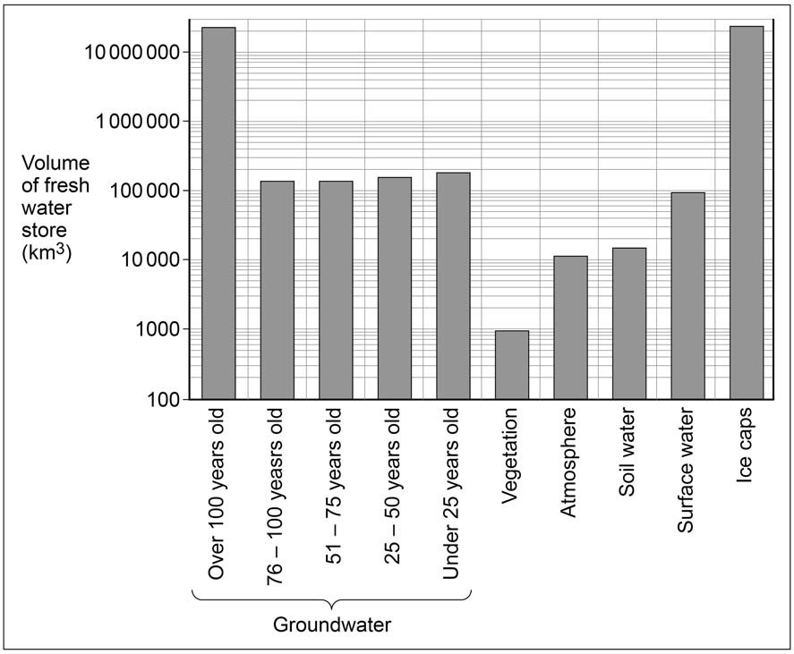
1

0
. 4 Figure 1
and
Figure 2
show information about the nature of a range of global stores of
fresh water.

Figure 1 Volume of fresh water held in different stores

(
Global volumes of groundwater to
2

km depth compared with other fresh water stores in the
atmosphere, in surface waters (wetlands, rivers and lakes) and within plants or in soils.)

Figure 2 Approximate length of time fresh water remains in different stores

Store | Residence time
Ice caps | 15 000 years
Groundwater | Up to 1000 years
Surface water | 2 weeks to 10 years
Soil water | 2-50 weeks
Atmosphere | 10 days
Vegetation | Varies

Using Figure 1 and Figure 2, analyse the nature of these global stores of fresh water.
[6 marks]

