A-level Economics

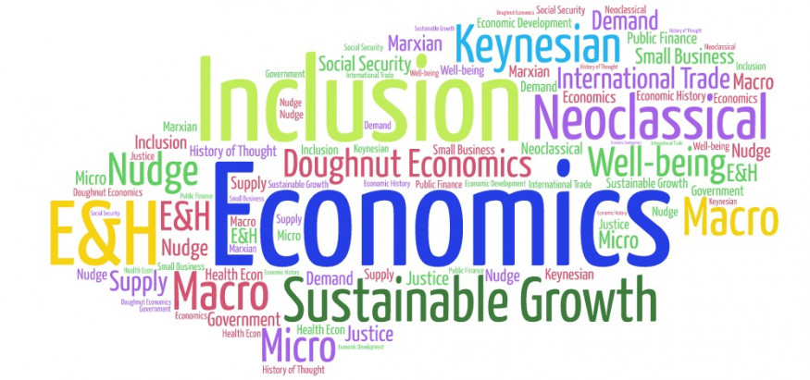

Bridging Course - Week 4

St Mary’s Catholic School
A-level Economics Bridging Course

Entry Requirements for Studying A-level Economics?
- Students are expected to achieve at least a grade 6 in GCSE Maths and English Language.
- Students must have an interest in the news and current affairs
- Students should have an interest in debates and discussion in lessons, and be willing, and able, to share their ideas.
What to expect from A-level Economics
There aren’t many A- level subjects as dynamic as Economics. The news is full of examples of Economics in action. Within the course we study human behaviour, how markets work and how they fail and seek to understand the dynamics of change at a micro level (e.g. within an industry) and at a macro level (e.g. within and between countries).
Whilst studying this course students will develop their analytic and evaluative skills. These will be tested through short explanation questions but a large amount of the course (1/3 of your overall mark) will involve writing longer essay style questions. The course will also use economic models and diagrams to analyse real life events.
It doesn’t matter if you haven’t studied Economics before. You might have an interest in Economics and want to know more about the impact economics has on the world around you. You might want to investigate some of the stories you hear in the news – Why do some economies grow and others don’t? Will the Eurozone survive? Why didn’t economists predict the Global Financial Crisis? This course will help you to understand all this and more.

This bridging course will provide you with a mixture of information about A-level Economics, and what to expect from the course, as well as key work to complete. Students who are expecting to study Economics at A-level, and are likely to meet the entry requirements, must complete the bridging course fully and thoroughly, to the best of their ability.

You should complete all work on paper and keep it in a file, in an ordered way. You will submit it to your teacher in September. All of the work will be reviewed and selected work will be assessed, and you will be given feedback on it. This work will be signalled to you. If you do not have access to the internet, please contact the school and appropriate resources will be sent to you.

If you are thinking about studying Economies at A-level you should attempt this work to see whether or not you think studying a subject like this is right for you. If you later decide to study Economics, you must ensure you complete this work in full. This work should be completed after you have read and completed the Study Skills work that all of Year 12 should complete.

Review of Week 3 Bridging Course

Last week you researched globalisation. To check your understanding complete the questions below:

- What is globalisation?
- How is globalisation caused?
- List one advantage and disadvantage of globalisation.

Answers are on the last page of this document

The following work requires a lot of reading, and some of the ideas might be challenging to understand on first reading. Remember to take regular breaks, go back to any of the tasks after some time away, and try your best. Your Economics teacher will go over the following with you in lessons, early in Year 12.

This fourth week of tasks will focus on building your knowledge of different economies. This work will be reviewed on return to school and used throughout the A- level course.

Task one

Using the recommended resources, you will complete the below country profile for three countries. One must be the UK. You can choose the other two countries however; I would suggest choosing two very different countries so that you can use these for future comparisons.

Throughout A- level Economics you will be asked to use your own knowledge of different countries to aid your exam responses. This task will allow you to begin to build this knowledge of different countries and their characteristics.

You may not find all data for each country.

Suggested resources

https://data.worldbank.org/

https://www.imf.org/en/Data

https://www.ons.gov.uk/

https://www.tutor2u.net/economics/collections/country-profile-special-podcasts

Below are three copies of the same document. If you are unable to print this document, then writing your answers in a notebook is fine.

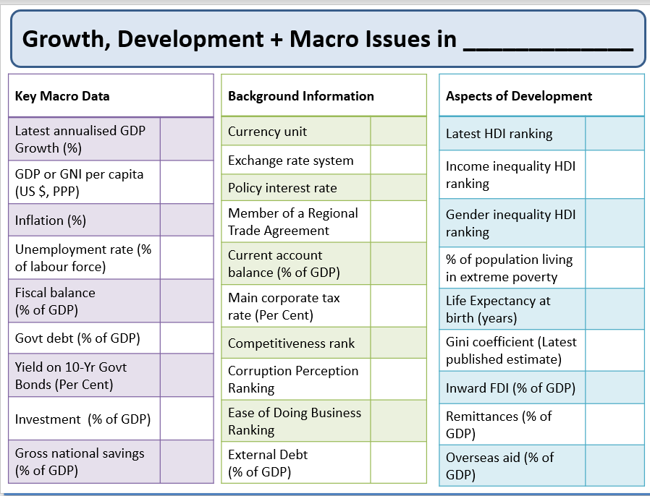

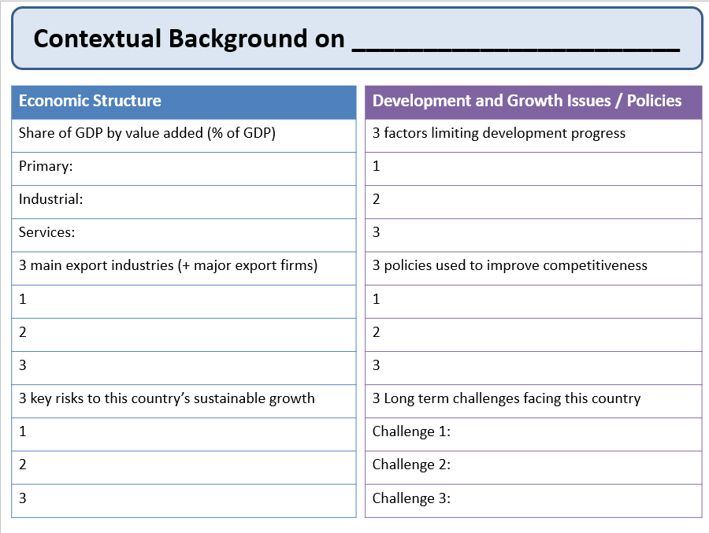

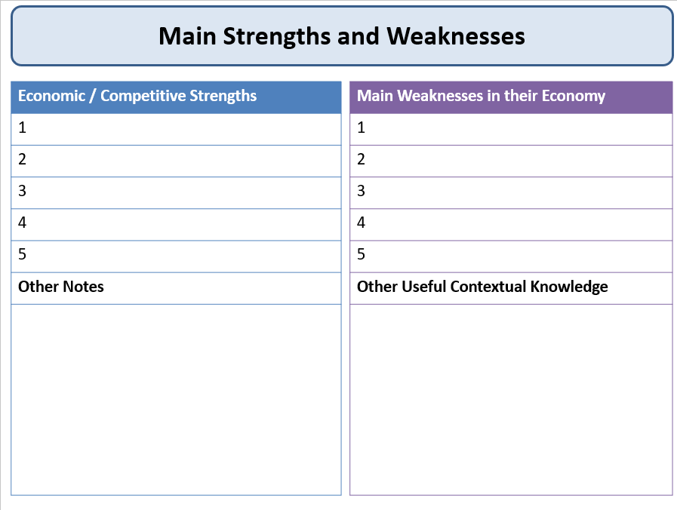

Answers to review questions

- Globalisation is a process of deeper integration between countries and regions of the world.

- Containerisation, technological change, economies of scale, differences in tax systems, less protectionism, TNC’s.

- Possible advantages : Encourages producers and consumers to benefit from deeper division of labour and economies of scale, competitive markets reduce monopoly profits and incentivise businesses to seek cost-reducing innovations ,enhanced growth has led to higher per capita incomes – and helped many of poorest countries to achieve faster economic growth and reduce extreme poverty measured as incomes < $1.90 per day (PPP adjusted) and gains from the sharing of ideas / skills / technologies across national borders.

Possible disadvantages: Inequality, inflation, vulnerability to external economic shocks, threats to the Global Commons.

